**Engineering Computation and Linear Algebra Programming Project**  
Department of Electrical & Computer Engg.  
University of Sharjah

The provided circuit is shown the figure below:

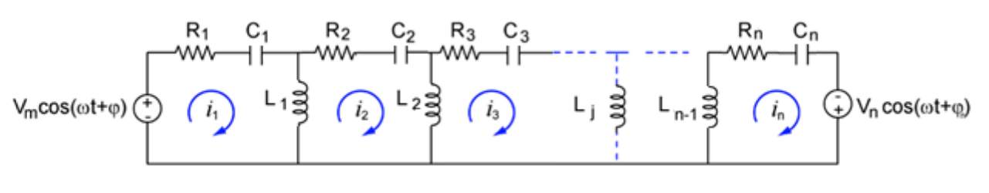

In phasor form voltage sources are:

The following Equations are referred as Eq. (1 & 2), respectively:

$$V_{m}\cos\left(ωt+ϕ_{1}\right)=V_{m}∠ϕ_{1} V_{n}\cos\left(ωt+ϕ_{2}\right)=V_{n}∠ϕ_{2}$$

Inductive and capacitive reactances are given by:

The following equations are referred as Eq. (3 & 4), respectively.

$$X_{L}=ωL X_{c}=\frac{1}{ωC}$$

Where L and C are inductance & capacitance of the respective inductor and capacitor.

For simplicity, we consider a circuit with three loop. Using KVL:

The following System of Equations are referred as Eq. (5, 6 & 7), respectively.

$$\left.\begin{matrix}\left(R_{1}-jX_{C_{1}}+jX_{L_{1}}\right)i_{1}-jX_{L_{1}}i_{2}=V_{m}∠ϕ_{1} \\ -jX_{L_{1}}i_{1}+\left({jX}_{L_{1}}+R_{2}-jX_{C_{2}}+jX_{L_{2}}\right)i_{2}-jX_{L_{2}}i_{3}=0 \\ -jX_{L_{2}}i_{2}+\left(R_{3}-jX_{C_{3}}+jX_{L_{2}}\right)i_{3}=V_{n}∠ϕ_{2}\end{matrix}\right\}$$

In Matrix Form: $ZI=V$:

The following systems of Equations are referred as Eq. (8 & 9), respectively.

$$\left[\begin{matrix}\left(R_{1}-jX_{C_{1}}+jX_{L_{1}}\right) & -jX_{L_{1}} & 0 \\ -jX_{L_{1}} & \left({jX}_{L_{1}}+R_{2}-jX_{C_{2}}+jX_{L_{2}}\right) & -jX_{L_{2}} \\ 0 & -jX_{L_{2}} & \left(R_{3}-jX_{C_{3}}+jX_{L_{2}}\right)\end{matrix}\right]\left[\begin{matrix}i_{1} \\ i_{2} \\ i_{3}\end{matrix}\right]=\left[\begin{matrix}V_{m}∠ϕ_{1} \\ 0 \\ V_{n}∠ϕ_{2}\end{matrix}\right]$$

$$\left[\begin{matrix}z_{11} & -z_{12} & 0 \\ -z_{12} & z_{22} & -z_{23} \\ 0 & -z_{23} & z_{33}\end{matrix}\right]\left[\begin{matrix}i_{1} \\ i_{2} \\ i_{3}\end{matrix}\right]=\left[\begin{matrix}V_{m}∠ϕ_{1} \\ 0 \\ V_{n}∠ϕ_{2}\end{matrix}\right]$$

For n loops:

The following matrix equation is referred as Eq. (10), which is the general form.

$$\left[\begin{matrix}\begin{matrix}z_{11} & {-z}_{12} & 0 \\ -z_{12} & z_{22} & {-z}_{23} \\ 0 & -z_{23} & z_{33}\end{matrix} & \begin{matrix}⋯ & 0 \\ ⋯ & 0 \\ ⋯ & 0\end{matrix} \\ \begin{matrix}⋮ & ⋮ & ⋮ \\ 0 & 0 & 0 \end{matrix} & \begin{matrix}⋱ & ⋮ \\ ⋯ & z_{nn}\end{matrix}\end{matrix}\right]\left[\begin{matrix}\begin{matrix}i_{1} \\ i_{2} \\ i_{3}\end{matrix} \\ \begin{matrix}⋮ \\ i_{n}\end{matrix}\end{matrix}\right]=\left[\begin{matrix}\begin{matrix}V_{m}∠ϕ_{1} \\ 0 \\ 0\end{matrix} \\ \begin{matrix}⋮ \\ V_{n}∠ϕ_{2}\end{matrix}\end{matrix}\right]$$

Where:

The following equations are referred as Eq. (11, 12, 13 & 14)

$$z_{11}=R_{1}-jX_{C_{1}}+jX_{L_{1}} \\ z_{ii}={jX}_{L_{i-1}}+R_{i}-jX_{C_{i}}+jX_{L_{i}} 1<i<n \\ z_{nn}=R_{n}-jX_{C_{n}}+jX_{L_{n-1}} \\ z_{ii+1}=jX_{L_{i}} 1≤i<n$$