Rever Test Environment Installation Guide

**Requirements:**

* Install [XCode](https://developer.apple.com/xcode/) 7.1.1 or higher
* Apple Developer Tools (iPhone simulator SDK, command line tools)
* Install [Node.js](https://nodejs.org/en/)

**Appium:**

* Open a terminal and install appium (use sudo if it doesn’t work):

$ npm install -g appium  
 $ appium

* Download [Appium.app](https://bitbucket.org/appium/appium.app/downloads/)
* Run it!

**Python Libraries:**

* Download [Python 2.7](https://www.python.org/downloads/)
* Python 2.7 already comes with PIP, the package manager for python
* Open a terminal and download the following libraries:

$ pip install Appium-Python-Client

$ pip install robotframework

$ pip install robotframework-appiumlibrary

**Run a test using Appium:**

* Open appium UI

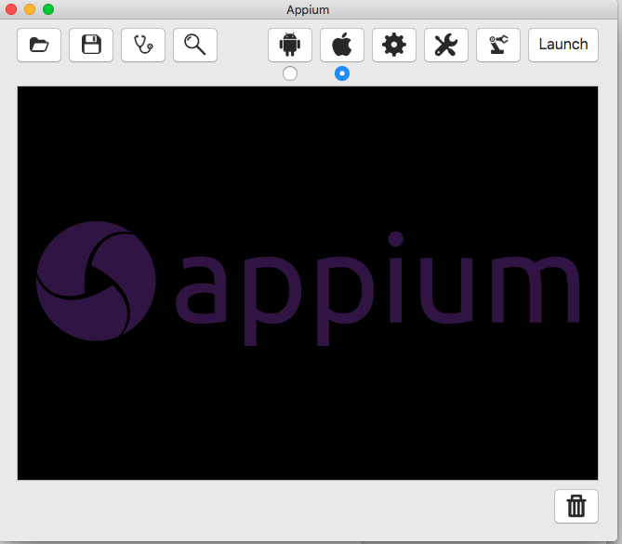

* First of all we need to check if everything was correctly installed, to do that, click on the Screen Shot 2016-10-06 at 3.04.40 PM.pngicon.
* You should see a screen like the below, indicating that everything is working fine:

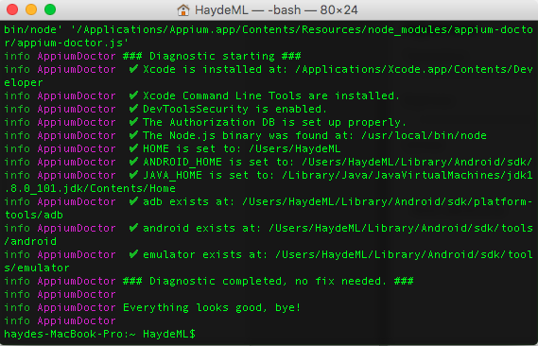

* Now we are going to setup Appium to run a test for Rever App on iOS:
* Click on the Screen Shot 2016-10-06 at 3.07.49 PM.png icon and you should see the screen below:

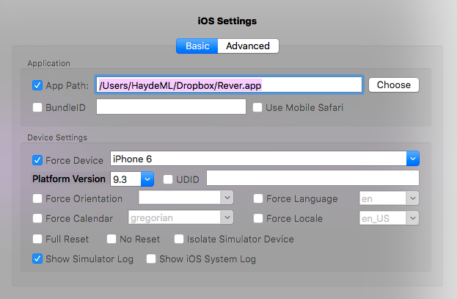

* The only fields we need are:
  + App Path: The path where our .app is located
  + Force Device: The device we want to emulate
  + Platform Version: OS Version to emulate
  + Show simulator Log: Mark this to see the log on the Terminal window.
* For the settings Screen Shot 2016-10-06 at 3.12.09 PM.png section leave it as it is. It should look like this:

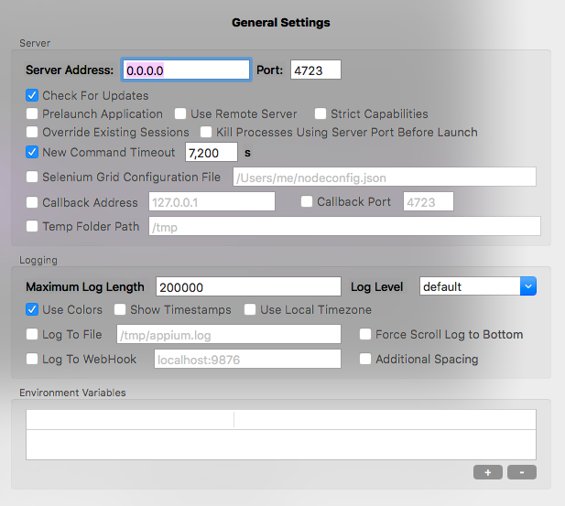

* Now we will launch appium server, we can do that 2 different ways:
  + Appium UI:Screen Shot 2016-10-06 at 3.16.02 PM.png
    - Click on button, you should see a screen like the below:

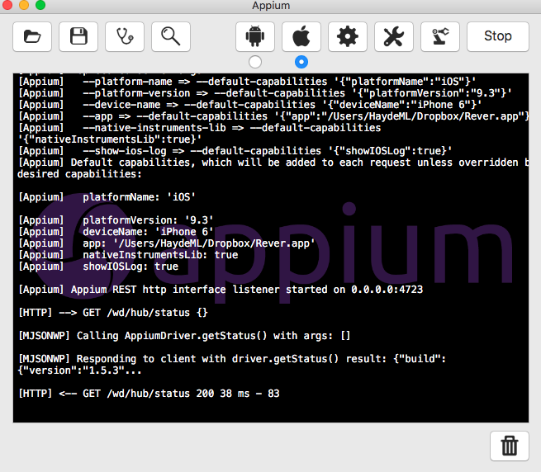

* As you can see on the top of the right corner the button changed from “Launch” to Stop which means that appium server is currently running.
* Now that we have all configured, we will click on the Screen Shot 2016-10-06 at 3.51.09 PM.pngbutton, this will launch the emulator (in this case) and the inspector tool.
  + In case it gives you the below error, verify the log, you might be using an unsupported iOS version, or the Appium server might not be started:

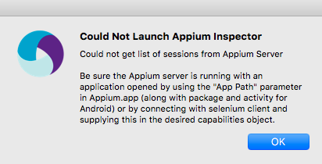

* Once that both the Appium server and the inspector are correctly running you should see something like the screen below:
  + First it will launch the emulator, it might open once and then die, give it a few seconds It will come back again:

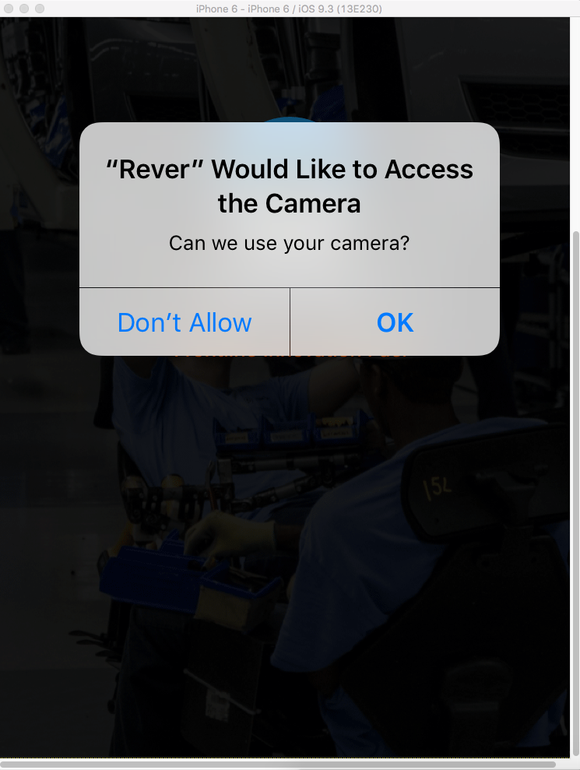

* Then it will launch the inspector UI:

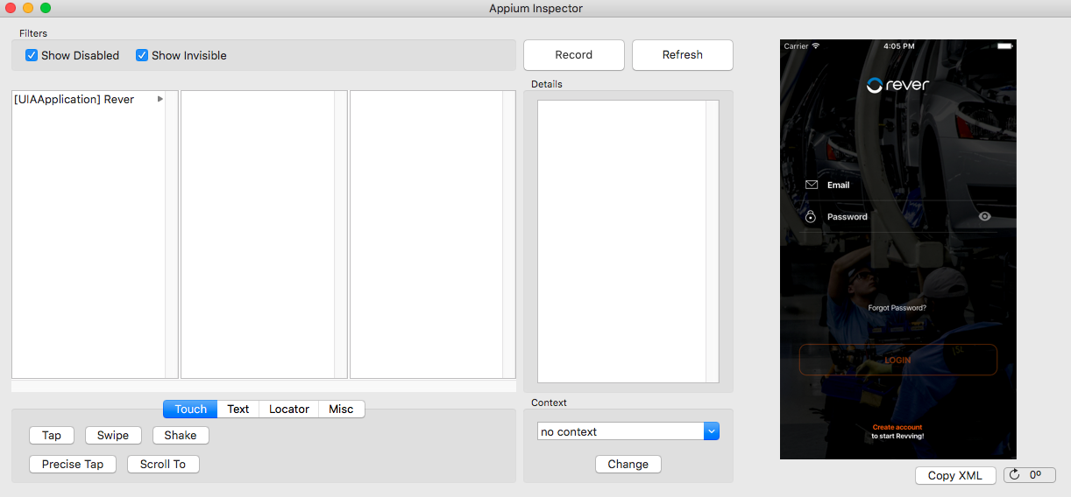

* Using this UI if you click on the “Record” button you will be able to generate scripts for test cases.
* The scripts generated will be in Python “.py” so you can just call them on the Terminal.
* Using the terminal to run Appium Test:
  + Open terminal
  + Type: appium&
  + You should see the below screen:

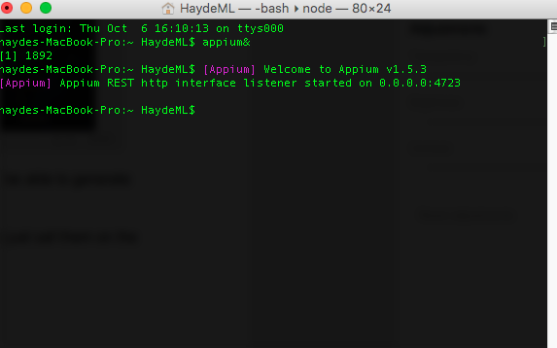

* Navigate to the Directory where your test is located and run it:
  + In this case I’m running simple_test.py

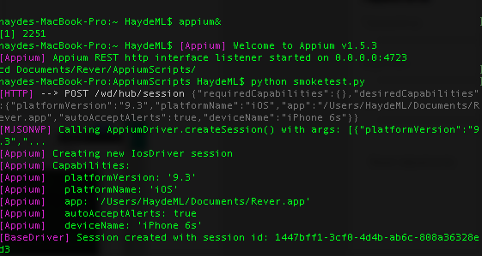

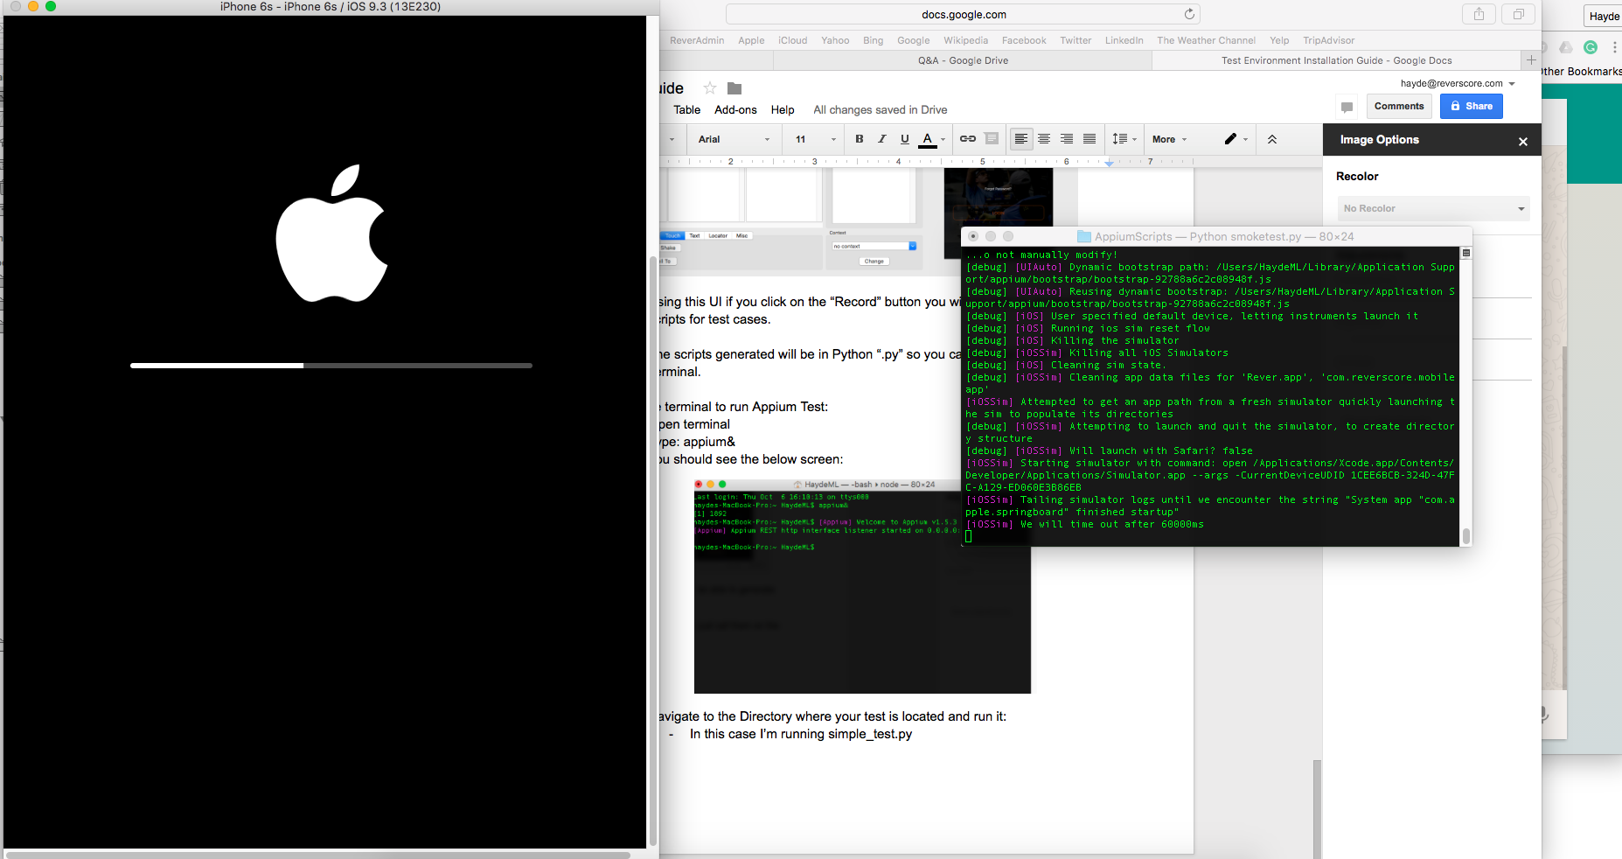

* The first image is how we started the server and ran the script, the second image is the log in terminal and the emulator being launched.

**Run a test using Robot Framework for detailed report of the test.**

* Navigate to the folder where the Test Suite is and run the below command (customized for this example):
  + robot -t smoketest TestRever.robot

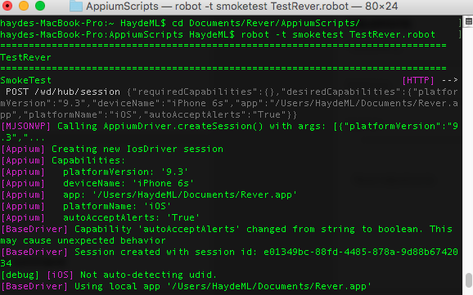

* This will again launch the emulator, complete the same step from the test, but this will provide reports:

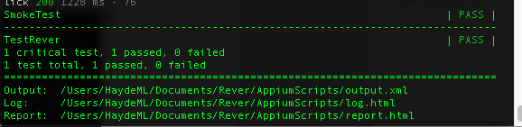

If we open the report file, it will look like this:

