**NAME: Hayden Cordeiro ROLL NO: 05 BATCH: D**

**EXPERIMENT NO.: 1**

**Aim**: To implement A* Algorithm

**Learning Objective**: To understand A*t and simulate the same in software.

**Learning Outcome**: Student are able to successfully simulate an A* algorithm.

**Course Outcome:**

|  |
| --- |
| **CSL703.1**To realize the basic techniques to build intelligent systems |

**Program Outcome:**

(PO 3) Design/ development of solutions: Breadth and uniqueness of engineering problems i.e., the extent to

which problems are original and to which solutions have previously been identified or codified

(PO 12) Life Long Learning

**Bloom's Taxonomy Level:**

* Remembering
* Understanding

**Input:**

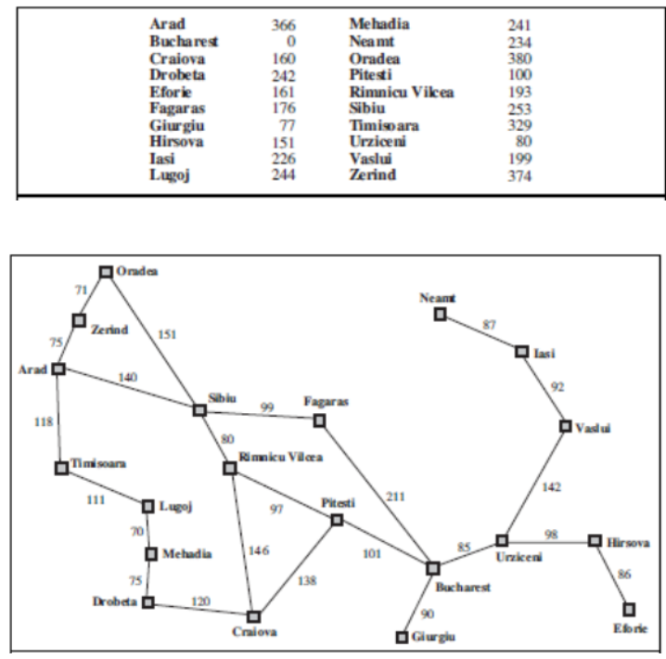

**Theory:**

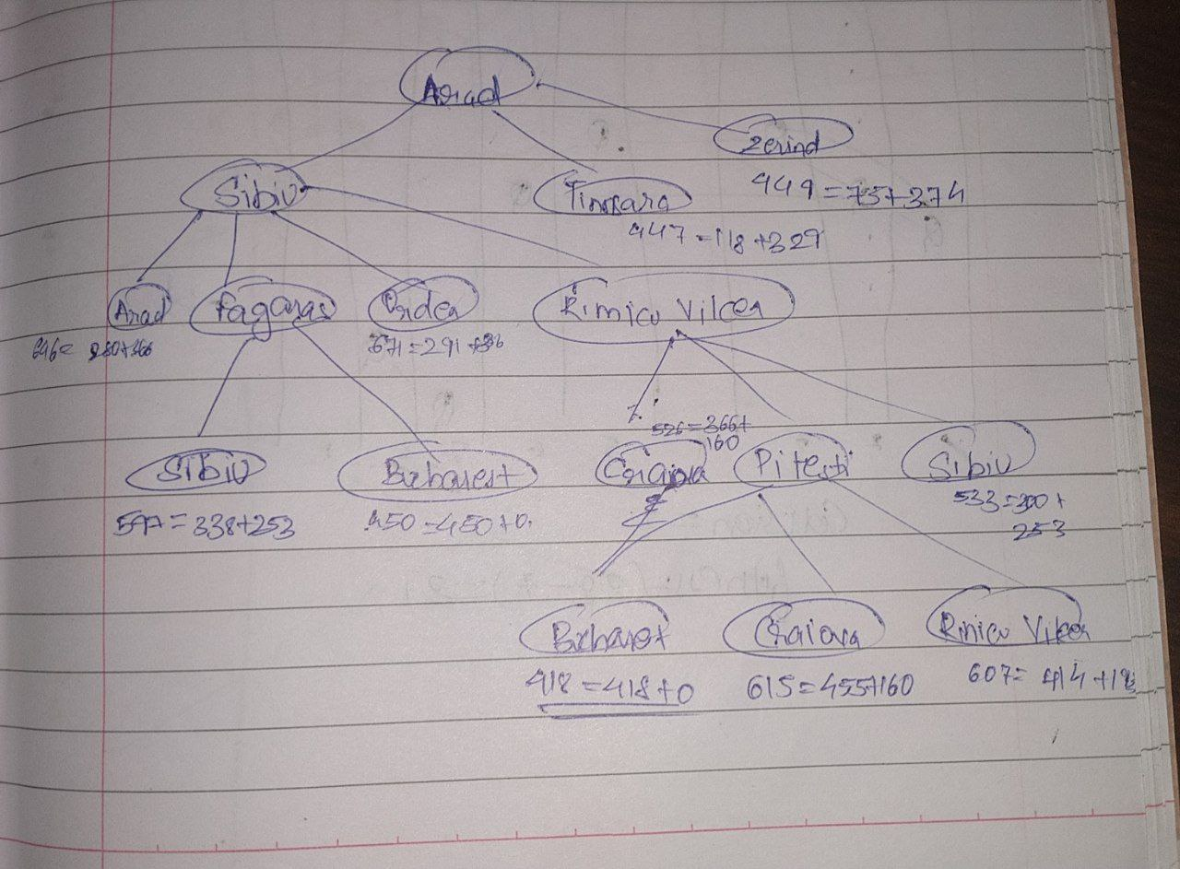

**Algorithm**:

1. Initialize the open list

2. Initialize the closed list

put the starting node on the open

list (you can leave its **f** at zero)

3. while the open list is not empty

a) find the node with the least **f** on

the open list, call it "q"

b) pop q off the open list

c) generate q's 8 successors and set their

parents to q

d) for each successor

i) if successor is the goal, stop search

successor.**g** = q.**g** + distance between

successor and q

successor.**h** = distance from goal to

successor (This can be done using many

ways, we will discuss three heuristics-

Manhattan, Diagonal and Euclidean

Heuristics)

successor.**f** = successor.**g** + successor.**h**

ii) if a node with the same position as

successor is in the OPEN list which has a

lower **f** than successor, skip this successor

iii) if a node with the same position as

successor is in the CLOSED list which has

a lower **f** than successor, skip this successor

otherwise, add the node to the open list

end (for loop)

e) push q on the closed list

end (while loop)

**Output**:

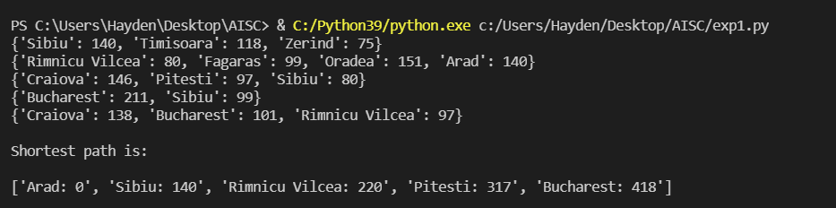

**Conclusion**: The A* is successfully implemented