**NAME: HAYDEN CORDEIRO BATCH: D ROLL NO.: 05**

**EXPERIMENT NO.: 02**

**AIM :** To implement Genetic Algorithm

**LEARNING OBJECTIVE :** To understand Genetic algorithms and simulate the same in software

**LEARNING OUTCOME :** Student are able to successfully simulate a Genetic algorithm.

**COURSE OUTCOME:**

|  |
| --- |
| CSL703.1 To realize the basic techniques to build intelligent systems |

**PROGRAM OUTCOME:**

(PO 3) Design/ development of solutions: Breadth and uniqueness of engineering problems i.e. the extent to which problems are original and to which solutions have previously been identified or codified

(PO 12) Lifelong Learning

**BLOOM’S TAXONOMY LEVEL:**

* Remembering
* Understanding

**THEORY:** Genetic Algorithms(GAs) are adaptive heuristic search algorithms that belong to the larger part of evolutionary algorithms. Genetic algorithms are based on the ideas of natural selection and genetics. They are commonly used to generate high-quality solutions for optimization problems and search problems.Genetic algorithms simulate the process of natural selection which means those species who can adapt to changes in their environment are able to survive and reproduce and go to next generation.Each generation consist of a population of individuals and each individual represents a point in search space and possible solution. Each individual is represented as a string of character/integer/float/bits.

**ALGORITHM:**

1) Randomly initialize populations p

2) Determine fitness of population

3) Until convergence repeat:

a) Select parents from population

b) Crossover and generate new population

c) Perform mutation on new population

d) Calculate fitness for new population

**OUTPUT:**

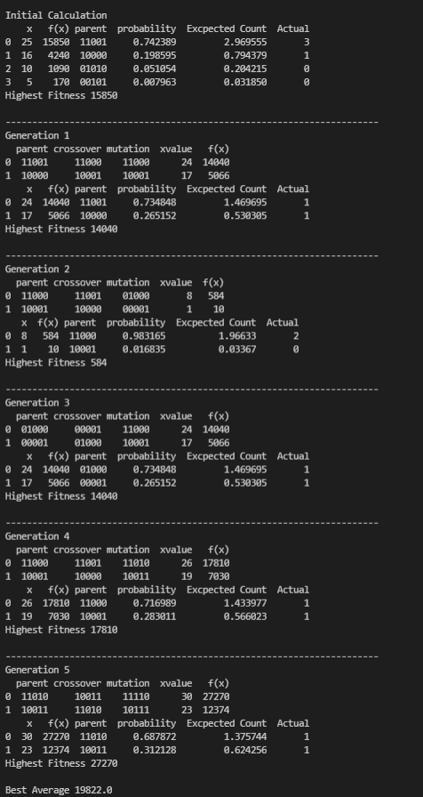

**CONCLUSION:** The Genetic Algorithm is successfully implemented