**NAME:Hayden Cordeiro BATCH:D ROLL NO.: 05**

**EXPERIMENT NO.: 03**

**Aim :** Implement Problem in PROLOG

**Learning Objective :** Implement Problems in PROLOG.

**Learning Outcome :** Students are able to successfully Implement Problems in PROLOG.

**Course Outcome**

|  |
| --- |
| CSL703.4 To realize the basic techniques in PROLOG |

**Program Outcome**

(PO 3) Design/ development of solutions: Breadth and uniqueness of engineering problems i.e. the extent to

which problems are original and to which solutions have previously been identified or codified

(PO 12) Lifelong Learning

**Bloom's Taxonomy Level**

* Remembering
* Understanding

**Theory:**

Prolog is a logic programming language. It has an important role in artificial intelligence. Unlike many other programming languages, Prolog is intended primarily as a declarative programming language. In prolog, logic is expressed as relations (called as Facts and Rules). Core heart of prolog lies at the logic being applied. Formulation or Computation is carried out by running a query over these relations.In prolog, We declare some facts. These facts constitute the Knowledge Base of the system. We can query against the Knowledge Base. We get output as affirmative if our query is already in the knowledge Base or it is implied by Knowledge Base, otherwise we get output as negative.

**Algorithm :**

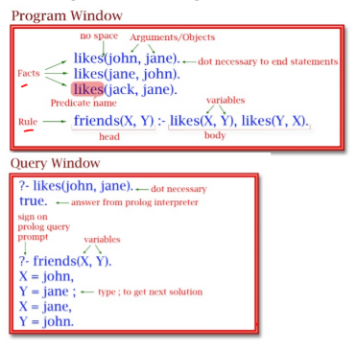

**Output :**

1. **Friends**

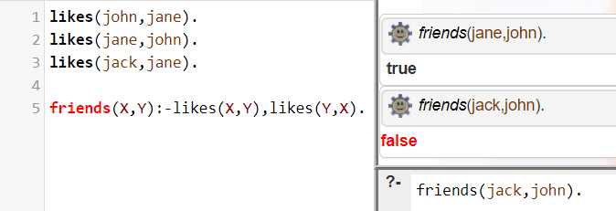

1. **Food**

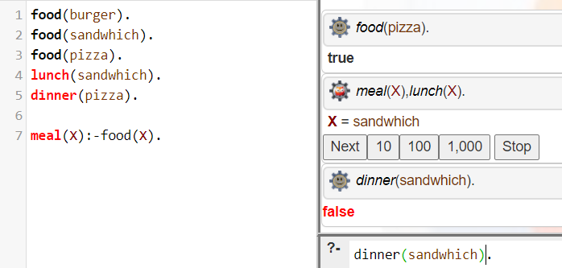

**3)Math add and subtract using dynamic input**

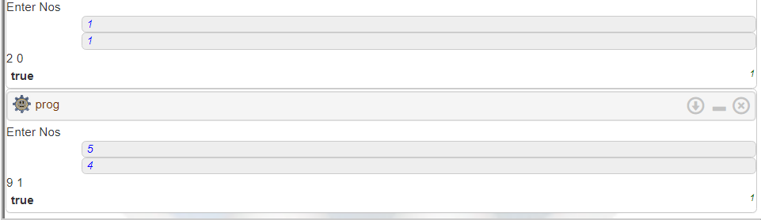

**4)about your self**

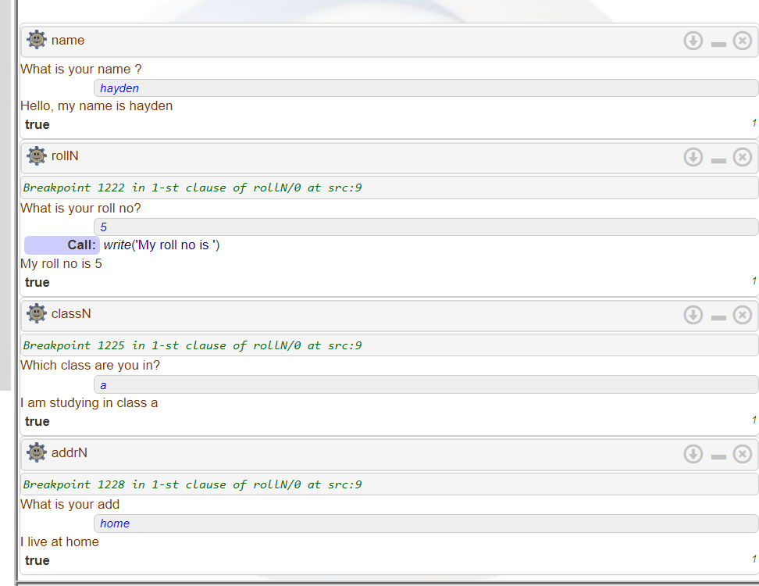

**5)list**

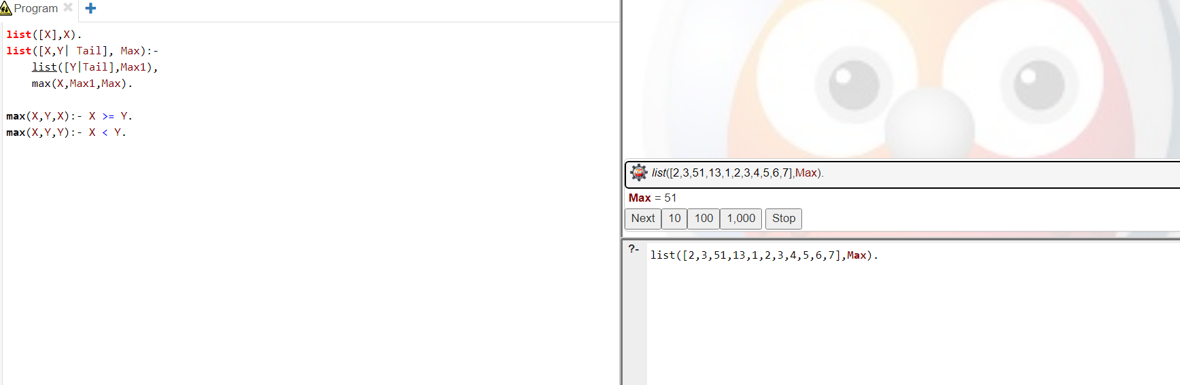

**Conclusion :** Problems in PROLOG is successfully implemented