**NAME:Hayden Cordeiro BATCH:D ROLL NO.:05**

**EXPERIMENT NO.: 04**

**Aim :** Simulation of Fuzzy Operations

**Learning Objective :** Simulation of Fuzzy Operations.

**Learning Outcome :** Students are able to successfully Simulate Fuzzy Operations.

**Course Outcome**

|  |
| --- |
| CSL703.5 To realize the basic Fuzzy operations |

**Program Outcome**

(PO 3) Design/ development of solutions: Breadth and uniqueness of engineering problems i.e. the extent to

which problems are original and to which solutions have previously been identified or codified

(PO 12) Lifelong Learning

**Bloom's Taxonomy Level**

* Remembering
* Understanding

**Theory:**

Fuzzy logic is a super set of conventional (or Boolean) logic and contains similarities and differences with Boolean logic. Fuzzy logic is similar to Boolean logic, in that Boolean logic results are returned by fuzzy logic operations when all fuzzy memberships are restricted to 0 and 1. Fuzzy logic differs from Boolean logic in that it is permissive of natural language queries and is more like human thinking; it is based on degrees of truth.

The graphical representation of fuzzy and boolean sets are different as well.

A fuzzy set is a pair (A,m) where A is a set and m : A -->[0,1].

For each x ε A, m(x) is called the grade of membership of x in (A,m). For a finite set A = {x1,...,xn}, the fuzzy set (A,m) is often denoted by {m(x1) / x1,...,m(xn) / xn}.

Let x ε A. Then x is called not included in the fuzzy set (A,m) if m(x) = 0, x is called fully included if m(x) = 1, and x is called a fuzzy member if 0 < m(x) < 1.The set { x ε A | m(x) > 0 } is called the support of (A,m) and the set { x ε A | m(x) =1 } is called its kernel.

**Fuzzy Addition**

Let us consider A1 = [a,b] and A2 = [c,d]

The addition of A1 and A2 is: [a,b] + [c,d] = [a+c, b+d]

**Fuzzy Subtraction**

Let us consider A1 = [a,b] and A2 = [c,d]

The subtraction of A1 and A2 is: [a,b] - [c,d] = [a-d, b-c]

**Fuzzy Complement**

The degree to which you believe something is not in the set is 1.0 minus the degree to which you believe it is in the set.

**Fuzzy Intersection**

If you have x degree of faith in statement A, and y degree of faith in statement B, how much faith do you have in statement A and B?

Eg: How much faith in "that person is about 6' high and tall"

**Fuzzy Union**

If you have x degree of faith in statement A, and y degree of faith in statement B, how much faith do you have in statement A or B?

Eg: How much faith in "that person is about 6' high or tall"

**Output :**

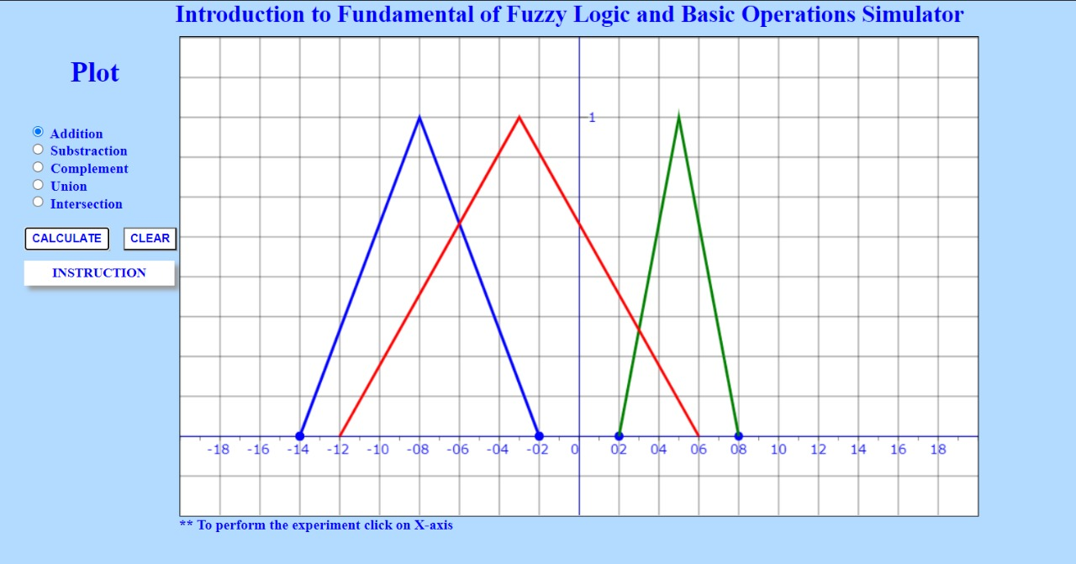

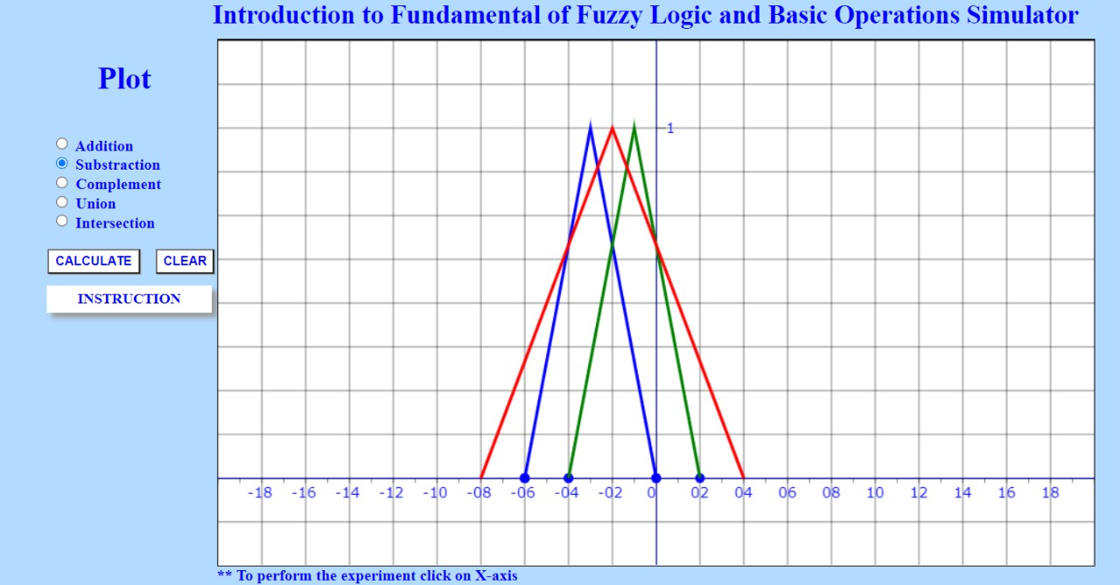

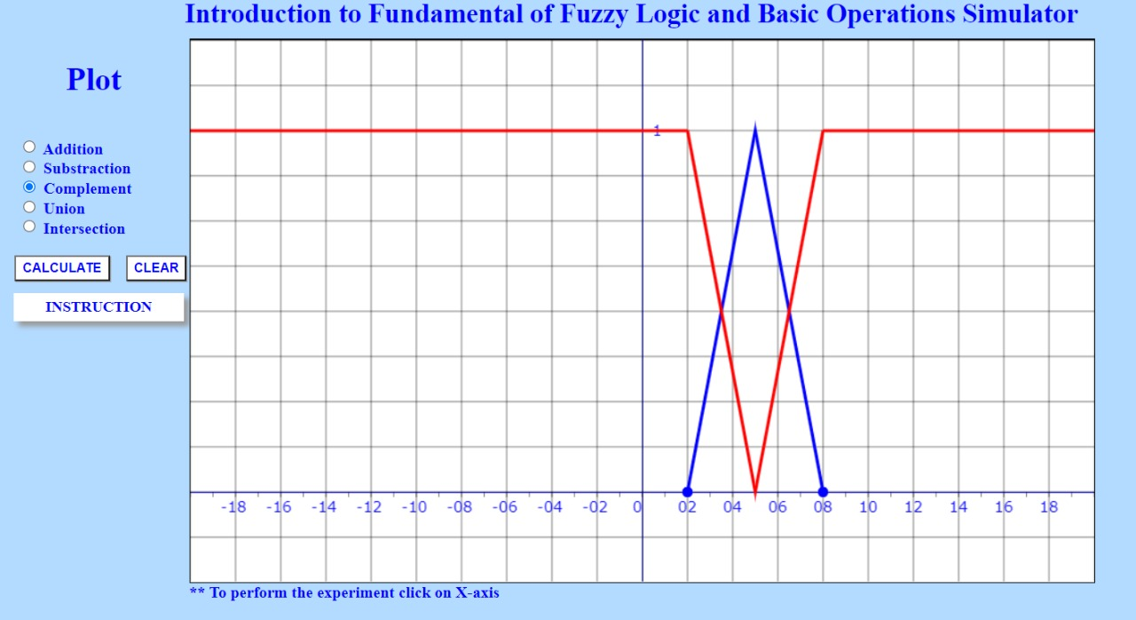

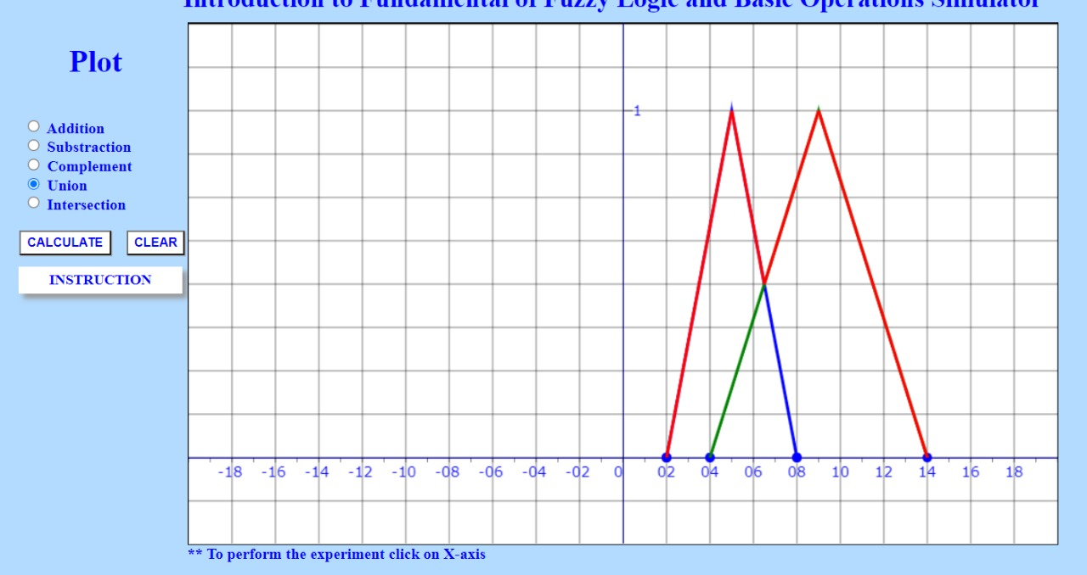

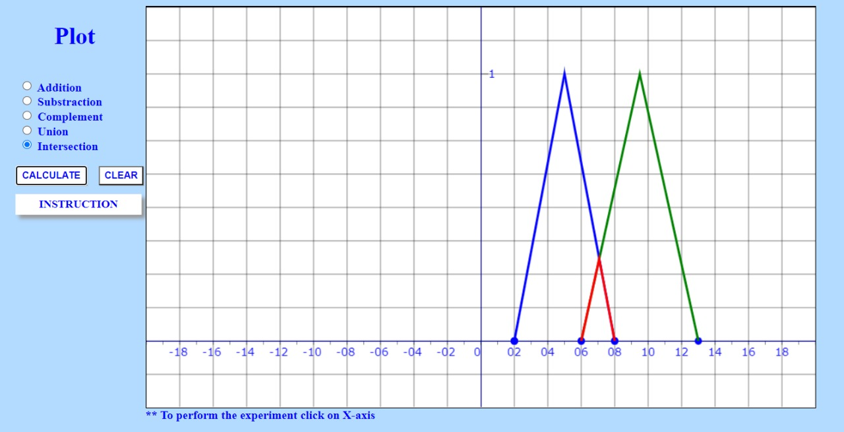

**Conclusion: Simulation of Fuzzy Operations is successfully demonstrated.**