**Don Bosco Institute of Technology**

**Department of Computer Engineering**

**Academic year – 2021-22**

**Class:** B.E. COMPUTER ENGINEERING

**Subject:** Computational Lab -I

**Course Code:** CSL704

**Experiment Title:** EXPERIMENT 2

**Student Name: Hayden Cordeiro**

**Roll No.:05**

**Batch:** D

**Date of Performance: 10-08-2021**

**Date of Submission: 10-08-2021**

Aim : : Vulnerability scanning using Nessus

Screenshots:

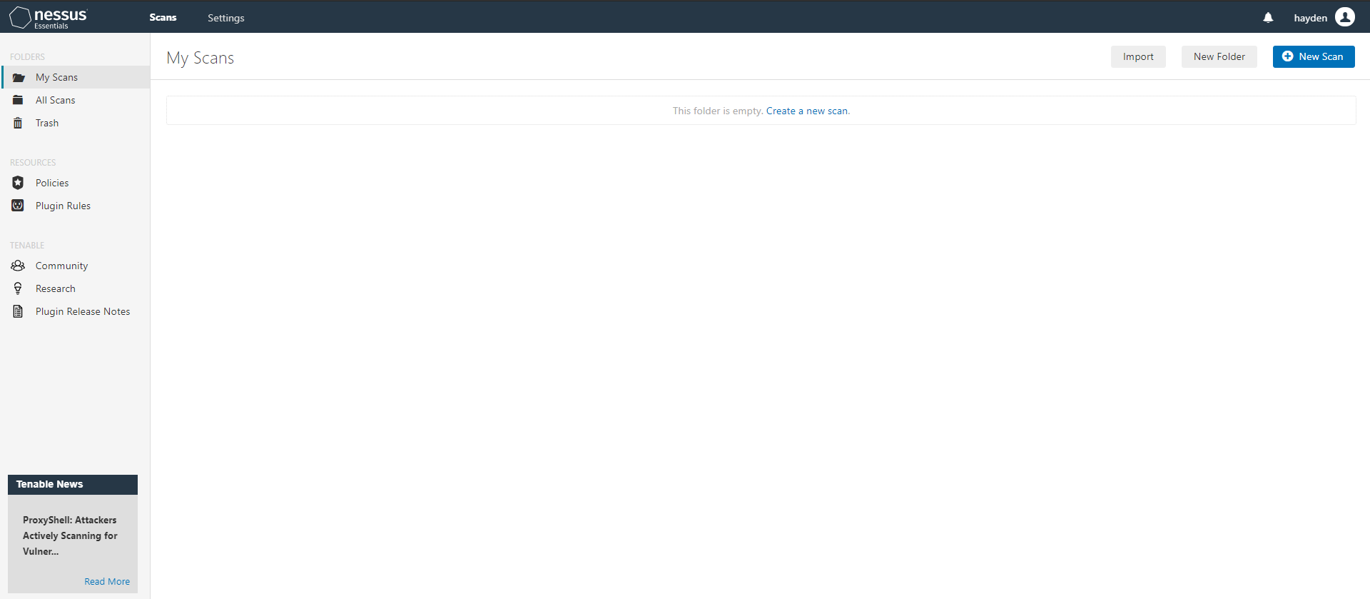

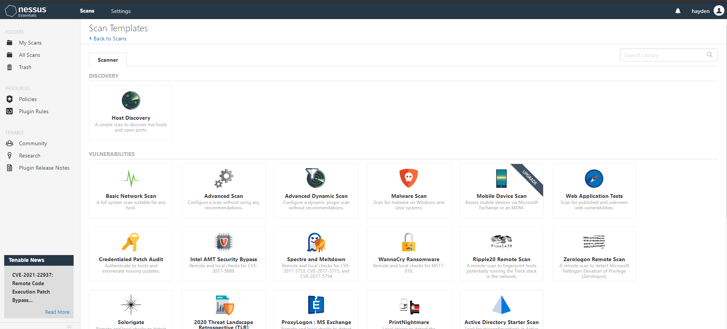

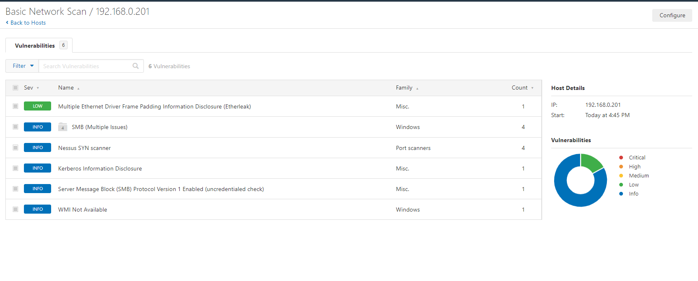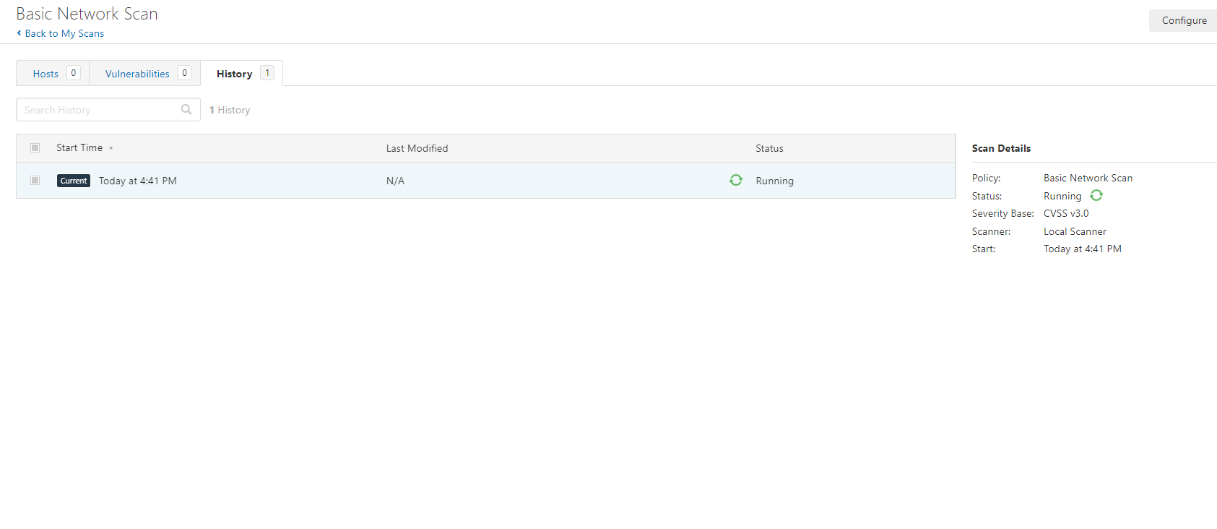

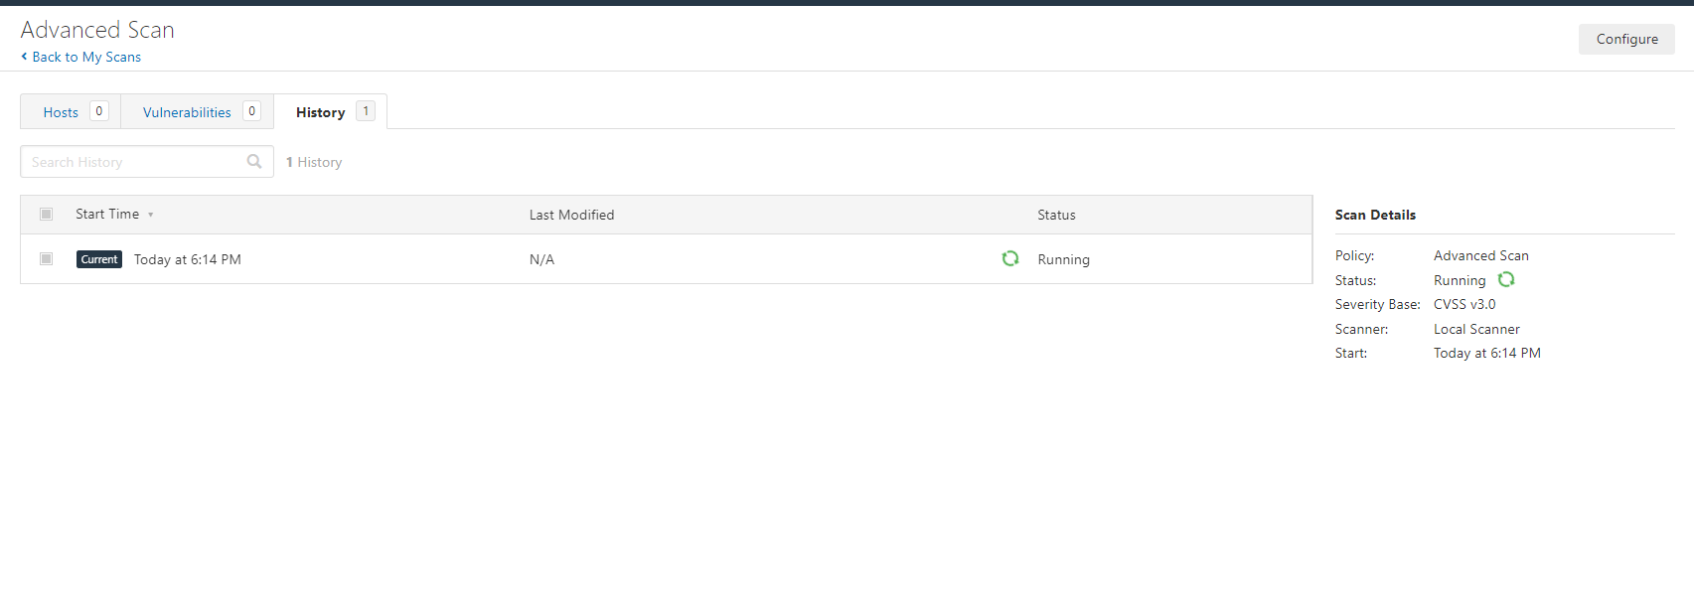

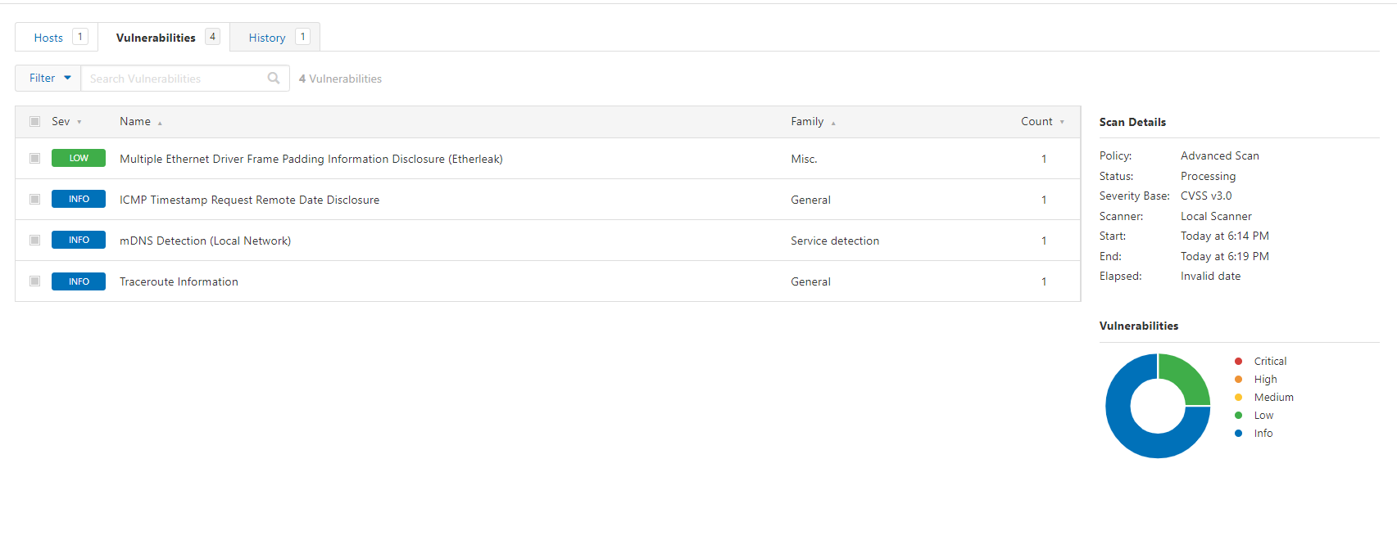

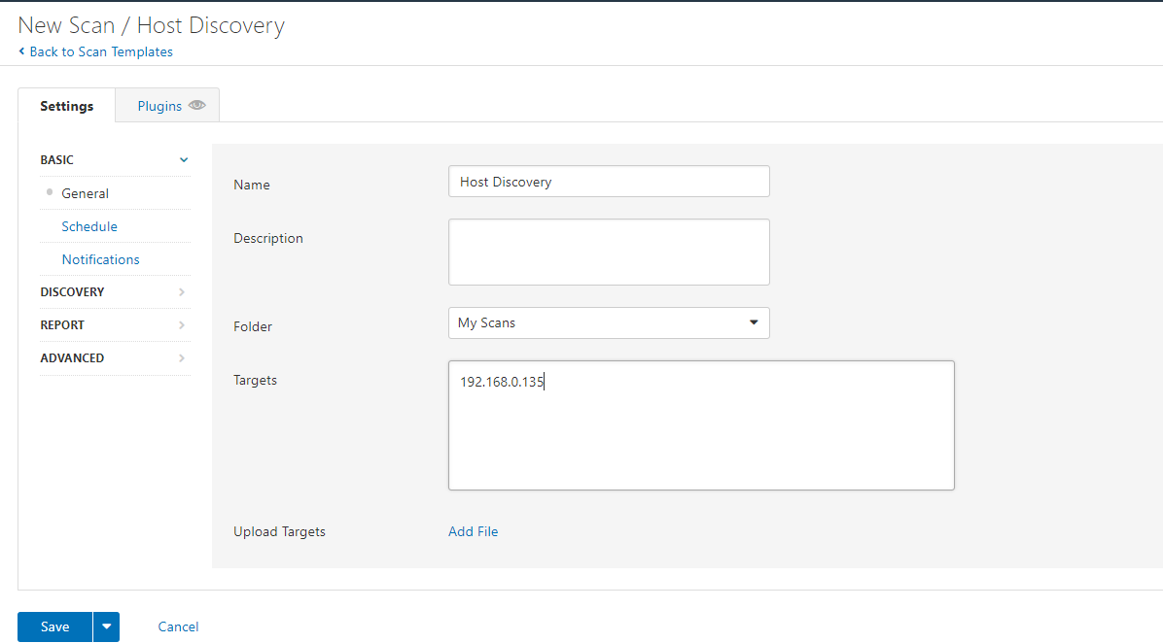

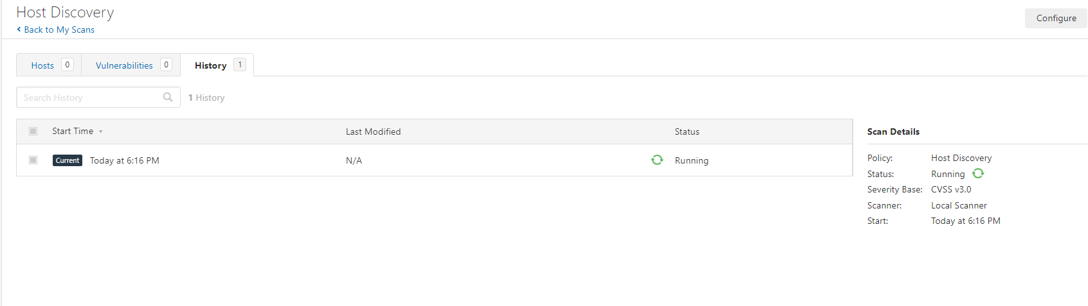

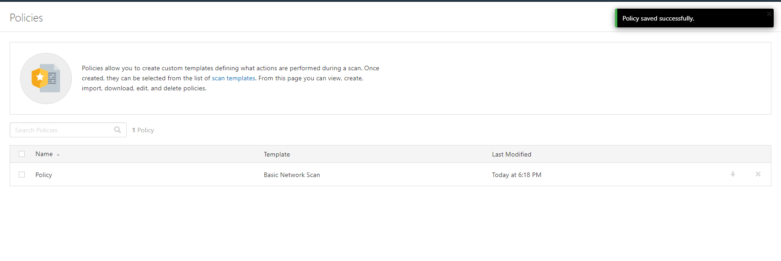

Conclusion : Hence we were able to successfully install and use Nessus tool.