**Don Bosco Institute of Technology**

**Department of Computer Engineering**

**Academic year – 2021-22**

**Class:** B.E. COMPUTER ENGINEERING

**Subject:** Computational Lab -I

**Course Code:** CSL704

**Experiment Title:** EXPERIMENT 6

**Student Name: Hayden Cordeiro**

**Roll No.:05**

**Batch:** D

**Date of Performance: 14-09-2021**

**Date of Submission: 14-09-2021**

**AIM:** Install and use a security app on an Android mobile (AndroidCrypt)

**Description:**

AndroidCrypt is free, open source, and contains no advertisements  
-256 bit AES encryption  
-uses the open source encryption library AESCrypt  
-compatible software available for Windows, Mac, Linux, and iOS

**Installation** **Steps AndroidCrypt**:

1. Download app from the google Google Playstore
2. After installing the app it may ask you for permissions
3. Allow all the necessary permissions

**Permissions**:

1. Read Storage
2. Write Storage

**Screenshots:**

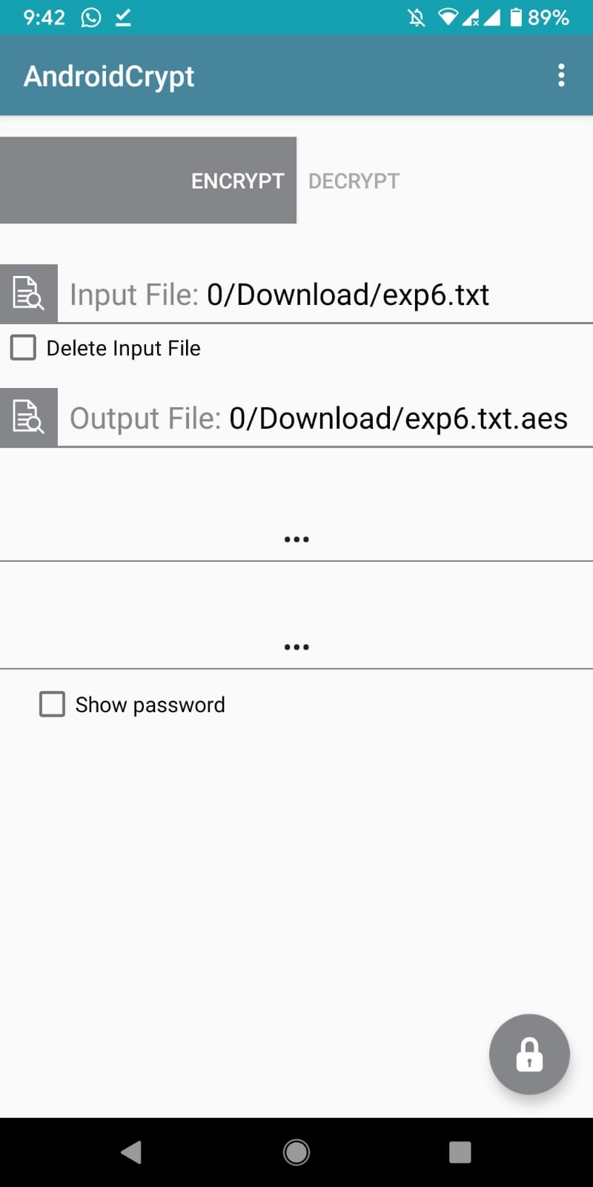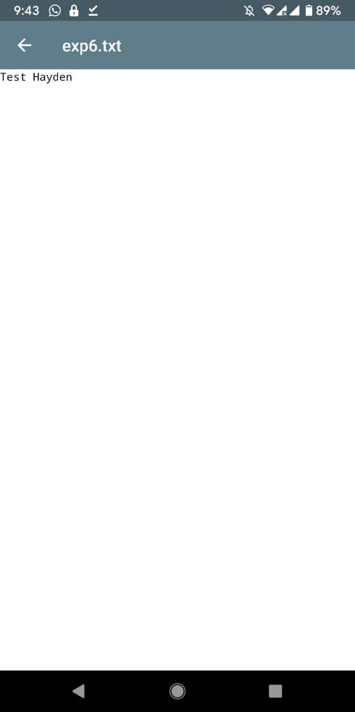

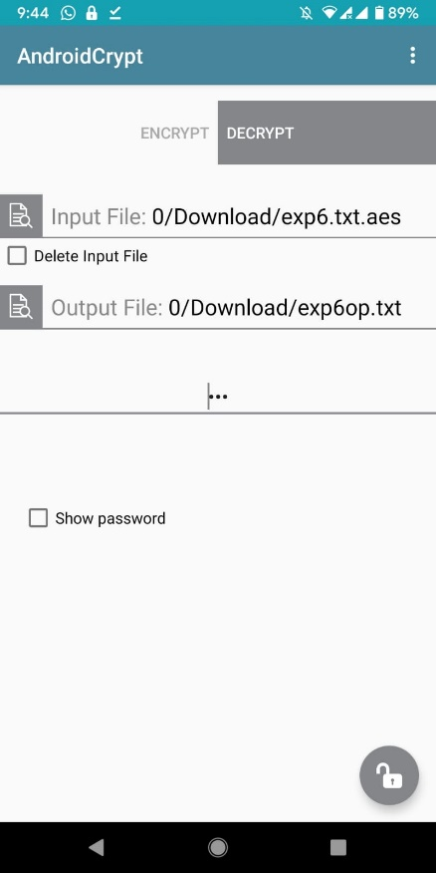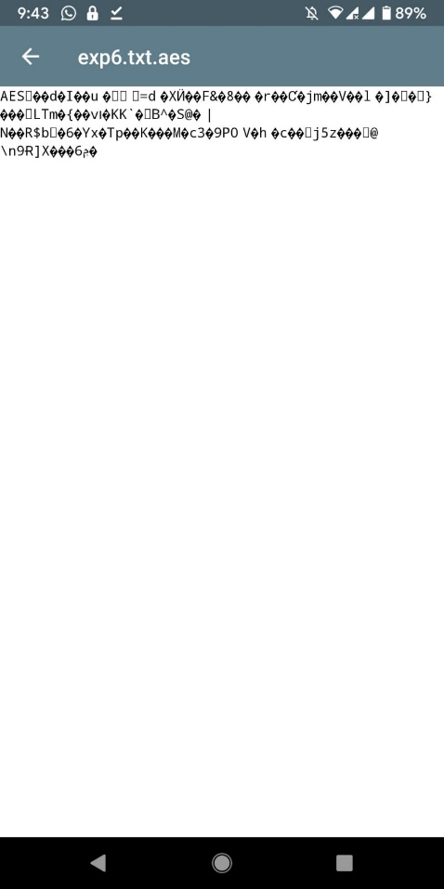

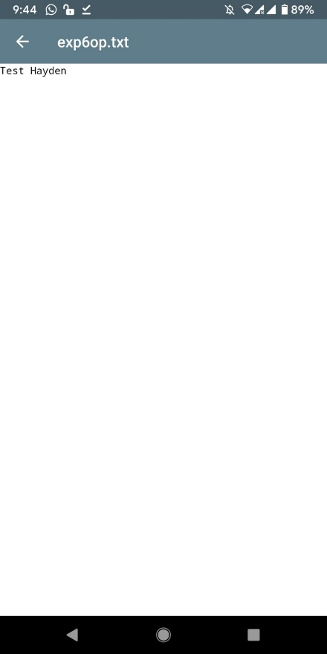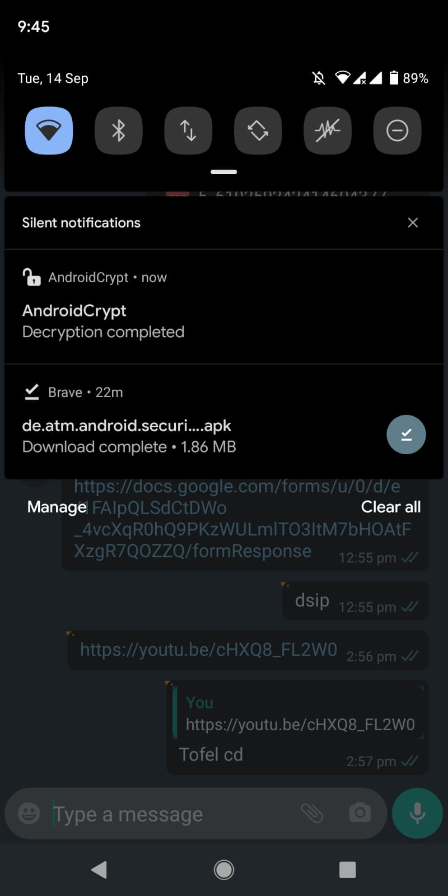

**Conclusion**:

We have successfully performed encryption and decryption using AndroidCrypt