**CSL702 - Mobile App. Development Tech. Lab Experiment 13**

Name: Hayden Cordeiro Roll No: 05 Class: BE COMPS

# AIM: Develop an application that uses GPS location information Description:

1. Open eclipse or android studio and select new android project
2. Give project name and select next
3. Choose the android version.Choose the lowest android version(Android 2.2) and select next
4. Enter the package name.package name must be two word seprated by comma and click finish
5. Go to package explorer in the left hand side.select our project.
6. Go to res folder and select layout.Double click the main.xml file.Add the code ANDROID CODE:

# AndroidManifest.xml

<?xml version="1.0" encoding="utf-8"?>

<manifest xmlns:andro[id="http://schemas](http://schemas.android.com/apk/res/android).and[roid.com/apk/res/android"](http://schemas.android.com/apk/res/android) package="com.hayden.experiment13">

<application android:allowBackup="true" android:icon="@mipmap/ic_launcher" android:label="@string/app_name"

android:roundIcon="@mipmap/ic_launcher_round" android:supportsRtl="true" android:theme="@style/Theme.Experiment13">

<activity android:name=".MainActivity" android:exported="true">

<intent-filter>

<action android:name="android.intent.action.MAIN" />

<category android:name="android.intent.category.LAUNCHER" />

</intent-filter>

</activity>

</application>

<uses-permission android:name="android.permission.ACCESS_FINE_LOCATION" />

<uses-permission android:name="android.permission.ACCESS_MOCK_LOCATION"

/>

<uses-permission android:name="android.permission.ACCESS_COARSE_LOCATION" />

</manifest>

# Activity_main.xml

<?xml version="1.0" encoding="utf-8"?>

<androidx.constraintlayout.widget.ConstraintLayout xmlns:andr[oid="http://schemas.android.co](http://schemas.android.com/apk/res/android)m/a[pk/res/android"](http://schemas.android.com/apk/res/android)

xmlns:a[pp="http://schemas.android.com](http://schemas.android.com/apk/res-auto)/ap[k/res](http://schemas.android.com/apk/res-auto)-[auto"](http://schemas.android.com/apk/res-auto) xmlns:tools="[http://schemas.android.com/tools"](http://schemas.android.com/tools) android:id="@+id/activity_main" android:layout_width="match_parent" android:layout_height="match_parent" tools:context=".MainActivity">

<Button

android:id="@+id/retrieve_location_button" android:layout_width="wrap_content" android:layout_height="wrap_content" android:layout_centerInParent="true" android:text="GET LOCATION" app:layout_constraintBottom_toBottomOf="parent" app:layout_constraintEnd_toEndOf="parent" app:layout_constraintStart_toStartOf="parent" app:layout_constraintTop_toTopOf="parent" />

</androidx.constraintlayout.widget.ConstraintLayout>

# MainActivity.java

package com.hayden.experiment13;

import androidx.appcompat.app.AppCompatActivity; import androidx.core.app.ActivityCompat;

import android.Manifest;

import android.content.pm.PackageManager; import android.os.Bundle;

import android.app.Activity; import android.content.Context; import android.location.Location;

import android.location.LocationListener; import android.location.LocationManager; import android.os.Bundle;

import android.view.View;

import android.view.View.OnClickListener; import android.widget.Button;

import android.widget.Toast;

public class MainActivity extends AppCompatActivity {

private static final long MINIMUM_DISTANCE_CHANGE_FOR_UPDATES = 1; // in Meters

private static final long MINIMUM_TIME_BETWEEN_UPDATES = 1000; // in Milliseconds

protected LocationManager locationManager; protected Button retrieveLocationButton;

@Override

public void onCreate(Bundle savedInstanceState) {

super.onCreate(savedInstanceState); setContentView(R.layout.activity_main);

retrieveLocationButton = (Button) findViewById(R.id.retrieve_location_button); locationManager = (LocationManager)

getSystemService(Context.LOCATION_SERVICE);

if (ActivityCompat.checkSelfPermission(this, Manifest.permission.ACCESS_FINE_LOCATION) != PackageManager.PERMISSION_GRANTED && ActivityCompat.checkSelfPermission(this, Manifest.permission.ACCESS_COARSE_LOCATION) != PackageManager.PERMISSION_GRANTED) {

// TODO: Consider calling

// ActivityCompat#requestPermissions

// here to request the missing permissions, and then overriding

// public void onRequestPermissionsResult(int requestCode, String[] permissions,

// int[] grantResults)

// to handle the case where the user grants the permission. See the documentation

// for ActivityCompat#requestPermissions for more details. return;

}

locationManager.requestLocationUpdates( LocationManager.GPS_PROVIDER, MINIMUM_TIME_BETWEEN_UPDATES, MINIMUM_DISTANCE_CHANGE_FOR_UPDATES,

new MyLocationListener()

);

retrieveLocationButton.setOnClickListener(new OnClickListener() {

@Override

public void onClick(View v) { showCurrentLocation();

}

});

}

protected void showCurrentLocation() {

if (ActivityCompat.checkSelfPermission(this, Manifest.permission.ACCESS_FINE_LOCATION) != PackageManager.PERMISSION_GRANTED && ActivityCompat.checkSelfPermission(this, Manifest.permission.ACCESS_COARSE_LOCATION) != PackageManager.PERMISSION_GRANTED) {

// TODO: Consider calling

// ActivityCompat#requestPermissions

// here to request the missing permissions, and then overriding

// public void onRequestPermissionsResult(int requestCode, String[] permissions,

// int[] grantResults)

// to handle the case where the user grants the permission. See the documentation

// for ActivityCompat#requestPermissions for more details. return;

}

Location location = locationManager.getLastKnownLocation(LocationManager.GPS_PROVIDER);

if (location != null) {

String message = String.format(

"Current Location \n Longitude: %1$s \n Latitude: %2$s", location.getLongitude(), location.getLatitude()

);

Toast.makeText(MainActivity.this, message, Toast.LENGTH_LONG).show();

}

}

private class MyLocationListener implements LocationListener { public void onLocationChanged(Location location) {

String message = String.format(

"New Location \n Longitude: %1$s \n Latitude: %2$s", location.getLongitude(), location.getLatitude()

);

Toast.makeText(MainActivity.this, message, Toast.LENGTH_LONG).show();

}

public void onStatusChanged(String s, int i, Bundle b) { Toast.makeText(MainActivity.this, "Provider status changed",

Toast.LENGTH_LONG).show();

}

public void onProviderDisabled(String s) { Toast.makeText(MainActivity.this,

"Provider disabled by the user. GPS turned off", Toast.LENGTH_LONG).show();

}

public void onProviderEnabled(String s) { Toast.makeText(MainActivity.this,

"Provider enabled by the user. GPS turned on", Toast.LENGTH_LONG).show();

}

}

}

# Output

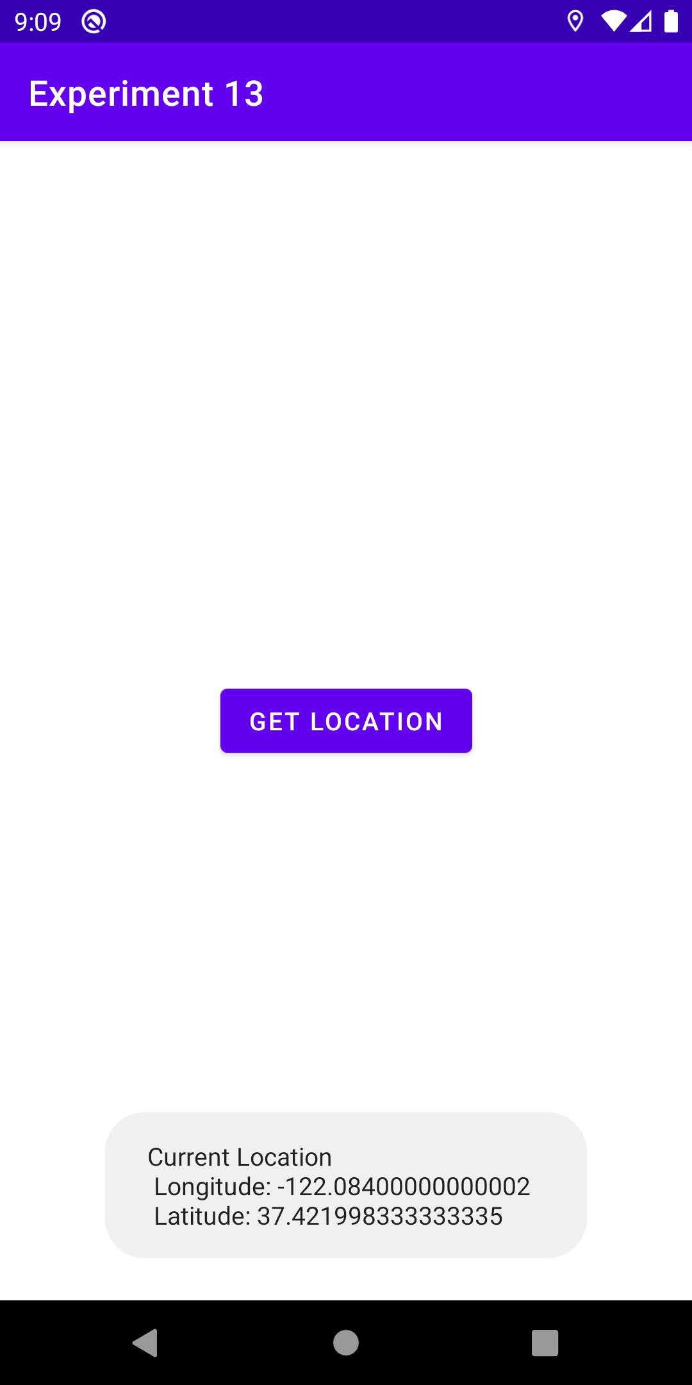

**Conclusion:** We have sucessfully implemented an android app that gets latitude and longitude of a user