Exp 11:

Name : Hayden Cordeiro

BECOMPS

Roll No : 05

* Write an application that draws basic graphical primitives on the screen.

App.js

import { StatusBar } from 'expo-status-bar';

import React from 'react';

import { StyleSheet, Text, View } from 'react-native';

export default function App() {

  return (

    <View style={styles.container}>

      <Text style={styles.Text}>MCC EXPERIMENT NO. 11</Text>

      <View style={styles.parent}>

          <View style={styles.child}>

            <Text style={styles.text1}>SQUARE</Text><View style={styles.square}/>

          </View>

          <View style={styles.child}>

            <Text style={styles.text1}>CIRCLE</Text><View style={styles.circle}/>

          </View>

          <View style={styles.child}>

            <Text style={styles.text1}>RECTANGLE</Text><View style={styles.rectangle}/>

          </View>

          <View style={styles.child}>

            <Text style={styles.text1}>TRIANGLE</Text><View style={styles.triangle}/>

          </View>

      </View>

      <StatusBar style="auto" />

    </View>

  );

}

const styles = StyleSheet.create({

  container: {

    padding:25,

    flex: 1,

    backgroundColor: '#1ecbe1',

  },

  Text:{

    textAlign:'center',

    alignItems:'center',

    fontWeight:'bold',

    color:'#1e6ae1',

    fontSize:18,

  },

  parent:{

    flexDirection:'column',

    borderWidth:1,

    borderColor:'#1e6ae1',

  },

  child:{

    // flex:1,

    margin:10,

    justifyContent:'space-around',

    alignItems:"center",

    flexDirection:'row',

  },

  text1:{

    fontSize:16,

    fontWeight:'bold',

    color:"#1e6ae1"

  },

  square:{

    height:100,

    width:100,

    borderWidth:2,

    borderColor:'#1e6ae1',

    backgroundColor:'#1ee196',

  },

  circle:{

    height:100,

    width:100,

    borderRadius:50,

    borderWidth:2,

    borderColor:'#1e6ae1',

    backgroundColor:'#1ee196',

  },

  rectangle: {

    width: 75 * 2,

    height: 75,

    backgroundColor: "#1ee196",

  },

  triangle:{

    width: 0,

    height: 0,

    backgroundColor: "transparent",

    borderStyle: "solid",

    borderLeftWidth: 50,

    borderRightWidth: 50,

    borderBottomWidth: 100,

    borderLeftColor: "transparent",

    borderRightColor: "transparent",

    borderBottomColor: "#1ee196",

  },

});

**Output**

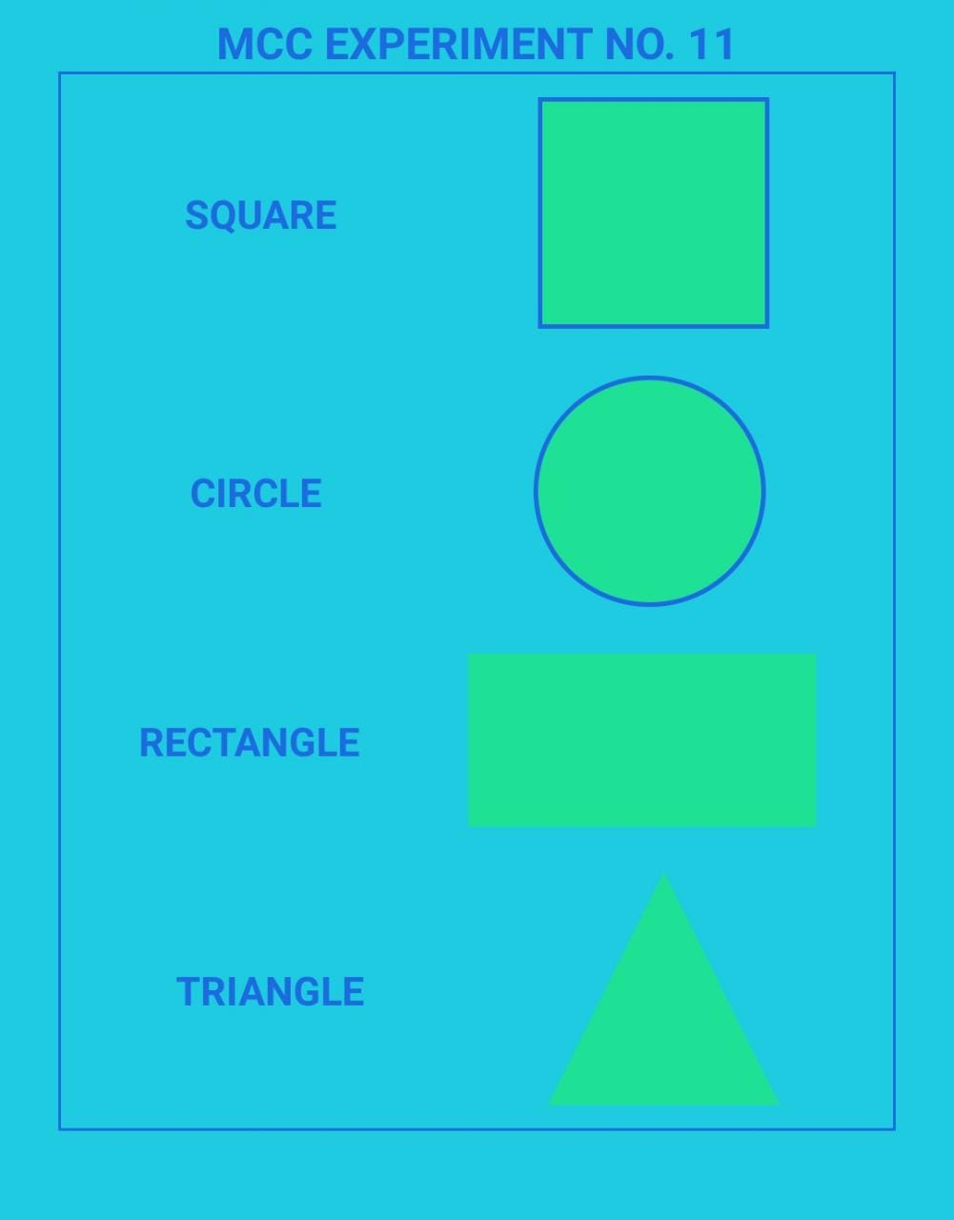

Conclusion:

* Successfully build an application that draws basic graphical primitives on the screen.