Name:Hayden Cordeiro

Roll No :05

Batch : D

**Experiment 12**

**Develop an application that makes use of Database**

**Aim**:- To develop an application that makes use of database.

**Code**:

**Firebase_api.dart**

import 'package:cloud_firestore/cloud_firestore.dart';

import 'package:todotrial/models/todo.dart';

class FirebaseApi {

static String UserID = "";

static String UserName = "";

static String UserPhotoURL = "";

static bool UisLoggedIn = false;

static Future<String> createTodo(ToDo todo) async {

final docToDo = FirebaseFirestore.instance.collection(UserID).doc();

await docToDo.set(todo.toJson());

todo.key = docToDo.id;

updateTodo(todo);

}

static updateTodo(ToDo todo) async {

final docToDo =

FirebaseFirestore.instance.collection(UserID).doc(todo.key).update({

"isDone": todo.isDone,

"key": todo.key,

"text": todo.text,

}).then((_) {

print("success updated!");

// print(todo.isDone);

// getTodo();

});

}

static getTodo(update) async {

QuerySnapshot querySnapshot =

await FirebaseFirestore.instance.collection(UserID).get();

var l = querySnapshot.docs.toList();

// map((DocumentSnapshot docSnapshot){

// return ToDo(docSnapshot.data()['key'], docSnapshot.data()['text'], docSnapshot.data()['isDone']);

// });

List<ToDo> l2 = [];

for (var i = 0; i < l.length; i++) {

// print(l[i].data());

l2.add(

ToDo(l[i].data()['key'], l[i].data()['text'], l[i].data()['isDone']));

}

// print(l2);

update(l2);

}

}

**todo.dart**

class ToDo {

String key;

String text;

bool isDone;

ToDo(this.key, this.text, this.isDone);

Map<String, dynamic> toJson() =>

{

'key': key,

'text': text,

'isDone': isDone

};

ToDo fromJson(Map<String, dynamic> json) {

return ToDo(json['key'], json['text'], json['isDone']);

}

}

**drawer.dart**

import 'package:flutter/material.dart';

import 'package:todotrial/widgets/createDrawerBodyItem.dart';

import 'package:todotrial/widgets/createDrawerHeader.dart';

import 'package:todotrial/routes/pageRoute.dart';

class NavigationDrawer extends StatelessWidget {

@override

Widget build(BuildContext context) {

return Drawer(

child: ListView(

padding: EdgeInsets.zero,

children: <Widget>[

createDrawerHeader(),

createDrawerBodyItem(

icon: Icons.home,

text: 'Home',

onTap: () => {

Navigator.pushReplacementNamed(context, pageRoutes.home),

}),

createDrawerBodyItem(

icon: Icons.account_circle,

text: 'Profile',

onTap: () => {

Navigator.pushReplacementNamed(context, pageRoutes.login),

}),

ListTile(

title: Text('App version 1.2.0'),

onTap: () {},

),

],

),

);

}

}

**home.dart**

import 'package:firebase_core/firebase_core.dart';

import 'package:flutter/cupertino.dart';

import 'package:flutter/material.dart';

import 'package:todotrial/api/firebase_api.dart';

import 'package:todotrial/models/todo.dart';

import 'package:todotrial/pages/drawer.dart';

class Home extends StatefulWidget {

@override

_HomeState createState() => _HomeState();

}

class _HomeState extends State<Home> {

// final todos = [

// ToDo('0', "create Project", true),

// ToDo('1', "Add a To Do", true),

// ToDo('2', "Complete All Your ToDos", false)

// ];

@override

void initState() {

super.initState();

FirebaseApi.getTodo(_update);

}

var todos = [];

// FirebaseApi.getTodo();

void _update(List<ToDo> count) {

// print("asdf");

setState(() => todos = count);

}

createAlertDialogue(BuildContext context) {

TextEditingController controllerText = TextEditingController();

return showDialog(

context: context,

builder: (context) {

return AlertDialog(

title: Text("Add ToDo"),

content: TextField(

controller: controllerText,

),

actions: <Widget>[

MaterialButton(

onPressed: () {

ToDo tempToDo =

ToDo("", controllerText.text.toString(), false);

FirebaseApi.createTodo(tempToDo);

Navigator.of(context).pop();

setState(() {

print(todos.length);

todos.add(tempToDo);

todos.sort((a, b) {

if (b.isDone) {

return -1;

}

return 1;

});

});

},

elevation: 0.5,

child: Text("Add"),

)

],

);

});

}

GestureDetector createTodo(double width, ToDo temp) {

return GestureDetector(

onTap: () {

setState(() {

ToDo tempToDo = (todos.elementAt(

todos.indexWhere((element) => element.key == temp.key)));

tempToDo.isDone = !tempToDo.isDone;

FirebaseApi.updateTodo(tempToDo);

todos.sort((a, b) {

if (b.isDone) {

return -1;

}

return 1;

});

});

},

child: Center(

child: Container(

width: 0.95 * width,

decoration: BoxDecoration(

color: Colors.white,

border: Border.all(

color: Colors.grey[100],

),

borderRadius: BorderRadius.all(Radius.circular(50))),

padding: EdgeInsets.symmetric(horizontal: 12, vertical: 15),

margin: EdgeInsets.only(top: 10),

child: Row(

mainAxisAlignment: MainAxisAlignment.spaceBetween,

children: <Widget>[

Text(

temp.text,

style: TextStyle(

fontSize: 17,

color: temp.isDone ? Colors.grey : Colors.black,

decoration:

temp.isDone ? TextDecoration.lineThrough : null,

),

),

Container(

height: 25,

width: 25,

decoration: BoxDecoration(

color: temp.isDone ? Colors.green : Colors.white,

borderRadius: BorderRadius.all(Radius.circular(20)),

border: Border.all(

color: Colors.grey[300],

)),

child: Icon(

Icons.done,

size: 16,

color: Colors.white,

),

)

],

))));

}

@override

Widget build(BuildContext context) {

double width = MediaQuery.of(context).size.width;

// double height = MediaQuery.of(context).size.height;

final GlobalKey<ScaffoldState> _scaffoldKey =

new GlobalKey<ScaffoldState>();

return SafeArea(

child: Scaffold(

key: _scaffoldKey,

drawer: NavigationDrawer(),

backgroundColor: Color(0xffF4F4F5),

appBar: AppBar(

leading: IconButton(

icon: Icon(

Icons.subject_sharp,

color: Color(0xff53A5D5),

size: 30.0,

),

onPressed: () {

_scaffoldKey.currentState.openDrawer();

},

),

elevation: 0.0,

centerTitle: true,

backgroundColor: Colors.white,

title: Text(

"All Task",

style: TextStyle(

color: Colors.black,

),

),

),

floatingActionButton: FloatingActionButton(

onPressed: () {

createAlertDialogue(context);

},

tooltip: 'Add',

backgroundColor: Color(0xff53A5D5),

child: Icon(

Icons.add,

),

),

floatingActionButtonLocation:

FloatingActionButtonLocation.centerFloat,

body: ListView(

children: [

// createTodo(width,false),

]..addAll(todos.map((todo) => createTodo(width, todo))))

// Container(

// height: 70,

// )

));

}

}

**login.dart**

import 'package:flutter/material.dart';

import 'package:shared_preferences/shared_preferences.dart';

import 'package:todotrial/api/firebase_api.dart';

import 'package:todotrial/pages/drawer.dart';

import 'package:google_sign_in/google_sign_in.dart';

import 'package:todotrial/routes/pageRoute.dart';

import 'package:todotrial/utils/shared_pref.dart';

// import 'package:shared_preferences/shared_preferences.dart';

class LoginScreen extends StatefulWidget {

@override

_LoginScreenState createState() => _LoginScreenState();

}

class _LoginScreenState extends State<LoginScreen> {

bool _isLoggedIn = false;

final GlobalKey<ScaffoldState> _scaffoldKey =

new GlobalKey<ScaffoldState>();

void _update(bool count) {

// print("asdf");

setState(() => _isLoggedIn = count);

}

@override

void initState() {

super.initState();

Shared_Pref.GetIsLogged(_update);

}

GoogleSignIn _googleSignIn = GoogleSignIn(scopes: ['email']);

_login() async {

try {

await _googleSignIn.signIn();

setState(() {

_isLoggedIn = true;

});

FirebaseApi.UserID = _googleSignIn.currentUser.email;

FirebaseApi.UserName = _googleSignIn.currentUser.displayName;

FirebaseApi.UserPhotoURL = _googleSignIn.currentUser.photoUrl;

FirebaseApi.UisLoggedIn = true;

Shared_Pref.SetUID(

_googleSignIn.currentUser.email,

_googleSignIn.currentUser.displayName,

_googleSignIn.currentUser.photoUrl,

true);

// print(FirebaseApi.UserID);

Navigator.pushReplacementNamed(context, pageRoutes.home);

} catch (err) {

print(err);

}

}

_logout() {

_googleSignIn.signOut();

setState(() {

_isLoggedIn = false;

});

FirebaseApi.UserID = "";

Shared_Pref.SetUID("", "", "", false);

}

@override

Widget build(BuildContext context) {

// TODO: implement build

return Scaffold(

key: _scaffoldKey,

drawer: NavigationDrawer(),

backgroundColor: Color(0xffF4F4F5),

appBar: AppBar(

leading: IconButton(

icon: Icon(

Icons.subject_sharp,

color: Color(0xff53A5D5),

size: 30.0,

),

onPressed: () {

_scaffoldKey.currentState.openDrawer();

},

),

elevation: 0.0,

centerTitle: true,

backgroundColor: Colors.white,

title: Text(

"All Task",

style: TextStyle(

color: Colors.black,

),

),

),

body: Center(

child: _isLoggedIn

? Column(

mainAxisAlignment: MainAxisAlignment.center,

children: <Widget>[

Image.network(

FirebaseApi.UserPhotoURL,

height: 50.0,

width: 50.0,

),

Text(FirebaseApi.UserName),

OutlineButton(

child: Text("Logout"),

onPressed: () {

_logout();

},

)

],

)

: Center(

child: OutlineButton(

child: Text("Login with Google"),

onPressed: () {

_login();

},

),

)),

);

}

}

**Sharedpref.dart**

import 'package:shared_preferences/shared_preferences.dart';

import 'package:todotrial/api/firebase_api.dart';

class Shared_Pref {

static SharedPreferences _pref;

static Future init() async {

_pref = await SharedPreferences.getInstance();

FirebaseApi.UserID = _pref.getString('UID') ?? "";

FirebaseApi.UserName = _pref.getString('UName') ?? "";

FirebaseApi.UserPhotoURL = _pref.getString('UPhoto') ?? "";

FirebaseApi.UisLoggedIn = _pref.getBool('isLoggedIn') ?? false;

}

static Future SetUID(

String username, String uName, String uPhoto, bool log) async {

await _pref.setString('UID', username);

await _pref.setString('UName', uName);

await _pref.setString('UPhoto', uPhoto);

await _pref.setBool('isLoggedIn', log);

}

static Future GetIsLogged(update) {

update(_pref.getBool('isLoggedIn') ?? false);

}

}

**createDrawerBodyItem.dart**

import 'package:flutter/material.dart';

Widget createDrawerBodyItem(

{IconData icon, String text, GestureTapCallback onTap}) {

return ListTile(

title: Row(

children: <Widget>[

Icon(icon),

Padding(

padding: EdgeInsets.only(left: 8.0),

child: Text(text),

)

],

),

onTap: onTap,

);

}

**createDrawerHeader.dart**

import 'package:flutter/material.dart';

Widget createDrawerHeader() {

return DrawerHeader(

margin: EdgeInsets.zero,

padding: EdgeInsets.zero,

decoration: BoxDecoration(

image: DecorationImage(

fit: BoxFit.fill,

image: NetworkImage(

"https://images.pexels.com/photos/281260/pexels-photo-281260.jpeg?cs=srgb&dl=pexels-francesco-ungaro-281260.jpg&fm=jpg"))),

child: Stack(children: <Widget>[

Positioned(

bottom: 12.0,

left: 16.0,

child: Text("Welcome to ToDo",

style: TextStyle(

color: Colors.white,

fontSize: 20.0,

fontWeight: FontWeight.w500))),

]));

}

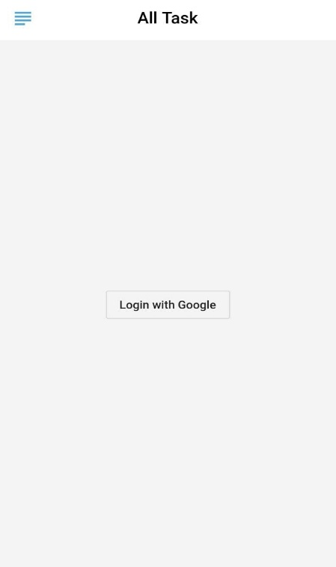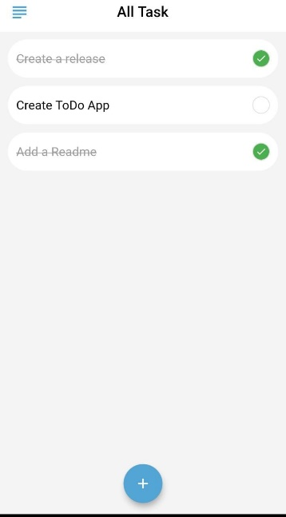**Output:**

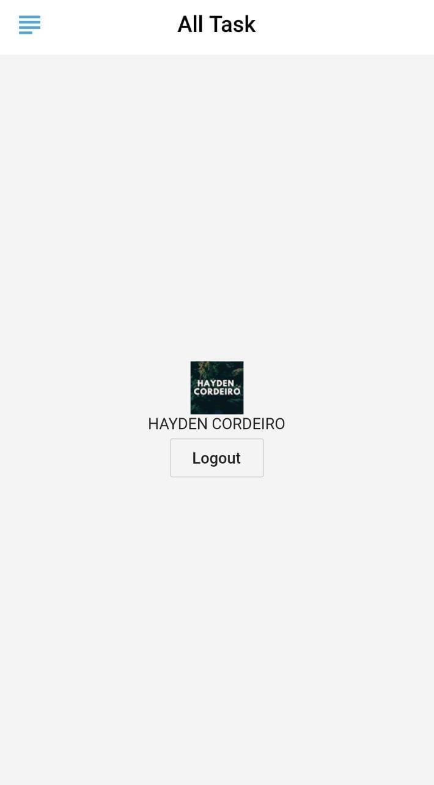

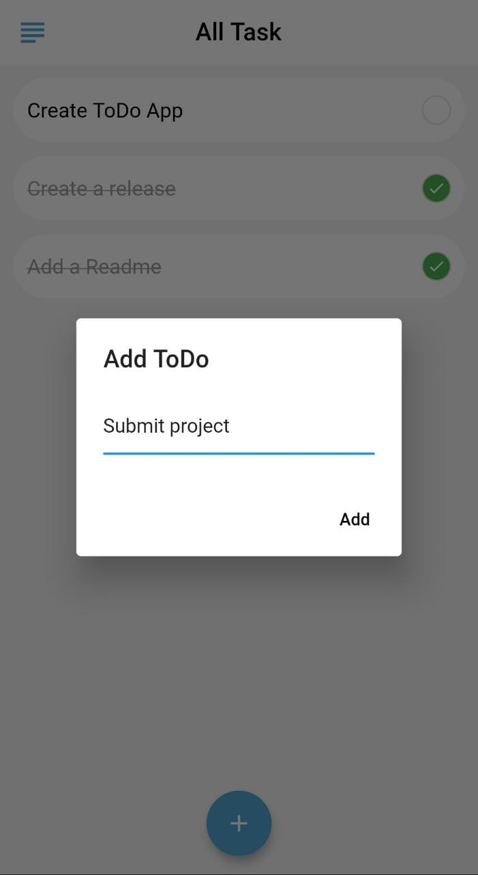

**Conclusion:**

Thus we have implemented a database in Android application using Flutter