**Experiment 9**

Name:Hayden Cordeiro BECOMP RollNo:05

# Aim:

To develop an Android Application that writes data to the SD Card/ or any other media

# Procedure:

* + - Open eclipse or android studio and create new project Select our project in the project explorer
    - Go to res folder and select layout Double click the main xml file Type the code for main.xml or drag and drop various components used in our program
    - Drag and drop relative layout and change its properties
    - Drag and drop image view and change its properties according to our programs
    - Screen layout can be viewed by clicking graphics layout tab Include necessary files Override OnCreate() function
    - Create Image view and initialize its using id of some components used in the xml program
    - Save the program Run the program
    - Output can be viewed in the android emulator

# Program:

**Code for Activity_main.xml:**

<?xml version="1.0" encoding="utf-8"?>  
<androidx.constraintlayout.widget.ConstraintLayout xmlns:android="http://schemas.android.com/apk/res/android"  
 xmlns:app="http://schemas.android.com/apk/res-auto"  
 xmlns:tools="http://schemas.android.com/tools"  
 android:layout_width="match_parent"  
 android:layout_height="match_parent"  
 tools:context=".MainActivity">  
  
  
  
  
 <LinearLayout  
 android:layout_width="393dp"  
 android:layout_height="268dp"  
 android:orientation="vertical"  
 app:layout_constraintBottom_toBottomOf="parent"  
 app:layout_constraintEnd_toEndOf="parent"  
 app:layout_constraintStart_toStartOf="parent"  
 app:layout_constraintTop_toTopOf="parent"  
 app:layout_constraintVertical_bias="0.525">  
  
 <EditText  
 android:id="@+id/editText"  
 android:layout_width="match_parent"  
 android:layout_height="wrap_content"  
 android:singleLine="true" android:textSize="30dp" />  
  
  
 <Button  
 android:id="@+id/button"  
 android:layout_width="match_parent"  
 android:layout_height="wrap_content"  
 android:text="Write Data" />  
  
 <Button  
 android:id="@+id/button2"  
 android:layout_width="match_parent"  
 android:layout_height="wrap_content"  
 android:text="Read Data" />  
  
 <Button  
 android:id="@+id/button3"  
 android:layout_width="match_parent"  
 android:layout_height="wrap_content"  
 android:text="Clear" />  
 </LinearLayout>  
</androidx.constraintlayout.widget.ConstraintLayout>

# Code for AndroidManifest.xml:

<?xml version="1.0" encoding="utf-8"?>  
<manifest xmlns:android="http://schemas.android.com/apk/res/android"  
 package="com.example.experiment1">  
  
 <uses-permission android:name="android.permission.WRITE_EXTERNAL_STORAGE" />  
 <uses-permission android:name="android.permission.READ_EXTERNAL_STORAGE"/>  
 <application  
  
 android:requestLegacyExternalStorage="true"  
 android:allowBackup="true"  
 android:icon="@mipmap/ic_launcher"  
 android:label="@string/app_name"  
 android:roundIcon="@mipmap/ic_launcher_round"  
 android:supportsRtl="true"  
 android:theme="@style/Theme.Experiment1">  
 <activity android:name=".MainActivity">  
 <intent-filter>  
 <action android:name="android.intent.action.MAIN" />  
  
 <category android:name="android.intent.category.LAUNCHER" />  
 </intent-filter>  
 </activity>  
 </application>  
  
</manifest>

**Code for MainActivity.java:**

package com.example.experiment1;  
  
import androidx.appcompat.app.AppCompatActivity;  
import androidx.core.app.ActivityCompat;  
  
import android.Manifest;  
import android.content.Context;  
import android.content.SharedPreferences;  
import android.os.Bundle;  
import android.util.Log;  
import android.view.View;  
import android.widget.Button;  
import android.widget.EditText;  
import android.widget.Toast;  
  
import java.io.BufferedReader;  
import java.io.File;  
import java.io.FileInputStream;  
import java.io.FileNotFoundException;  
import java.io.FileOutputStream;  
import java.io.IOException;  
import java.io.InputStreamReader;  
  
  
public class MainActivity extends AppCompatActivity {  
  
  
 @Override  
 protected void onCreate(Bundle savedInstanceState) {  
 super.onCreate(savedInstanceState);  
 setContentView(R.layout.activity_main);  
 final Button button = findViewById(R.id.button);  
 final Button showButton = findViewById(R.id.button2);  
 final Button clearButton = findViewById(R.id.button3);  
 final EditText textInp = findViewById(R.id.editText);  
  
  
 ActivityCompat.requestPermissions(MainActivity.this,  
 new String[]{Manifest.permission.READ_EXTERNAL_STORAGE, Manifest.permission.WRITE_EXTERNAL_STORAGE},  
 1);  
  
  
 button.setOnClickListener(new View.OnClickListener() {  
 public void onClick(View v) {  
// store data  
  
 try{  
 File f=new File("/sdcard/myfile.txt"); f.createNewFile();  
 FileOutputStream fout=new FileOutputStream(f);  
 fout.write(textInp.getText().toString().getBytes()); fout.close();  
 ShowToast(v,"Data Written in SDCARD");  
  
 }  
 catch (Exception e)  
 {  
 ShowToast(v,e.getMessage());  
  
 }  
  
 }  
 });  
 showButton.setOnClickListener(new View.OnClickListener() {  
 public void onClick(View v) {  
// read data  
 String message;  
 String buf = "";  
 try {  
 File f = new File("/sdcard/myfile.txt");  
 FileInputStream fin = new FileInputStream(f);  
 BufferedReader br = new BufferedReader(new InputStreamReader(fin));  
 while ((message = br.readLine()) != null) {  
 buf += message;  
 }  
 textInp.setText(buf);  
 br.close();  
 fin.close();  
  
 } catch (FileNotFoundException e) {  
 e.printStackTrace();  
 } catch (IOException e) {  
 e.printStackTrace();  
 }  
  
 Toast.makeText(getBaseContext(), "Data Recived from SDCARD", Toast.LENGTH_LONG).show();  
  
  
 }  
 });  
  
 clearButton.setOnClickListener(new View.OnClickListener() {  
 public void onClick(View v) {  
// clear data  
 textInp.setText("");  
 ShowToast(v,"Cleared Input");  
 }  
 });  
  
 }  
  
 public void ShowToast(View v,String msg){  
  
 Toast.makeText(v.getContext(), msg,  
 Toast.LENGTH_SHORT).show();  
  
 }  
}

# Inputs:

Request permission

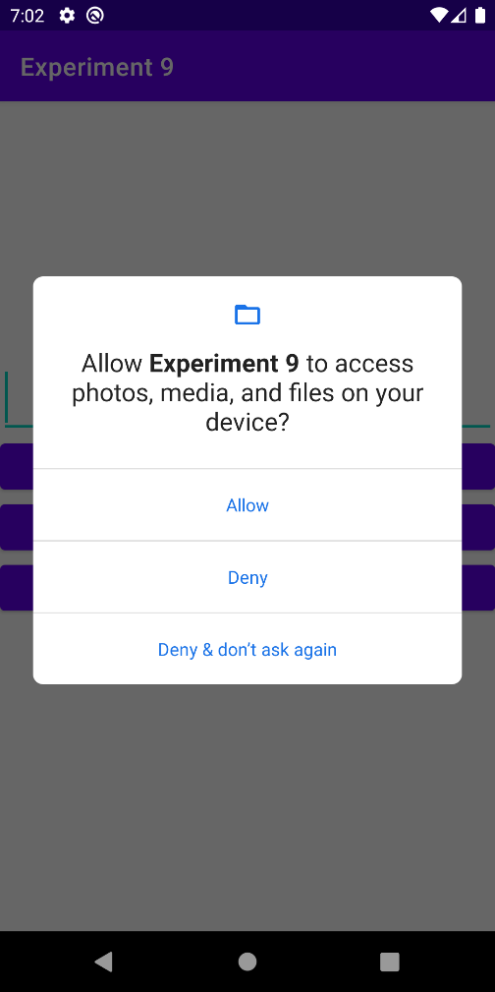

Write Data

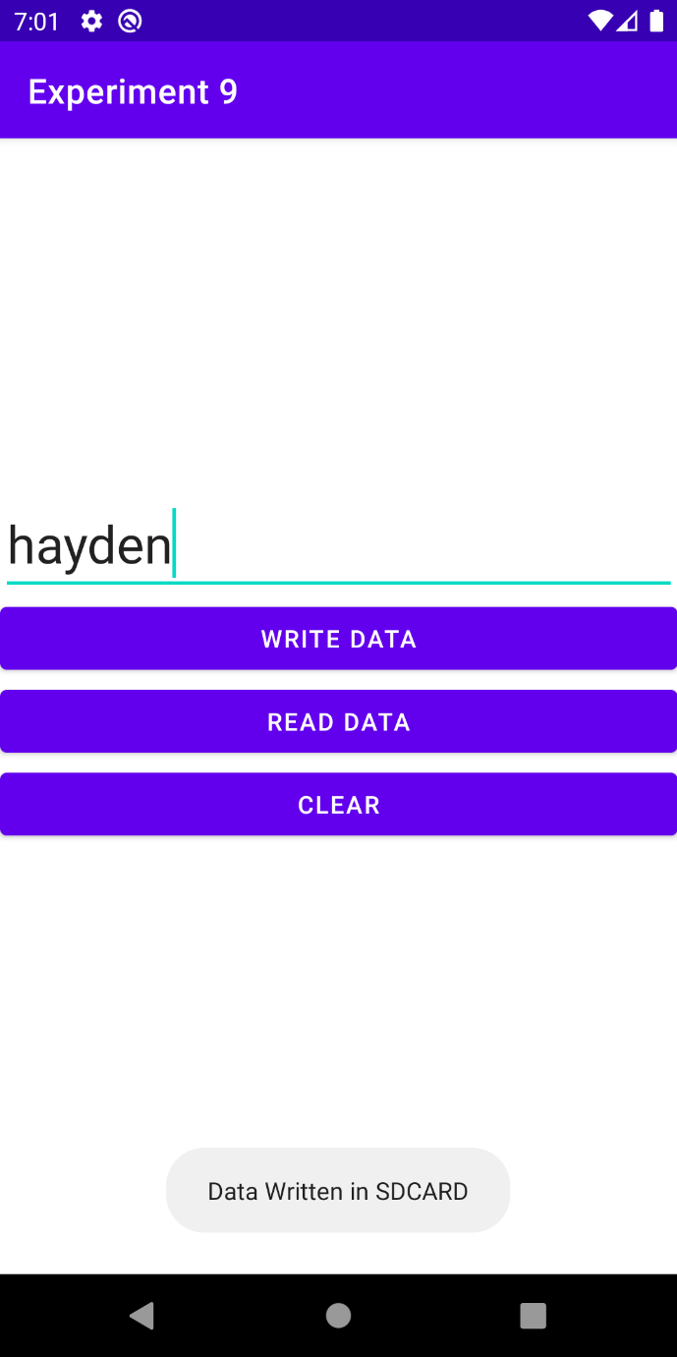

Clear

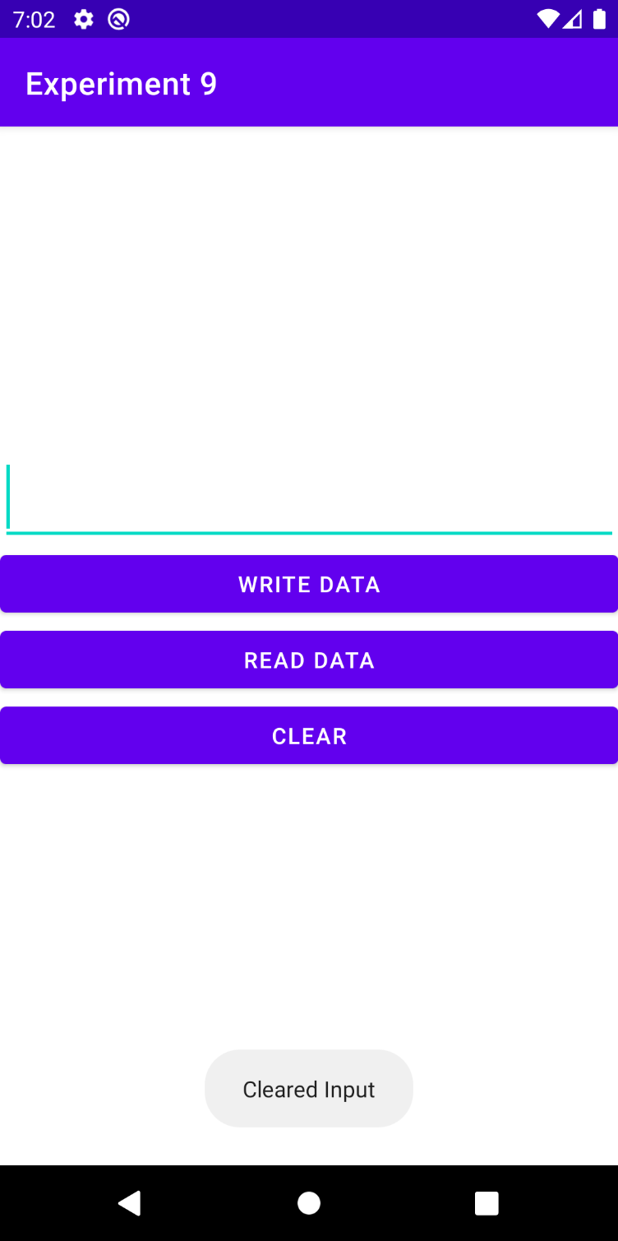

# 

# Read Data

# 

# Conclusion:

Thus Android Application that writes data to the SD Card is developed and executed successfully.