Don Bosco Institute of Technology
Department of Computer Engineering

Academic year – 2021-22

Class: B.E. COMPUTER ENGINEERING

Subject: Computational Lab -I

Course Code: CSL704

Experiment Title: Use of steganographic tools like OpenStego, to detect data hiding or unauthorized file copying

Student Name: Hayden Cordeiro

Roll No.: 05

Batch: D

Date of Performance: 27/7/21

Date of Submission: 27/7/21

Aim : To use steganographic tools like OpenStego, to detect data hiding or unauthorized file copying

Screenshots:

Installation

Visit
https://www.openstego.com/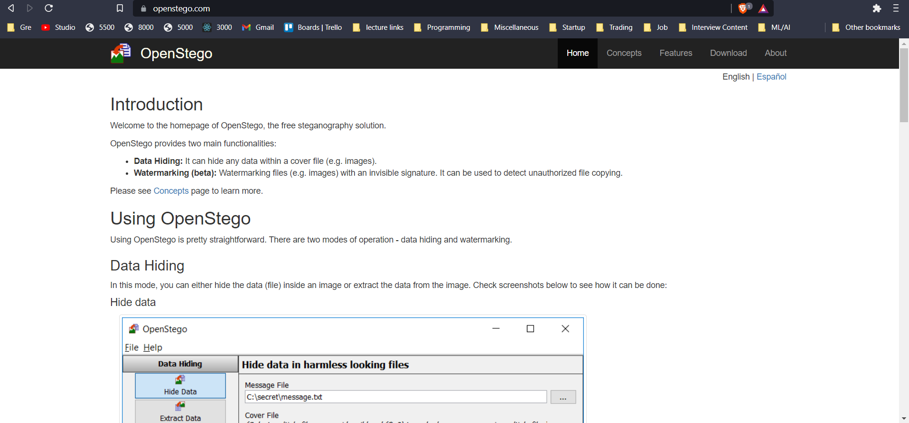

Hit the download button in the navbar and download openstego-0.8.0.zip.
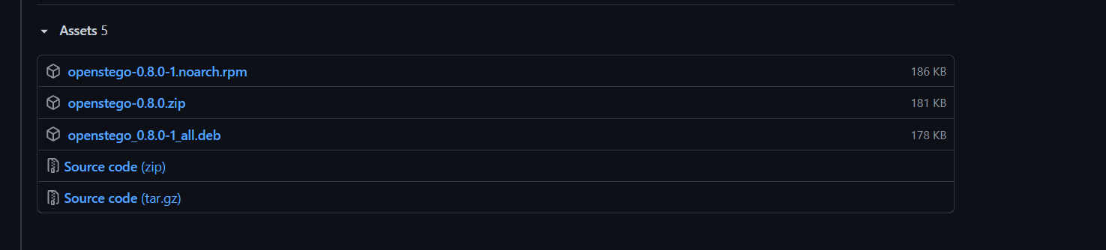

Extract the folder and run openstegno.bat
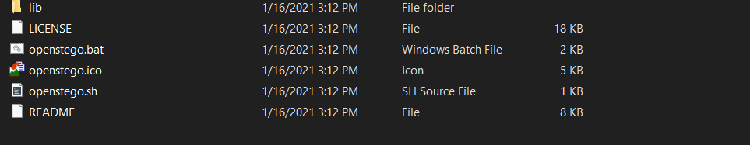

Data Hiding

Hide Data

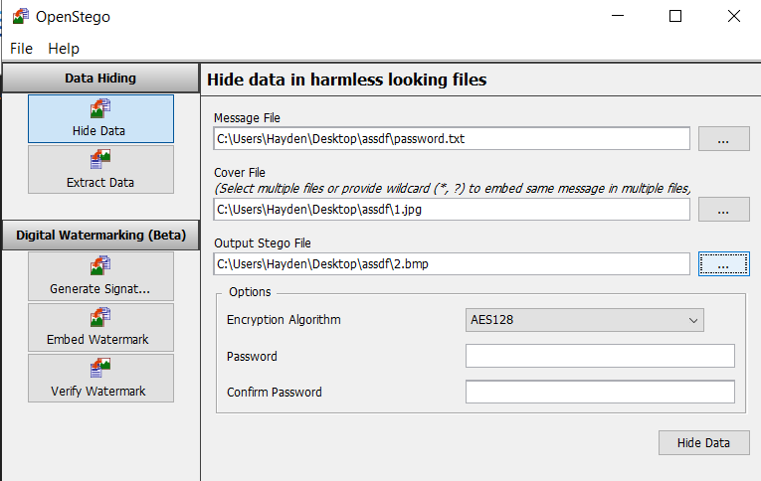
Input Files

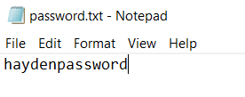


Output


Extract Data
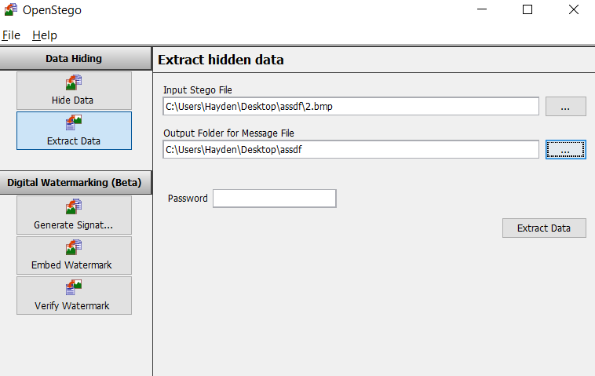

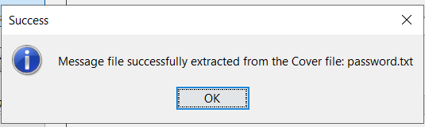

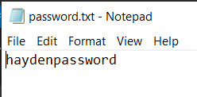

Digital Watermarking

Generate signature
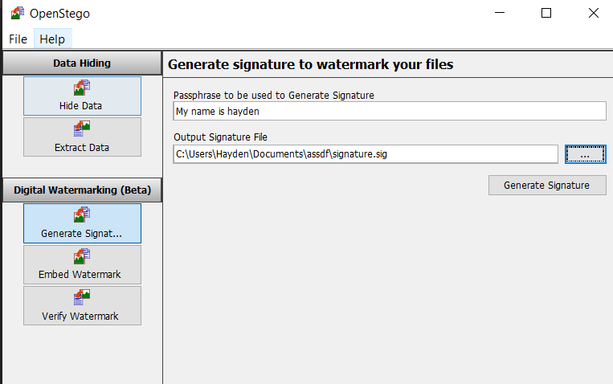

Watermark Files
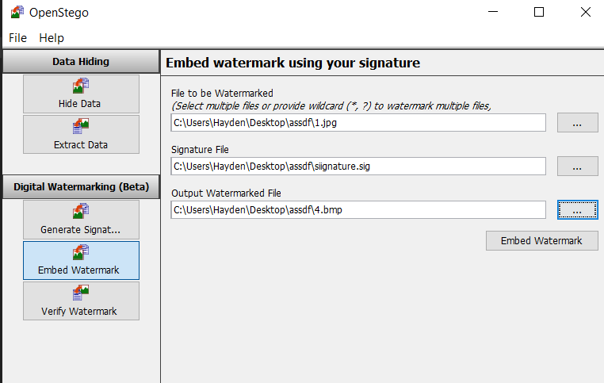

Verify Watermark
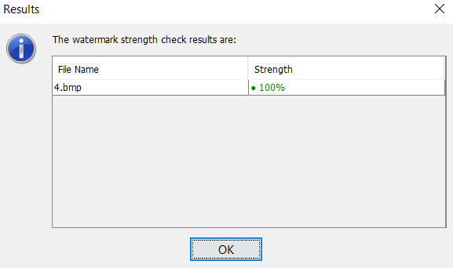

Conclusion :Students were able to use the tool to perform different operations like hiding data, extracting data, creating signature files, embedding watermark and verifying the watermark.

