SC4001 Neural Networks and Deep Learning
Programming Assignment
Part A: Regression Problem

Name: Gan Yee Hong
Matriculation No.: U2320111K

Generative AI Declaration
- Generative AI Tool Used: Anthropic Claude (Opus 5).
- Purpose of Use: Code generation for the experiment scripts, and assistance with report writing, rephrasing and generating the graphs.
- Verification Method: Manual code review, execution testing, debugging, and validation against the assignment requirements. Parameter counts were hand-checked against the layer shapes, and all reported numbers were produced by running the submitted code.

Question A1
(a) Block diagram and parameter count
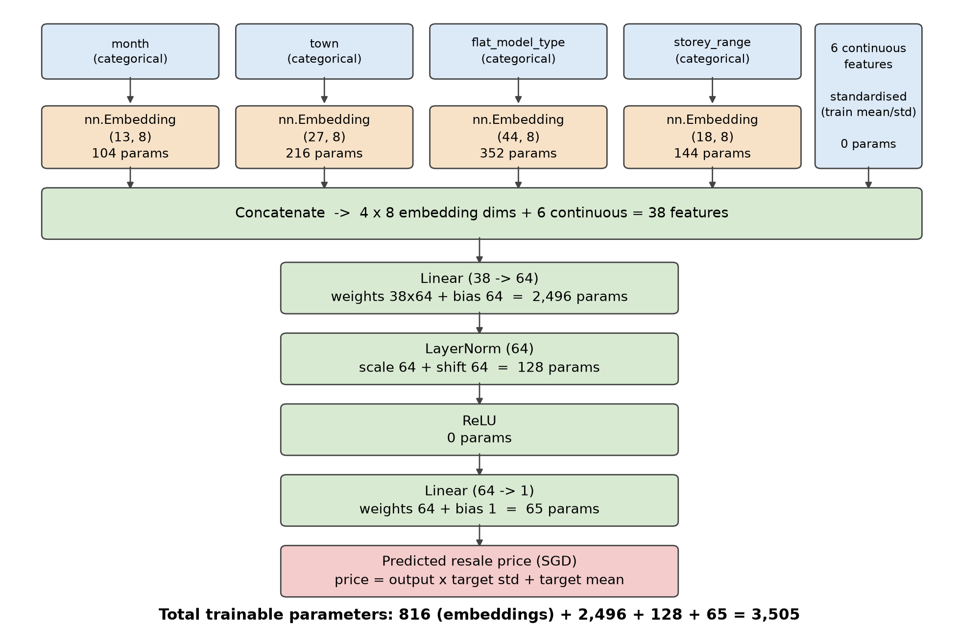
Figure 1. Baseline model (embedding dimension 8, hidden width 64).
- Embedding layer: embedding table heights are represented by ( i = categories seen in training + 1 for unseen categories, j = embedding dimension). The parameter count is i × j. For month this gives (12 + 1) × 8 = 104.
- Input features: 4 categorical features through embedding tables (dimension 8) + 6 standardised continuous features = 38 inputs.
- MLP layer: 38 inputs through a hidden layer of width 64 with LayerNorm and ReLU, followed by a linear output unit. A linear layer of n inputs and m outputs costs n × m + m params (weights + biases); LayerNorm costs 2 × 64 (a scale and a shift per unit) params; ReLU has no params.
Embedding layer | Shape | Params | MLP layer | Calculation | Params
month | (13, 8) | 104 | Linear 1 (38→64) | 38 × 64 + 64 | 2,496
town | (27, 8) | 216 | LayerNorm (64) | 2 × 64 | 128
flat_model_type | (44, 8) | 352 | ReLU | 0 | 0
storey_range | (18, 8) | 144 | Linear 2 (64→1) | 64 × 1 + 1 | 65
Subtotal |  | 816 | + |  | 2,689
Total |  |  |  |  | 3,505
Table 1. Trainable parameters of the baseline: 3,505.
(b) Hyperparameter search using Ray grid search and selected configuration
- All 25 combinations run with ray.tune.grid_search. Trained on 2017 to 2020 (87,370 rows), and validating on 2021 (29,057 rows)
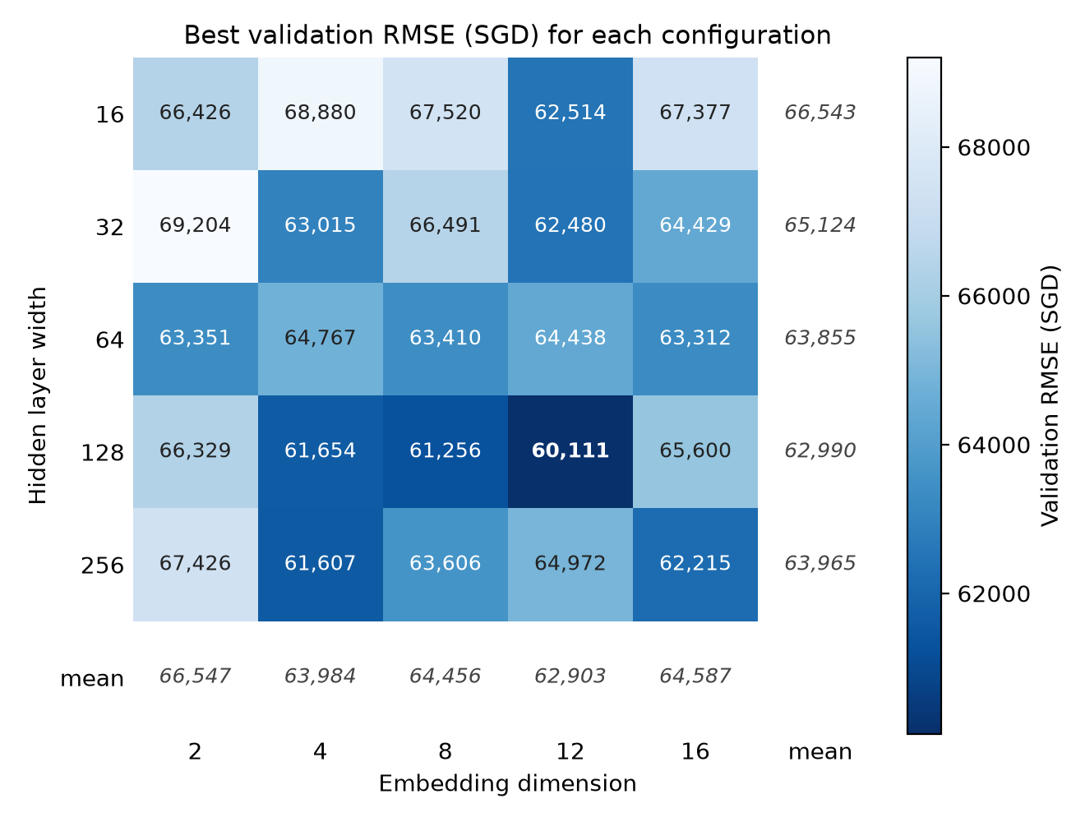
Figure 2. Best validation RMSE (SGD) for all 25 configurations, with row and column means.
- Optimal configuration: hidden width 128, embedding dimension 12 for all four categorical features (8,649 trainable parameters); best validation RMSE SGD 60,111 at epoch 13, with training stopping at epoch 17.
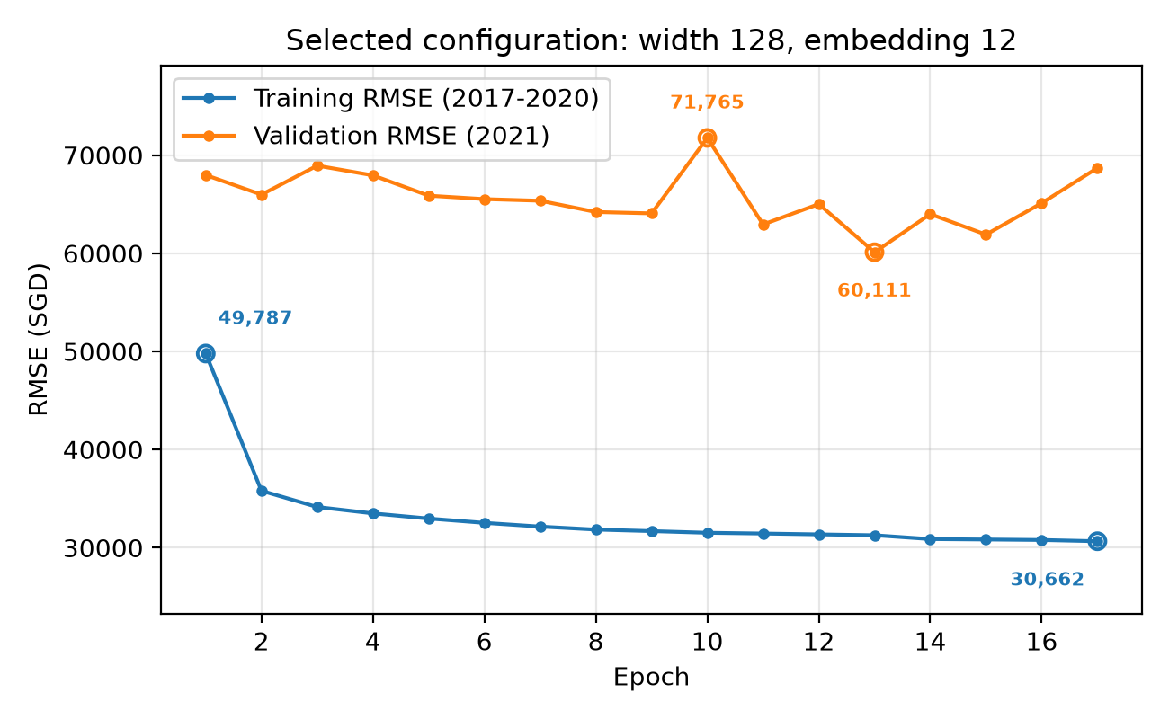
Figure 3. Training and validation RMSE curves for the selected configuration.
(c) Retraining with training combined with validation dataset and test performance
- Epoch: As validation combined with training, the epoch count was fixed at the 13 epochs identified during selection.
- Preprocessing: category encoders and standardisation statistics refitted on the combined 2017 to 2021 rows (116,427). The 2022 test year was used once only.
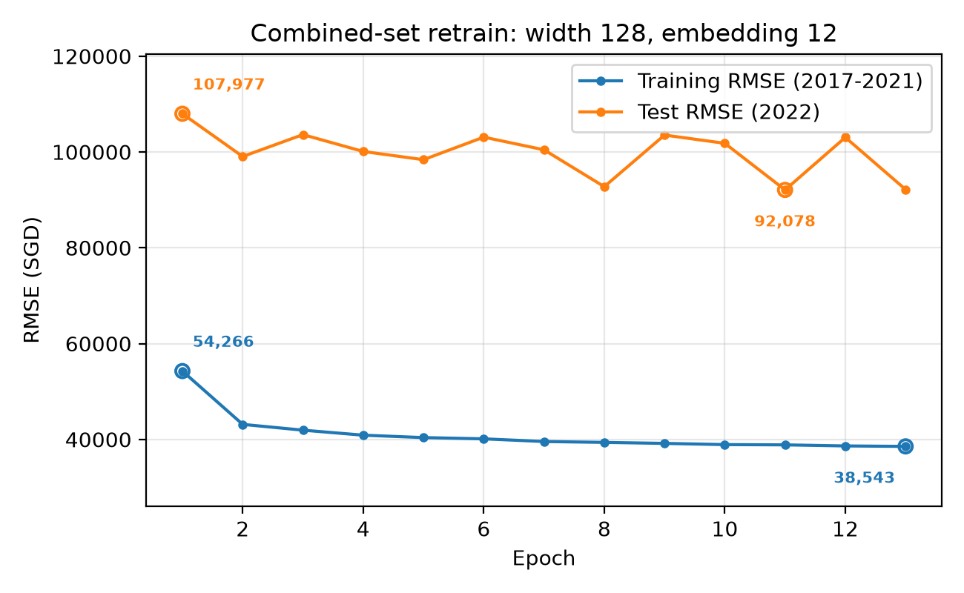
Figure 4. Training and testing RMSE curves.
Partition | Rows | RMSE (SGD) | R²
Train (2017 to 2021) | 116,427 | 38,838 | 0.9405
Test (2022) | 26,702 | 92,163 | 0.7070
Table 2. Final A1 performance: test RMSE SGD 92,163, R² 0.7070.
(d) Discussion
- Configuration choice:
  - Evidence 1: Width 128 with embedding 12 sits at the intersection of the best row mean (SGD 62,990) and the best column mean (SGD 62,903) based on Figure 2.
  - Evidence 2: Validation RMSE improves with width up to 128 then worsens at 256, and with embedding dimension up to 12 then worsens at 16, so both show a capacity optimum.
- Not underfitting: On Table 2, training RMSE falls to 38,838 with R² 0.9405. Besides, widening to 256 and growing the embedding to 16 both make validation worse, so extra capacity does not help.
- Overfitting, but only in the late epochs:
  - Reason 1: On figure 2, after the best epoch, validation RMSE rises from 60,111 to 68,704 by epoch 17 while training RMSE keeps falling from 31,274 to 30,662. That is why early stopping stops at 17.
  - Reason 2: On figure 2, at epoch 1, validation already sits about 18,000 SGD above training(large gap). Memorisation is not possible at this stage yet, and it still stays roughly that far apart throughout, which means that test set is quite different from the training set.

Question A2
(a) Remove all categorical variables and use only the six continuous features; (b) retain both inputs but replace the hidden ReLU with a Sigmoid. Perform Experiment over five seeds. Report the mean and standard deviation of test RMSE and R².
Seed | Baseline RMSE | R² | No cat. RMSE | R² | Sigmoid RMSE | R²
42 | 92,163 | 0.7070 | 104,733 | 0.6216 | 83,465 | 0.7597
43 | 95,047 | 0.6884 | 113,439 | 0.5561 | 89,848 | 0.7215
44 | 93,226 | 0.7002 | 116,883 | 0.5287 | 99,952 | 0.6554
45 | 97,333 | 0.6732 | 105,005 | 0.6196 | 101,275 | 0.6462
46 | 100,421 | 0.6521 | 114,988 | 0.5439 | 100,027 | 0.6548
Table 3. Per-seed test results for the three models (RMSE in SGD).
Model | Params | Test RMSE (SGD) | Test R² | Δ RMSE vs baseline
Baseline (A1) | 8,649 | 95,638 ± 3,316 | 0.6842 ± 0.0220 | n/a
(a) No categorical | 1,281 | 111,010 ± 5,738 | 0.5740 ± 0.0437 | +15,372 (5.2 SE)
(b) Sigmoid | 8,649 | 94,913 ± 7,886 | 0.6875 ± 0.0504 | −724 (−0.2 SE)
Table 4. Mean ± sample standard deviation over five seeds; SE is the standard error of the difference in means.
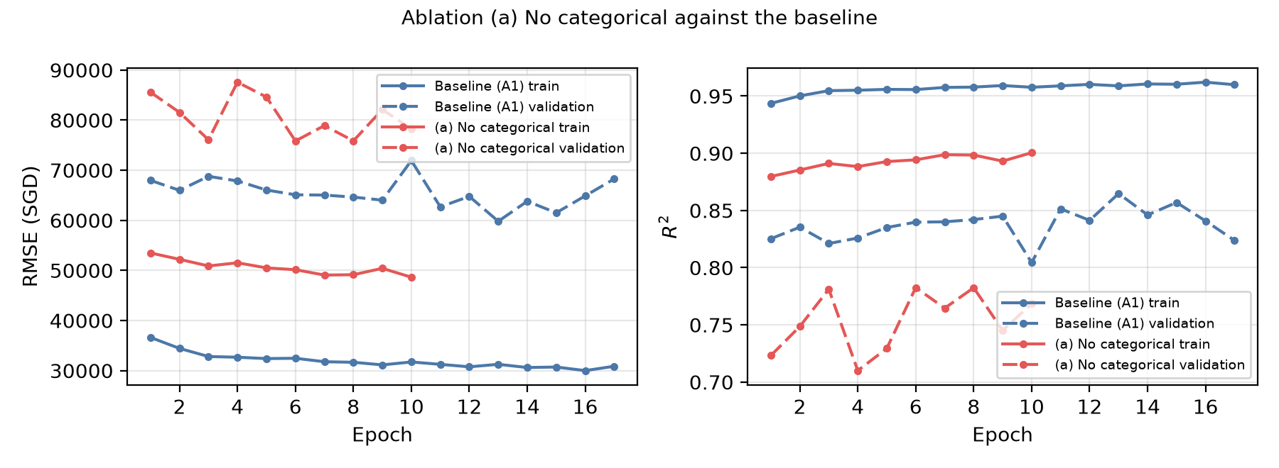
Figure 5. Ablation (a) no categorical embeddings: train and validation RMSE and R² against epochs.
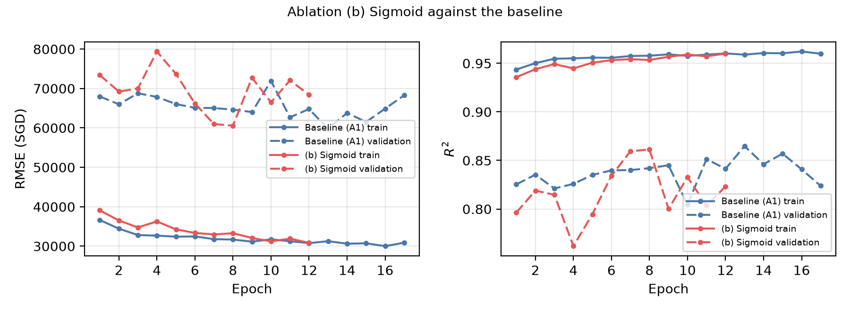
Figure 6. Ablation (b) Sigmoid in place of ReLU: train and validation RMSE and R² against epochs.
(b) Removing the categorical embeddings
- Result: decisively harmful. In Figure 5 and Table 4, RMSE rises by around SGD 15000 and R² falls from 0.684 to 0.574, with 5.2 standard errors. Every one of the five seeds is worse than its baseline.
- Reason: Lost capacity (8,649 to 1,281 parameters), and the information removed from the input.
(c) Replacing ReLU with Sigmoid
- Result: In Figure 6 and Table 4, mean accuracy barely changes (0.2 standard errors), but the spread across seeds is larger (RMSE s.d. is SGD 7,886 against 3,316, R² s.d. is 0.0504 against 0.0220).
- Reason: Sigmoid saturates and its gradients vanish once pre-activations grow, whereas ReLU does not. However, the mean still didn’t change much because the LayerNorm immediately before the activation normalizes pre-activations in a usable range. However, the outcome becomes more dependent on initialisation.
- Conclusion: the categorical embeddings carry real signal, whereas the hidden activation affects reliability more than accuracy here.

Question A3
(a) Selecting λ in wide-and-deep architecture
- λ selected on the validation (year 2021), early stopping as in A1. Selected λ = 0.
λ | 0 | 0.25 | 0.5 | 1 | 2
Best validation RMSE (SGD) | 61,407 | 61,721 | 67,331 | 64,504 | 63,719
Best epoch | 13 | 13 | 4 | 4 | 4
Table 5. λ selection on 2021.
(b) Five-seed evaluation. Report the mean and sample standard deviation of test RMSE and R², with relevant plots, and compare against the A1 baseline results.
Selected λ = 0
Seed | 42 | 43 | 44 | 45 | 46
Test RMSE (SGD) | 98,736 | 98,942 | 99,166 | 96,222 | 90,831
Test R² | 0.6637 | 0.6623 | 0.6608 | 0.6806 | 0.7154
Table 6. Per-seed results for the selected wide-and-deep model (λ = 0).
Model | Params | Test RMSE (SGD) | Test R²
Baseline (A1) | 8,649 | 95,638 ± 3,316 | 0.6842 ± 0.0220
Wide-and-deep (λ = 0) | 8,704 | 96,779 ± 3,532 | 0.6766 ± 0.0231
Table 7. Model comparison.
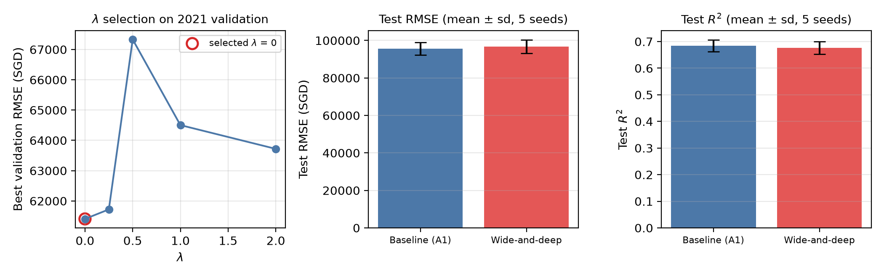
Figure 7. Left: λ selection on validation. Right: five-seed test RMSE.
(c) Explain the mechanism by which the change could affect optimisation or generalisation, and determine whether the evidence is consistent with that mechanism. Discuss at least one limitation or confound in the comparison.
- Mechanism: In the original wide-and-deep design, the wide branch (linear branch) gets more crossed features the deep branch never sees, so it genuinely adds something new.
  - Not working in this case: Both branches receive exactly 54 numbers, the MLP can already learn by itself, so it adds nothing new.
  - The embeddings now receive gradients from two paths instead of one: since the linear branch's gradient is scaled by λ, the total is about (1 + λ) times larger. A larger gradient means larger updates step, so raising λ has much the same effect as raising the learning rate.
- Evidence: In Figure 7, validation RMSE is best at λ = 0, and worse for λ ≥ 0.5. The best epoch collapses from 13 to 4 for every λ ≥ 0.5. It means the step size is too large, not a model lacking capacity.
- Confound: Even λ = 0 the linear branch is switched off, the two models are not identical. The unused branch is still constructed, and drawing its initial weights from random number. The order the training data is shuffled also. The two models see the data in a different order even though their MLP weights start out identical.
- Limitation: λ was chosen on 2021 using a single seed, but scored on 2022, which A1 showed is a different distribution. The best λ on one year need not be the best on the next.

Question A4
(a) Use Captum's FeatureAblation on the test set to explain the final A1 baseline and the A3 wide-and-deep model, trained with the same seed. Present the ten scores in SGD in a labelled bar plot, report the top three features per model.
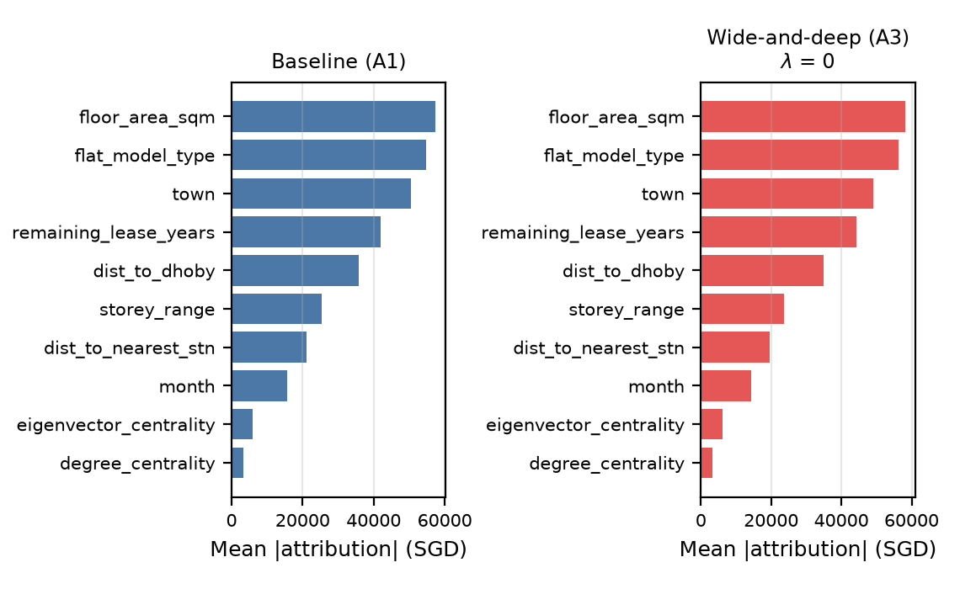
Figure 8. Mean absolute FeatureAblation attribution per feature, in SGD.
Model | 1st | 2nd | 3rd
Baseline (A1) | floor_area_sqm | flat_model_type | town
Wide-and-deep (λ = 0) | floor_area_sqm | flat_model_type | town
Table 8. Three most important features per model.
(b) Discussion and limitation
- Observation: identical ranking for baseline and wide-and-deep structure. This is expected because λ = 0 makes them the same architecture.
- Feature importance: flat size, flat type and town dominate at roughly SGD 50,000 to 59,000 each. The two MRT graph features degree_centrality and eigenvector_centrality are least important.
- Limitation: FeatureAblation removes one feature at a time, so it cannot split the credit fairly when several features represent the similar thing. Town, dist_to_dhoby and the two centrality measures all describe where the flat is. If one of them is removed, the others still tell the model the location, so the prediction barely moves and that feature scores low. The low centrality scores therefore mean "we have this information elsewhere too", not "location does not matter".
- Future mitigation: ablating the correlated location features together as a group

