SC4001 Neural Networks and Deep Learning
Programming Assignment
Part B: Classification Problem

Name: Gan Yee Hong
Matriculation No.: U2320111K

Generative AI Declaration
- Generative AI Tool Used: Anthropic Claude (Opus 5).
- Purpose of Use: Code generation for the experiment scripts, and assistance with report writing, rephrasing and generating the graphs.
- Verification Method: Manual code review, execution testing, debugging, and validation against the assignment requirements. Parameter counts were hand-checked against the layer shapes, and all reported numbers were produced by running the submitted code.

Question B1
(a) Implement and train an AlexNet-like architecture shown in Figure B1. Use a batch size of 128 and train the network with learning rates from {1e⁻⁵, 1e⁻⁴, 1e⁻³, 1e⁻², 1e⁻¹}.
(i) Validation loss and validation accuracy
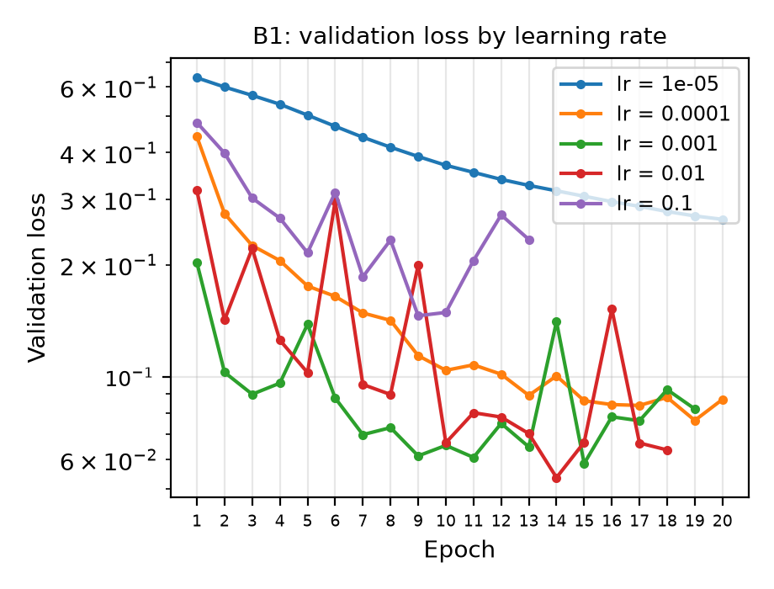 | 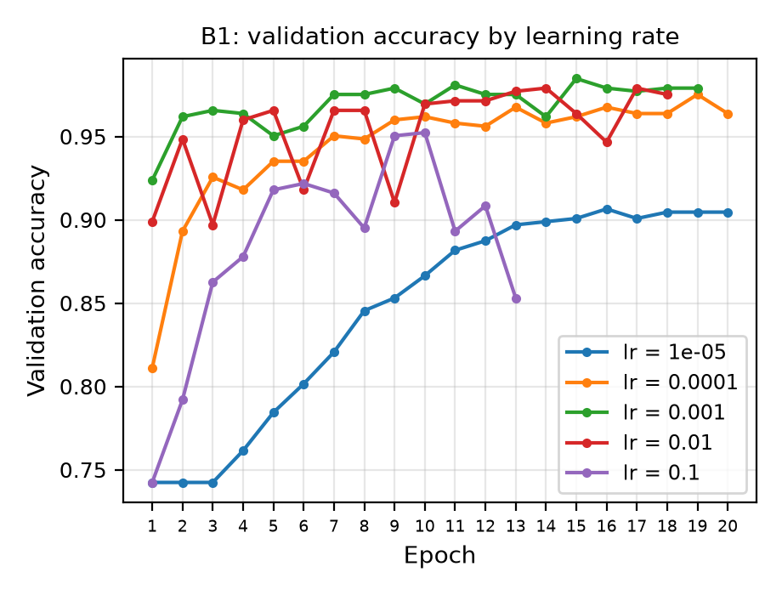
Figure 1. Validation loss, log scale. | Figure 2. Validation accuracy.
(b) Present a table containing the learning rate, best epoch, validation loss, validation classification error (1 − accuracy), sensitivity, and specificity.
Learning rate | Best epoch | Val loss | Val error | Sensitivity | Specificity
0.00001 | 20 | 0.2647 | 0.0954 | 0.9666 | 0.7259
0.0001 | 19 | 0.0763 | 0.0248 | 0.9820 | 0.9556
0.001 | 15 | 0.0585 | 0.0153 | 0.9897 | 0.9704
0.01 | 14 | 0.0536 | 0.0210 | 0.9871 | 0.9556
0.1 | 9 | 0.1458 | 0.0496 | 0.9871 | 0.8444
Table 1. Learning-rate sweep at batch size 128. Selected: 0.001.
(c) Choosing the learning rate based on the lowest validation classification error and explain.
- Selected: learning rate = 0.001. Based on Table 1, it gives the lowest validation classification error (0.0153).
- Reasons based on the Figure 1 and 2:
  - The five rates differ in both how fast they converge and whether they converge at all.
    - At 0.00001 the loss is still falling when the 20 epochs run out, so it has not converged within the epochs, meaning the steps are too small.
    - 0.0001 converges smoothly but slowly near epoch 19.
    - 0.001 converges fastest, reaching a low loss within three epochs and then holding steady in a narrow band, with the highest accuracy from epoch 7 onward.
    - 0.01 reaches a similar low point but oscillates on the way, so it is never stable.
    - 0.1 the loss never drops below about 0.15 and accuracy falls away after epoch 10, not converging.
  - Convergence degrades as the step size grows, and 0.001 is the largest rate that still converges stably.
(d) Why sensitivity and specificity are also needed.
- Definition: Sensitivity is the proportion of pneumonia cases the model correctly identifies, and specificity is the proportion of healthy cases it correctly clears. The two describe opposite mistakes.
- Reason: Accuracy alone is misleading here because the classes are not balanced. Pneumonia makes up 74% of the validation set and 62.5% of the test set, so a model that simply answered "pneumonia" every time would already score 0.7424 and 0.6250 without looking at the image at all.
- Evidence: Accuracy also cannot tell which of the two mistakes the model is making. The model on the test set gives accuracy 0.8269, sensitivity 0.9974 and specificity 0.5427. 0.8269 accuracy sounds reasonable, but it shows that the model finds almost every pneumonia case while wrongly flagging 46% of healthy patients.
- Conclusion: These two values show where generalization breaks down. Between validation and test, sensitivity barely moves, from 0.9897 to 0.9974, while specificity falls from 0.9704 to 0.5427. The entire loss of accuracy therefore sits on the healthy class.
(e) Evaluate the final model once on the test set and report its accuracy, sensitivity, and specificity.
- The AlexNet-like model was trained on train plus validation set and evaluated once on the test set gives accuracy 0.8269, sensitivity 0.9974 and specificity 0.5427.

Question B2
(a) Determine the optimal batch size for a VGG-like architecture, using learning rate 0.001 from B1, with batch sizes 16, 32, 64, 128 and 256. Plot validation (i) loss and (ii) accuracy against epochs for the five batch sizes
(i) Validation loss and (ii) Validation accuracy
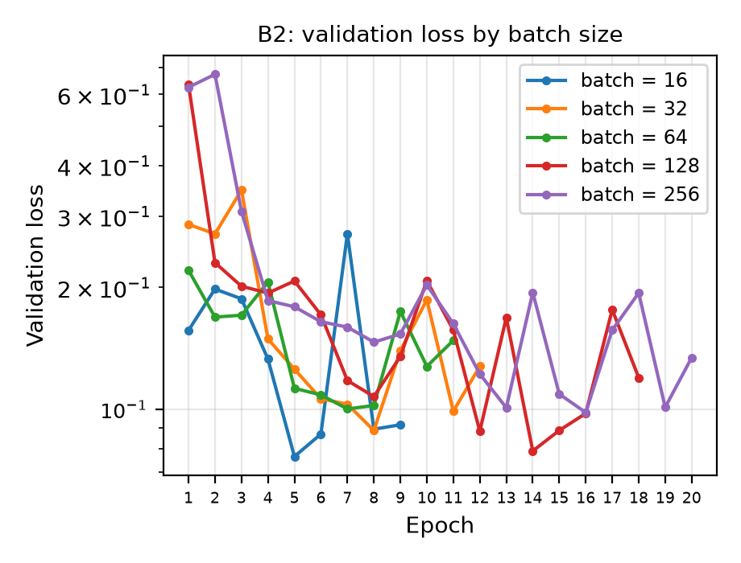 | 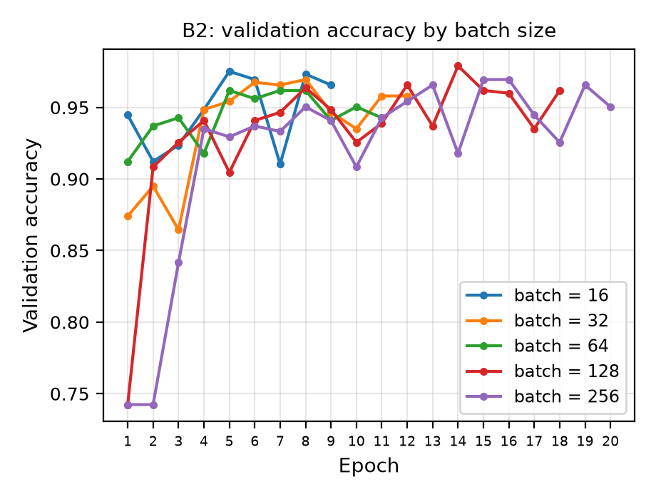
Figure 3. Validation loss, log scale. | Figure 4. Validation accuracy.
(b) Present a table containing the batch size, best epoch, validation loss, validation classification error (1 − accuracy), sensitivity, and specificity.

Batch size | Best epoch | Val loss | Val error | Sensitivity | Specificity
16 | 5 | 0.0764 | 0.0248 | 0.9846 | 0.9481
32 | 8 | 0.0886 | 0.0305 | 0.9871 | 0.9185
64 | 7 | 0.1002 | 0.0382 | 0.9820 | 0.9037
128 | 14 | 0.0789 | 0.0210 | 0.9949 | 0.9333
256 | 16 | 0.0982 | 0.0305 | 0.9794 | 0.9407
Table 2. Batch-size sweep at learning rate 0.001. Selected: 128.
(c) Choosing the batch size based on the lowest validation classification error and explain.
- Selected: 128 batch size. Based on Table 2, it has the lowest validation classification error.
- Reasons:
  - The pattern can be seen from the best epoch column, which rises with batch size: 5, 8, 7, 14, 16. The reason is how many times the weights are adjusted in one pass through the 4708 training images.
  - At batch 16 the weights are updated 295 times (4708/16) per epoch, but at batch 256 only 19 times (4708/256). A large batch therefore needs more epochs to make the same amount of progress.
  - The trade-off is quality against quantity: each large-batch update averages over more images so it points in a more reliable direction, while small batches take many more steps but each one is noisier. That noise shows up in the results as the lower specificity at batch 32 and 64. Batch 128 sits in between, with updates steady enough to be reliable and still enough of them to converge inside 20 epochs.
(d) Evaluate the final model once on the test set and report its accuracy, sensitivity, and specificity.
VGG-like model was trained on train plus validation set and evaluated once on the test set gives accuracy 0.7949, sensitivity 1.0000 and specificity 0.4530.

Question B3
(a) Build for a compact ResNet-like architecture shown in Figure B3. Use the best learning rate obtained in part B1 and batch size in part B2 to train the network. Report the accuracy, sensitivity, and specificity of the model.
Trained at learning rate 0.001 from B1 and batch size 128 from B2.
ResNet-like model was trained on train plus validation set and evaluated once on the test set gives accuracy 0.9311, sensitivity 0.9590 and specificity 0.8846.
(b) Comparison of the three architectures
Architecture | Accuracy | Sensitivity | Specificity | Class. Error | Parameters | MFLOPs
B1 AlexNet-like | 0.8269 | 0.9974 | 0.5427 | 0.1731 | 99,569 | 39.06
B2 VGG-like | 0.7949 | 1.0000 | 0.4530 | 0.2051 | 18,185 | 19.46
B3 ResNet-like | 0.9311 | 0.9590 | 0.8846 | 0.0689 | 77,169 | 25.30
Table 3. All three on the test set, at learning rate 0.001 and batch 128. MFLOPs stand for floating-point operations.
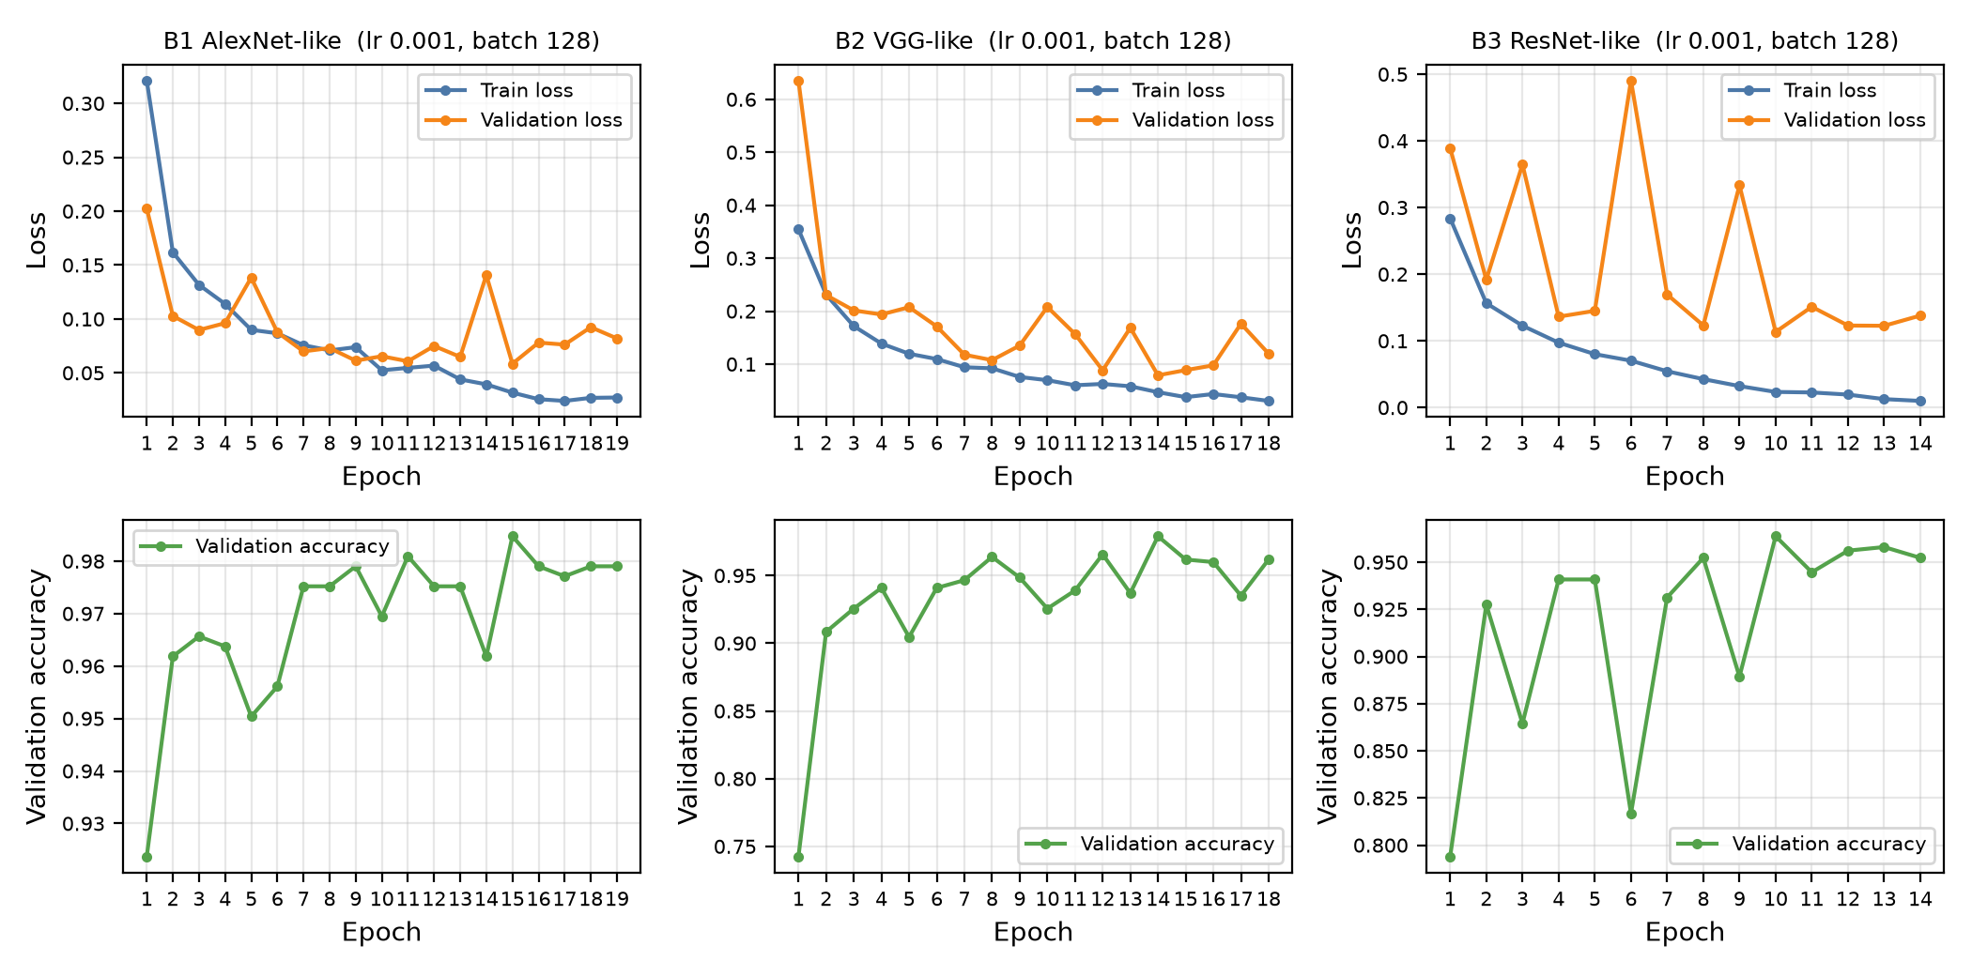
Figure 5. Train and validation loss (top) and validation accuracy (bottom) against epochs for the three architectures, at learning rate 0.001 and batch size 128.
(c) Pros and cons based on Table 3
- B1 AlexNet-like:
  - Pros: More accurate than B2 (0.8269 against 0.7949) and better at clearing healthy cases (0.5427 against 0.4530).
  - Cons: Expensive on both counts (99,569 parameters and 39.1 MFLOPs). Its 5x5 kernels are expensive, and 65,600 of its parameters, 66% of the total, sit in the one fully connected layer from the pooled 4x4 map to 64 units. Its capacity is in the classifier rather than the features, which is why dropout is needed there.
- B2 VGG-like:
  - Pros: By far the cheapest, with 18,185 parameters and half the FLOPs, because global average pooling removes the fully connected head and every kernel is 3x3.
  - Cons: It is the most accurate per FLOP, but the least accurate overall and has the worst specificity (0.4530): squeezing a 32 channel map down to one vector can cause loss of information.
- B3 ResNet-like:
  - Pros: The most accurate of the three (0.9311) and by far the best specificity (0.8846), while using fewer parameters and FLOPs than B1.
  - Cons: It has the lowest sensitivity (0.9590) of the three and overfits hardest: in Figure 5 its training loss falls to about 0.01 while validation stays near 0.13, and its validation curve is the most erratic. The 1x1 projection convolutions also add parameters.
- Conclusion:
  - B1 and B2 are both heavily biased towards pneumonia, with sensitivity of at least 0.9974 but specificity of only 0.5427 and 0.4530.
  - B3 breaks that pattern on this run, giving up a little sensitivity for a large gain in specificity, which lifts its accuracy to 0.9311.
  - However, Figure 5 shows B3 is also the most erratic and most overfitted of the three, so this single run is weak evidence of an architectural advantage. B1 is the more dependable choice, B3 the more promising but less stable one.

Question B4
(a) Explore if XAI methods can identify these patches by using Grad-CAM technique. Select randomly FIVE representative X-rays from pneumonia patients. Implement Grad-CAM onarchitectures developed in B1-B3
Images: five pneumonia X-rays drawn at random from the test set (indices 170, 346, 409, 516, 536).
Method: Grad-CAM from Captum, taken at the last convolutional stage of each network and scaled up to 64x64. All three models give these five images a pneumonia probability of about 1.00, so any difference between the maps is not a difference in confidence.
(b) Overlay Grad-CAM heatmaps on X-ray images
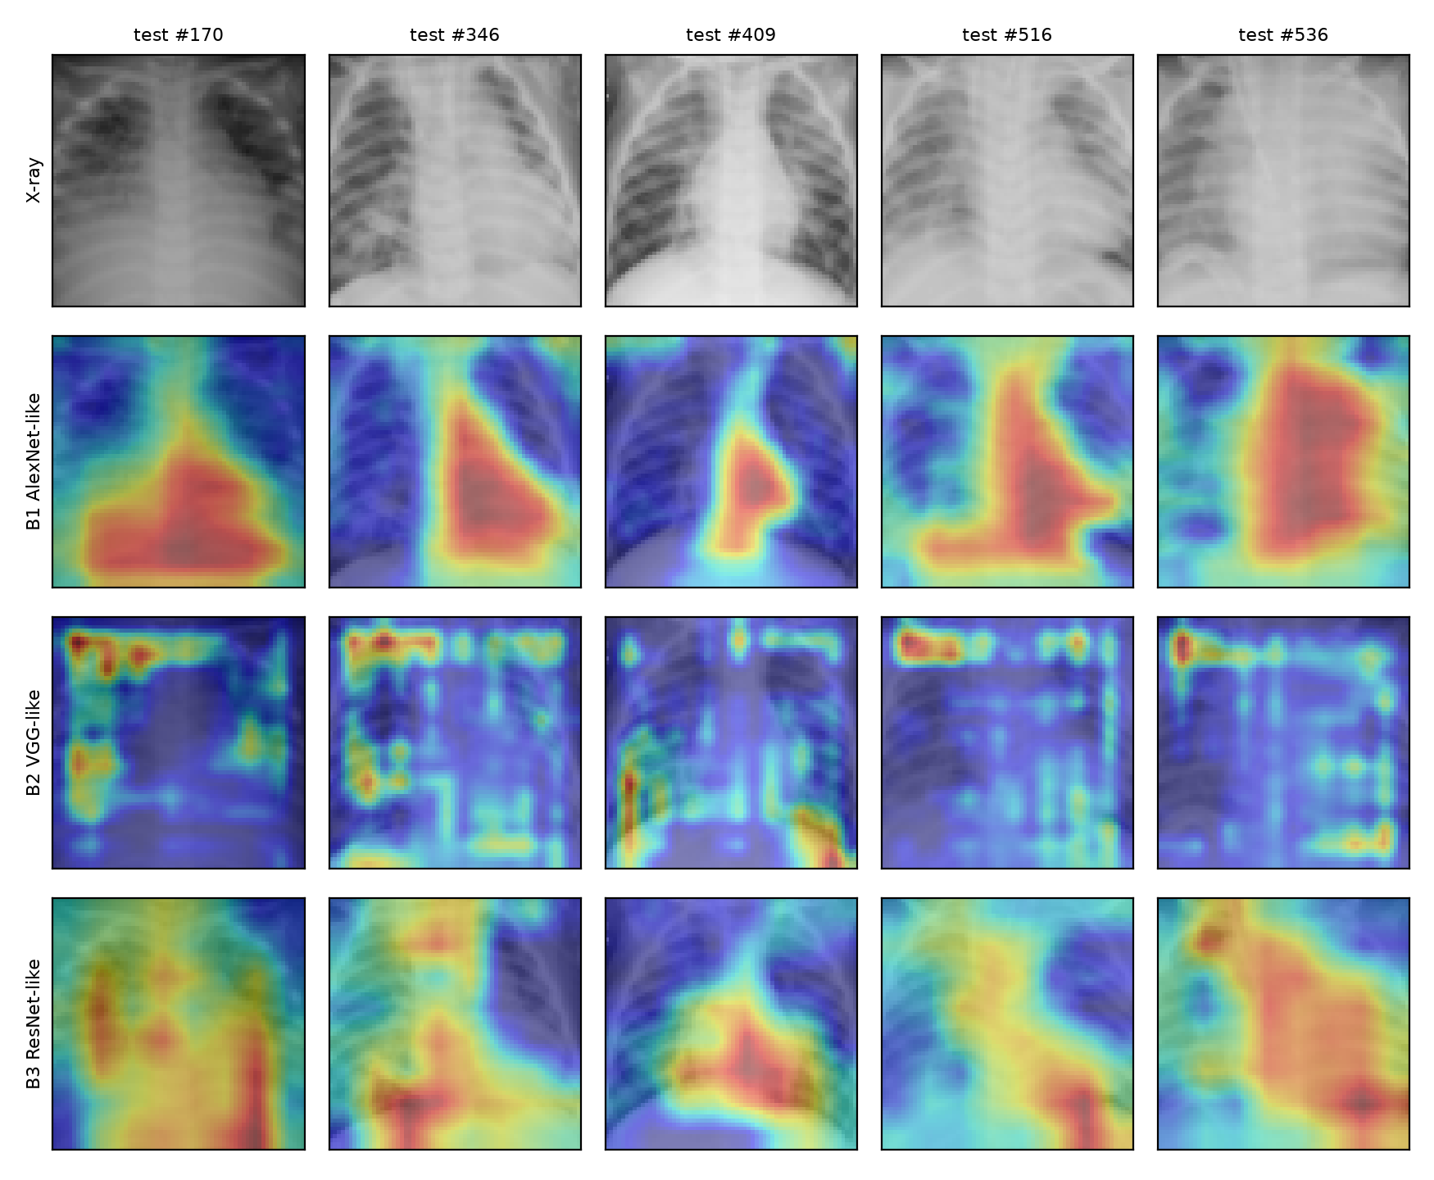
Figure 6. Grad-CAM overlays. Rows: original X-ray, then B1, B2 and B3.
Pair of models | Mean Grad-CAM correlation
B1 vs B2 | -0.122
B1 vs B3 | +0.521
B2 vs B3 | +0.212
Table 4. How closely the heatmaps agree, averaged over the five images.
(c) Compare the results
- Observations:
  - B1 and B3 behave alike: both produce smooth, joined up regions over the middle and lower lung fields, which is where the white cloudy patches appear. They are the only pair that really agree (correlation +0.52).
  - B2 is the odd one out: its maps break into small spots along the image border and the rib edges, and they are essentially unrelated to B1's (-0.12). B2 has the worst specificity (0.4530), and a model keying on the edges of the picture rather than the lungs is exactly the kind that would wrongly label healthy chests.
- Conclusion: Grad-CAM only partly identifies the abnormal patches, and whether it does depends on the architecture. B1 and B3 do concentrate on the middle and lower lung fields where consolidation appears, so their explanations look clinically plausible. B2 does not, despite being trained on the same data with the same settings. At 64x64 the maps are also too coarse to outline a patch, so they can indicate a region but not a lesion boundary.

