Debug Notes – output in Verbose Mode:

ADE7953:initialize function started

ADE7953:initialize function completed

ADE7953::functionBitVal function details:

Address input (dec): 771

Byte requested (dec): 0

Returned Value (dec): 3 Returned Value (HEX): 3

ADE7953::functionBitVal function completed

ADE7953::functionBitVal function details:

Address input (dec): 771

Byte requested (dec): 1

Returned Value (dec): 3 Returned Value (HEX): 3

ADE7953::functionBitVal function completed

spiAlgorithm32_write function started

ADE7953::spiAlgorithm32_write function details:

Address Byte 1(MSB)[HEX]: 3

Address Byte 2(LSB)[HEX]: 3

Written bytes (1(MSB) to 4)[HEX]: 0 0 0 1

spiAlgorithm32_write function completed

ADE7953::functionBitVal function details:

Address input (dec): 4

Byte requested (dec): 0

Returned Value (dec): 4 Returned Value (HEX): 4

ADE7953::functionBitVal function completed

ADE7953::functionBitVal function details:

Address input (dec): 4

Byte requested (dec): 1

Returned Value (dec): 0 Returned Value (HEX): 0

ADE7953::functionBitVal function completed

spiAlgorithm8_write function started

ADE7953::spiAlgorithm8_write function details:

Address Byte 1(MSB)[HEX]: 0

Address Byte 2(LSB)[HEX]: 4

Written bytes (1 of 1)[HEX]: 7F

spiAlgorithm8_write function completed

ADE7953::functionBitVal function details:

Address input (dec): 257

Byte requested (dec): 0

Returned Value (dec): 1 Returned Value (HEX): 1

ADE7953::functionBitVal function completed

ADE7953::functionBitVal function details:

Address input (dec): 257

Byte requested (dec): 1

Returned Value (dec): 1 Returned Value (HEX): 1

ADE7953::functionBitVal function completed

spiAlgorithm16_write function started

ADE7953::spiAlgorithm16_write function details:

Address Byte 1(MSB)[HEX]: 1

Address Byte 2(LSB)[HEX]: 1

Written bytes (1(MSB) to 2)[HEX]: 0 78

spiAlgorithm16_write function completed

In the Vrms(V)

ADE7953::functionBitVal function details:

Address input (dec): 796

Byte requested (dec): 0

Returned Value (dec): 28 Returned Value (HEX): 1C

ADE7953::functionBitVal function completed

ADE7953::functionBitVal function details:

Address input (dec): 796

Byte requested (dec): 1

Returned Value (dec): 3 Returned Value (HEX): 3

ADE7953::functionBitVal function completed

ADE7953::spiAlgorithm32_read function started

ADE7953::spiAlgorithm32_read function details:

Returned bytes (1(MSB) to 4)[HEX]: 0 1 1011011 1111110

ADE7953::spiAlgorithm32_read function completed

ADE7953::calibration function executed

Vrms (V): 4.66

In the Vrms(V)

ADE7953::functionBitVal function details:

Address input (dec): 796

Byte requested (dec): 0

Returned Value (dec): 28 Returned Value (HEX): 1C

ADE7953::functionBitVal function completed

ADE7953::functionBitVal function details:

Address input (dec): 796

Byte requested (dec): 1

Returned Value (dec): 3 Returned Value (HEX): 3

ADE7953::functionBitVal function completed

ADE7953::spiAlgorithm32_read function started

ADE7953::spiAlgorithm32_read function details:

Returned bytes (1(MSB) to 4)[HEX]: 0 1 1011011 10001101

ADE7953::spiAlgorithm32_read function completed

ADE7953::calibration function executed

Vrms (V): 4.66

In the Vrms(V)

ADE7953::functionBitVal function details:

Address input (dec): 796

Byte requested (dec): 0

Returned Value (dec): 28 Returned Value (HEX): 1C

ADE7953::functionBitVal function completed

ADE7953::functionBitVal function details:

Address input (dec): 796

Byte requested (dec): 1

Returned Value (dec): 3 Returned Value (HEX): 3

ADE7953::functionBitVal function completed

ADE7953::spiAlgorithm32_read function started

ADE7953::spiAlgorithm32_read function details:

Returned bytes (1(MSB) to 4)[HEX]: 0 1 1011100 1100101

ADE7953::spiAlgorithm32_read function completed

ADE7953::calibration function executed

Vrms (V): 4.67

In the Vrms(V)

ADE7953::functionBitVal function details:

Address input (dec): 796

Byte requested (dec): 0

Returned Value (dec): 28 Returned Value (HEX): 1C

ADE7953::functionBitVal function completed

ADE7953::functionBitVal function details:

Address input (dec): 796

Byte requested (dec): 1

Returned Value (dec): 3 Returned Value (HEX): 3

ADE7953::functionBitVal function completed

ADE7953::spiAlgorithm32_read function started

ADE7953::spiAlgorithm32_read function details:

Returned bytes (1(MSB) to 4)[HEX]: 0 1 1011101 100100

ADE7953::spiAlgorithm32_read function completed

ADE7953::calibration function executed

Vrms (V): 4.68

In the Vrms(V)

ADE7953::functionBitVal function details:

Address input (dec): 796

Byte requested (dec): 0

Returned Value (dec): 28 Returned Value (HEX): 1C

ADE7953::functionBitVal function completed

ADE7953::functionBitVal function details:

Address input (dec): 796

Byte requested (dec): 1

Returned Value (dec): 3 Returned Value (HEX): 3

ADE7953::functionBitVal function completed

ADE7953::spiAlgorithm32_read function started

ADE7953::spiAlgorithm32_read function details:

Returned bytes (1(MSB) to 4)[HEX]: 0 1 1011010 11110100

ADE7953::spiAlgorithm32_read function completed

ADE7953::calibration function executed

Vrms (V): 4.65

In the Vrms(V)

ADE7953::functionBitVal function details:

Address input (dec): 796

Byte requested (dec): 0

Returned Value (dec): 28 Returned Value (HEX): 1C

ADE7953::functionBitVal function completed

ADE7953::functionBitVal function details:

Address input (dec): 796

Byte requested (dec): 1

Returned Value (dec): 3 Returned Value (HEX): 3

ADE7953::functionBitVal function completed

ADE7953::spiAlgorithm32_read function started

ADE7953::spiAlgorithm32_read function details:

Returned bytes (1(MSB) to 4)[HEX]: 0 1 1011100 1101101

ADE7953::spiAlgorithm32_read function completed

ADE7953::calibration function executed

Vrms (V): 4.67

In the Vrms(V)

ADE7953::functionBitVal function details:

Address input (dec): 796

Byte requested (dec): 0

Returned Value (dec): 28 Returned Value (HEX): 1C

ADE7953::functionBitVal function completed

ADE7953::functionBitVal function details:

Address input (dec): 796

Byte requested (dec): 1

Returned Value (dec): 3 Returned Value (HEX): 3

ADE7953::functionBitVal function completed

ADE7953::spiAlgorithm32_read function started

ADE7953::spiAlgorithm32_read function details:

Returned bytes (1(MSB) to 4)[HEX]: 0 1 1011011 10001

ADE7953::spiAlgorithm32_read function completed

ADE7953::calibration function executed

Vrms (V): 4.65

In the Vrms(V)

ADE7953::functionBitVal function details:

Address input (dec): 796

Byte requested (dec): 0

Returned Value (dec): 28 Returned Value (HEX): 1C

ADE7953::functionBitVal function completed

ADE7953::functionBitVal function details:

Address input (dec): 796

Byte requested (dec): 1

Returned Value (dec): 3 Returned Value (HEX): 3

ADE7953::functionBitVal function completed

ADE7953::spiAlgorithm32_read function started

ADE7953::spiAlgorithm32_read function details:

Returned bytes (1(MSB) to 4)[HEX]: 0 1 1011100 101

ADE7953::spiAlgorithm32_read function completed

ADE7953::calibration function executed

Vrms (V): 4.67

In the Vrms(V)

ADE7953::functionBitVal function details:

Address input (dec): 796

Byte requested (dec): 0

Returned Value (dec): 28 Returned Value (HEX): 1C

ADE7953::functionBitVal function completed

ADE7953::functionBitVal function details:

Address input (dec): 796

Byte requested (dec): 1

Returned Value (dec): 3 Returned Value (HEX): 3

ADE7953::functionBitVal function completed

ADE7953::spiAlgorithm32_read function started

ADE7953::spiAlgorithm32_read function details:

Returned bytes (1(MSB) to 4)[HEX]: 0 1 1011011 1110111

ADE7953::spiAlgorithm32_read function completed

ADE7953::calibration function executed

Vrms (V): 4.66

In the Vrms(V)

ADE7953::functionBitVal function details:

Address input (dec): 796

Byte requested (dec): 0

Returned Value (dec): 28 Returned Value (HEX): 1C

ADE7953::functionBitVal function completed

ADE7953::functionBitVal function details:

Address input (dec): 796

Byte requested (dec): 1

Returned Value (dec): 3 Returned Value (HEX): 3

ADE7953::functionBitVal function completed

ADE7953::spiAlgorithm32_read function started

ADE7953::spiAlgorithm32_read function details:

Returned bytes (1(MSB) to 4)[HEX]: 0 1 1011101 10000101

ADE7953::spiAlgorithm32_read function completed

ADE7953::calibration function executed

Vrms (V): 4.69

In the Vrms(V)

ADE7953::functionBitVal function details:

Address input (dec): 796

Byte requested (dec): 0

Returned Value (dec): 28 Returned Value (HEX): 1C

ADE7953::functionBitVal function completed

ADE7953::functionBitVal function details:

Address input (dec): 796

Byte requested (dec): 1

Returned Value (dec): 3 Returned Value (HEX): 3

ADE7953::functionBitVal function completed

ADE7953::spiAlgorithm32_read function started

ADE7953::spiAlgorithm32_read function details:

Returned bytes (1(MSB) to 4)[HEX]: 0 1 1011101 11011100

ADE7953::spiAlgorithm32_read function completed

ADE7953::calibration function executed

Vrms (V): 4.69

I2C Algorithm Notes and alternative approaches:

Example about how the address is split into MSB and LSB and sent to the communication functions:

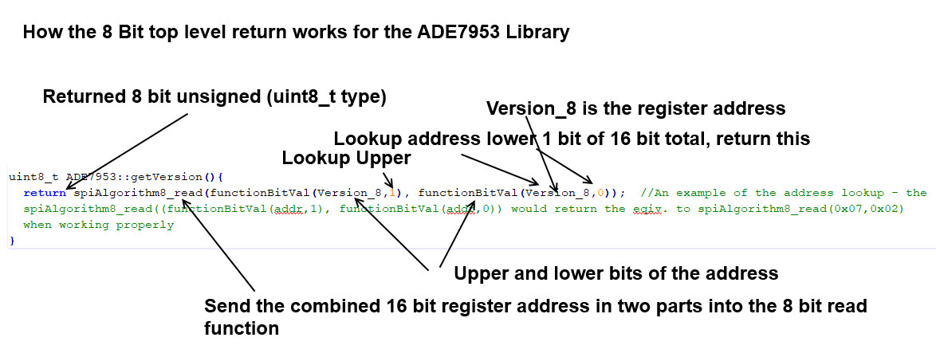

I2C Algorithm Operation:

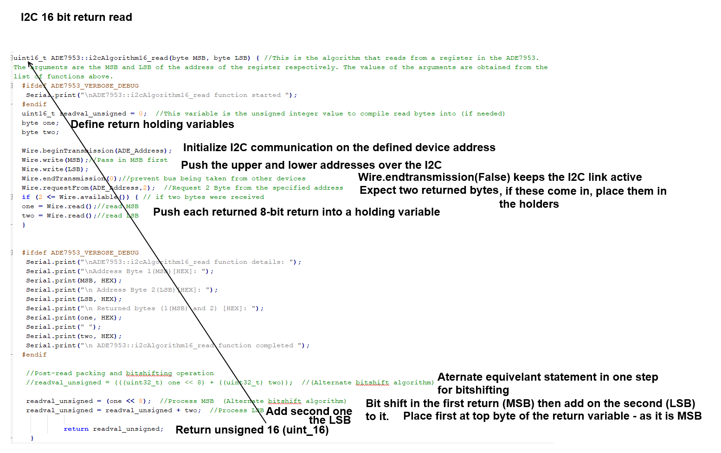

Alternative I2C implementations:

