SWEN422 Assignment 2, Team 1

# Personas

## The Hon Delegate from New Zealand:



### Persona:

Comfortable with visualisation systems in general. He is an expert in the subject matter of world hunger. He is driven by his work and is personally motivated by the fight against world hunger. As part of his duties he has visited many different countries, including many in which he has seen first-hand the effects of poverty and hunger. Because of this he now he feels it to be his duty of conscience to alleviate crises of hunger throughout the world.

### Scenario

He is defending a resolution to combat world hunger. He needs a graphical representation of recent increase in hunger (the beginnings of a crisis). He also needs a global overview of where the hunger is acute.

### Goals

Needs a visualisation that will be convincing, and justify some expenditure of resources in some region.

Needs a concise and powerful graph, which is not language specific, so as to give him the best chance of convincing the largest number of participating states.

The Journalist:



### Persona:

She is writing an article praising or criticising the progress made by governments along certain UN resolutions. The journalist has recently got a job at the New York times, and wants to impress her superiors with a report that will resonate with people in the context of modern social issues. Firstly, she needs approval from her editor to pursue the story. She needs a visualisation which will inform a narrative. In the article itself, representations of the overall progress in combatting world hunger is required. Individual case studies on countries which have successfully solved the problem, as well as case studies of countries wherein hunger has gotten worse.

### Scenario

She is informing the general public of the progress made in combating world hunger in individual nations abroad and globally. The reason she is doing this is to hold accountable policies and leaders which have either combatted or contributed to the problem of world hunger.

### Goals

She is interested in the curve, and comparative size, of the problems of hunger. She is interested in analysing hunger trends in comparable nations (such as Mexico, Peru and Venezuela).

The High-School Student:

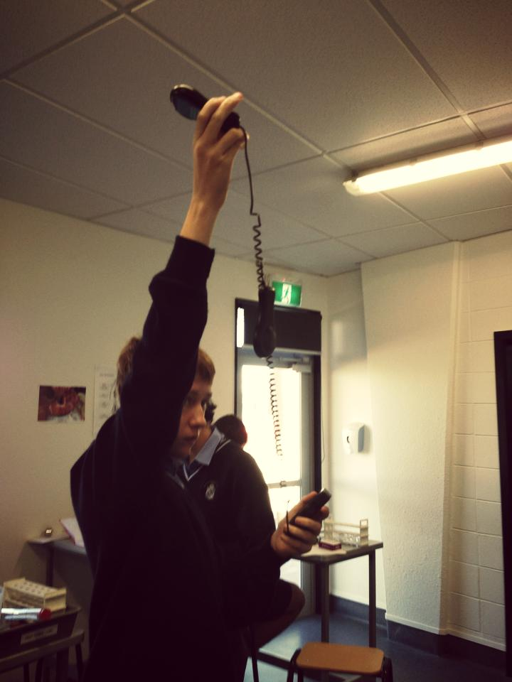

### Persona:

The student is as comfortable as any member of that generation with computer interaction, however, the student lacks knowledge in the interpretation of visualisations, the interaction with complicated UI, and in the subject of world hunger itself.

### Scenario

The student wants a visually arresting graph to download, print, and glue next to some explanatory text. It is important that the visualisation is uncomplicated and expresses the precise and limited topics which the student understands (specifically, Venezuela).

### Goals

Must make a poster about the Venezuela crisis which began in 2010. Among the things on the poster is a demonstration of the impact of the crisis on hunger in Venezuela.