# Blood Plasma Well Trial 2024-07-25, D223 150μL Sample

* Data from each well is shown, including raw data in the first plot from each section, group processed data in the second plot, and individually processed data by trial in the third plot.
* The sample was prepared by removing from the freezer, rocking for 35 minutes, and then rested for 7 minutes in the well slide.
* Samples were pipetted into 3 50μL wells and then covered with a 22mmx22mm No. 1 Cover Glass slip.
* Data was taken using a 40x immersion objective lens by using a dropper bottle to place water on the cover glass slip atop the well slide then immersing the lens in the water drop, then focusing the objective over each well using a motorized XYZ stage.
* In the 'group processed' plots, an array was made combining data from all trials in that well, and then the 'apply' function was used for processing.
* In the 'individual processing' plots, the 'apply' function was used individually on each trial, and then the resulting pre-processed data was then plotted together in a figure.

Well 1 Data

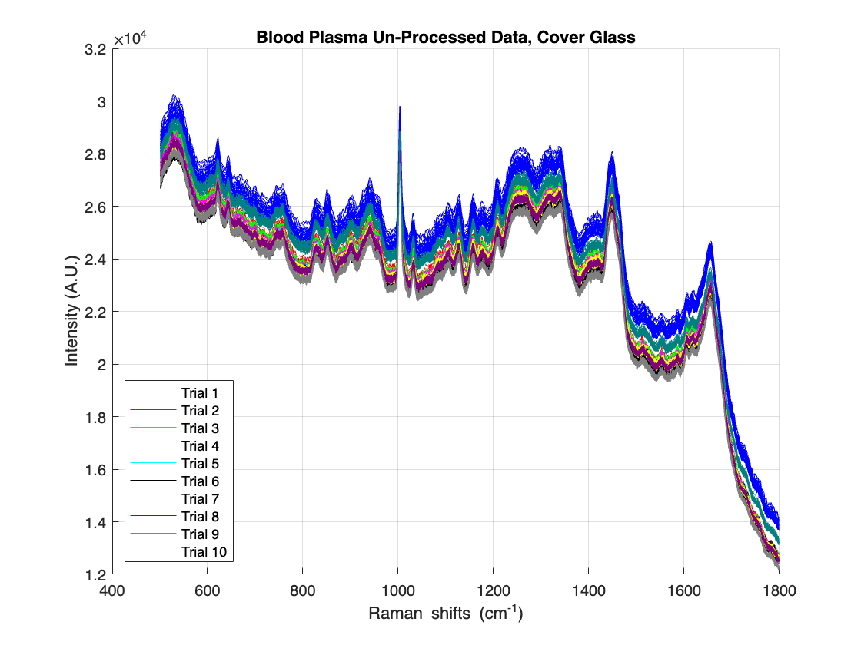

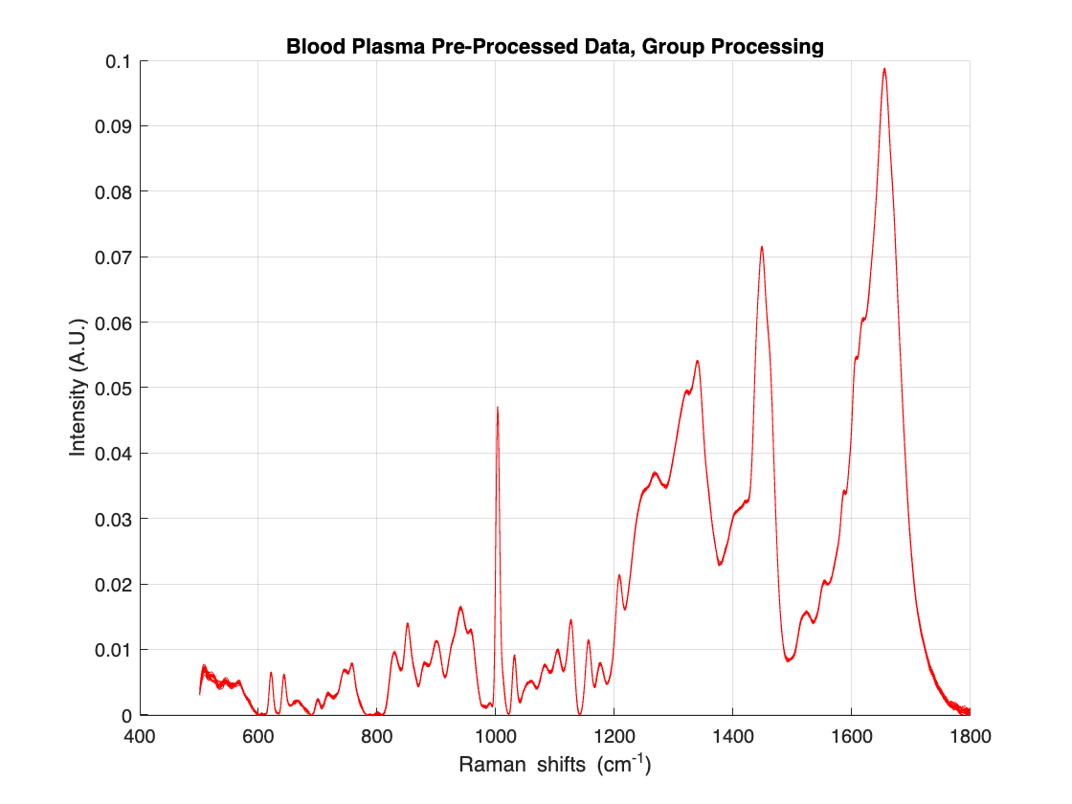

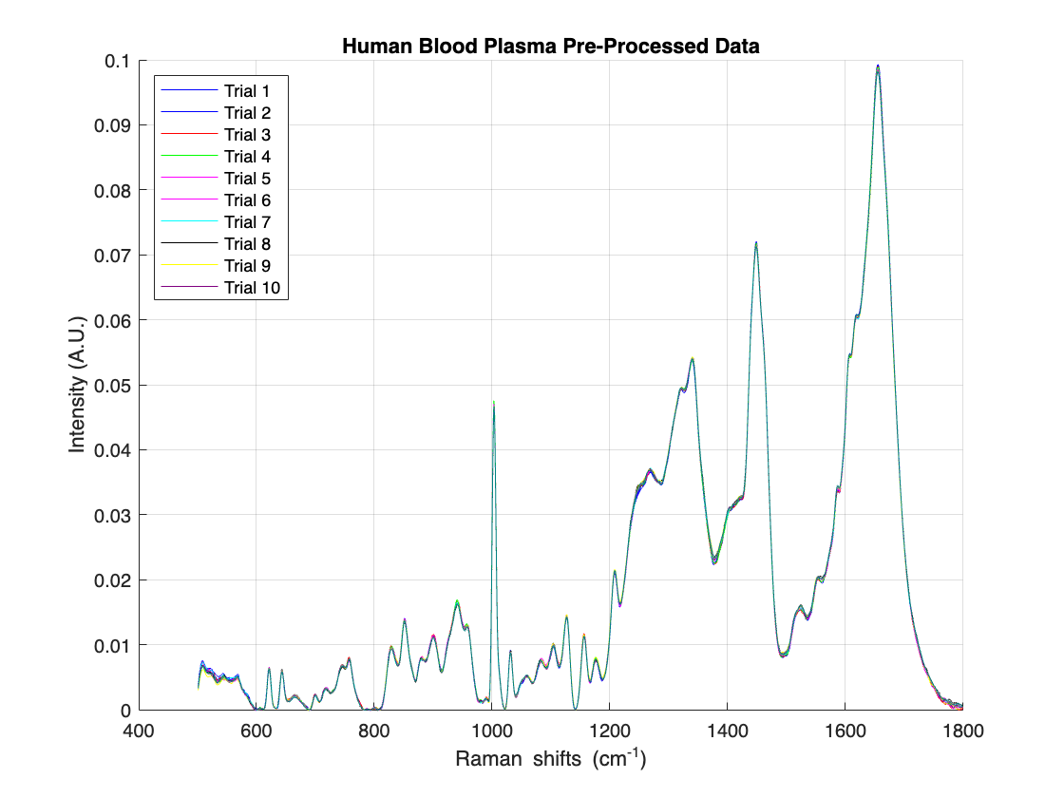

Well 2 Data

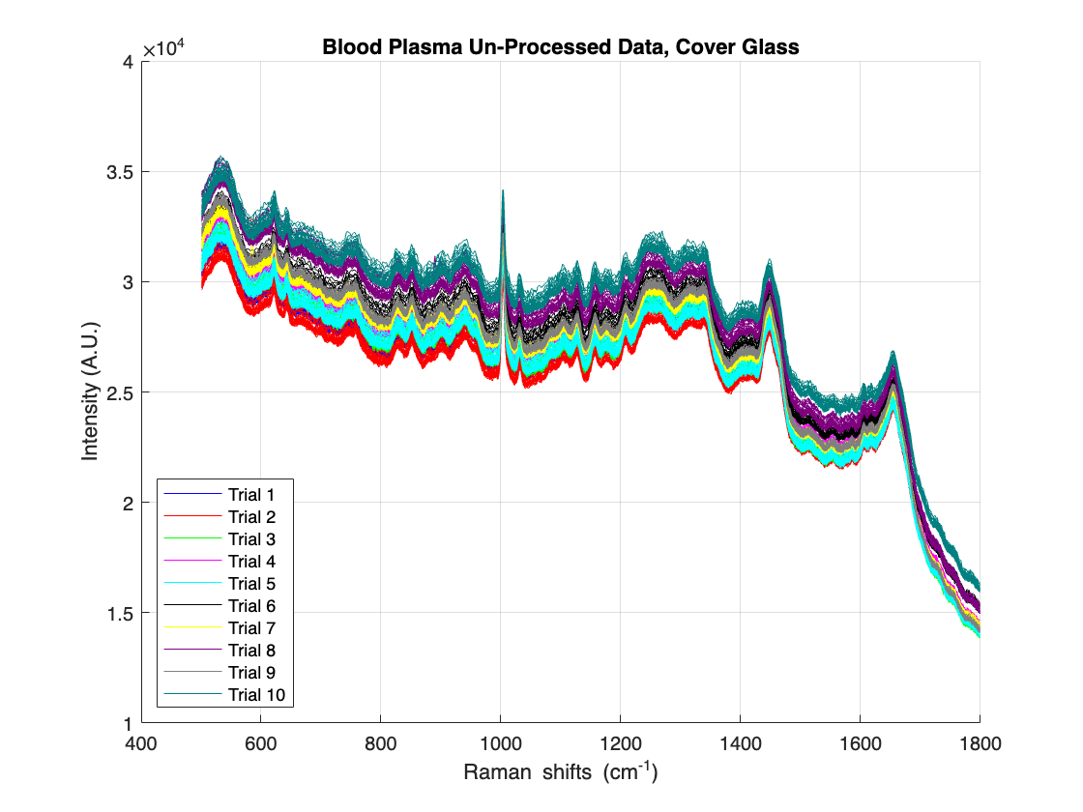

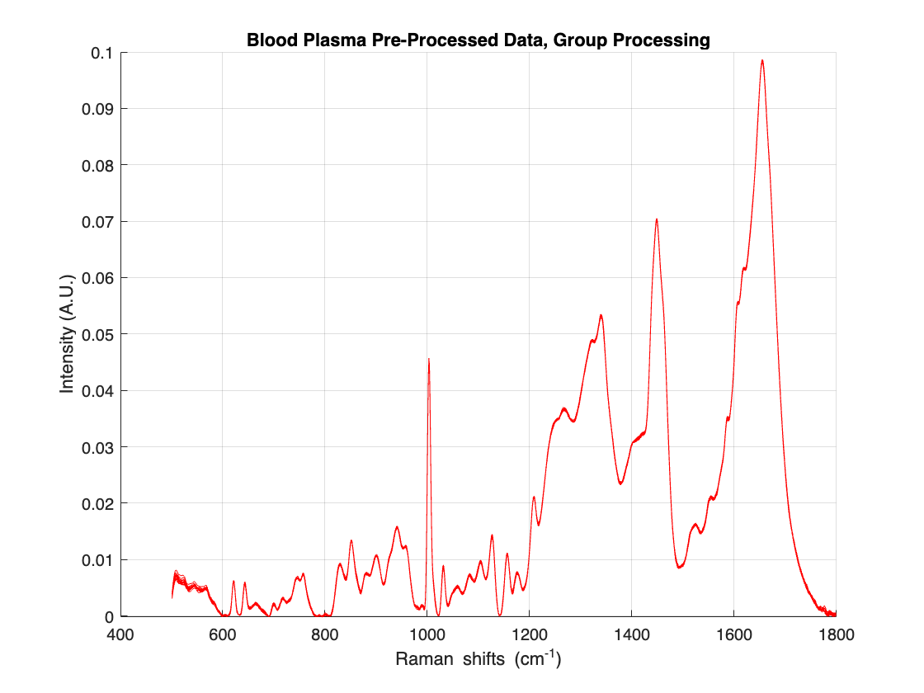

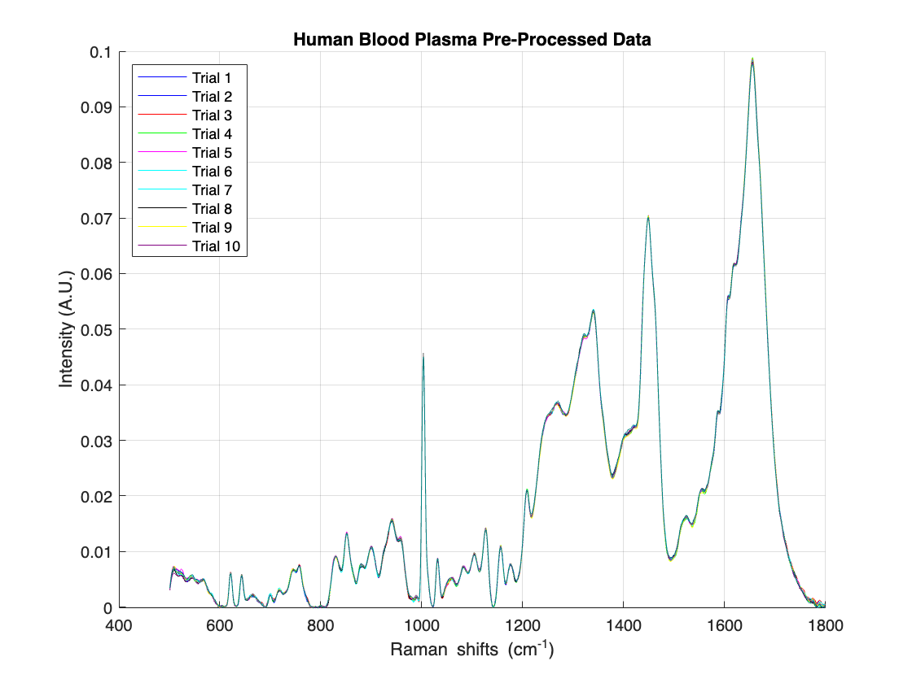

Well 3 Data

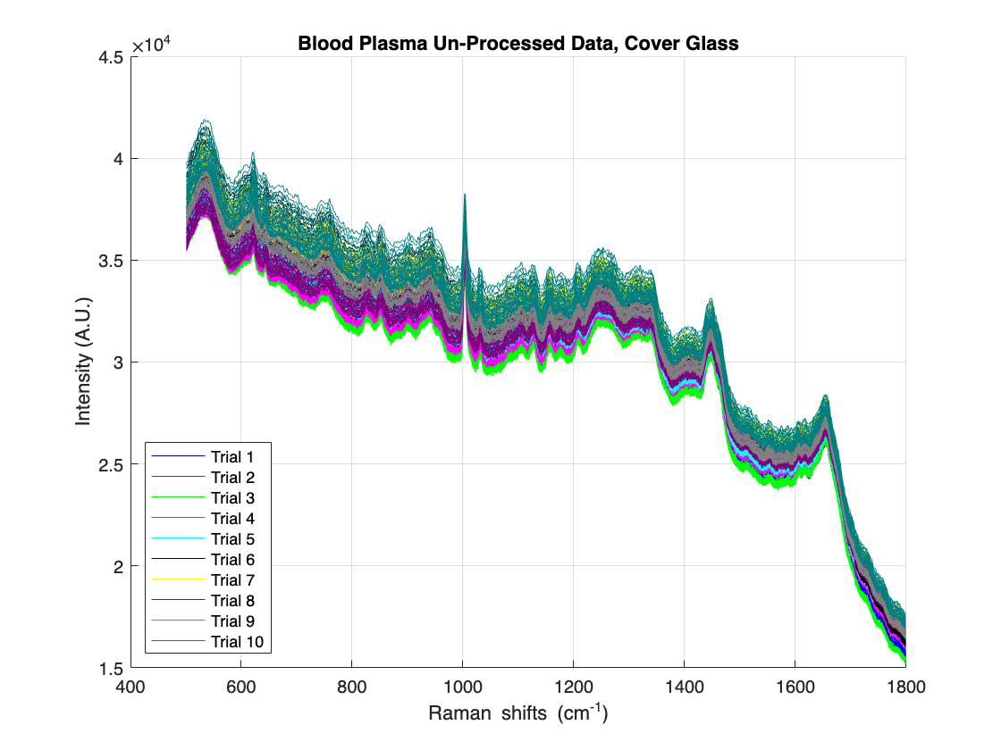

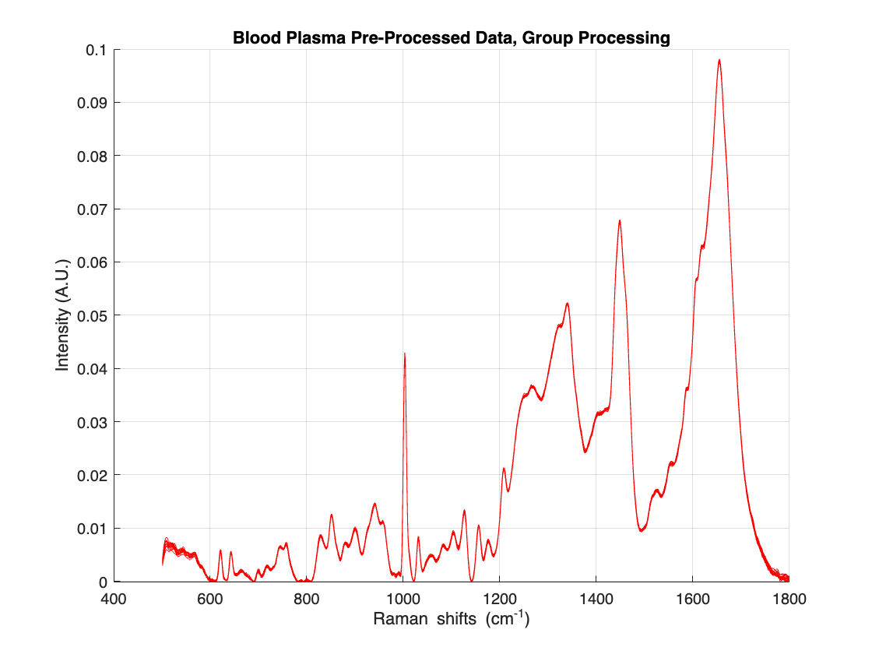

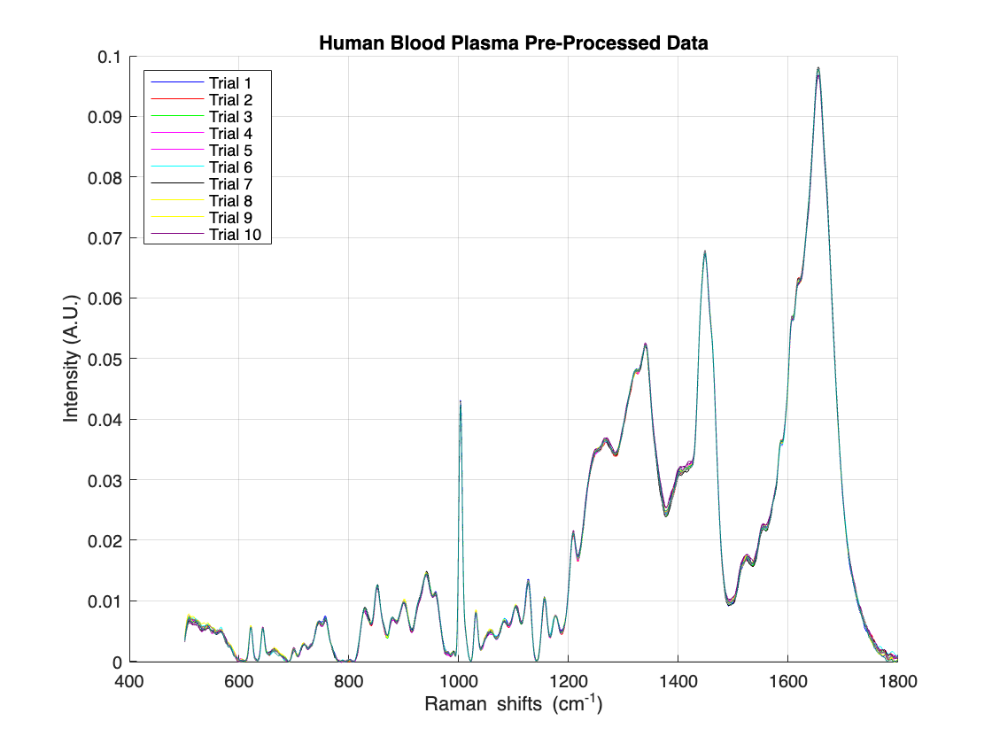

Well Comparison Plots

* Raw data is shown in the first figure of this section, with red, blue, and green corresponding to well 1, 2 and 3 respectively.
* Processing was performed on the entire dataset for each well, resulting in 3 sets of pre-processed data, shown in red, blue, and green in accordance with the raw data.
* The third plot contains pre-processing of the grouped data, where an array was made containing all data from each well and was subsequently processed using the 'apply' function.

