Project Report on:  
Medical Decision Support System

***Sustainable Development Goals***

The SDGs are 17 goals set by the United Nations to improve the world, in this simple report we intend to demonstrate how our project applies 7 of those goals.

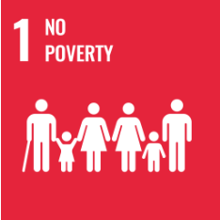The core of our project is to provide health services to those to need them the most, thus alleviating the effects of poverty while improving people's health.  
  
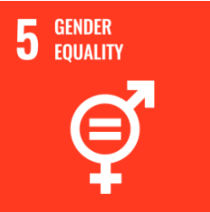Because of their different physiology from men, many diseases primarily or only affect women, this hinders women in society, our project will tackle those diseases to empower women  
  
Our system is innovative and applies cutting-edge technology to a major sector of the economy, telemedicine helps improve health outcomes in rural communities, lessening their reliance on cities, and making those communities more sustainable. 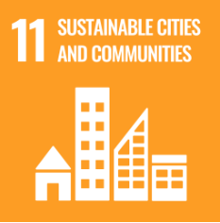

***Datasets***

1- Breast Cancer:

* <https://data.world/deviramanan2016/nki-breast-cancer-data>
* <https://data.world/health/breast-cancer-wisconsin>
* <https://data.world/datagov-uk/bb018553-dc1e-472b-922e-80204c31d8e5>

2- Diabetes:

* <https://www.kaggle.com/datasets/mathchi/diabetes-data-set>
* <https://data.world/chhs/ca-diabetes-prevalence-2014>
* <https://data.world/data-society/pima-indians-diabetes-database>
* <https://data.world/chhs/f9feb1b8-16de-41fc-a983-084bcf80db11>

3- Liver Cirrhosis:

* <https://www.kaggle.com/datasets/fedesoriano/cirrhosis-prediction-dataset>
* <http://biogps.org/dataset/E-GEOD-49541/expression-data-for-nonalcoholic-fatty-liver-disea/>
* <https://www.cdc.gov/nchs/pressroom/sosmap/liver_disease_mortality/liver_disease.htm>

# 4- Chronic Kidney Disease:

# <https://www.kaggle.com/datasets/mansoordaku/ckdisease>

* <https://archive.ics.uci.edu/ml/datasets/chronic_kidney_disease>
* <https://data.world/cdc/us-chronic-disease-indicators>

5- Hepatitis C:

* <https://www.kaggle.com/datasets/fedesoriano/hepatitis-c-dataset>
* <https://archive.ics.uci.edu/ml/datasets/hepatitis>
* <https://data.world/us-hhs-gov/193c5d6e-51b7-4397-a282-03b10f03b3a6>
* <https://archive.ics.uci.edu/ml/datasets/Chronic_Kidney_Disease>

6- Lower Respiratory Infections:

* <https://open.africa/ko_KR/dataset/lower-respiratory-infections-under-5-years-2017>
* <https://data.england.nhs.uk/dataset/nhsof-3-2-emergency-admissions-for-children-with-lower-respiratory-tract-infections>

7- Lung cancer:

* <https://archive.ics.uci.edu/ml/datasets/lung+cancer>
* <https://www.kaggle.com/datasets/yusufdede/lung-cancer-dataset>
* <https://data.world/cancerdatahp/lung-cancer-data>

8- Coronavirus

* <https://ourworldindata.org/coronavirus>
* <https://www.kaggle.com/datasets/imdevskp/corona-virus-report>
* <https://www.ons.gov.uk/peoplepopulationandcommunity/healthandsocialcare/conditionsanddiseases/datalist?filter=datasets>

9- Alzheimer's:

* <https://www.kaggle.com/datasets/tourist55/alzheimers-dataset-4-class-of-images>
* <https://catalog.data.gov/dataset/alzheimers-disease-and-healthy-aging-data>
* <https://chronicdata.cdc.gov/Healthy-Aging/Alzheimer-s-Disease-and-Healthy-Aging-Data/hfr9-rurv>

10- Heart disease:

* <https://www.kaggle.com/datasets/johnsmith88/heart-disease-dataset>
* <https://archive.ics.uci.edu/ml/datasets/heart+disease>
* <https://ieee-dataport.org/open-access/heart-disease-dataset-comprehensive>

11- Tuberculosis:

* <https://www.kaggle.com/datasets/tawsifurrahman/tuberculosis-tb-chest-xray-dataset>

12- Stroke:

* <https://www.kaggle.com/datasets/fedesoriano/stroke-prediction-dataset>
* <https://gist.github.com/aishwarya8615/d2107f828d3f904839cbcb7eaa85bd04>
* [https://data.world/us-hhs-gov/12ea7a13-b229-43b4-b19b-1459e9a64d3](https://data.world/us-hhs-gov/12ea7a13-b229-43b4-b19b-1459e9a64d3f)