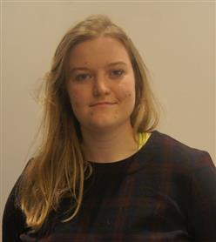Curriculum Vitae

Victoria Hayes

Consultant

Tel: +353 (1) 417 2952

Mobile: +353 (0)87 947 7977

Email: vihayes@deloitte.ie

Office: Dublin, Ireland

Professional experience

Victoria joined Deloitte in August 2019. Currently, she is participating in an apprenticeship programme, mixing on the job learning with classroom based learning. Currently she is in the eighth month of this two year programme and is working in the Department of Social Protection on the EESSI team for three days a week.

Clients

**Department of Social Protection (February 2019 – Present)**

*Automation Tester*

Victoria has offered support to the test teams working on the EESSI project. As part of her role, Victoria was responsible for:

* Creating automated test cases
* Creation of documentation relating to test cases
* Attending demos of test cases to clients
* Running manual test cases

Education / other

Leaving Certificate at St. Andrew’s College (2014)

Level 5 Cert Animal Healthcare at Dun Laoghaire Institute of Further Education (2015)

Currently studying for Level 6 certificate in Software Development (2021)

**Technical Skills**

Packages/Applications: MS Office Suite, Microsoft Visual Studio, Specflow, C#, HTML5, CSS