Telling apart Bombus species, Western US

Notes from Robin Thorp

**Males vs. females**

Females have 12 anennal segments, males of 13. Males also have a flatter-end to their abdomen whereas females have a teardrop shaped abdomen

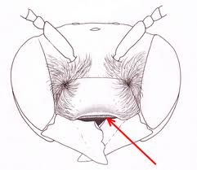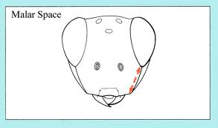

Clypeus

**Terms**

Malar space: the space between the eyes and mandibles

Clypeus: space above the mandibles (red arrow)

1. ***Bombus bifarius***
   1. Square malar space
   2. Notch of black near the thorax through the yellow stripe
   3. Looks most like *B. huntii* but *B. huntii* doesn’t have the notch

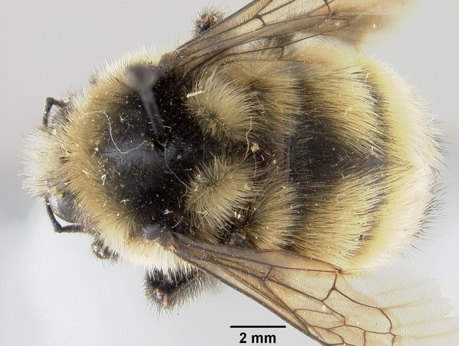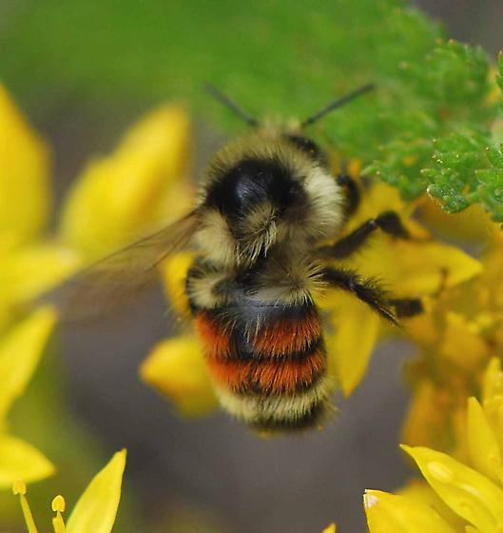

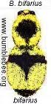

Notch (both females)

1. ***Bombus huntii***
   1. square malar space
   2. yellow and then two red stripes on abdomen
   3. yellow band at top of abdomen is complete (no notch)

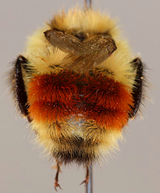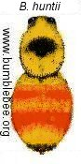

1. ***Bombus centralis***
   1. Long malar space
   2. 2 yellow and 2 red on abdomen

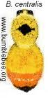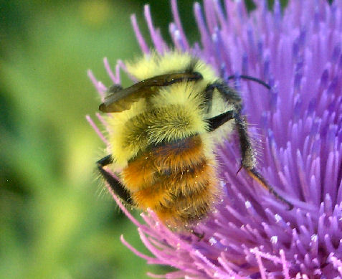

1. ***Bombus flavifrons***
   1. More black on front of thorax
   2. Mix of yellow and black hairs on front of thorax, look cloudy

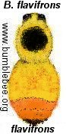

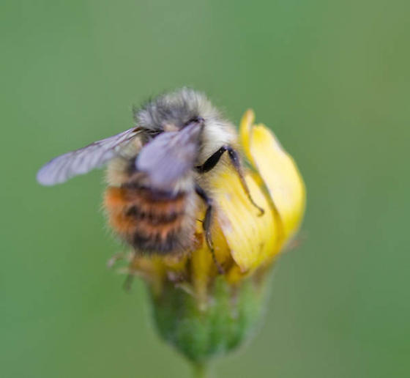

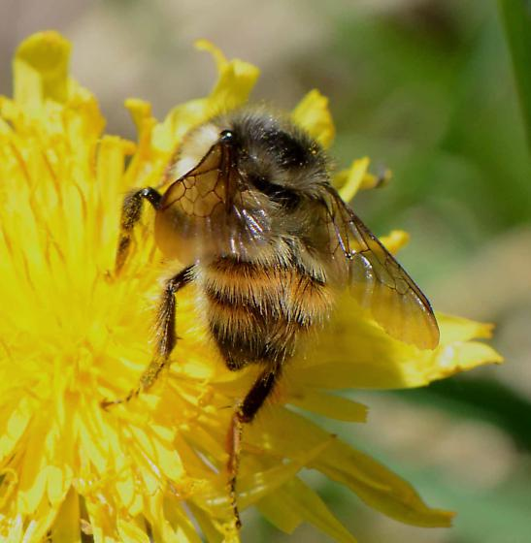

1. ***Bombus sylvicola***
   1. 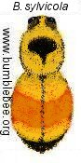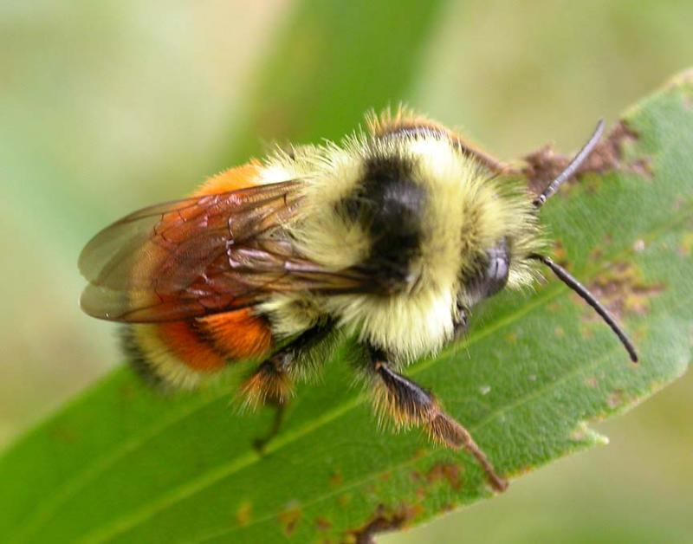black spot on thorax
2. 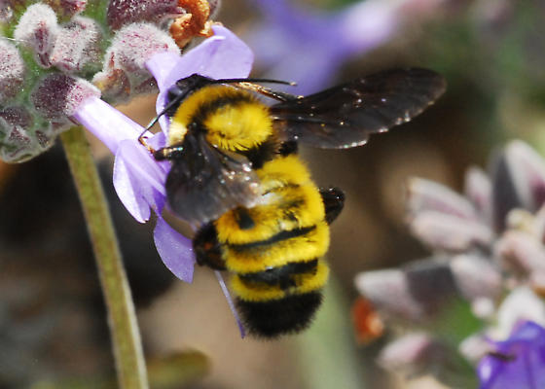***Bombus sonorus*** 
   1. yellow and black stripes, no orange

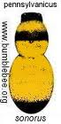

1. ***Bombus fervidus*** 
   1. Males are blight yellow
   2. More of a line than a dot of black on thorax, unlike nevadensis, which is more of a dot. No black at the top of the abdomen.

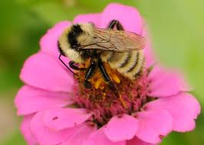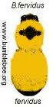

1. ***Bombus nevadensis*** 
   1. Long malar length and clypeus
   2. Yellow and black

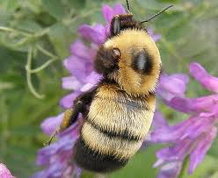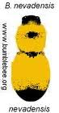

1. ***Bombus occidentalis***

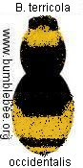

1. *Bombus rufocinctus*

