NFL Data Exchange API
Author: Anthony Valeri
Last Updated: 12/17/2024

The NFL Data Exchange API is a REST API that returns data in JSON format and utilizes API keys for authentication and authorization. The API has a built-in test page powered by Swagger and it supports the openapi specification, OAS version 3. The API has two environments a test environment which can be utilized when testing new functionality, and a production environment which should be used for live production applications. The test environment has data, which is not refreshed on a regular basis, but can be refreshed on demand by e-mailing NFL IT at fistech@nfl.com with the restore request and reason the refreshed data is being requested. The production environment data is refreshed on a nightly basis as transaction and game data gets processed.
The different environment details are included below:
Environment | URL
Test | https://ww2.nfl.info/nfldataexchange2023/swagger/index.html
Production | https://www.nfl.info/nfldataexchange2023/swagger/index.html

The test environment and production environment have different back-end databases, as such the API Keys can not be shared across the two environments, a separate will be required for each environment.

To utilize the API, navigate to the swagger URL from your browser
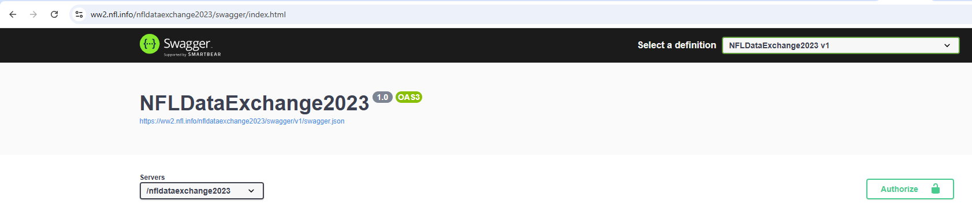
Click on the Authorize button
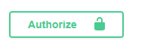
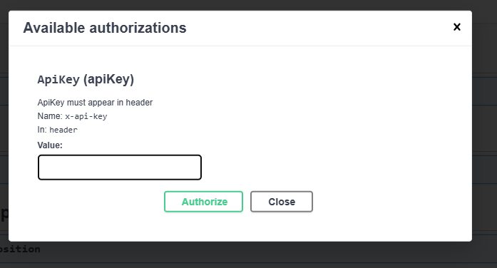

Paste in your provided API key and click on Authorize, the page will indicate that the API key has been stored for the session.
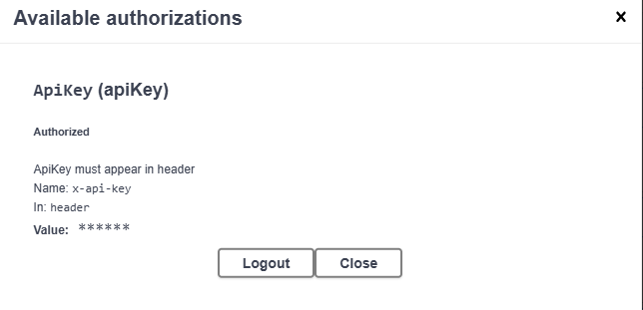
Click Close to go back to the list of available methods.
Scroll down the list to a method you want to try invoking:
Click on the down arrow to expand the method and view the available parameters for the method:
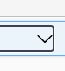
The pane will expand and show you available parameters
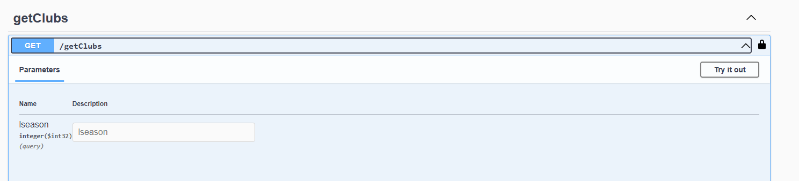
Click on the Try it out button
Type in a value for the parameters, and click on Execute
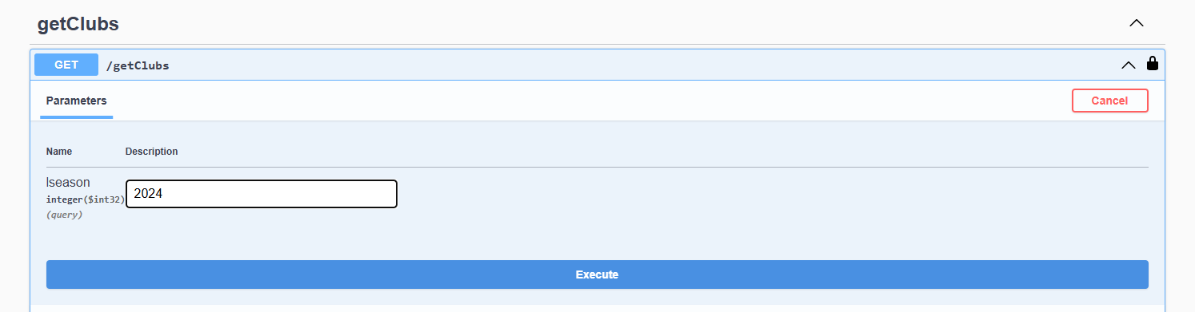

A loading indicator will appear to show that the request is in progress
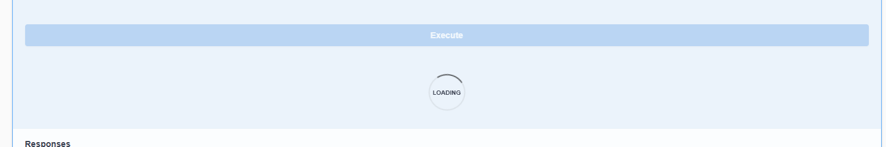
A sample command to invoke the api will be shown, along with the data that is returned from the method.
