NFL EVERGAME – GDA MODULE MVP

MVP Requirements:

1) MVP Requirements

A. Security, Access, and Identity
- User login & authentication flows (happy path + error states)
  - Okta SSO integration
  - Login + 2-factor authentication
  - Role-Based Access Control (RBAC) including non-NFL users (e.g., GDAs)
- Account details (view/update)
- View & edit user profile settings

B. User, Team, and Event Administration
- User creation via email invite (Leader/GDA)
- Full event daily sync and manual API pull request (GMS)
  - GMS Source of truth for teams, events, users
- Schedule daily API pull and manual API pull request
  - Teams & Venues
- Event/Task List templates (Admin)

C. Core Dashboards (4 Personas)
- Institutional dashboard (Admin)
  - Summarized activity / readiness across all stadiums and games
- Venue dashboard (Admin/Leader)
  - Stadium-level readiness and activity
- Game Status (FTR Lead)
  - Game-Level readiness and activity
- Game dashboard (All)
  - Includes:
    - Overview
    - Task list
    - Task detail (edit/assign/delete/comment)
    - Report issue
    - Game systems (surface system readiness/status)

D. Task Management (Readiness Execution)
- View tasks organized by completion time / deadline / sub filter (position)
- Task filtering
  - By user/assignee
  - By milestone
  - By system and/or position
- Task list management: Add / Edit / Delete tasks
  - Edit tasks (incl. assign/reassign)
- In-task commenting + user tagging (e.g., @mentions)

E. Issues Management
- All Issues / My Issues (All)
  - View issue
  - Edit issue
  - Remove issue
- Create and track issues related to tasks and games
- Issue-to-task linkage (association required for readiness traceability)
- Issue-to-incident linkage, status
- Issue and Incident ‘open items’

F. Notifications and Alerts (Operational Readiness)
- Alerts/notifications for:
  - Tagged comments (mentions)
  - Failures and issues

- Readiness updates:
  - Countdown and/or automation based on task deadlines
  - Basic “readiness status” surfacing on dashboards

G. Interoperability (Core Integrations)
- Pull scheduled events into the app via NFL API
- Assign GDAs to events via NFL API (GMS)
- Open Items (Mentioned being brought in from GMS Api)

H. Platform Delivery (Mobile-First Web)
- Web-based platform optimized for mobile
- Full scope delivery supports all 4 user personas (Executive, Admin/NFL Lead, FTR, GDA/All)
- Consistent UX patterns across desktop and mobile web

I. Admin Tools
- Admin Tools (Admin)
  - Tasks (list/add/edit/delete)
  - Issues (list/add/edit/delete)
  - Incidents (list/add/edit/delete)
  - All Media (list/add/edit/delete)
  - CSV exports
  - Dashboards/Status views (admin/exec/lead home view)
    - Operational Reporting:
      - View all stadium-relevant games
      - Summarized readiness across systems
        - Incidents
        - Open Issues
        - Delays
        - Game Equity
      - Filters: stadium, game, timeframe

User Flow Supporting Diagram:

https://www.figma.com/design/uUDoRrhsDBsaYclQe2KSht/Evergame-NFL-%7C-MVP--Copy--2?node-id=4005-571&p=f&t=QMlwARHOZ7GPqnXa-0

1) ADMIN USER FLOW (Desktop)

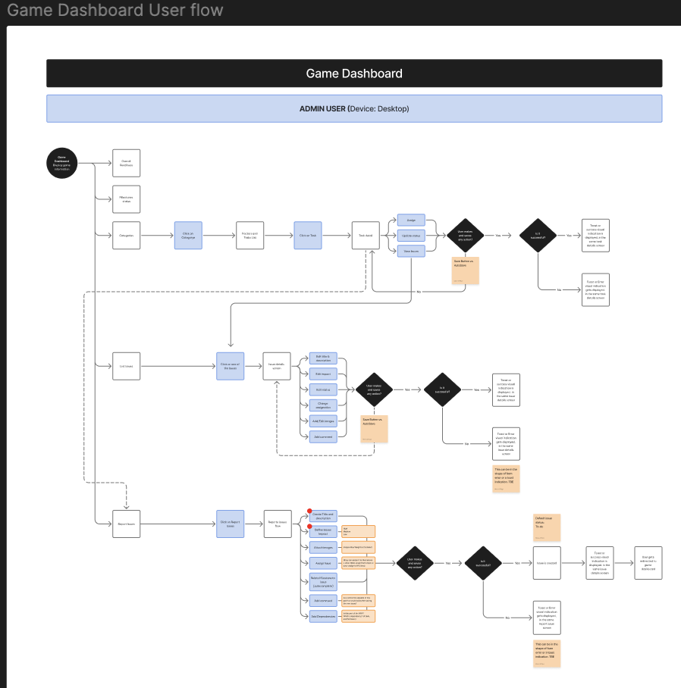

1.1 Login + Landing
- User opens the Evergame Platform (desktop web).
- User logs in (SSO/credentials).
- User lands on the Game Dashboard.

1.2 Primary Navigation (Admin sees these main areas)
From the dashboard, Admin can access:
- Overall Readiness
- Milestones Status
- Categories
- List Issues
- Report Issues

1.3 Flow A — Work Tasks (Categories → Task Detail → Save)
- From Game Dashboard, click Categories.
- Click a Category.
- System shows Factors and Tasks List.
- Click a Task.
- System opens Task Detail.
- Admin performs actions in Task Detail (as needed):
  - Assign (to a Lead or GDA)
  - Update Status
- Click Save.
- System response:
  - If successful: show success confirmation (toast) and updates reflect on screen.
  - If unsuccessful: show error (toast) and keep user on the task detail screen to retry.

1.4 Flow B — Manage Issues (List Issues → Issue Detail → Save)
- From Game Dashboard, click List Issues.
- Click an Issue from the list.
- System opens Issue Details.
- Admin may update any/all of the following (per diagram):
  - Edit Title & Description
  - Edit Impact
  - Edit Status
  - Change Category
  - Add/Edit Images
  - Add Comments
  - Add Attachments
- Click Save.
- System response:
  - If successful: success toast; issue details persist and reflect in the list/dashboard.
  - If unsuccessful: error toast; user remains on Issue Details.

1.5 Flow C — Report a New Issue (Report Issues → Form → Submit)
- From Game Dashboard, click Report Issues.
- Click into the Report Issue Form.
- User completes the form (fields/actions shown in the diagram):
  - Create Title & Description (required)
  - Define Issue Impact (required)
  - Attach Images (optional / recommended when relevant)
  - Assign Lead (optional/role-based)
  - Select impacted Factors/Tasks (associate the issue to the right area)
  - Add Comment (optional)
  - Add Dependencies (optional)
- Click Submit/Save.
- System response:
  - If successful: issue is created (default status: To-Do) and user is routed to confirmation/issue record; issue appears in relevant lists.
  - If unsuccessful: error toast; user remains on the form to correct and resubmit.

2) NFL LEAD USER FLOW (Tablet/Mobile)
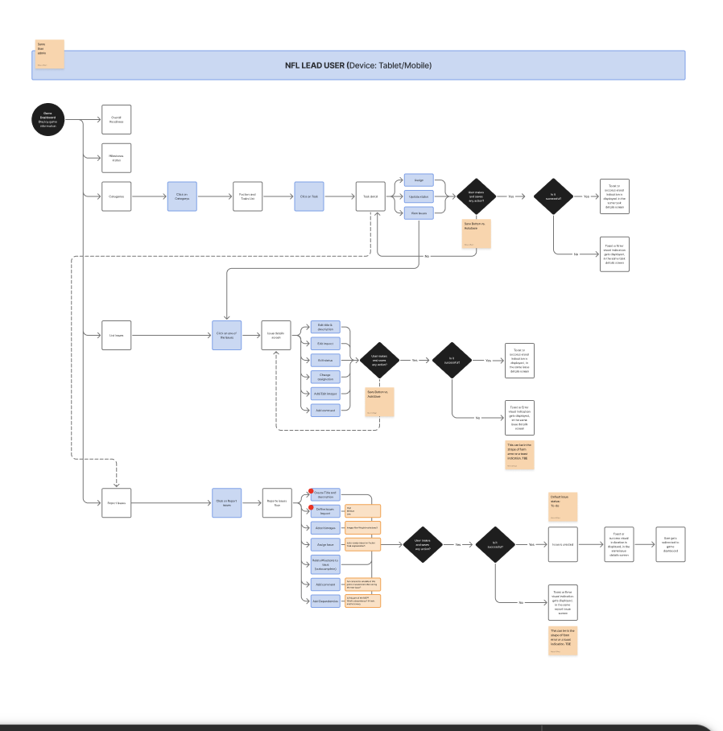

2.1 Login + Landing
- User opens the Evergame Platform
- User logs in.
- User lands on the Game Dashboard

2.2 Primary Navigation (Lead sees these main areas)
- Overall Readiness
- Milestones Status
- Categories
- List Issues
- Report Issues

2.3 Flow A — Manage Tasks (Categories → Task Detail → Save)
- Tap Categories.
- Tap a Category.
- System shows Factors and Tasks List.
- Tap a Task.
- System opens Task Detail.
- Lead actions available in Task Detail:
  - Assign tasks (typically to GDAs)
  - Update Status
- Tap Save.
- System response:
  - If successful: success toast; updates reflect immediately.
  - If unsuccessful: error toast; user remains on task detail.

2.4 Flow B — Update Issues (List Issues → Issue Detail → Save)
- Tap List Issues.
- Tap an Issue.
- System opens Issue Details.
- Lead can update (as shown in diagram):
  - Title & Description
  - Impact
  - Status
  - Category
  - Images
  - Comments
  - Attachments
- Tap Save.
- System response:
  - Success: toast; issue updates persist.
  - Fail: toast; remain on Issue Details.

2.5 Flow C — Report Issue (Report Issues → Form → Submit)
- Tap Report Issues.
- Complete form:
  - Title & Description (required)
  - Impact (required)
  - Attach images (optional)
  - Assign Lead (if applicable)
  - Select impacted Factors/Tasks
  - Comments, Dependencies (optional)
- Submit.
- System response:
  - Success: issue created, status defaults To-Do, appears in issue lists + drives notifications.
  - Fail: error toast; remain on form.

3) GDA USER FLOW (Tablet/Mobile)
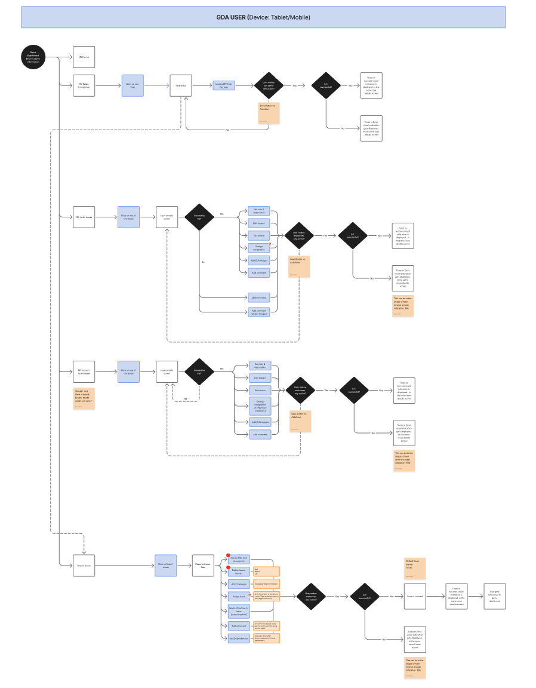

3.1 Login + Landing
- User opens the Evergame Platform
- User logs in.
- User lands on the Game Dashboard (GDA view).

3.2 Primary Navigation (GDA sees these main areas)
From the diagram, GDA has:
- My Tasks
- My Tasks Completion
- My Created Issues
- (Potentially) My Team’s Issues (noted as a design question in the flow)
- Report Issues

3.3 Flow A — Complete/Update Task Progress (My Tasks Completion → Task Detail → Save)
- Tap My Tasks Completion (or My Tasks, depending on final nav naming).
- Tap a task type/item → system opens Task Detail.
- Tap Update Task Progress (e.g., In Progress / Complete).
- Tap Save.
- System response:
  - Success: toast; updated progress reflects on Task Detail and in task lists.
  - Fail: toast; user stays on Task Detail to retry.

3.4 Flow B — View / Update Issues (My Created Issues → Issue Detail)
- Tap My Created Issues.
- Tap an issue → system opens Issue Details.
- System checks: Was this issue created by me?
  - Yes (created by me): GDA can take “edit” actions shown in the diagram:
    - Edit Title & Description
    - Edit Impact
    - Edit Status
    - Change Category
    - Add/Edit Image
    - Add Comment
    - Then Save
  - No (not created by me): user is routed to a view-only path with limited actions (per diagram):
    - View details
    - Add comment / evidence
- Save (if edits are allowed).
- System response:
  - Success: toast; updates persist.
  - Fail: toast; remain on issue detail.

3.5 Flow C — Report Issue (Report Issues → Form → Submit)
- Tap Report Issues.
- Complete Report Issue Form:
  - Title & Description (required)
  - Impact (required)
  - Attach Images (optional)
  - Assign Lead
  - Select impacted Factors/Tasks (associate issue to the right area)
  - Comments / Dependencies (optional)
- Tap Submit/Save.
- System response:
  - Success: issue created (default status To-Do) + routed/visible in issues.
  - Fail: error toast; remain on form.

