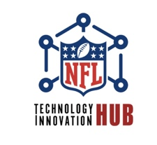I Natural Language Lookup Media

Monday, November 21, 2023

TwelveLabs | NFL Innovation HUB

Participants:
- NFL Team Representatives
- TwelveLabs Team
- N-Ovate Team

Key Discussion Points:

TwelveLab's AI Model and Architecture:
- Presentation of TwelveLab’s large visual video language models.
- Explanation of the model's ability to transform video into statistical representations for various tasks, including semantic search.
- The process of video embedding and its application in identifying specific video scenes.

Security and Data Privacy:
- Videos are deleted after processing is complete. This is achieved via indexing and a one-way hashing function that does not allow for re-creation of original content. Thus, making the transfer of video acceptable.
- Upon completion of the POC with TwelveLabs, the final architecture is malleable and we are confident in our ability meet any future security requirements (which may include hosting the TwelveLabs platform in the NFL AWS environment)

Operational and Deployment Considerations:
- Discussed the deployment model, including scalability, redundancy, and data replication for high availability.
- Considerations for transitioning from a hybrid to a fully in-house deployment model.

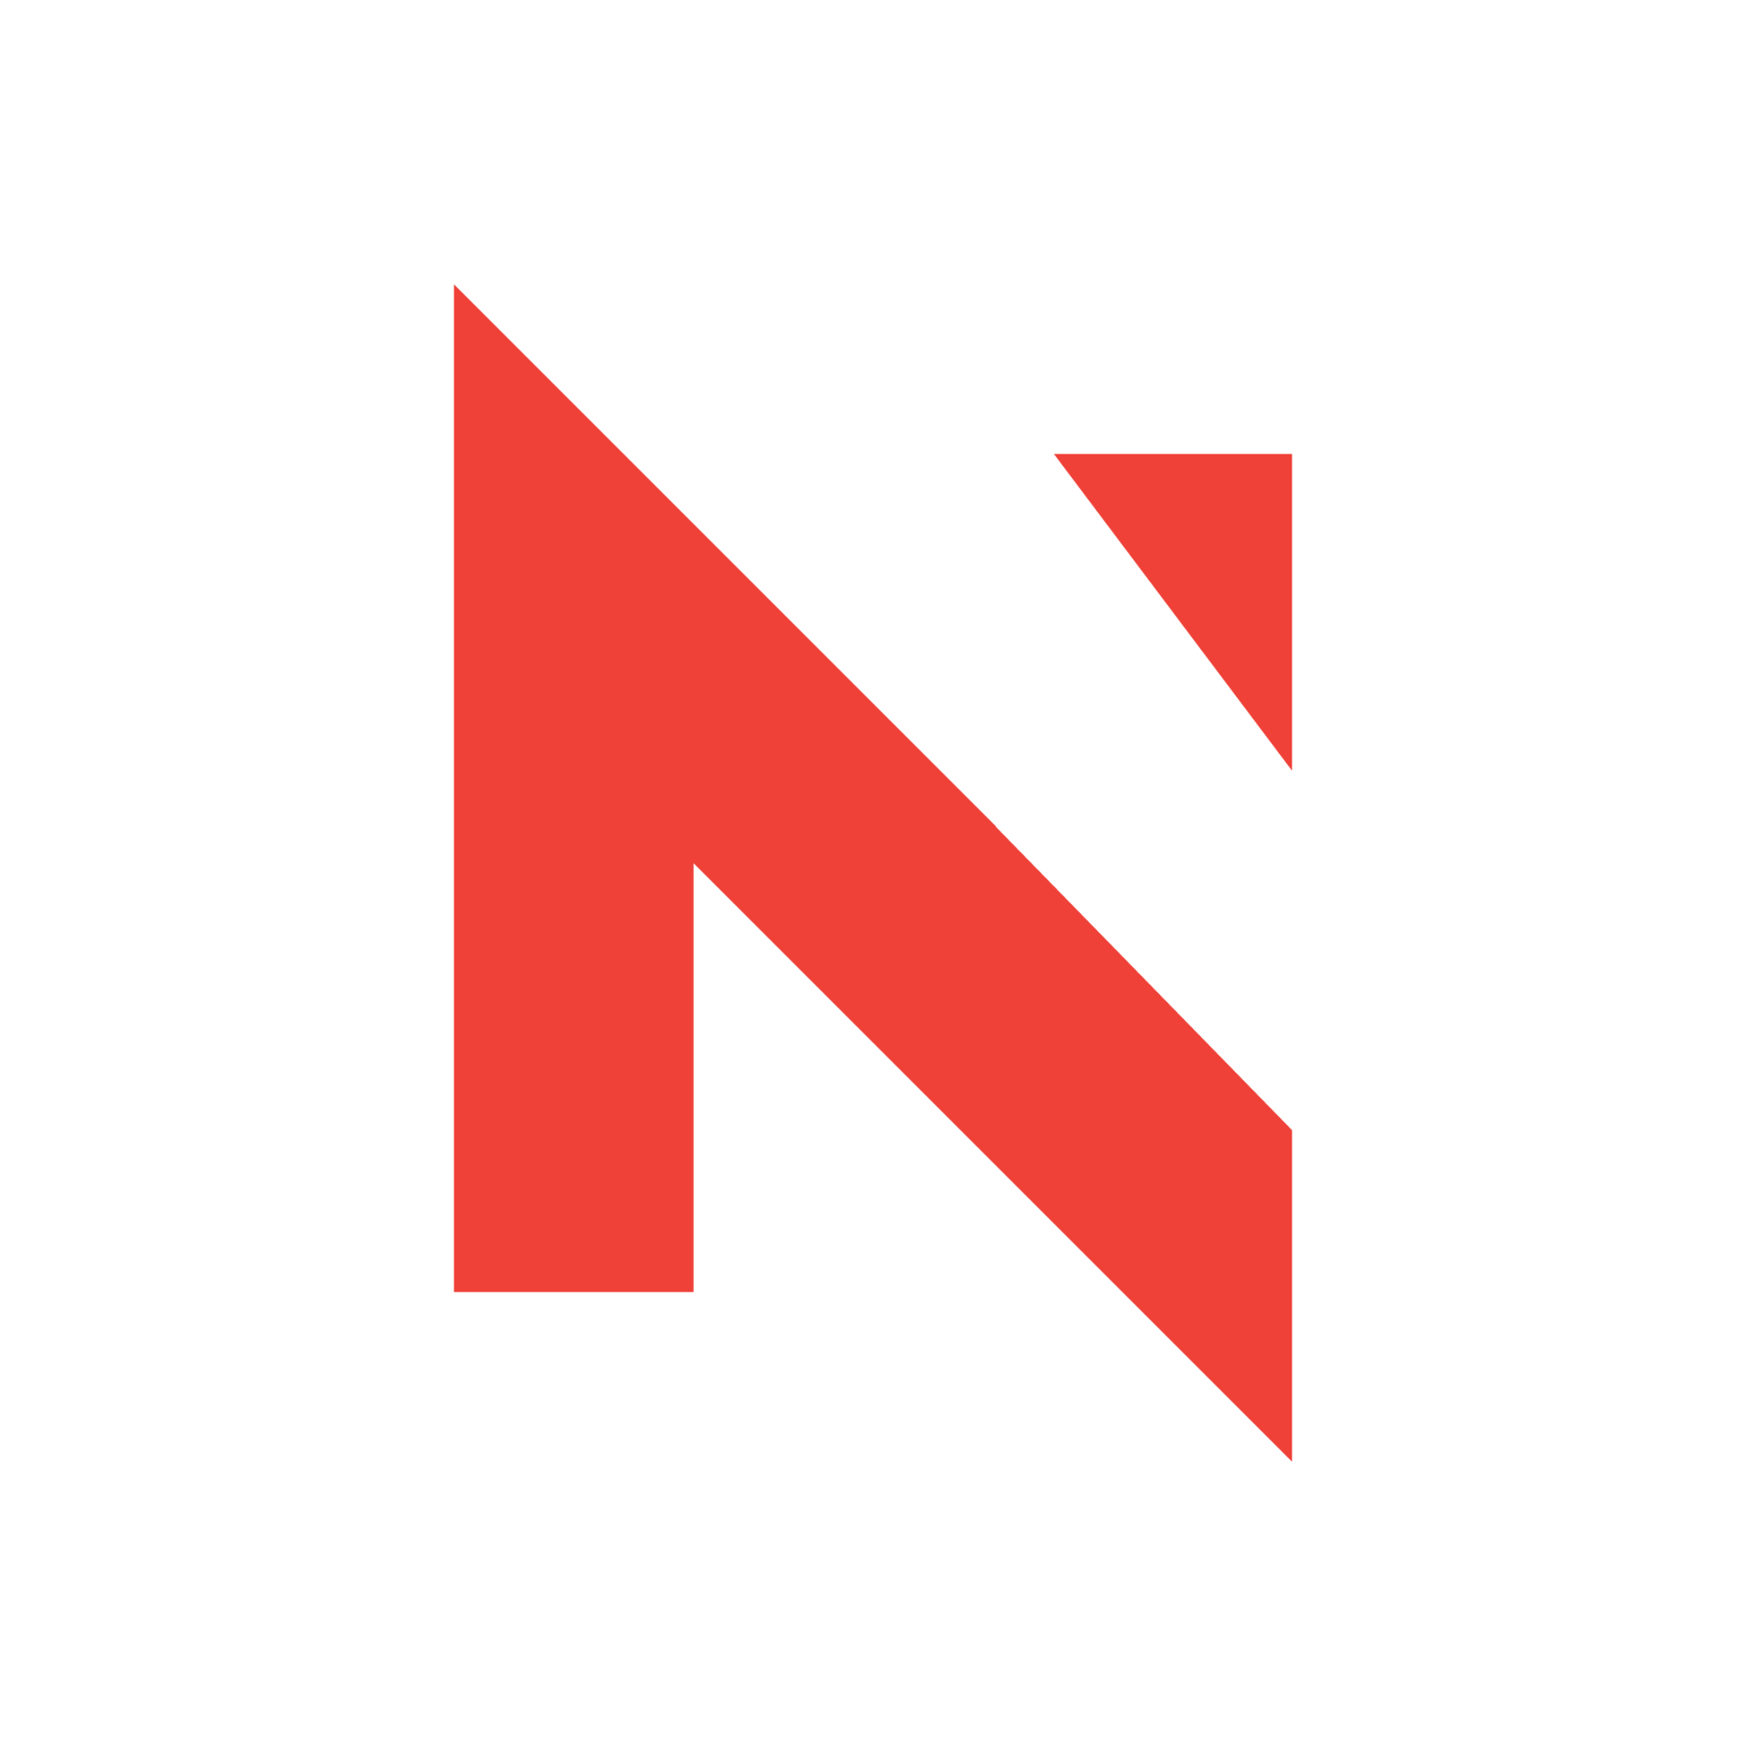
Incident Response and Ethics in AI:
- Addressing NFL’s concerns about incident response capabilities and ethical considerations in AI model training.
- Assurance of ethical data acquisition and adherence to AI safety and bias benchmarks by TwelveLab.

Cost and Infrastructure Implications:
- Discussions on the cost implications of different deployment models.
- Proposals for monitoring and reporting usage during the MVP phase to better understand the cost footprint in a potential full-scale deployment.

Next Steps and Action Items:
- Recommend inspection into diligence of viability of TwelveLabs and legal review of data sharing agreement (if it's covered by existing agreement).



