Some considerations on the dipole edge effects
31-03-11

Table of Contents
Preamble 1
Conclusion 1
Pole face rotation component 2
Codes comparison 4
SOLEIL case 4
Thom-X case 5
Fringe field term component 6
Linear fringe field 8
General fringe field 10

Preamble
The goal of this note is to analyze, in the foot step of K. Brown, the dipole vertical focusing terms present in the edge and fringe field components. The main motivation is driven by the strong effective component in the Thom-X dipole case where the radius of curvature is very short.
First, the main focusing terms induced by the edge pole face rotation is first derived as well as the corresponding transfer map. To end, the correction terms induced by the fringe field effect is also revisited.

Conclusion
The well know relation of the vertical focusing effect in presence of a pole face rotation at the exit of a dipole is derived and is opposite in sign of the horizontal case. This vertical effect is only due to the longitudinal fringe field B_{s} experienced by the particle together with its horizontal speed or (x') at the exit of the pole. A simple relation is then derived in the kick approximation for the pole face effect and is in good accordance regarding the chromaticities as compared to BETA and MADX code. This kick transfer may restore the TRACY case.
Finally, the vertical correction term induced by the fringe field effect seems to be 4 times smaller than the commonly estimations done by K. Brown K1 dimensionless integral. The difference cames from how the horizontal orbit is considered in the dipole.

Pole face rotation component
The X, Z and S directions are for the horizontal, vertical and longitudinal normal to the pole face. The reference trajectory is composed of arc in the dipole and straight out of the dipole and fix the geometry of the machine. We assume an infinitely large dipole magnet with no horizontal B_{x} field components.
s
x
v
Teta
B
s
z

Bz
s

Figure 1 : Sketch of dipole magnet

From the Maxwell equation Rot (B) = 0, the relation between B_{s} and B_{z} is :
and gives for the longitudinal fieldto the first order.

The standard dynamic relations of a moving particle in magnetic field (constant energy) are :

The vertical force is the given by the term -V_{x}B_{s}. Neglecting the horizontal orbit perturbation of the fringe field extension, V_{x} can be replaced by . Using the standard relations
,and we can express the vertical focusing along the fringe field exit of the pole as :

K_{z} being the usual notation for the normalized quadrupole strength.
Integrating K_{z} over the fringe field extension (from inside the magnet B(s₁)=B₀ to the end of the field B(s₂)=0) leads to the total focusing effect (1/fz) in the vertical plane :

It is the well know relation of the vertical focusing effect in presence of a pole face rotation at the exit of a dipole and is opposite in sign of the horizontal case. This vertical effect is only due to the fringe field B_{s} experienced by the particle together with its horizontal speed or (x') at the exit of the pole. From this statement, we can easily generalize including the horizontal slope component x' as well as energy deviation delta at the exit of the pole by :

The ± sign stands for entrance and exit of the dipole. These kick formulation is symplectic by construction and is in good accordance with the codes BETA and MADX concerning the chromaticities (large and compact rings). To complete this first derivation, there is a pending effect in the horizontal plane coming from the term -V_{z}B_{s}. Following the same scheme, the horizontal quadrupole kicks has also to be implemented with z' components :

A coupling components is then present by the fringe field of the dipole.

Codes comparison

SOLEIL case
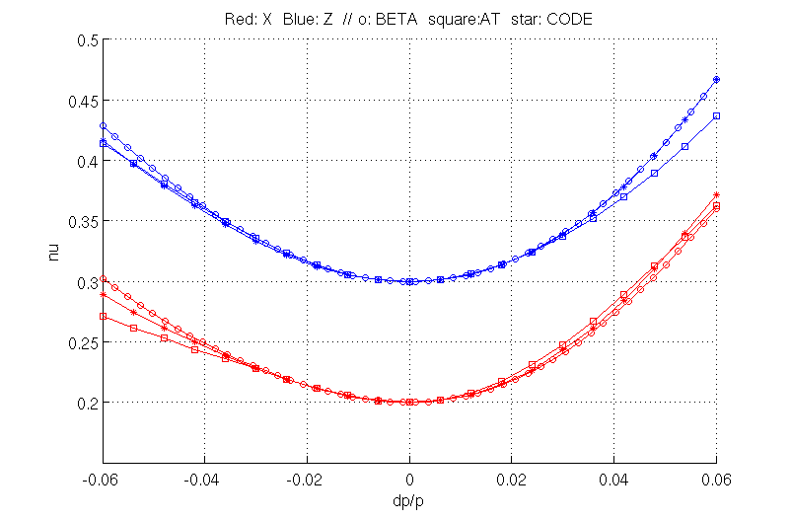
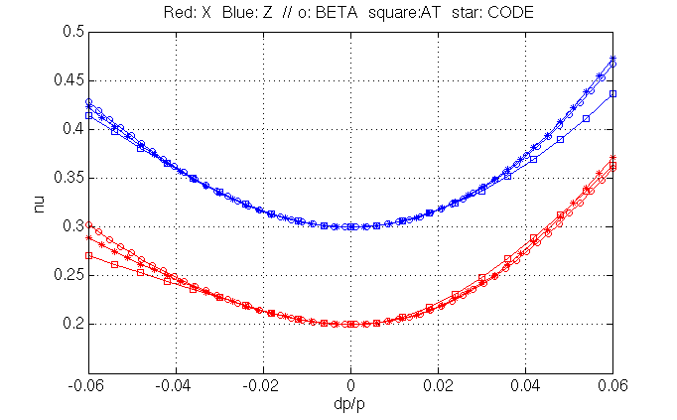
Horizontal (red) and vertical chromaticities tracking from different codes on the SOLEIL lattice. In The second plots, the vertical previous kick edge relation is included in CODE.
All the codes seems to be OK ... weak dipole (radius=5.36m)

Thom-X case
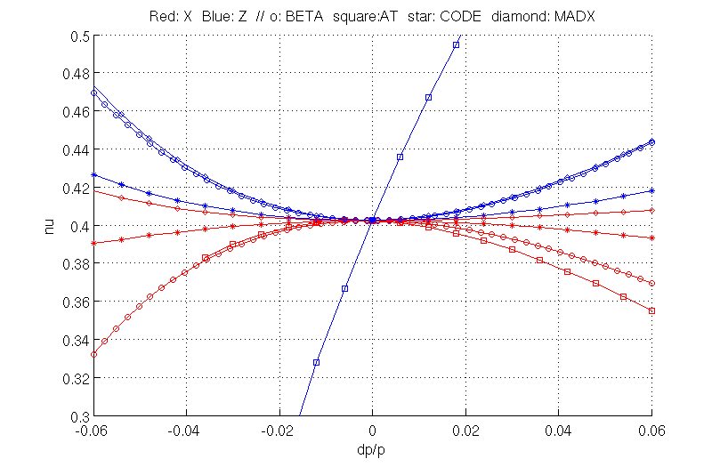
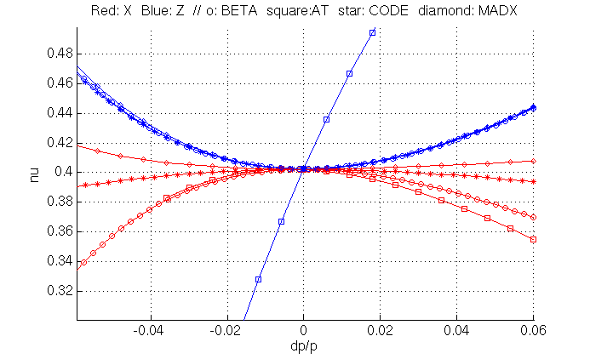
Horizontal (red) and vertical chromaticities tracking from different codes on the SOLEIL lattice. In The second plots, the vertical previous kick edge relation is included in CODE.
In the second plot, all the codes are in goods accordance in the vertical plane except TRACY. In the horizontal plane, they all disagree : H strong dipole (radius=0.352m) approach may differ.

Fringe field term component
At this stage we do not take into account the horizontal orbit depression in the fringe fields area. These term is known as the correction phi (K. Brown, Transport Code Notice) to be added to the vertical focusing quadrupole edge kick.
In figure 2, an example of dipole Bz profile as well as the relative X orbit depression are plotted from Thom-X ring model. The presence of fringe field induced a large orbit depression of the order of -1.4 mm. The total deviation with the fringe field extension is kept constant. In other words, the dipole bore length as well as the fringe field extension as been designed to fit the hard edge model deviation (reference orbit).
Removing the pole face rotation term (teta) to simplify, the vertical focusing along the fringe field exit of the pole as induced by this horizontal orbit perturbation x is also expressed by the relation :

with x'=Vx/V is the horizontal slope considered to be small. The K. Brown formulation is expressed as follow for arbitrary field profile :

with g the pole gap and B0 the field in the flat region well inside the magnet. There no easily available source were can be found the demonstration this relation, but an other derivation, in the specific case of a linear drop off off the field can be found (H. Wiedemann, Particles Accelerators Physics Books p. 131-134). In both cases, for a linear drop over dipole gap length, the K₁ integral is equal 1/6.

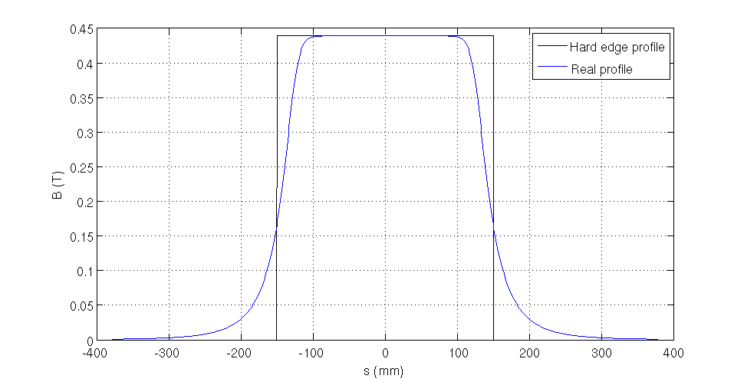
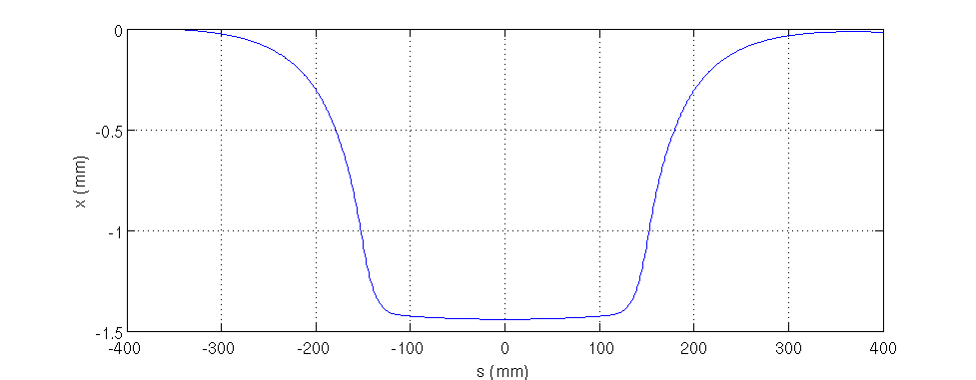
Figure 2 : Bz field profile and relative X orbit for Thom-X ring dipole (45 deg, r=0.352 m, Leff=300 mm, 50 MeV)

Linear fringe field
With the B drop profile expressed as , the K₁ integral is (Transport page 96) :

In the H. Wiedemann derivation, using the previous relations, with and one get for the horizontal slope x' :

The focusing term is the given by

The two results are in accordance but reveal that the horizontal orbit used is not closed and the slope x' presents a quadratic diverging behavior. The drop off of the field has been set such as the total integrated field is not conserved. The vertical quadrupole kick being strongly correlated to this slope, the kick strength may be really lower in case of closed orbit behavior (x'=0 at the end of the fringe field).
In the closed orbit case, one has to integrate over 0 to g/2 and multiply by 2 by symmetry :

The effective strength is then 4 times weaker. To illustrate these differences, a set of plots are sketched in both cases, without closed orbit consideration and with. The plot are the following from top to bottom : B profile, horizontal orbit, horizontal slope x' and comparison between tracking in the field and kick effect in the vertical plane. The previous results are well depicted in this case of linear field drop off over one gap.
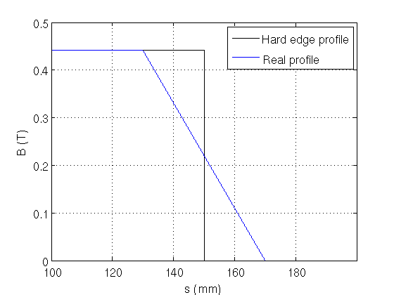
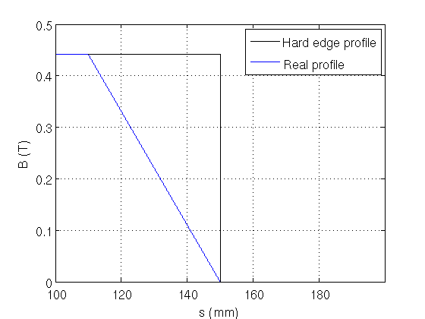

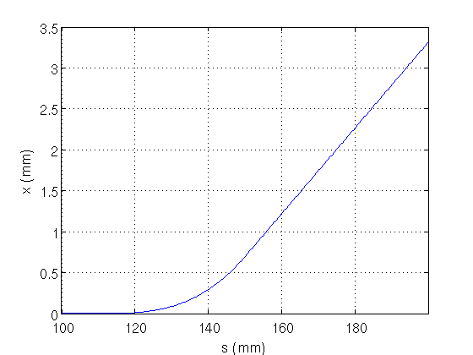
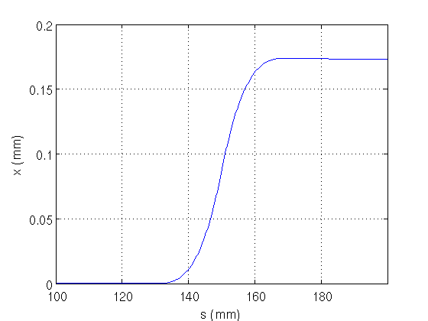

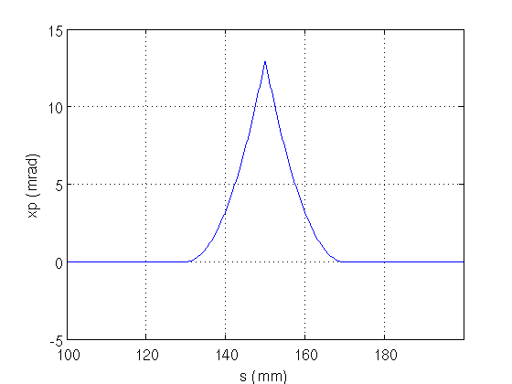
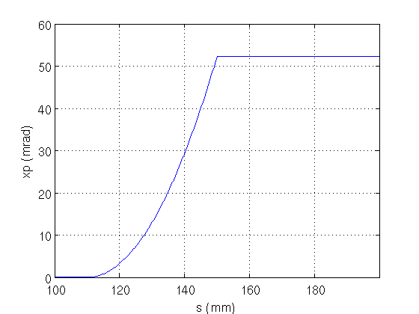

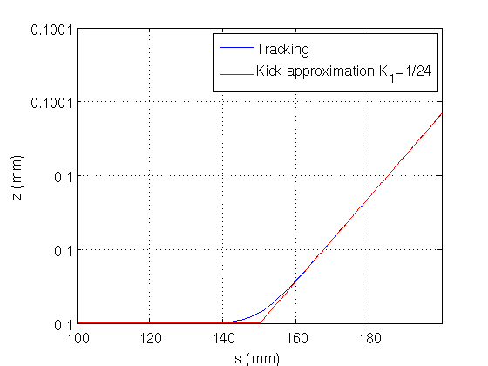
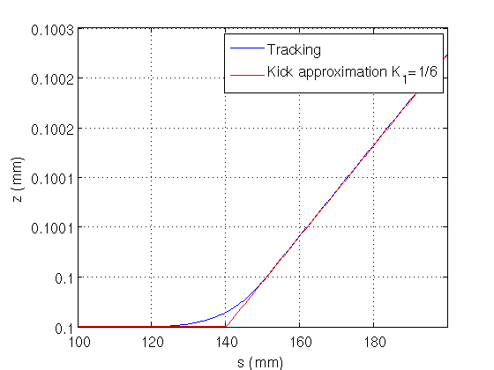

Case K. Brown/ H. Wiedemann Case with closed orbit
with diverging orbit or not closed.

General fringe field

From the dynamic equation we derived the following relation for the vertical focusing effect :

The dimensionless K₁ integral, as defined by K. Brown is the given by :

Using the well known trick of integration by part :

The first term of left hand side is null and K₁ integral is then given by :

With lack of deviation or non-closed orbit, the differential horizontal slope is leading to K. Brown relation :

With closed orbit, the differential horizontal slope is from s₁ to s₀ (hard edge limit) and to from s₀ to s₂ leads to the modified K. Brown relation :

Finally, depending on how the dipole effective length is set relative to the geometric arc and total deviation preservation as well, there is many different issues from this last relation. It can even be canceled with a shorter effective length. Nevertheless, in the standard case, where the dipole effective length is equal to the arc length and deviation preserved, this last dimensionless integral is about 4 times smaller than the usual relation derived by K. Brown as previously shown for the linear drop off case.
To illustrate these differences, a set of plots are sketched in tow cases for the Thom-X dipole modelized by RADIA code: with the effective length fitted to the arc length (300 mm) and with an effective length shorter in order to cancel the defocusing vertical correction terms. The plot are the following from top to bottom : B profile, horizontal orbit, horizontal slope x' and comparison between tracking in the field and kick effect in the vertical plane. The kick model is based on the modified dimensionless integral.
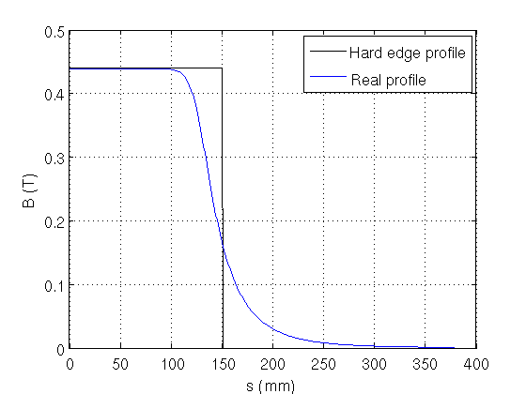
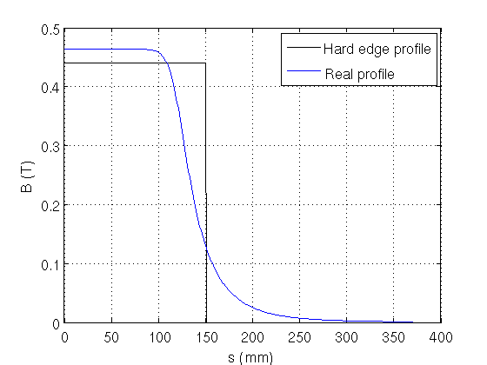

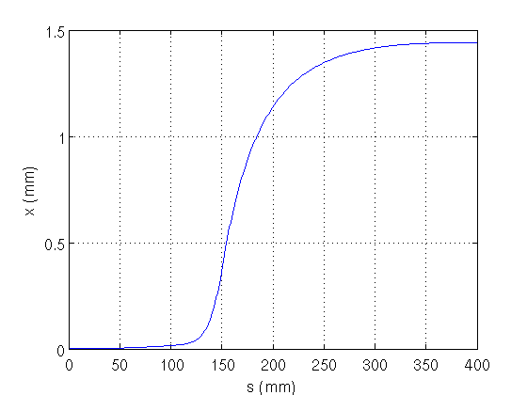
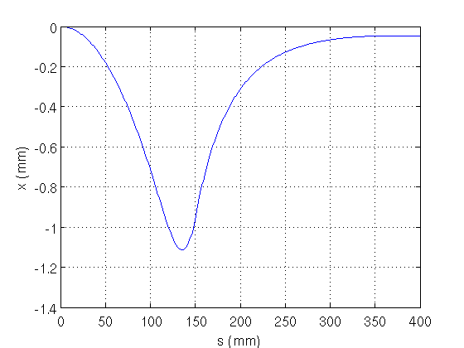

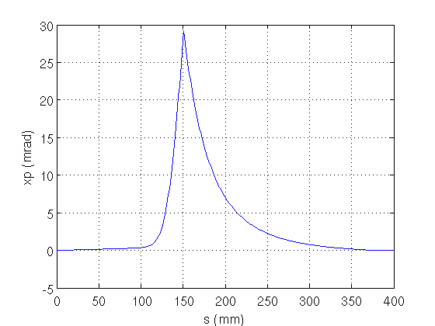
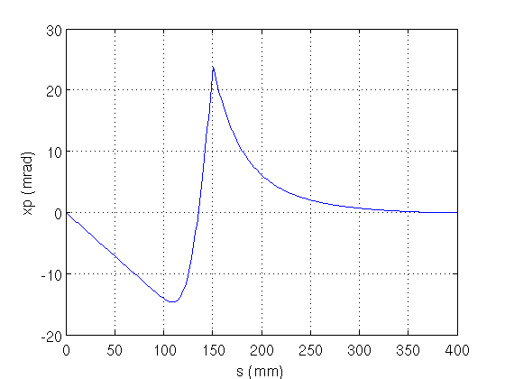

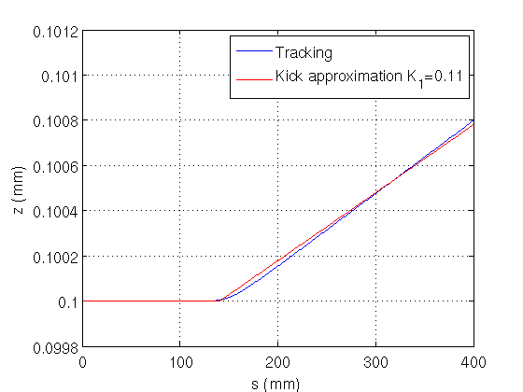
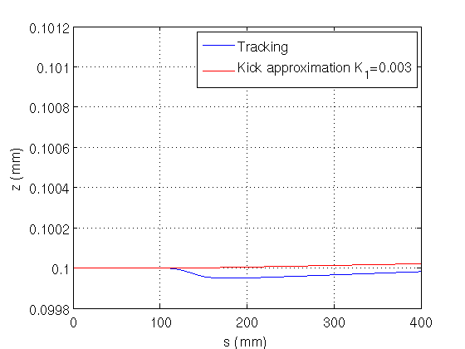

Case with effective length fitted to Case with effective length shorter
the arc length and orbit closed. to cancel the vertical kick
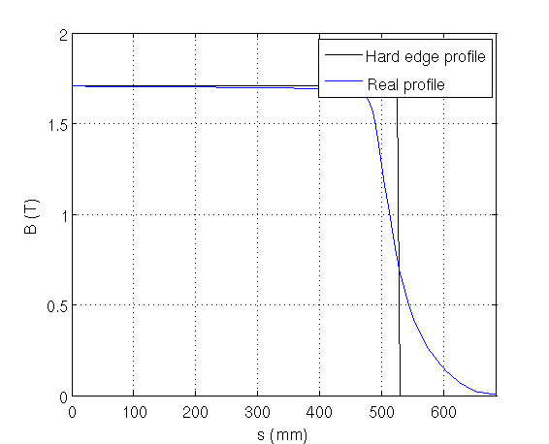
Application to the SOLEIL storage ring dipole :
Lff=1.05 m, Bmax=1.71 T
Straigth dipole of pi/16 deviation.

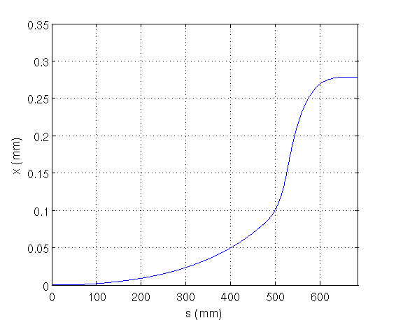

The horizontal orbit depression is about 0.3 mm

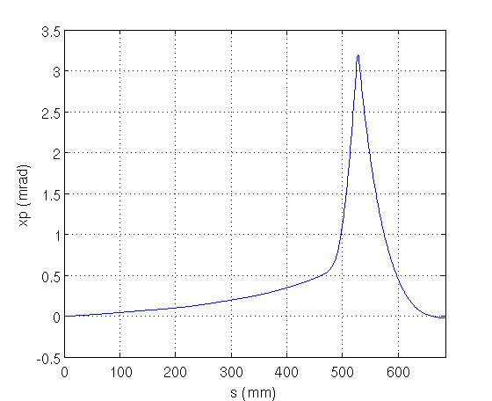

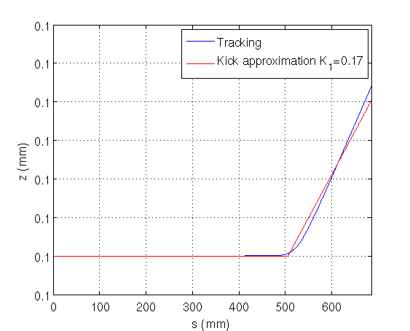
The K₁ integral is only 0.17 leading to a fringe field length Lff=6*K1*gap=38 mm.
The present value in used is K₁=0.7, leading to Lff=160 mm.
Here again, a reduced factor by 4 is expected. The impact is small, about 0.015 in vertical tune shift.

