Some considerations on the dipole edge effects
24-05-11

Table of Contents
Preamble 1
Conclusion 1
Pole face rotation component 2
Codes comparison 4
SOLEIL case 4
Thom-X case 5
Fringe field term component 6
Linear fringe field 7
General fringe field 8

Preamble
The goal of this note is to analyze, in the foot step of K. Brown, the dipole vertical focusing terms present in the edge and fringe field components. The main motivation is driven by the strong effective component in the Thom-X dipole case where the radius of curvature is very short.
First, the main focusing terms induced by the edge pole face rotation is first derived as well as the corresponding transfer map. To end, the correction terms induced by the fringe field effect is also revisited.

Conclusion
The well know relation of the vertical focusing effect in presence of a pole face rotation at the exit of a dipole is derived and is opposite in sign of the horizontal case. This vertical effect is only due to the longitudinal fringe field B_{s} experienced by the particle together with its horizontal speed or (x') at the exit of the pole. A simple relation is then derived in the kick approximation for the pole face effect and is in good accordance regarding the chromaticities as compared to BETA and MADX code. This kick transfer may restore the TRACY case.
Finally, the vertical correction term induced by the fringe field effect estimated by K. Brown K1 dimensionless integral is derived.

Pole face rotation component
The X, Z and S directions are for the horizontal, vertical and longitudinal normal to the pole face. The reference trajectory is composed of arc in the dipole and straight out of the dipole and fix the geometry of the machine. We assume an infinitely large dipole magnet with no horizontal B_{x} field components.
s
x
v
Teta
B
s
z

Bz
s

Figure 1 : Sketch of dipole magnet

From the Maxwell equation Rot (B) = 0, the relation between B_{s} and B_{z} is :
and gives for the longitudinal fieldto the first order.

The standard dynamic relations of a moving particle in magnetic field (constant energy) are :

The vertical force is the given by the term -qV_{x}B_{s}. Neglecting the horizontal orbit perturbation of the fringe field extension, V_{x} can be replaced by . Using the standard relations
,and we can express the vertical focusing along the fringe field exit of the pole as :

K_{z} being the usual notation for the normalized quadrupole strength.
Integrating K_{z} over the fringe field extension (from inside the magnet B(s₁)=B₀ to the end of the field B(s₂)=0) ans supposing that Ө is constant, leads to the total focusing effect (1/fz) in the vertical plane :

It is the well know relation of the vertical focusing effect in presence of a pole face rotation at the exit of a dipole and is opposite in sign of the horizontal case. This vertical effect is only due to the fringe field B_{s} experienced by the particle together with its horizontal speed or (x') at the exit of the pole. From this statement, we can easily generalize including the horizontal slope component x' as well as energy deviation delta at the exit of the pole by :

The ± sign stands for entrance and exit of the dipole. These kick formulation is symplectic by construction and is in good accordance with the codes BETA and MADX concerning the chromaticities (large and compact rings). Note that there is a pending effect in the horizontal plane coming from the term -qV_{z}B_{s} to be further investigated.

Codes comparison

SOLEIL case
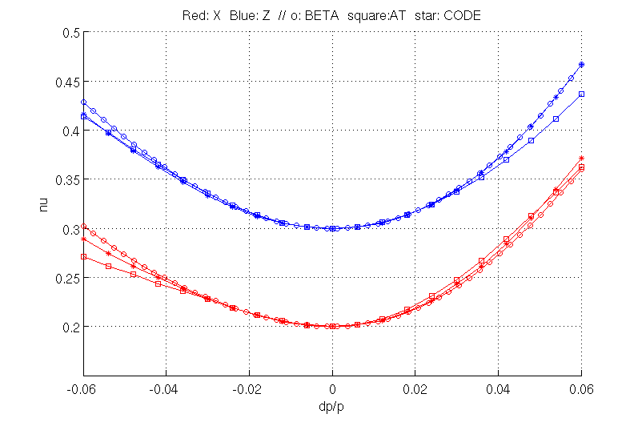
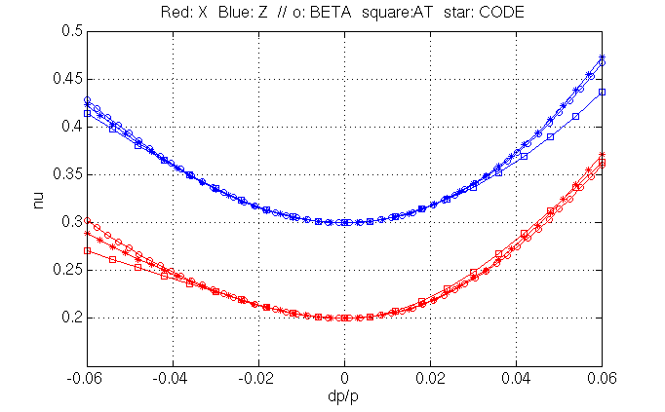
Horizontal (red) and vertical chromaticities tracking from different codes on the SOLEIL lattice. In The second plots, the vertical previous kick edge relation is included in CODE.
All the codes seems to be OK ... weak dipole (radius=5.36m)

Thom-X case
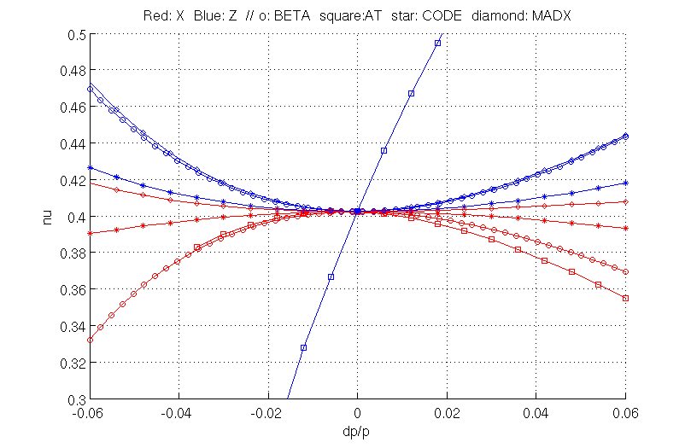
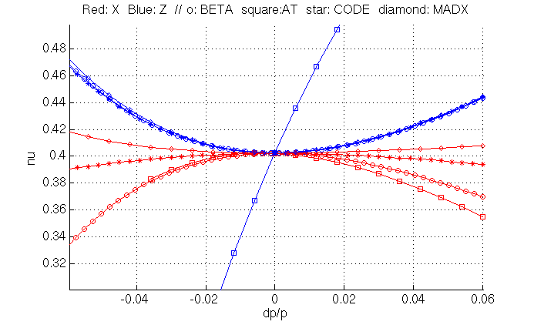
Horizontal (red) and vertical chromaticities tracking from different codes on the SOLEIL lattice. In The second plots, the vertical previous kick edge relation is included in CODE.
In the second plot, all the codes are in goods accordance in the vertical plane except TRACY. In the horizontal plane, they all disagree : H strong dipole (radius=0.352m) approach may differ.

Fringe field term component
At this stage we do not take into account both the real horizontal orbit depression in the fringe fields area. These term is known as the correction phi (K. Brown, Transport Code Notice) to be added to the vertical focusing quadrupole edge kick.
In figure 2, an example of dipole Bz profile as well as the relative X orbit depression are plotted from Thom-X ring model. The presence of fringe field induced a large orbit depression of the order of -1.4 mm. The total deviation with the fringe field extension is kept constant. In other words, the dipole bore length as well as the fringe field extension as been designed to fit the hard edge model deviation (reference orbit).
Removing the pole face rotation term (teta) to simplify, the vertical focusing along the fringe field exit of the pole as induced by this horizontal orbit perturbation x is also expressed by the relation :

with x'=Vx/V is the horizontal slope considered to be small. The K. Brown formulation is expressed as follow for arbitrary field profile :

with g the pole gap and B₀ the field in the flat region well inside the magnet. There no easily available source were can be found the demonstration this relation, but an other derivation, in the specific case of a linear drop off off the field can be found (H. Wiedemann, Particles Accelerators Physics Books p. 131-134). In both cases, for a linear drop over dipole gap length, the K₁ integral is equal 1/6.
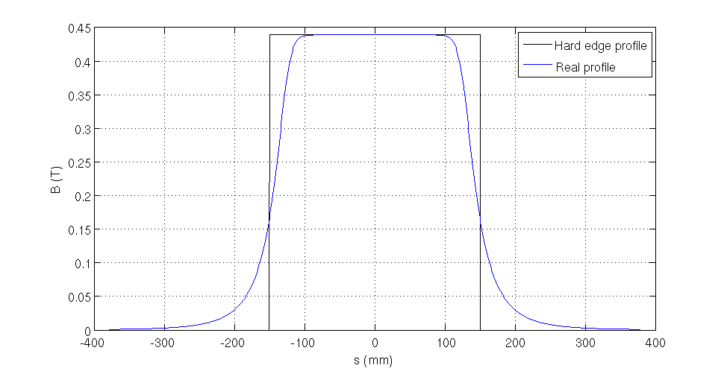
Figure 2 : Thom-X ring dipole Bz field profile (45 deg, r=0.352 m, Leff=300 mm, 50 MeV)
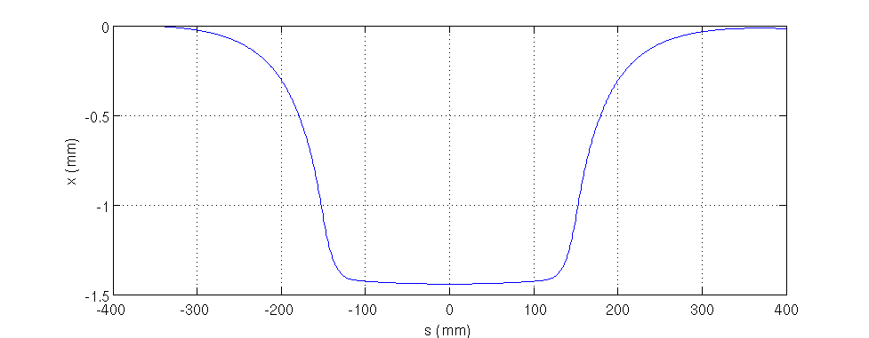
Figure 3 : Thom-X ring dipole relative X orbit for (45 deg, r=0.352 m, Leff=300 mm, 50 MeV)

Linear fringe field
With the B drop profile expressed as , the K₁ integral is (Transport page 96) :

In the H. Wiedemann derivation, using the previous relations, with and one get for the horizontal slope x' :

The focusing term is the given by

The two results are in accordance

General fringe field

From the dynamic equation we derived the following relation for the vertical focusing effect :

The dimensionless K₁ integral, as defined by K. Brown is the given by :

Using the well known trick of integration by part :

one get :

where s1 is located far enough inside the magnet to be in the flat field region B₀ and s₂ far outside where the field and x' are null. The deviation rate and cumulated are :

Combining this 2 last equations we get the well know relation :

