Normal Distribution Introduction

Elise Haylett

2/18/2020

library(tidyverse)

## ── Attaching packages ───────────────────────────────────────── tidyverse 1.3.0 ──

## ✓ ggplot2 3.2.1 ✓ purrr 0.3.3  
## ✓ tibble 2.1.3 ✓ dplyr 0.8.4  
## ✓ tidyr 1.0.2 ✓ stringr 1.4.0  
## ✓ readr 1.3.1 ✓ forcats 0.4.0

## ── Conflicts ──────────────────────────────────────────── tidyverse_conflicts() ──  
## x dplyr::filter() masks stats::filter()  
## x dplyr::lag() masks stats::lag()

# set the parameters of the normal model  
mu <- 100  
sigma <- 15  
  
ggplot(NULL, aes((mu - 4 * sigma):(mu + 4 * sigma))) +   
 stat_function(fun = dnorm, args = list(mu, sigma)) +  
 scale_x_continuous(breaks = seq(mu - (4 * sigma),   
 mu + (4 * sigma), sigma)) +  
 labs(title = "Standard IQ Tests", x = " WAIS scores", y = "density") +   
 theme_linedraw()

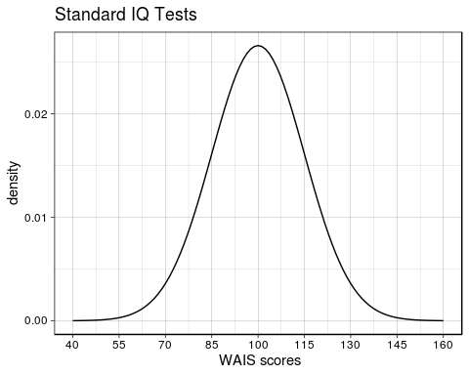

mu <- 0  
sigma <- 1  
ggplot(NULL, aes((mu - 4 * sigma):(mu + 4 * sigma))) +   
 stat_function(fun = pnorm, args = list(mu, sigma)) +  
 scale_x_continuous(breaks = seq(mu - (4 * sigma),   
 mu + (4 * sigma), sigma)) +  
 labs(x = "x", y = "F(x)") + theme_linedraw()

pnorm(-3:3, 0, 1)

## [1] 0.001349898 0.022750132 0.158655254 0.500000000 0.841344746 0.977249868  
## [7] 0.998650102

pnorm(-3:3) #default is mean = 0, sd = 1

## [1] 0.001349898 0.022750132 0.158655254 0.500000000 0.841344746 0.977249868  
## [7] 0.998650102

pnorm(1) - pnorm(-1) # between 1 sd

## [1] 0.6826895

pnorm(2) - pnorm(-2) # between 2 sds

## [1] 0.9544997

pnorm(3) - pnorm(-3) # between 3 sds

## [1] 0.9973002

pnorm(2/3) - pnorm(-2/3) # between 2/3 sds

## [1] 0.4950149

# vectorizing calculations  
pnorm(1:3) - pnorm(-1:-3)

## [1] 0.6826895 0.9544997 0.9973002