# Node

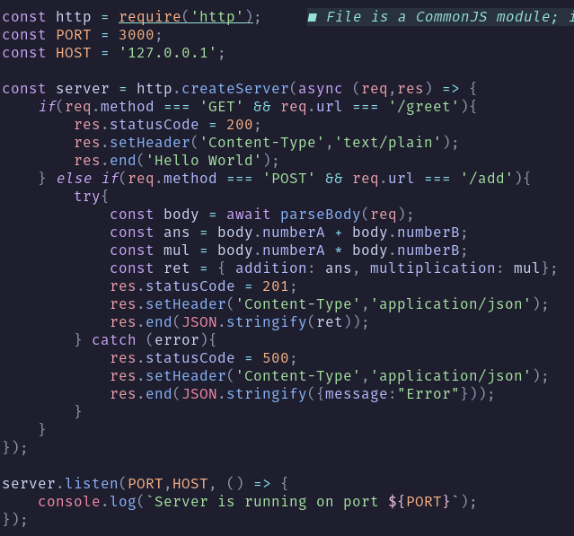

# Express

# Modules

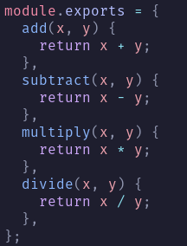

# ES6

## 

# 

# React

When using list items you need a key value like the index to give the element a unique value.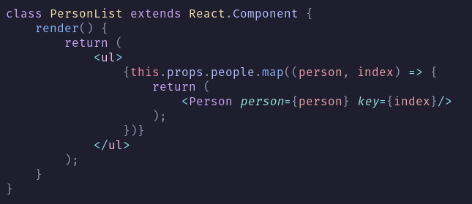

Want to return a bunch of components without wrapping it inside a div:

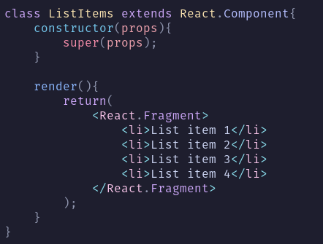

### Binding

### State

State is initialized in the constructor.

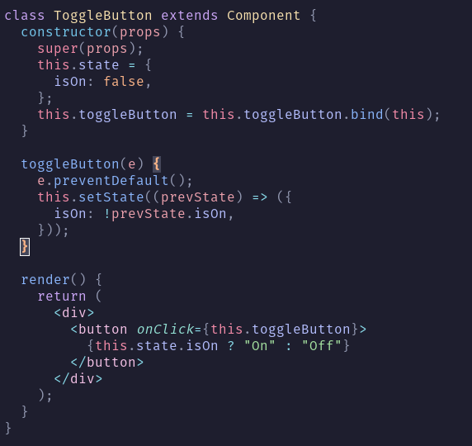

### Ref

### Person List Example

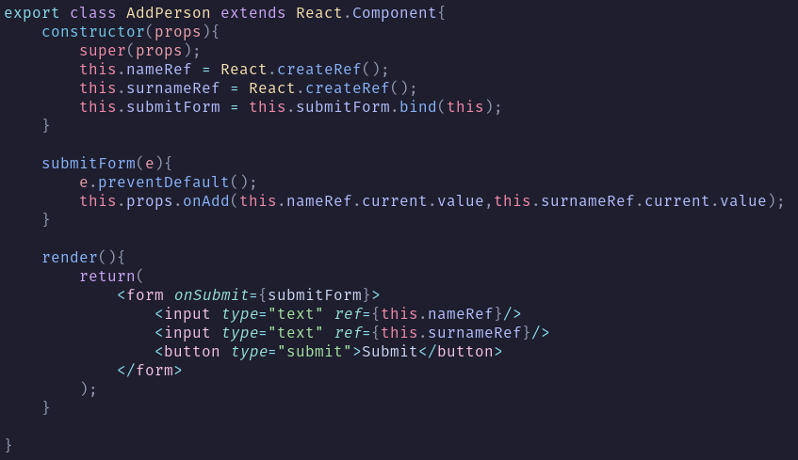

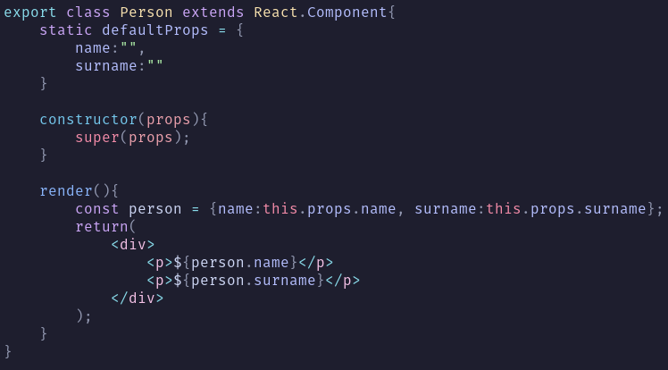

# Babel

npm init

npm install express

npm install --save-dev @babel/cli @babel/core @babel/preset-env

npm install react react-dom

npm i --save-dev @babel/preset-react babel-loader webpack webpack-cli css-loader style-loader webpack-dev-server

npm i postcss postcss-loader react-router-dom path

# 

# Mongo Queries

Basic layout

Filter age greater than 25 and only show name and age fields:

$eq – Equal to

$ne – Not equal to

$gt – Greater than

$gte – Greater than or equal to

$lt – Less than

$lte – Less than or equal to

$in – Matches any value in an array

$nin – Matches none of the values in an array

$and – Requires all conditions to be true

$or – Requires at least one condition to be true

$not – Inverts the effect of a query

$nor – Matches documents that fail both conditions

$exists – Checks if a field exists

$type – Checks the type of a field

$all – Matches all elements in an array

$elemMatch – Matches documents with an array that contains at least one element matching all criteria

$size – Matches documents with arrays of a specific size

Find all products between 50 and 100:

Find users from NY or older than 3o: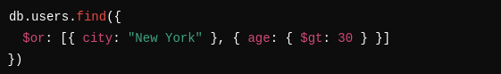

Find all where phone field exists:

Products that contain red and blue

Find with at least one address in CA (Address is an array)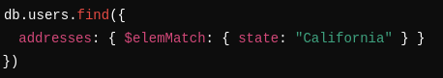

### Sorting

1 = ascending -1 = descending

Sort by age

Sort first by name then surname

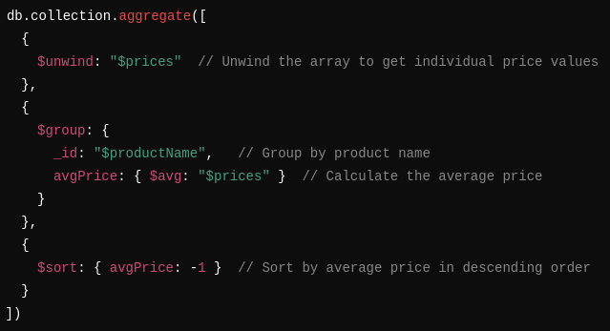

Count of each product type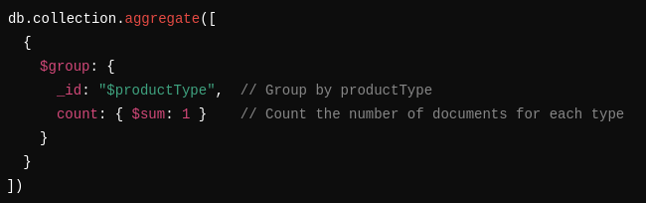

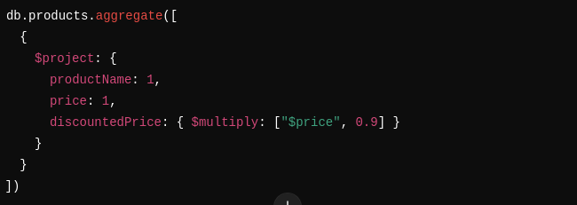

Count products in category: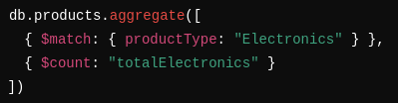

Sum all prices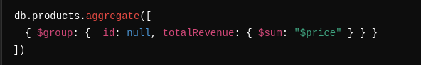

Average of all prices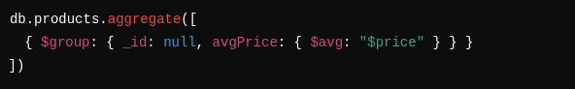

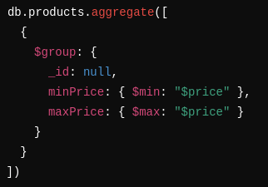

## 

# Links

<https://docs.google.com/document/d/1eG4hCx6ICryRWsafVUweGgjHOjZuLlvJKVtTiiSZ3G0/edit?usp=sharing>

<https://github.com/hayley-d/IMY220>