????????? MVP ???
???2026-06-03 / v2
??? discussion-checklist.md ??????????? 7 ????????? 8 ?????????
1. ????
????????????????????????????????????????????
- ??????????????????????????????????
- ?????????????????????????????????
- ????????????????????????????????????
2. MVP ??
?????????????????????????????
- ????????????????????????
- ????????????? / ?? / ?? / ???? CRUD?
- ???????????????? is_featured?recommend_score?sort_order?
- ??????????????????????????
3. ????
????????????????????????????????????????????
???? | ???? 10 ??????????????
???? | ???????????????????????
???? | ?????????????????????????

4. ??????????
?????????????????????????????????????????????
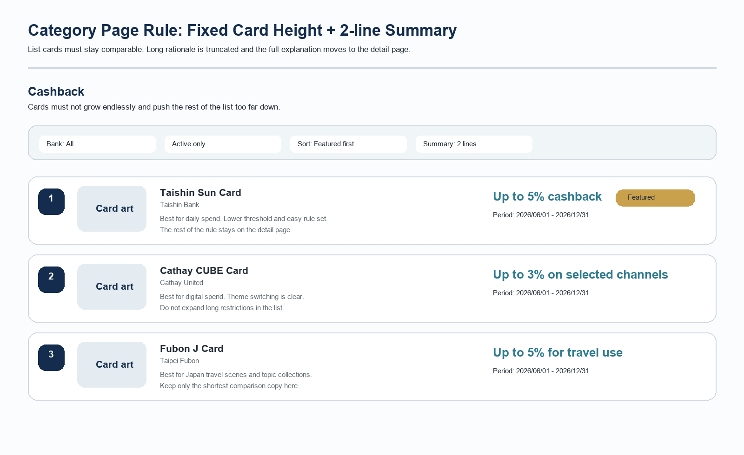
?????? | ?????????????????????????
?????? | ???????????????????????????????????????
?????? | ????????? 2 ????????????????? 2 ????????????????
????? | ?????????????????????????????????????????????

5. ?????
???????????????????????????????????????????
- ??????????????????????
- ???????????????????????????
- ???????????????????????????
6. ???????????
MVP ??????????????????????????????????????????????
???? | ????????????????????????????
???? | ??? C?????????????????
???? | ? manual_summary ??????????????????????????????

???? | ???? | ?????
summary_mode | ?? | ????????????????????
target_audience | ???? | ????????????????????????????????????
highlight_1 | ???? | ?????????????????????????????????????????
highlight_2 | ???? | ? highlight_1 ??????????????
manual_summary | ???????? | ??????????????????
summary_preview | ???? | ?????????????? 2 ????

?????? | ?????????{??}?{??1}?{??2}??????????????????????
???? | ????????????????????????????????

7. ???????????
???????????????????????????????????????????????????????????????
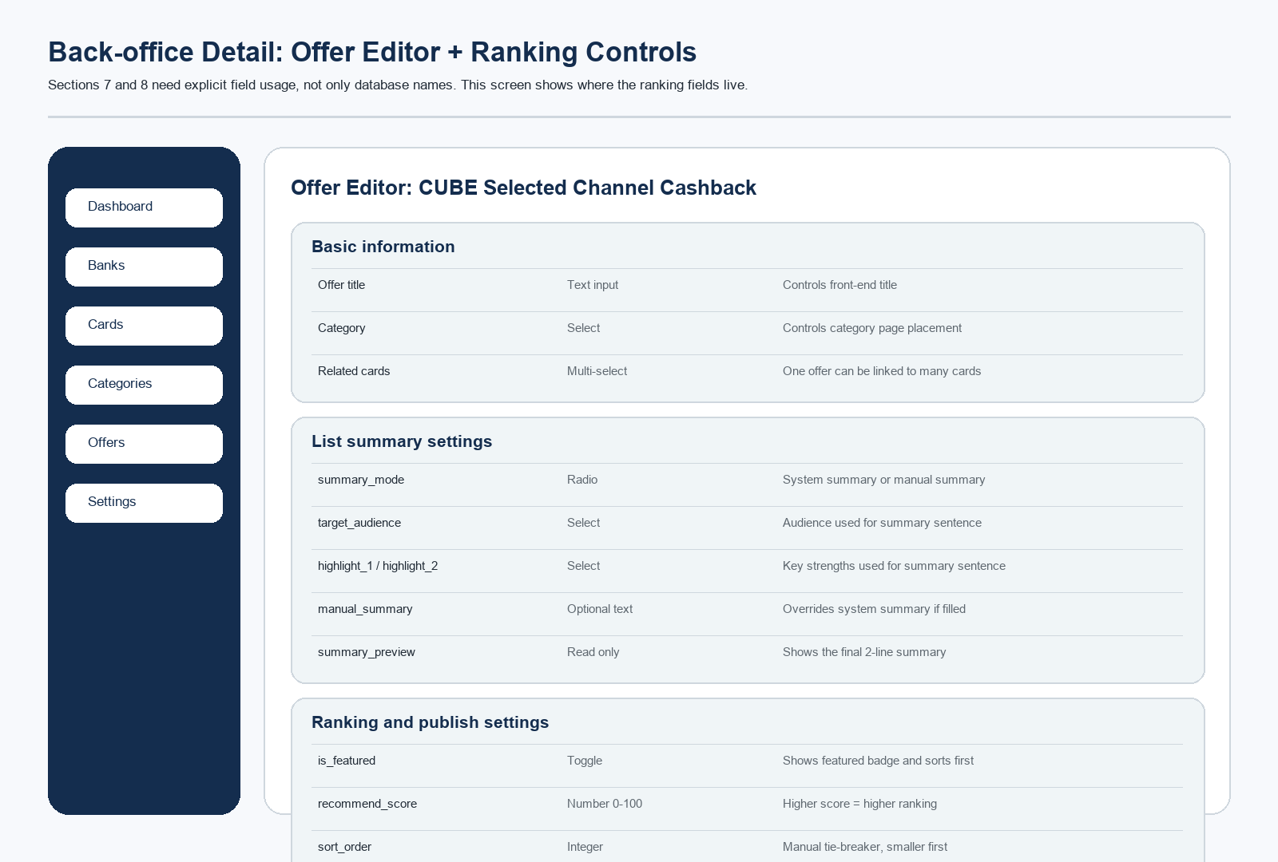
???? | ???? | ???????
banks | name / slug / logo_url / website_url / is_active | ?????????????????????????????
cards | bank_id / name / slug / image_url / summary / is_active | ?????????????????????????????????????
categories | name / slug / icon_name / sort_order / is_active | ??????????????????????????????
offers | title / summary / description / start_date / end_date / reward_type / reward_value / reward_cap / min_spend / conditions / source_url / tags / is_featured / recommend_score / sort_order / is_published | ????????????????????????????????????
offer_cards | offer_id / card_id | ?????????????????????????????

7.1 ??????????
????????????????????????????
?? | ?? | ????
???? | ???? / ???? / ????? | ?????????????????
?????? | summary_mode / target_audience / highlight_1 / highlight_2 / manual_summary / summary_preview | ???????????????????
??????? | is_featured / recommend_score / sort_order / is_published / updated_at | ????????????????
???? | description / conditions / reward_cap / min_spend / source_url | ??????????????????

8. ????????????
??????????????????????????????????????????????
?????? | ????? is_published ??????? end_date ????????
???? | is_featured ? recommend_score ? sort_order ? updated_at?
???? | ???????????????????????????????

?? | ???? | ?????? | ??? | ???? | ???? / ????
is_featured | Boolean | ???? | false | ???????????????????? | ???????????
recommend_score | Integer | ???? | 0 | ???????????????? | ???????????
sort_order | Integer | ???? | 0 | ???????????????? recommend_score ??????????? | ???????????
updated_at | Datetime | ?????? | ???? | ???????????????????????????? | ?????????????

8.1 ??????
?????????????????????????????????
- is_featured????????????????????????????
- recommend_score????????????????????????????????????
- sort_order??????????????????????????????
- updated_at???????????????????????????????
9. ?????????
?????????????????????????
- ????Next.js?Prisma?SQLite?Tailwind CSS???????? PostgreSQL?
- ?????? schema ?????????? CRUD??????????????????
- ?????????? RWD ???????????????????
10. ??????
?????????????????????????
- ?????????????
- ?????? + ???????
- SEO ?????????????????????
11. ??????
??????2026-06-03 / v2?????? credit-card-mvp-spec ?????????
- ???????????????????????????
- ?????? 2 ??????????? 2 ????????????????
- ????????????? summary_mode?target_audience?highlight_1?highlight_2?manual_summary?summary_preview ???
- ??? 7 ????????????????????????????
- ??? 8 ??????????? is_featured?recommend_score?sort_order?updated_at ????????
- ??????????????????????????????????????????
- ?????????????????????? credit-card-mvp-spec?

