Analysis summary

GBE data – risk-taking and recent events (eventually will look at affect and aging)

Hayley Brooks

**Some basics:**

P(Gamble):

* across all trials = .64
* gain trials = .70
* loss trials = .55
* mixed trials = .67

**How does risk-taking change as a function of previous trial type and outcome?** This does not take into consideration current trial stuff. Overall, there is less risk-taking following safe outcomes across all trial types and this relationship seems to get stronger as the task progresses. Perhaps this is because people who are likely to choose safe at first are also more likely to continue to play it safe across the task. Across safe outcomes, there is a larger difference in risk-taking following a loss safe outcome (negative value) relative to a gain safe and mix safe outcome (value >=0). Ignoring safe outcomes, risk-taking is consistently higher following loss trials and is lowest following a gain win. Toward the end of the task, a more apparent pattern emerges with risk-taking being highest following losses, in the middle following mixed trials and lowest following gain trials. **Trial 1 is not plotted because there is no t-1 for trial 1.**

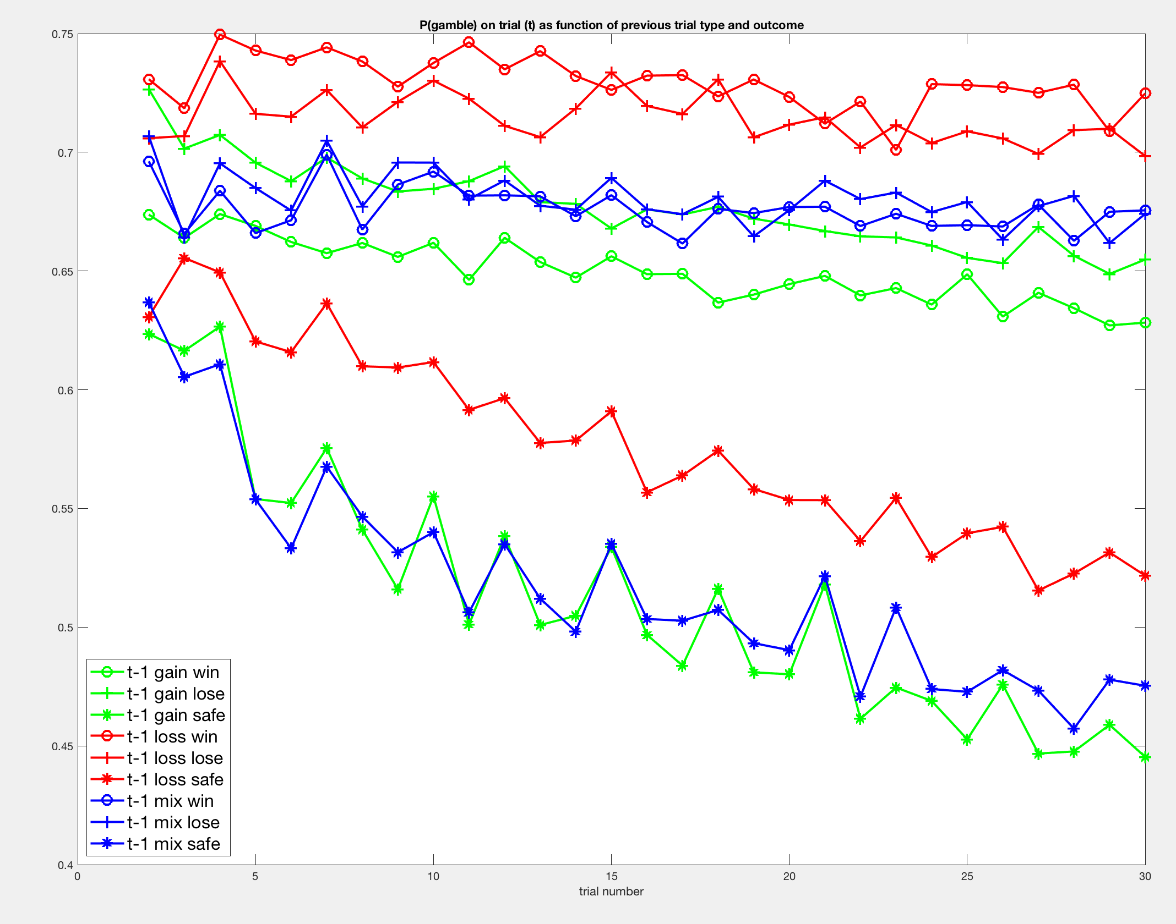

**How does risk-taking change as a function of previous trial amount?** This involved splitting up the gain and loss type amounts by zero, small/medium (1-99), and large outcomes (100+). Across the task, there is more risk-taking following loss outcomes and less risk-taking following gain outcomes. Across all outcome/trial types, risk-taking is lowest following large gain outcomes. Within previous loss trials, risk-taking is highest following really large losses and losses of zero (which is considered a risky win). It looks like people are behaving differently following a zero outcome depending on whether the outcome was considered a win (in the loss trials) or the outcome was considered a loss (in the gain trials).

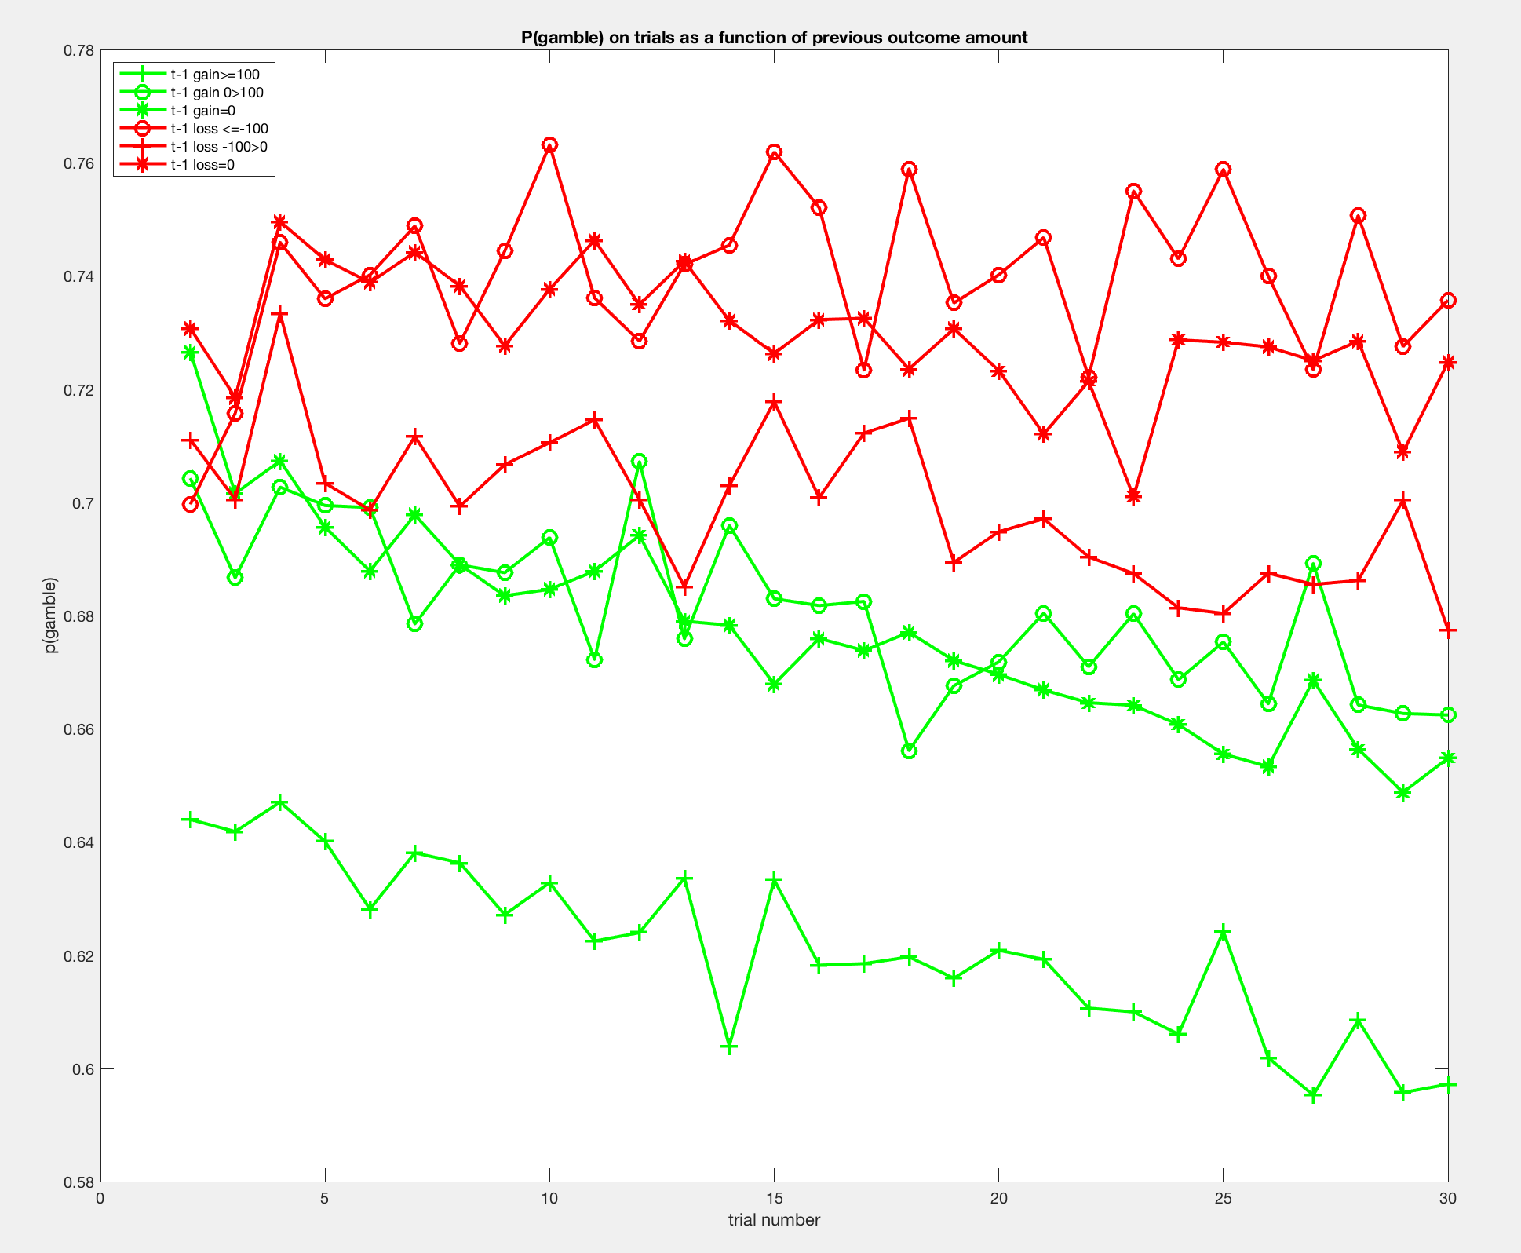

**How does risk-taking change as a function of both previous trial type and outcome and current trial type?** Plotted p(gamble) across 30 trials splitting it up by current trial. The three plots represent p(gamble) on current gain trials, current loss trials, and current mix trials. X-axis is trial number, and y-axis is p(gamble). Each line represents the previous trial type/outcome (gain lose, gain win, loss lose, loss win, mix lose, mix win). Not really seeing a big pattern emerge here.

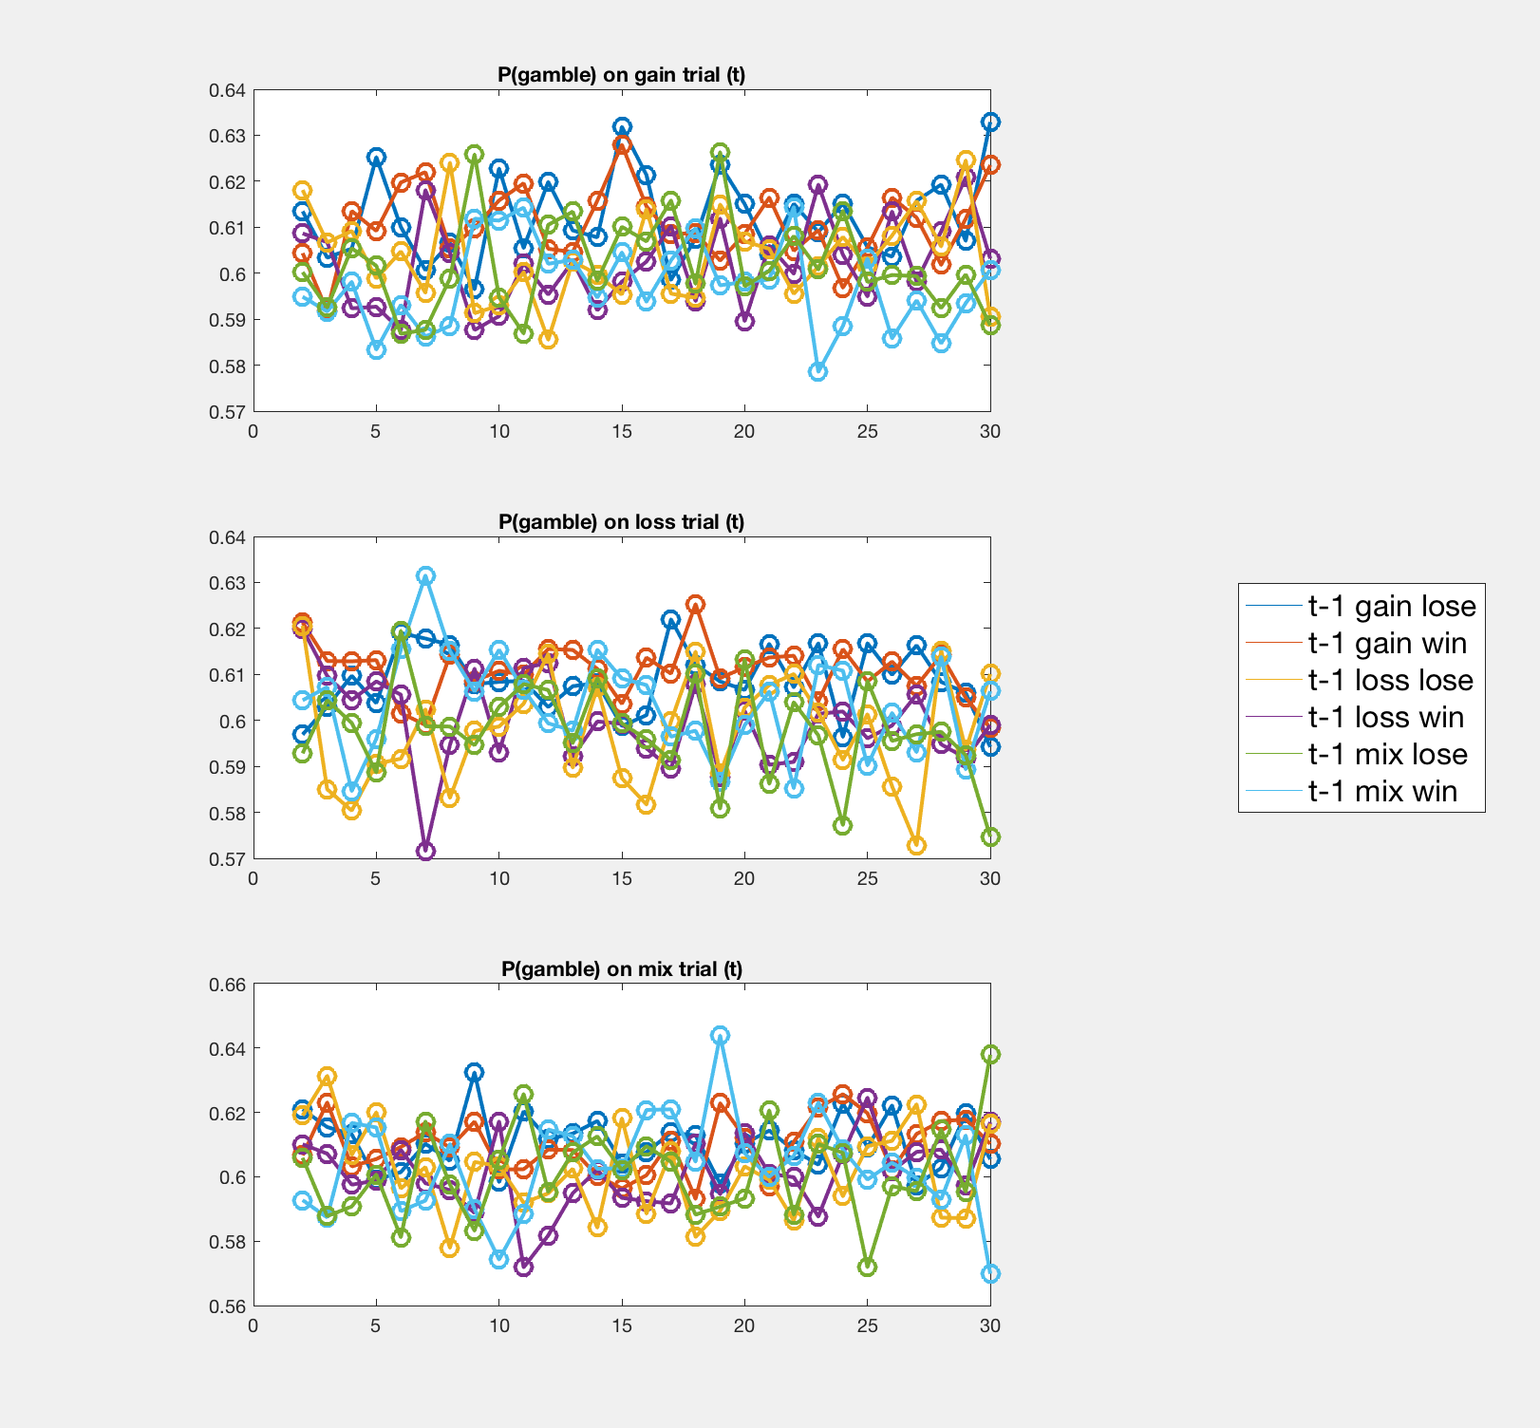

Plot the results above but group p(gamble) into bins (trials 2-10, 11-20, and 21-30). On current gain and loss trials, risk-taking may be higher following gain trials (regardless of whether outcome was win or lose) relative to other previous trial types. This difference seems largest in the middle of the task.

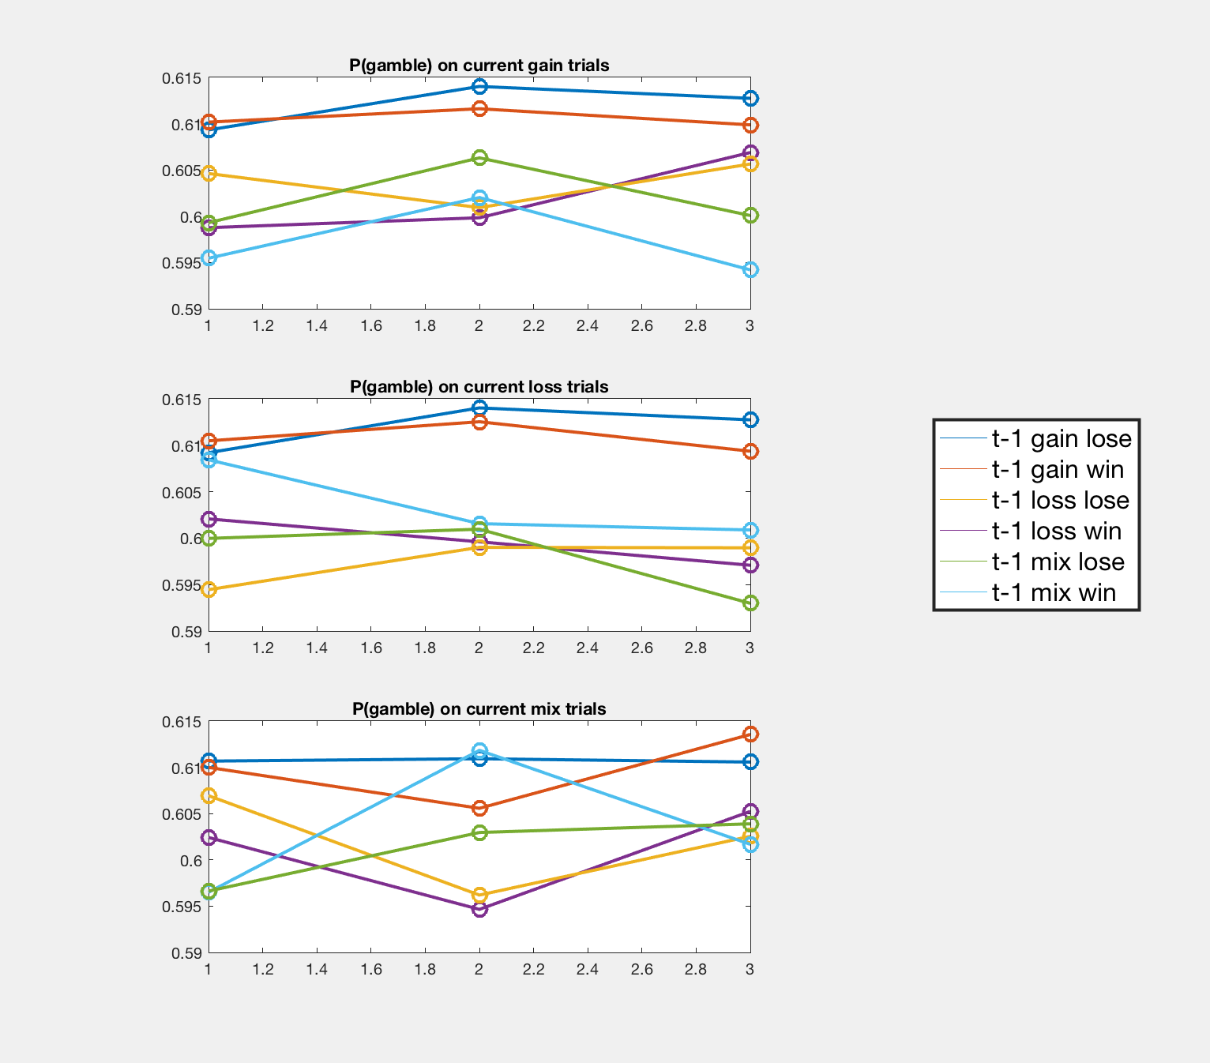

When looking at risk-taking as a function of just previous trial stuff, there is generally more risk-taking following gains and less risk-taking following losses. However, when taking into consideration both previous and current trials, there is actually more risk-taking following gain trials and less risk-taking following loss trials on both current gain and loss trials?

By collapsing across both current and previous trials (like in the last two figures), could we be missing stuff? For example, people are much more likely to gamble on gain trials (p = .7) and at the same time, there seems to be a negative effect of previous gain trial on risk-taking but when these are grouped together, the current trial stuff may be overshadowing the previous trial effect.