**MRIQC output: Image Quality Metrics (IQMs)**

*Some of these are no-reference IQM 🡪 measurement cannot be compared to a reference value because there is no ground truth on what that reference value should be.

**ANAT (T1W)**

**MEASURES BASED ON NOISE MEASUREMENTS**

CJV: coefficient of joint variation – higher values are related to the presence of heavy head motion and large INU (intensity non-uniformity) artifacts which is an artifact that is “[mainly produced by improper image acquisition process](https://ieeexplore.ieee.org/document/7449935)”. INU is also called bias field and affects the intensities of the homogenous tissue regions (e.g. GM, WM, and CSF). This measure is related to SNR and CNR. Lower values are better.

CNR: contrast-to-noise ratio: an extension of the SNR calculation to evaluate how separated the tissue distributions of GM and WM are, or the mean of the gray matter intensity values minus the mean of the white matter intensity values divided by the standard deviation of the values outside the brain.

Higher values indicate better quality.

SNR: signal-to-noise ratio – calculated within the tissue mask. It is the mean intensity of the foreground. Higher values are better. (SNR, CNR, FBER highly correlated [Shehzad et al 2015](https://www.frontiersin.org/10.3389/conf.fnins.2015.91.00047/event_abstract)).

SNRD: Dietrich’s SNR – a different way to measure SNR that uses the air background as reference ([Dietrich et al 2007](https://onlinelibrary.wiley.com/doi/full/10.1002/jmri.20969)). This must be an air mask around the head and it should not contain artifacts.

ART_QI2: [Mortamet’s quality index 2](https://onlinelibrary.wiley.com/doi/full/10.1002/mrm.21992) (QI2) – calculation of goodness-of-fit of a centered chi squared distribution on the air mask, once the artifactual intensities detected for computing the QI1 (see description below) index have been removed.

**MEASURES BASED ON INFORMATION THEORY**

EFC: entropy-focus criterion – uses the Shannon entropy of voxel intensities (or the average minimum number of voxels) as an indication of ghosting and blurring induced by head motion. Lower values are better, with EFC = 0 for all the energy concentrated in one pixel.

FBER: foreground-background energy ratio – mean energy of image values within the head relative to outside the head. Higher values are better.

**MEASURES TARGETING SPECIFIC ARTIFACTS**

INU: summary statistics (max, min and median) of INU field. Values closer to 1 are better.

The MRIQC group report includes the range and median but not split up into max and min as mentioned on the mriqc website.

ART_QI1: proportion of voxels with intensity corrupted by artifacts normalized by the number of voxels in the background. Lower values are better. Uses the same method as ART_QI2 ([Mortamet et al 2009](https://onlinelibrary.wiley.com/doi/full/10.1002/mrm.21992))

WM2MAX: white-matter to maximum intensity ratio- median intensity within the WM mask over the 95% percentile of the full intensity distribution, that captures the existence of long tails due to hyper-intensity of the carotid vessels and fat. Values should be around the interval [0.6, 0.8].

**OTHER**

FWHM: Full-width half maximum smoothness – spatial distribution of the image intensity values in units of voxels. Lower values are better.

ICVS: computes ICV (intracranial volume) fractions corresponding the partial volume maps of CSF, GM, WM. They should move within a normative range.

RPVE: residual partial voluming error of CSF, GM, and WM. Lower values are better.

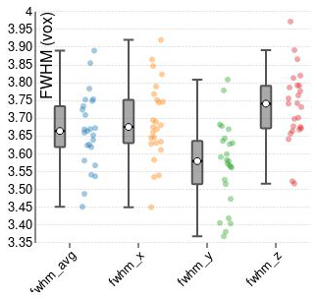Summary stats: Mean, SD, 5% percentile and 95% percentile of the distribution of background, CSF, GM, and WM. “Sometimes (with datasets that have been partially processed), the air mask will be empty. In those cases, the background stats will be zero for the mean, median, percentiles and kurtosis (k; kurtosis has to do with tails), the sum of voxels in the other remaining labels for n, and finally the MAD (mean absolute deviation).”

Overlap: the overlap of the TPMs (tissue probability maps) estimated from the image and the corresponding maps from the [ICBM nonlinear-asymmetric 2009c template](http://nist.mni.mcgill.ca/?p=904). This is related to volumes projected from MNI space (a blurb from the website linked above):

“A number of unbiased non-linear averages of the MNI152 database have been generated that combines the attractions of both high-spatial resolution and signal-to-noise while not being subject to the vagaries of any single brain (Fonov et al., 2011). The procedure involved multiple iterations of a process where, at each iteration, individual native MRIs were non-linearly fitted to the average template from the previous iteration, beginning with the MNI152 linear template. We present an unbiased standard magnetic resonance imaging template brain volume for normal population. These volumes were created using data from ICBM project.

ICBM 2009c Nonlinear Asymmetric template – 1×1x1mm template which includes T1w,T2w,PDw modalities, and tissue probabilities maps. Intensity inhomogeneity was performed using N3 version 1.11 Also included brain mask, eye mask and face mask. Sampling is different from 2009a template.”

**BOLD**

**MEASURES FOR SPATIAL INFORMATION (similar as above)**

EFC: entropy-focus criterion – uses the Shannon of voxel intensities (or the average minimum number of voxels) as an indication of ghosting and blurring induced by head motion. Lower values are better.

FBER: foreground-background energy ratio – mean energy of image values within the head relative to outside the head. Higher values are better.

FWHM: Full-width half maximum smoothness – spatial distribution of the image intensity values in units of voxels. Lower values are better.

SNR - Signal-to-noise ratio – calculated within the tissue mask

(SNR, CNR, FBER highly correlated [Shehzad et al 2015](https://www.frontiersin.org/10.3389/conf.fnins.2015.91.00047/event_abstract))

Summary statistics: mean, standard deviation, 5% percentile and 95% percentile of the tissue distribution of foreground (FG – inside the head mask) and background (BG – “hat” mask)

p95 – percentile 95 of the intensity distribution within the head mask or the hat mask. K is kurtosis.

**MEASURES FOR TEMPORAL INFORMATION**

DVARS – D refers to temporal derivative of time courses. VARS refers to root mean square (RMS) variance over voxels and indexes the rate of change of BOLD signal across the entire brain at each frame of data (dvars_nstd).

MRIQC calculates 2 additional DVARS: dvars_std which is normalized w/ SD of the temporal difference time series and dvars_vstd is a voxel-wise standardization of DVARS, where the temporal difference time series is normalized across time by that voxel standard deviation across time before computing the RMS of the temporal difference. Lower values are better.

DVARS from scanners at several Universities (Shehzad et al 2015):

* I think these are DVARS_VSTD – they are described in the paper as “standardized DVARS”. NYU was described as the “best” and CMU as the “worst” of the imaging sites measured.

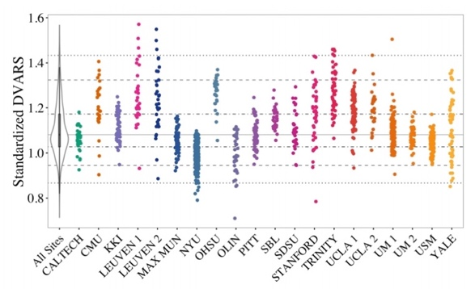

**MEASURES OF TEMPORAL INFORMATION (CONT)**

GCOR: Global correlation – calculates an optimized summary of time-series correlation. The average correlation of all pairs of voxel time series inside of the brain. Illustrates differences between data due to motion/physiological noise/imaging artifacts (such as signal bleeding). Values closer to zero are better.

tSNR: temporal SNR. Measure of image time course stability ([Murphy et al 2007](https://www.semanticscholar.org/paper/How-long-to-scan-The-relationship-between-fMRI-to-Murphy-Bodurka/b97363545a50106cab807b82f383bfcda5fa37dd)). Higher values are better.

**MEASURES FOR ARTIFACTS AND OTHER**

Fd_mean – framewise displacement – A measure of subject head motion, which compares the motion between the current and previous volumes. This is calculated by summing the absolute value of displacement changes in the x, y and z directions and rotational changes about those three axes. The rotational changes are given distance values based on the changes across the surface of a 50mm radius sphere.

Fd_num – number of timepoints above FD threshold - threshold set to .2mm

Fd_perc – percent of FDs above the FD threshold w.r.t the full timeseries – threshold set to .2mm

Lower values are better for all FD measures.

GSR: ghost to signal ratio along the two possible phase-encoding axes (labeled in reports as gsr_x and gsr_y). Lower values are better.

AOR: AFNI’s outlier ratio – mean fraction of outliers per fMRI volume as given by AFNI’s 3dToutcount

AQI: AFNI’s quality index – mean quality index as computed by AFNI’s [3dTqual](https://afni.nimh.nih.gov/pub/dist/doc/program_help/3dTqual.html) – “small values of the index are ‘good’, indicating that the sub-brick is not very different from the norm. The purpose of this program is to provide a crude way of screening fMRI time series for sporadic abnormal images, such as might be caused by large subject head motion or scanner glitches”

Dummy – number of *dummy* scans – a number of volumes in the beginning of the fMRI timeseries identified as non-steady state

Resources:

<https://mriqc.readthedocs.io/en/stable/iqms/bold.html>

<http://preprocessed-connectomes-project.org/quality-assessment-protocol/#taxonomy-of-qa-measures>