Slide 1 – Title The New Typeography

Slide 2 – Pic of Tshichold

Jan Tschichold revolutionized Typography. He was a typographer who was taught the tradition of calligraphy at Leipzig Academy that had heard talk of new ‘isms’ in art which the art historian could not explain, so he took it upon himself to find out.

Slide 3 - image <http://media.tumblr.com/tumblr_l5kloipeN21qc34xw.jpg> <http://theformofbeauty.tumblr.com/post/812697699/20-bauhaus-design-posters-beauty-in-simplicity>

He visited the first exhibition of work at the Bauhaus in Weimar 1923 which showcased the new direction they were taking. It was an experience that shook Tshichold’s belief in the traditions he had been schooled.

Confused, he contacted Laszlo Moholy-Nagy, a Professor at the Bauhaus. It was through Moholy-Nagy that Thishichold began to learn about contemporary Russian Art & Design which focused on Constructivism.

Slide 4 - <http://www.iconofgraphics.com/moholy/large/moholynagy_typophoto.jpg>

He embraced the movement, changing his name to Ivan/Iwan and campaigned for elemental typography and photomontage.

Slide 5 -

He moved from historical scripts and calligraphy towards experimental geometric lettering and away from centered arrangement to more dynamic compositions using sans-serif type.

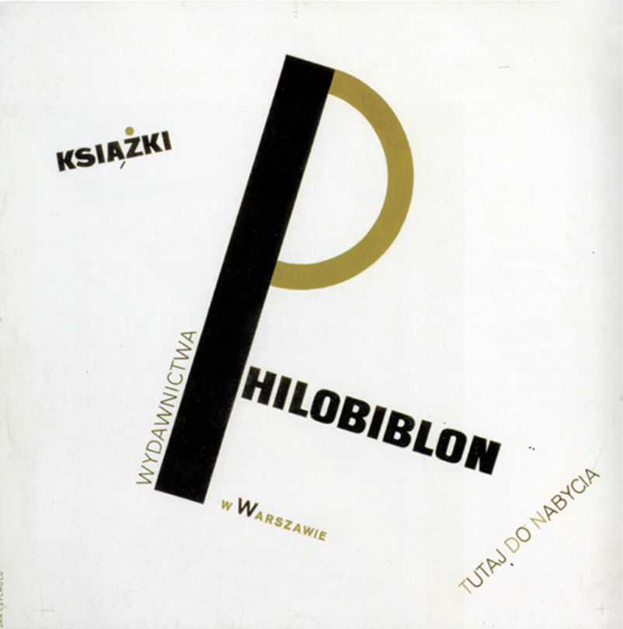We can see this in the 1924 design of the poster for Polish publisher Philobiblon

Slide 6 – <http://media.sundancechannel.com/UPLOADS/blog/wordpress/images/2010/01/MoMA-New-Typography.png>

The ideas of New Typography included asymmetrical composition, sans serif type, preference of the lowercase, the use of photography, grids, geometrical forms and the absence of decoration.

The essence was clarity and the overall objective was functional design using the most straightforward means to deliver a message in the shortest most efficient matter.

7-  [http://andrealaborde.files.wordpress.com/2012/05/typographic-news-spread.jpg](http://www.tipografos.net/imagens/elementare-typo-tschi.jpg)

In 1925 He wrote material about constructivism in typography for a special issue of Typographische Mitteilungen titled Elementare Typographie which educated designers printers and typesetters to design with the principals mentioned in mind.

8 - Title ‘The typographers Bible’

9 - <http://wiedler.ch/download/felix/books/29_title.jpg>

In 1928 he then published Die Neue Typographie which set rules for standardization of modern type usage.

The New Typography was organized around the principles of:

* Asymmetric balance of elements

<http://ha065.files.wordpress.com/2011/03/jan-tschichold-2.jpg>

Which he believed expressed the age of the machine through contrasting elements

* Content designed by hierarchy

<http://img.artlebedev.ru/everything/izdal/novaya-tipografika/novaya-tipografika-216-217.jpg>

* Intentional white space utilization he seen as an active element not a passive background

<http://275design.files.wordpress.com/2010/10/bayer_cat.jpg>

* Sanserif typography

<http://designhistorylab.com/sp2010dhl/wu/pics/tschichold.jpg>

and <http://tipografos.net/posters/tschichold-phoebus-palast.jpg>

He supported Moholy-Nagy’s ‘typophoto’ approach naming photography the preferred method of illustration. To Tishichold sans serif was the only face that properly complimented photography

Almost overnight, typographers and printers adapted this way of working for a huge range of printed matter, from business cards and brochures to magazines, books, and advertisements.

Many sans-serif typefaces were designed during the 1920s. Johnston by Edward Johnston

<http://upload.wikimedia.org/wikipedia/commons/thumb/7/7a/Johnston_Font_Sample.svg/220px-Johnston_Font_Sample.svg.png>

which inspired the Gill Sans series by Eric Gill.

<http://3.bp.blogspot.com/-BMek-mXndsw/UXYzLbntkaI/AAAAAAAAD6A/9N-RUWETEHU/s1600/gill-sans-presentation-font.jpeg>

Bayer’s universal alphabet

<http://www.type.nu/bayer/univer.gif>

and Jakob Erbar’s Erbar

<http://en.wikipedia.org/wiki/Erbar_(typeface)#mediaviewer/File:Erbar-5.jpg>

Futura

<http://upload.wikimedia.org/wikipedia/commons/thumb/5/50/Futura_Specimen.svg/2000px-Futura_Specimen.svg.png>

designed by paul renner became the most widely used geometric sans-serif family.

Slide - “The important movement toward developing a “world language without words” began in the 1920s, continued into the 1940s, and still has important influences today.”

New Typography is seen as a revolution that influenced the further development of typography and font styles.

Resources:

Christopher Burke Active Literature - Jan Tschichold and New Typography

<http://guity-novin.blogspot.co.uk/2012/03/history-of-type-face.html>

<http://www.designishistory.com/1920/jan-tschichold/>

<http://www.eyemagazine.com/review/article/faith-in-asymmetry>

<http://www.eyemagazine.com/review/article/reflections-of-a-typographer>

Philip B. Meggs. “Meggs' History of Graphic Design.” iBooks.

<http://dezignrogue.blogspot.co.uk/2013/02/jan-tschichold-and-new-typography.html>

<http://www.moma.org/visit/calendar/exhibitions/1015>

<http://www.olivertomas.com/books/the-new-typography/>

<http://www.designhistory.org/Avant_Garde_pages/DieNeueType.html>

<http://www.britannica.com/EBchecked/topic/607663/Jan-Tschichold>

<http://bauhaus-online.de/en/atlas/das-bauhaus/idee/bauhaus-weimar>

<http://www.electrolibrary.com/gdhistory/wp-content/pdf/lectures/hogd_lecture8_slides_sp11.pdf>

<http://www.historyofgraphicdesign.weareswift.com/wp-content/uploads/2012/11/Week-6-The-Bauhaus-and-the-New-Typography.pdf>