Wrocław University of Science and Technology



Faculty of Electronics, Photonics and Microsystems PYTHON LABORATORY

Theme of class: Data Types,Files

Student: Hayrettin Aycetin (276807)

Date of class: 06.11.2023 15:15-16:55

Group No:3

Submition Date:19.11.2023

Lab assistant: Aleksander Kubeczek, Alicja Kwaśny GRADE:

Task 1

Write a Python program to calculate the product, multiplying all the numbers in a given tuples

Original Tuple: (4, 3, 2, 2, -1, 18)   
Product multiplying all the numbers of the said tuple: -864   
Original Tuple: (2, 4, 8, 8, 3, 2, 9)   
Product multiplying all the numbers of the said tuple: 27648



Comments:

I just made a basic function which takes result as 1 since 1 has no power on multiplication.Then I iterate over the tuple and change the results one by one.

Task 2

Write a Python function to check if a list is a palindrome or not. Return true otherwise false.

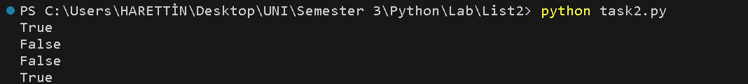

Comments:

I just made a basic function which takes x as a parameter and equals reversed x to reversed_list to check if its equal to normal one and prints true or false.

Task 3

Write a Python program to find all keys in a dictionary that have the given value.   
Sample Output:   
Original dictionary elements:   
{'Theodore': 19, 'Roxanne': 20, 'Mathew': 21, 'Betty': 20}   
Find all keys in the said dictionary that have the specified value:   
['Roxanne', 'Betty']



Comments:

I just made a basic for loop to iterate over key and values and I am looking for Betty and Roxanne keys whose values are 20 so I just print x if y equals to 20.

X – keys

Y-values

Task 4

Write a Python program that removes all duplicate elements from an array and returns a new   
array.   
Sample Output:   
Original array: 1 3 5 1 3 7 9   
After removing duplicate elements from the said array: 1 3 5 7 9   
Original array: 2 4 2 6 4 8   
After removing duplicate elements from the said array: 2 4 6 8



Comments:

I define my array as list firstly to use set() function from numpy library to clean duplicates then I turned those lists to array.

Task 5

Write a Python program to write and read a list content to and from a file. It could be comma separated file, .txt, etc, your choice.

Output:



Output:

Comments:

I defined two functions first one is reading from file and the second one is writing to file.Using the synthax of python I successfully managed to read and write from txt file.

Task 6

Write a Python program to count the frequency of words in a file. Plot the results using bar graph

Comments:

For starting I generated a lorem ipsum text from an online generator and upload it as a

word_frequency.txt you can see it on the zip. Then I opened it with f and read the text with f.read command and make it equal to text. Then I used built-in function split to separate words as a list from the text. After this step I used a for loop to check the word frequency and also I just cut the punctuations with strip and make all the words lower. I stored words in a dictionary to use if and else statements to count. Lastly I assigned keys of this dictionary to x and values to y and made a plot.

Task 7

Write a Python program to handle a ZeroDivisionError exception when dividing a number by

zero.

Comments:

Firstly I defined a function which takes dividend and divisor as parameters then checks divisor if its zero to handle ZeroDivisionError.

Task 8

Read CO2 emission file and visualize the data in at least 2 different type of charts of your choice, then save them in 3 different picture formats of your choice. The graphs should make   
logical sense and one should be able to read them.

First Visualization: Country vs Population

Output:

Comments:

Firstly I used read_csv command to read csv as data file as a dataframe and after used data.iloc to Purely integer-location based indexing for selection by position(from documentation).To take countries it was easy but to take population I needed to replace ‘,’ as empty string and define it as float type.After I used basic graph properties like labeling etc and I made a scatter plot.In the end I used savefig() command to save figures and show () command to show . Its important to save first then show otherwise the saved figures were empty.

Second Visualization: Country vs CO2 Emission

Output:

Comments:

I made this one with the same approach like the previous but in this one I just changed scatter to bar.