Wroclaw University of Science and Technology



Faculty of Electronics, Photonics and Microsystems PYTHON LABORATORY

Theme of class: Raspberry Pi, sensors, project

Student: Hayrettin Aycetin (276807)

Date of class: 29.12.2023 15:15-16:55

Group No:3

Submition Date:31.12.2023

Lab assistant: Aleksander Kubeczek, Alicja Kwaśny GRADE:

In this project my pair was Yasin Aslan(276719).He had the Rasspery Pi connected to his pc and I had Analog Discovery board connected to mine.

**SETUP**

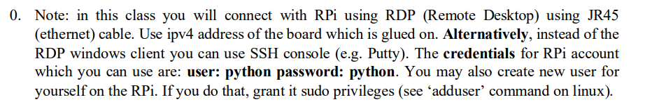

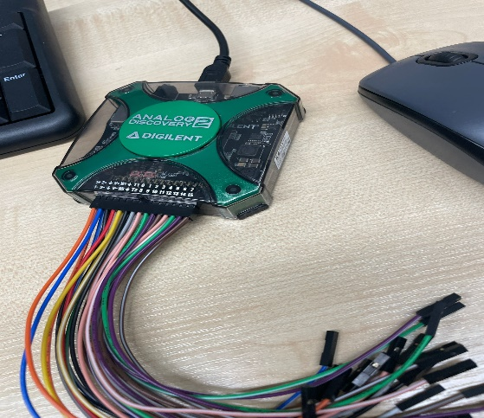

**Analog Discovery Pinout**

**Raspberry Pi Pinout for UART**

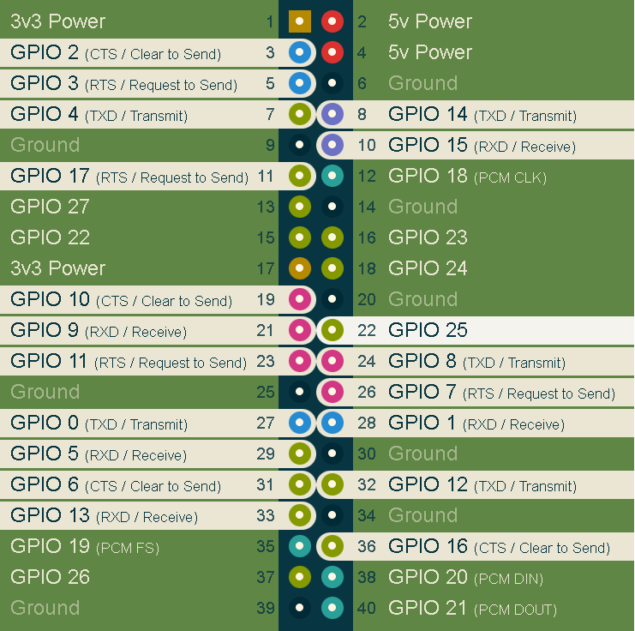

**Comments :**First we connected Raspberry Pi with using RDP (Remote Desktop) using JR45 (ethernet) cable then we used ipv4 address of the board which is glued on. The main difficulty for us was to determine the correct connections of Analog Discovery and Raspberry Pi. We connected as Input from Analog Discovery pin 7 to pin 8 on Raspberry Pi GPIO 8(TXD/TRANSMIT) ,as output from Analog Discovery we chose pin 15 and connected it to pin 10 on Raspberry Pi pin 10 GPIO15(RXD/Receive).Lastly we connected ground of Analog Discovery to pin 6(Ground) on Raspberry Pi. To understand this stage better we used description below which basically states that we need to connect inverse.

**Serial**



**Comments:** We couldn’t use the code above because we lost time on understanding the setup and instead of serial we tried to use wiringpi library but it didn’t work properly.The code above first opens a file called "humidity.txt" and reads the contents into a variable. Then, it opens the serial port at 9600 baud rate and sends the contents of the file to the device .It waits for one second and then reads one line of data from the device and prints it to the console. Finally, it closes the serial port.Basically this code is used to communicate with Analog Discovery connected to a serial port.

**ProtocolUart**

**Comments:** This whole code was provided before so basically we set our transmit to output pin of Analog Discovery which is 15 and receive to input pin of Analog Discovery but of course we connected with Raspberry Pi opposite way.



**Comments :** We have chosen temperate and humidity sensor and connected as below to our Raspberry Pi slot D5 because it was told like that in the code which we took from github.

Above I have written the code in a more clear way and readable in Visual Studio Code but I didn’t import humidity sensor library to my computer with pip install so that’s why I have that error there.

Here is the code that we wrote in Raspberry Pi.

Here we are running the code and taking the measurements from our sensor.

Here is the text file that we store our measurements.

**Comments :**In this part we had base of our script from GitHub(which is below) but we changed it a bit. Firstly we have opened a file called “humidity.txt” in write mode ,formatted our data and assigned it to data_str. Then using .write notation we wrote our data to our file.

Above is the code from Github to use our sensor.

**Comments :**Unfortunately as I mentioned before we couldn’t send our file from Raspberry Pi to our Analog Discovery Device but If we had more time I think we could do it with the codes that we wrote here.

CONCLUSION

In this lab we have learned how two devices are sending each other files via UART method. We also understood how Raspberry Pi works with sensors and how it interacts with different devices.