1. Aşağıdaki komutla derleme yapın:

**ng build --prod --base-href /coreui/**

veya

**ng build --prod --base-href /toh/**

Bu komutta geçen “coreui” ifadesi, projenin deploy edileceği server root dizini altındaki proje adıdır. (örnek: C:/wamp64/wwww/coreui)

1. Oluşturulan js ve css dosyaları ile .index.html dosyası projenizin dist isimli dizini içindeki proje adı olan dizin içinde oluşturulur:

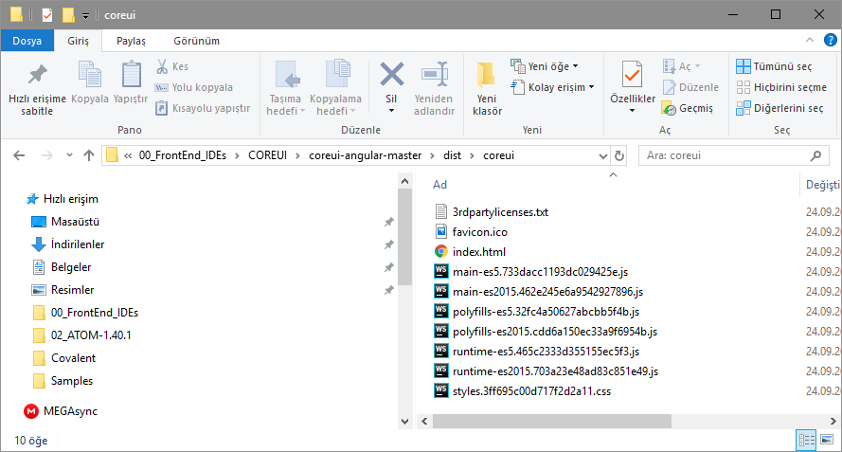

1. Yukardaki proje dizini olduğu gibi kullanılacak web server içine kopyalanır (örneğin wamp için: D:\wamp64\www\ isimli dizin içine)

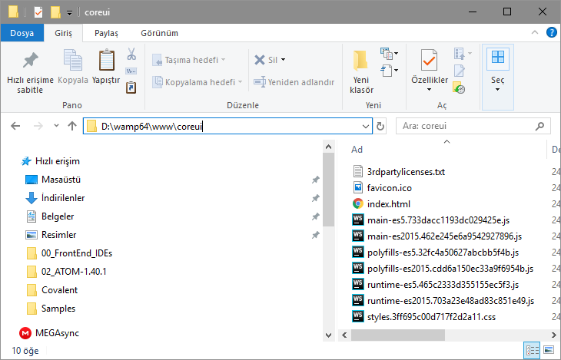

1. Wamp sunucusunu configure edin (Bknz: <https://angular.io/guide/deployment>)

There is no single configuration that works for every server. The following sections describe configurations for some of the most popular servers. The list is by no means exhaustive, but should provide you with a good starting point.

[Apache](https://httpd.apache.org/):

add a [rewrite rule](http://httpd.apache.org/docs/current/mod/mod_rewrite.html) to the .htaccess file as shown below (<https://ngmilk.rocks/2015/03/09/angularjs-html5-mode-or-pretty-urls-on-apache-using-htaccess/>):

RewriteEngine On

# If an existing asset or directory is requested go to it as it is

RewriteCond %{DOCUMENT_ROOT}%{REQUEST_URI} -f [OR]

RewriteCond %{DOCUMENT_ROOT}%{REQUEST_URI} -d

RewriteRule ^ - [L]

# If the requested resource doesn't exist, use index.html

RewriteRule ^ /index.html

1. Wamp çalıştırılır (ekranın sağ altındaki W ikonu yeşil olunca çalışsıyor demektir)
2. http://localhost/coreui/index.html ile oluşturulan proje yayımlanır.

**How to deploy to github:**

<https://angular.io/guide/deployment>

Deploy to GitHub pages

Another simple way to deploy your Angular app is to use [GitHub Pages](https://help.github.com/articles/what-is-github-pages/).

1. You need to [create a GitHub account](https://github.com/join) if you don't have one, and then [create a repository](https://help.github.com/articles/create-a-repo/) for your project. Make a note of the user name and project name in GitHub.
2. Build your project using Github project name, with the Angular CLI command [ng build](https://angular.io/cli/build) and the options shown here:

**ng build --prod --output-path docs --base-href /<project_name>/**

<Project_name>: the name of directory where the Project will be deployed under the server root. For example, if the Project will b deployed to “C:/wamp64/www/toh”

Then Project name will be “toh” and the compile command will be:

**ng build --prod --output-path docs --base-href /toh/**

1. When the build is complete, make a copy of docs/index.html and name it docs/404.html.
2. Commit your changes and push.
3. On the GitHub project page, configure it to [publish from the docs folder](https://help.github.com/articles/configuring-a-publishing-source-for-github-pages/" \l "publishing-your-github-pages-site-from-a-docs-folder-on-your-master-branch).

You can see your deployed page at https://<user_name>.github.io/<project_name>/.

Check out [angular-cli-ghpages](https://github.com/angular-buch/angular-cli-ghpages), a full featured package that does all this for you and has extra functionality.