1. Create a dir for the python project in python_apps (e.g. D:\python_apps\window_app)

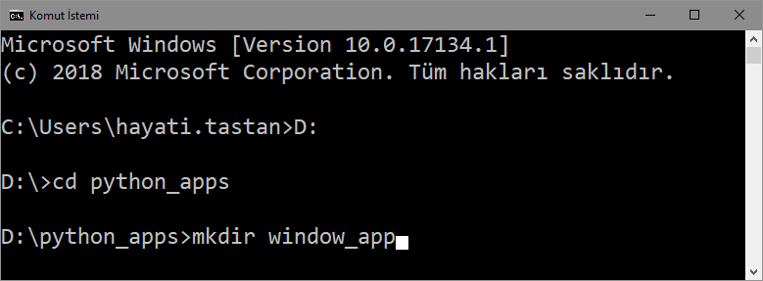

1. Create a *.ui using Qt designer in Project dir (e.g. WindowsApp_HT.ui)

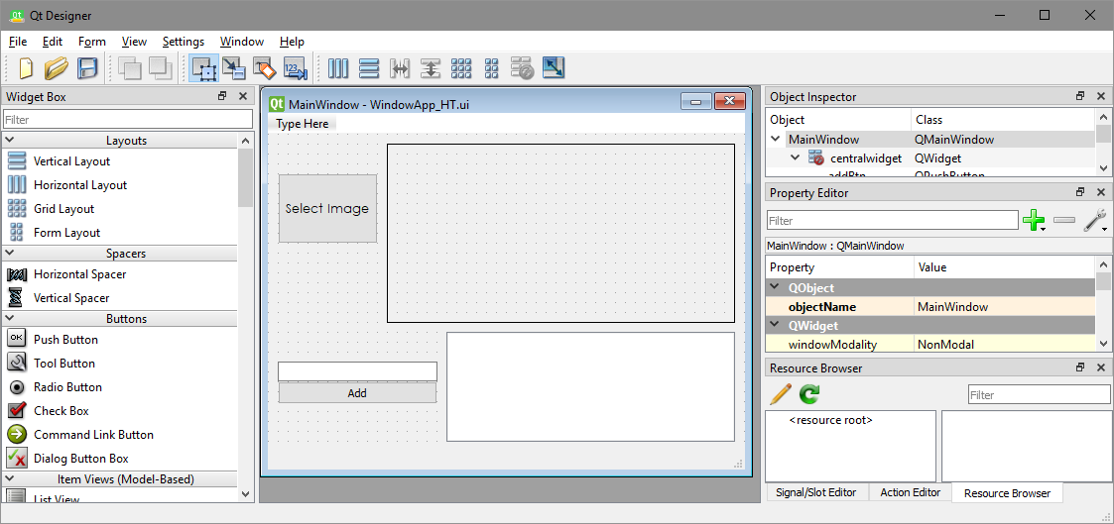

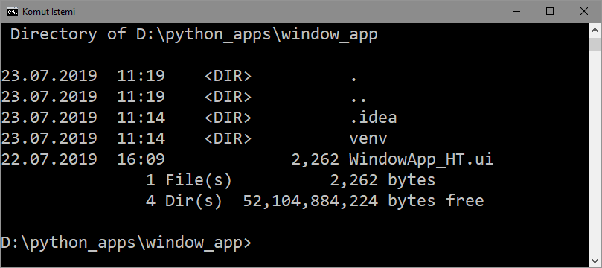

1. Convert ui to py at command prompt:

**C:\gdal\apps\Python37\Scripts\pyuic5 WindowApp_HT.ui > WindowApp_HT.py**

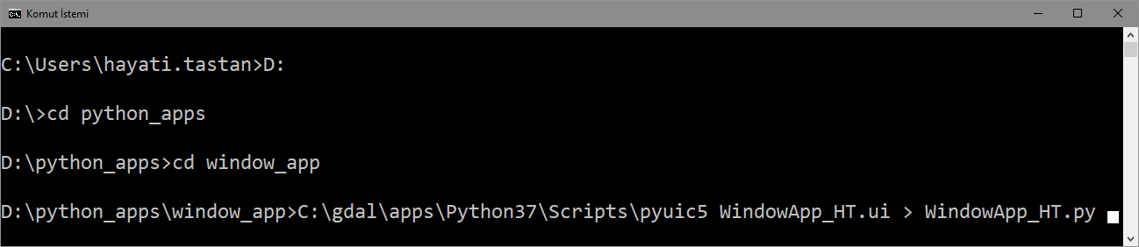

1. Create a pyCharm Project for the Project dir (e.g: C:\pycharm_apps\window_app)

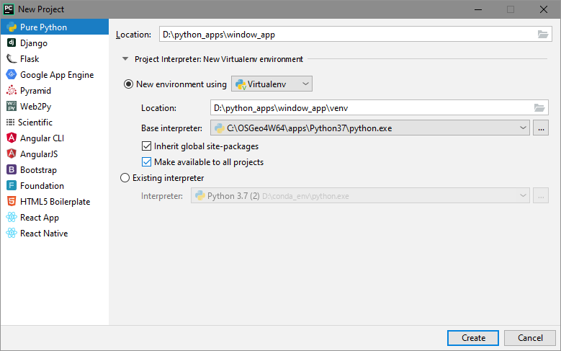

1. Copy **pycharm.bat** and **pyqgis.bat** into pyCharm Project dir

**copy ..\window_app>cp ..\define_env\*.bat .**

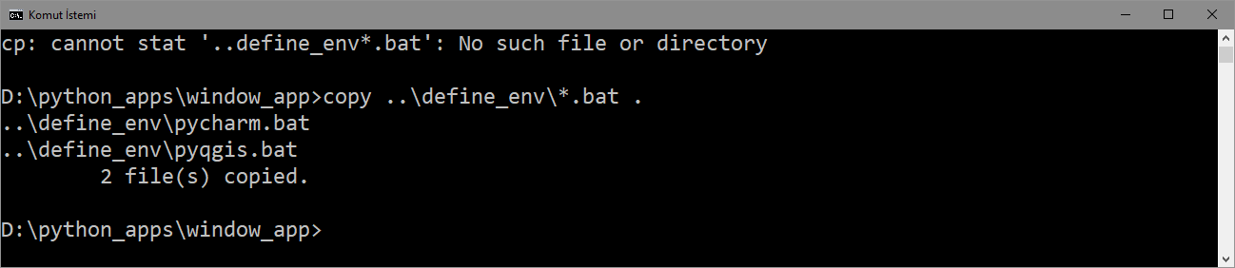

1. In pyCharm termninal

**Run pycharm.bat**

**Or:**

@echo off

SET OSGEO4W_ROOT=C:\OSGeo4W64

call "%OSGEO4W_ROOT%"\bin\o4w_env.bat

call "%OSGEO4W_ROOT%"\apps\grass\grass-7.4.0\etc\env.bat

@echo off

path %PATH%;%OSGEO4W_ROOT%\apps\qgis\bin

path %PATH%;%OSGEO4W_ROOT%\apps\grass\grass-7.4.0\lib

path %PATH%;C:\OSGeo4W64\apps\Qt5\bin

path %PATH%;C:\OSGeo4W64\apps\Python37\Scripts

set PYTHONPATH=%PYTHONPATH%;%OSGEO4W_ROOT%\apps\qgis\python

set PYTHONHOME=%OSGEO4W_ROOT%\apps\Python37

set PATH=C:\Program Files\Git\bin;%PATH%

start "PyCharm aware of QGIS" /B "C:\Program Files\JetBrains\PyCharm 2019.1\bin\pycharm64.exe" %*

cmd.exe

**run pyqgis.bat**

**or:**

@echo off

SET OSGEO4W_ROOT=C:\OSGeo4W64

call "%OSGEO4W_ROOT%"\bin\o4w_env.bat

call "%OSGEO4W_ROOT%"\apps\grass\grass-7.4.0\etc\env.bat

path %PATH%;%OSGEO4W_ROOT%\apps\qgis\bin

path %PATH%;%OSGEO4W_ROOT%\apps\grass\grass-7.4.0\lib

path %PATH%;C:\OSGeo4W64\apps\Qt5\bin

path %PATH%;C:\OSGeo4W64\apps\Python37\Scripts

set PYTHONPATH=%PYTHONPATH%;%OSGEO4W_ROOT%\apps\qgis\python

set PYTHONHOME=%OSGEO4W_ROOT%\apps\Python37

set PATH=C:\Program Files\Git\bin;%PATH%

cmd.exe

**Cd C:\python_projects\windows_app\venv\Scripts**

**path %PATH%;C:\OSGeo4W64\bin**

**Set %PATH%;**

(install required packages with pip)

**pip install --trusted-host pypi.org --trusted-host files.pythonhosted.org pyqt5**

**pip install --trusted-host pypi.org --trusted-host files.pythonhosted.org pyqt5-stubs**

**pip install --trusted-host pypi.org --trusted-host files.pythonhosted.org opencv-python==4.1.0.25**

**pip install --trusted-host pypi.org --trusted-host files.pythonhosted.org opencv-contrib-python==4.1.0.25**

**pip install --trusted-host pypi.org --trusted-host files.pythonhosted.org matplotlib==3.1.0**

**pip install --trusted-host pypi.org --trusted-host files.pythonhosted.org homography==0.1.5**

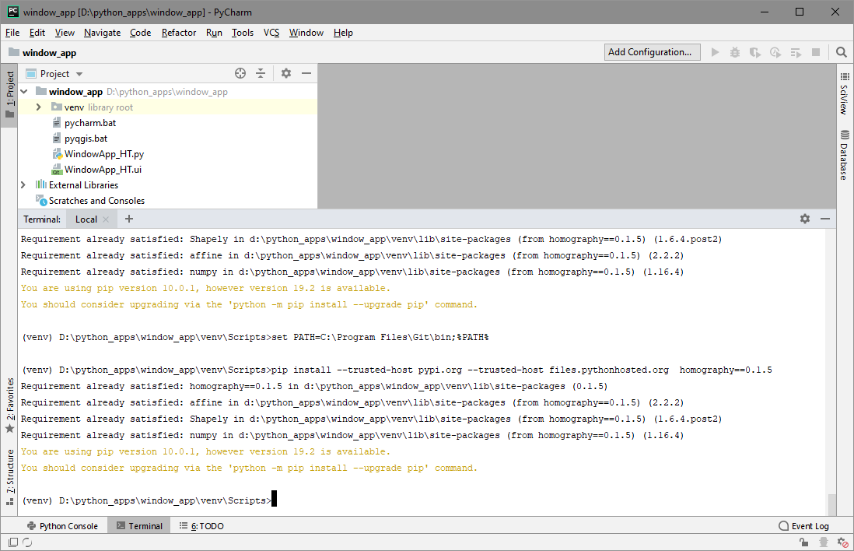

1. Run /Edit config, Templates/Python:

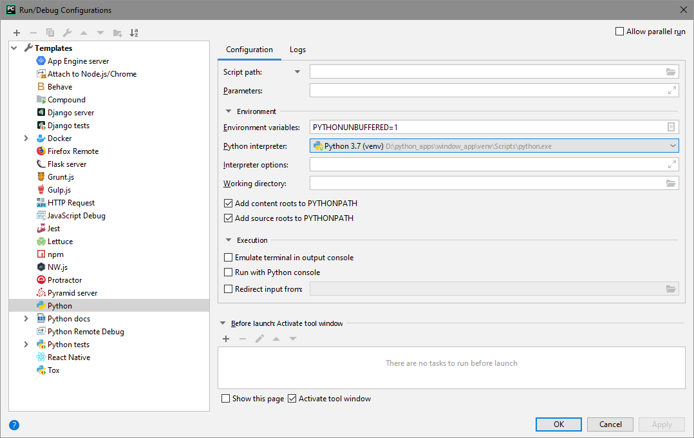

1. File /Settings, Project: window_app/Project Interpreter:

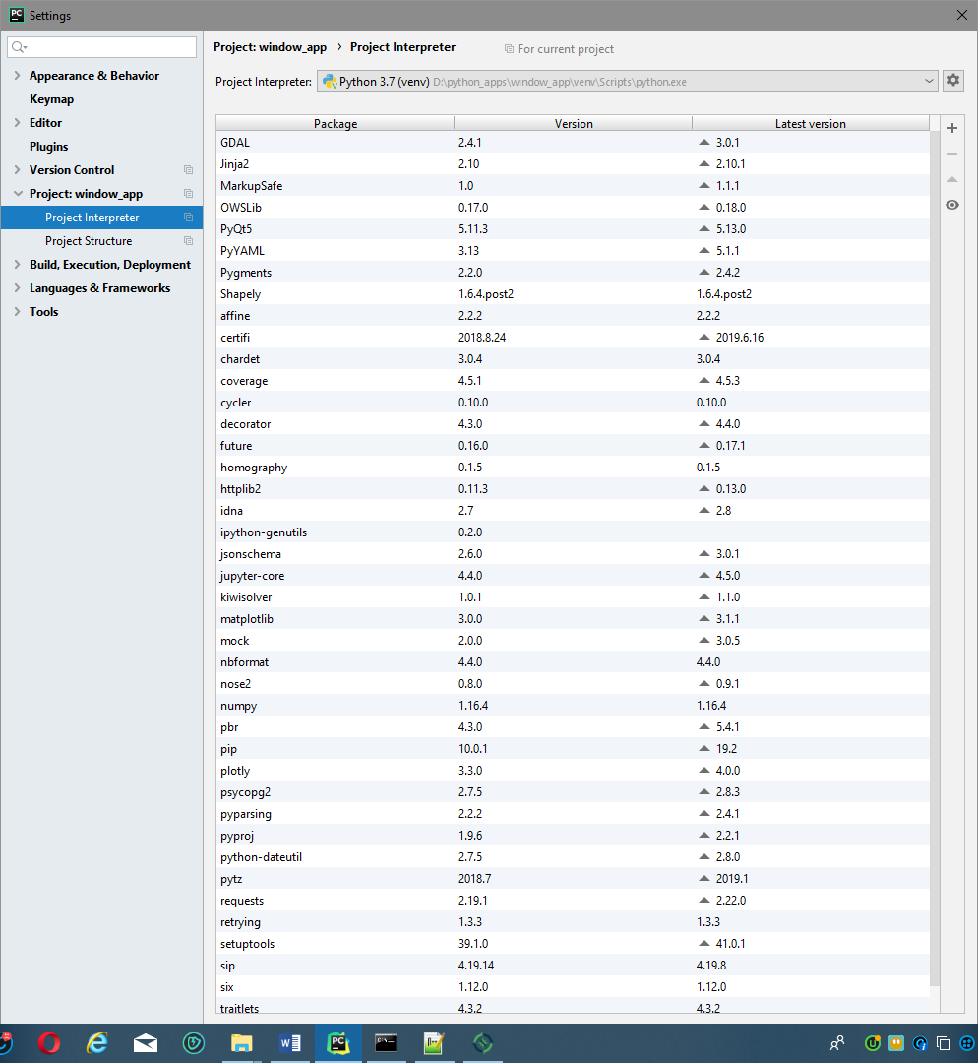

1. File /Settings, Project: window_app/Project Structure: (to see site-packages select Lib/site-packages)

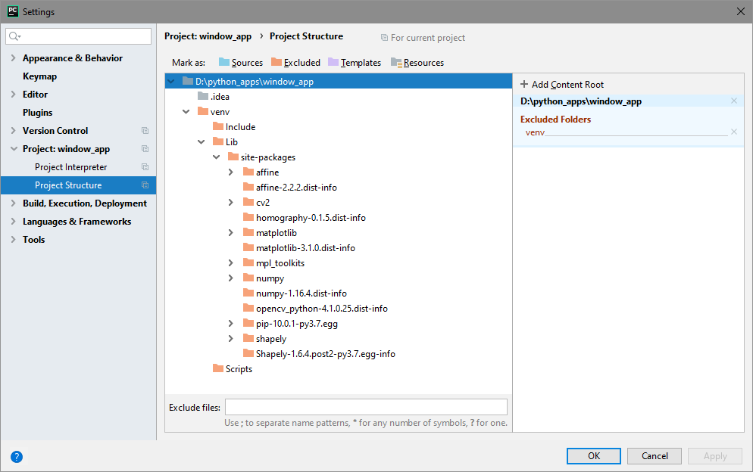

1. Run **WindowsApp_HT.py:**

