**Transferring pyCharm Project to github.com:**

**A- Connect to your github account**

1. Download **git** software “Git-2.22.0-64-bit.exe” from <https://gitforwindows.org/>
2. Install Git-2.22.0-64-bit.exe into C:\Program Files\Git
3. Define git.exe in pyCharm (Settings/Version Control/Git) as

**C:\Program Files\Git\bin\git.exe**

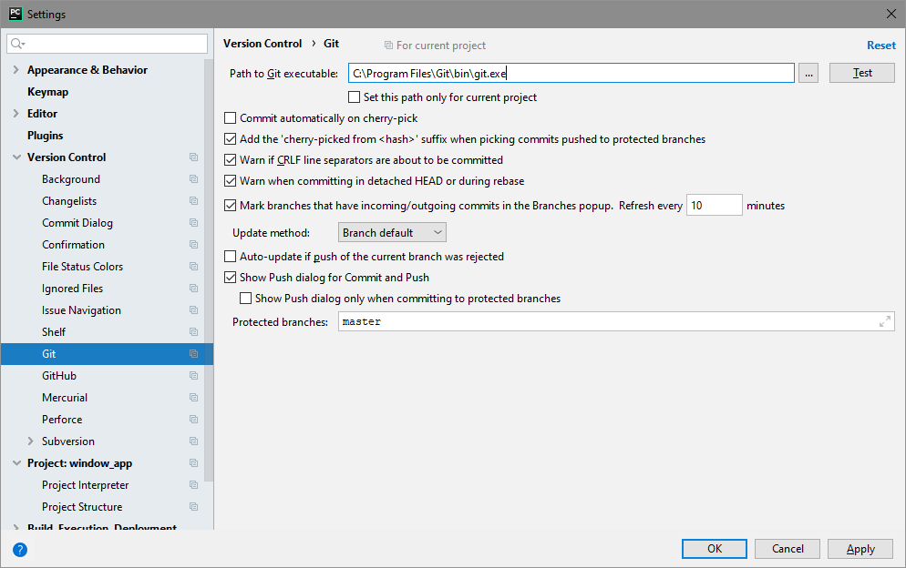

1. Define your github account in pyCharm (Settings/Version Control/GitHub):

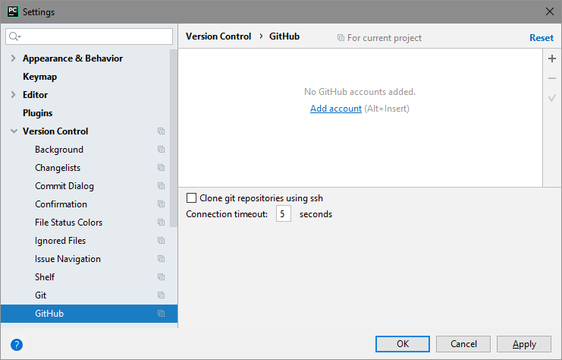

Select + sign in upper right

and enter your login (haytastan) and password (Çocuklar+KH):



Now you are connected to your GitHub account…

**B- Define settings for git in pyCharm:**

1. VCS/Enable Version Control Integration:

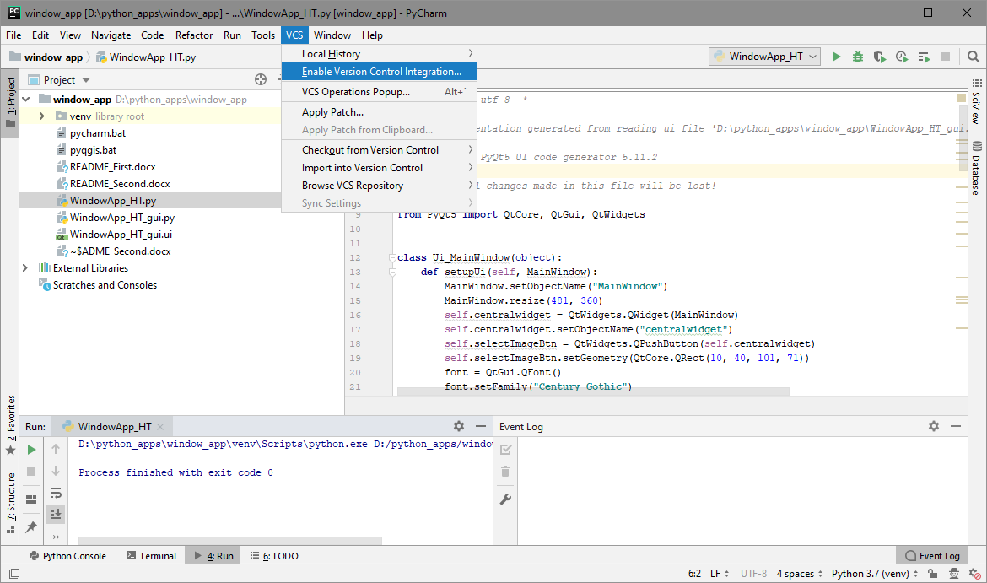

1. Select version control system as “git”:

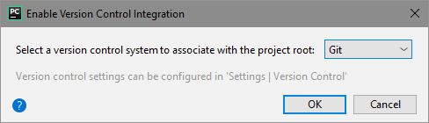

1. VCS/Import into version control/Share Project on github

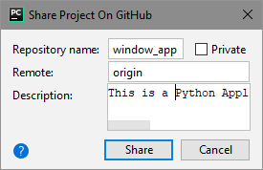

1. Add files to the GitHub repriotory “window_app” as initial commit:

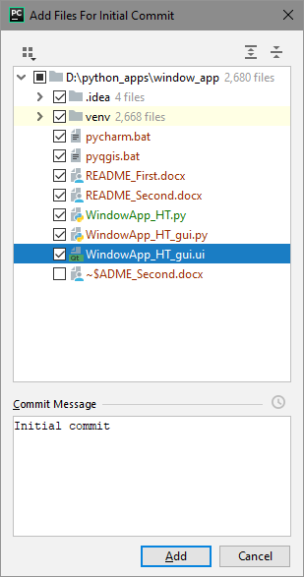

1. My account and my repositories at github.com:

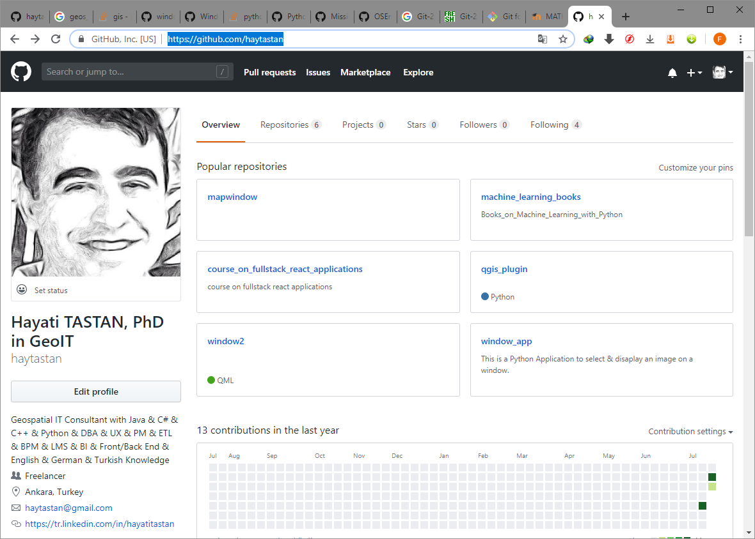

1. Let’s see new repository named **window_app** that I pushed (sent) to my account at github:

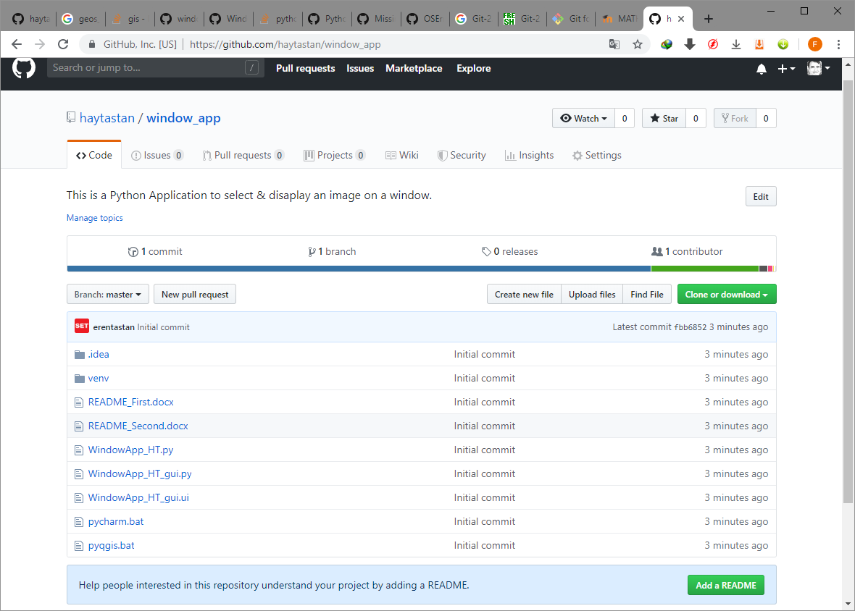

**P.A.:** This repository is public, thus it can be copied by everybody.