**D- Sending changed files (in blue) or new files (in red) to github (e.g. README_Second.doc)**

1. Select changed file (file in blue) and right click of the Mouse and select git/ Commit file from the pulldown menü):

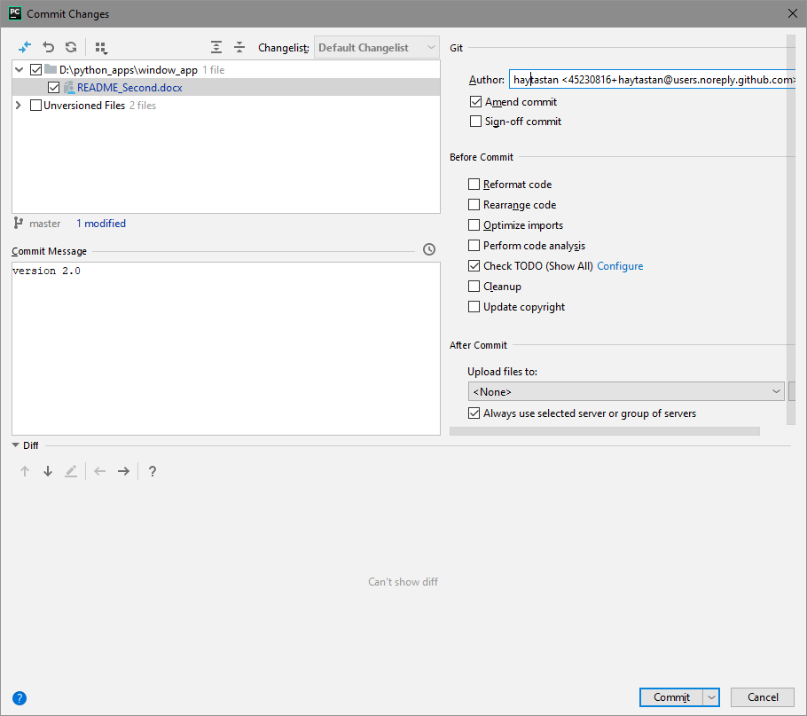

1. Select new file (file in red) and right click of the mouse and select **git/ Add** from the pulldown menu):

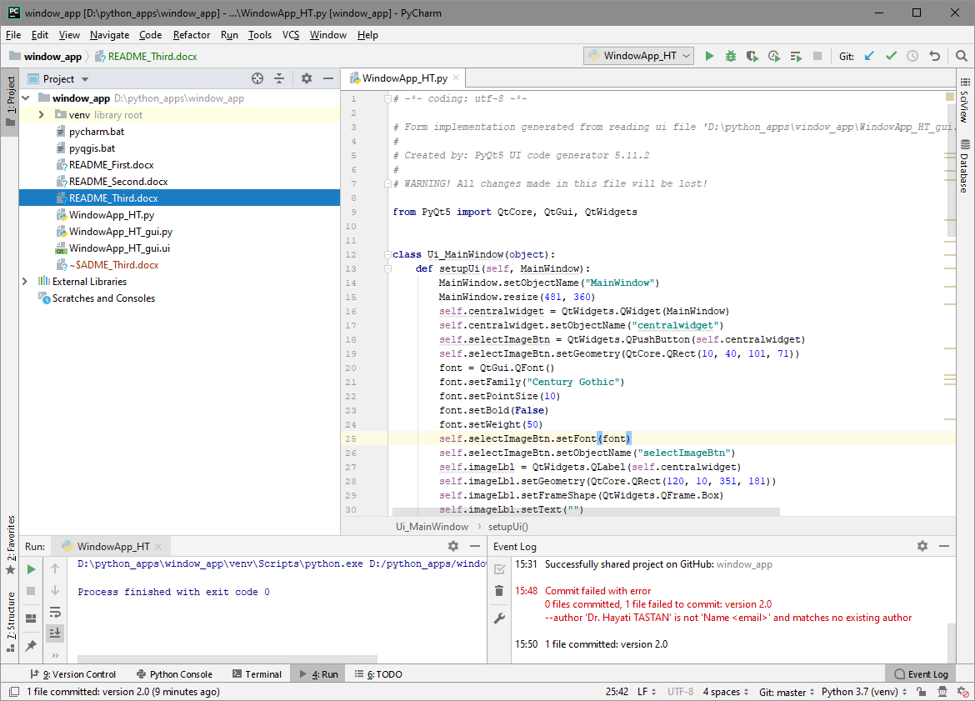

See that the file’s color changed to green (which means “ready to commit”)

1. Select the file (file in green) and right click of the mouse and select **git/ commit file** from the pulldown menu):

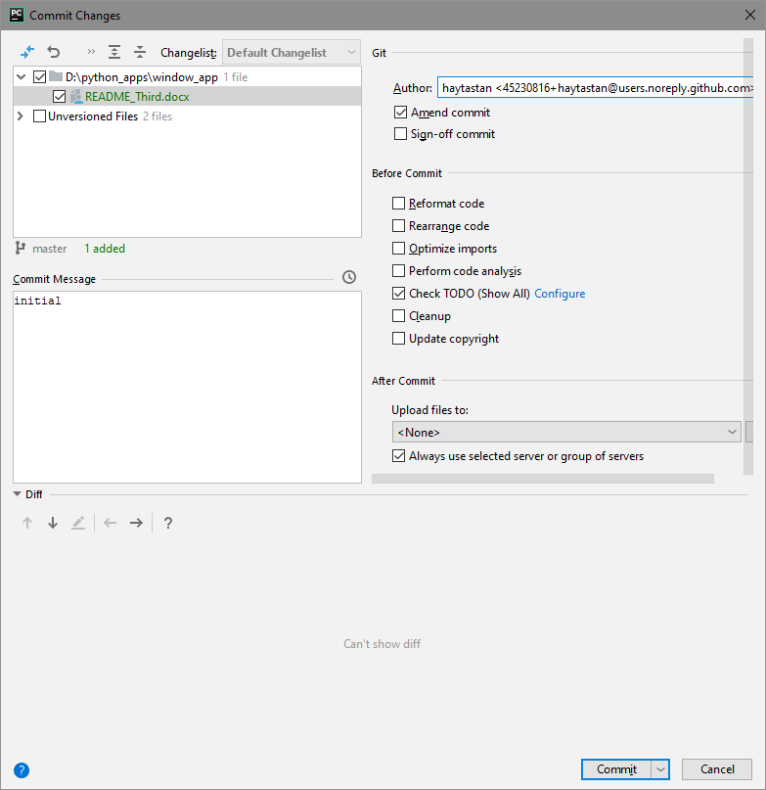

**See that all files which have been committed (sent) to github will have the color black.**

1. Sent all commits to github (VCS/Git/Push):

