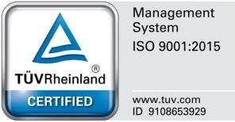Republic of the Philippines

**UNIVERSITY OF RIZAL SYSTEM**

Province of Rizal

Name of Student: ____________________________ Year and Section: ____________

Course and Major: ___________________________ College: ____________________

Campus: ____________________________ Semester/Summer 20____-20____

**CHECKLIST OF REQUIREMENTS FOR INTERNSHIP**

**Before the Internship:**

_____ 1. Parental Consent for Student Internship

_____ 2. Recommendation Letter

_____ 3. Notarized Memorandum of Agreement (MOA)

______4. Internship Contract Agreement

_____ 5. Certification of Acceptance

______6. Others: Internship Orientation

_________________

**During the Internship:**

______1. Journal/Logbook (weekly checking)

______2. Daily Time Record (monthly checking)

______3. Others: Internship IT Related Seminar

________________________

**After the Internship:**

______1. Evaluation Form accomplished by the HTE’s Representative sealed in the envelope.

______2. Certificate of Completion/Training

* with company LOGO
* with designated number of hours
* originally signed by the HTE’s Representative.

______3. Narrative report by the student intern.

Submitted: ______________________________ Date: ________________

Signature of Student

Verified: ______________________________ Date: ________________

*Printed Name and Signature of SIPP Coordinator*