LEARNING MANAGEMENT SYSTEM IN SCIENCE

OF GRADE 8 FOR JIANE THERESE

INTERNATIONAL SCHOOL

A

Capstone Project   
Presented to the

Faculty of College of Computer Studies

University of Rizal System

Binangonan, Rizal

In Partial Fulfillment

of the Requirements of the Degree

Bachelor of Science in Information Technology

NATASHA JANA SJ. CASERES

ERIKA NIÑA A. ARAGONES

JOMARI V. FLORES

JOEMARI GETIZO

JHERWIN A. JALINA

JORGE STANLEY B. TALOSIG

January 2022

**APPROVAL SHEET**

This Capstone Project entitled LEARNING MANAGEMENT SYSTEM IN SCIENCE OF GRADE 8 FOR JIANE THERESE INTERNATIONAL SCHOOL has been prepared and submitted in partial fulfillment of the requirements for the degree Bachelor of Science in Information Technology by NATASHA JANA SJ. CASERES, ERIKA NIÑA A. ARAGONES, JOMARI V. FLORES, JOEMARI GETIZO, JHERWIN A. JALINA, and JORGE STANLEY B. TALOSIG who are hereby recommended for the corresponding oral examination.

___________________ **YVES XAVIER S. CANDELARIA, MSIT**

Date Adviser

Approved in partial fulfillment of the requirements for the degree Bachelor of Science in Information Technology by the Oral Examination Committee with a rating of ___.

**MARK ANTHONY M. ZAMORA, MSIT ROWENA F. TANJUAKIO, MSIT**

Member Member

**ARISTOTLE C. MAYORCA, MSIT**

Chairman

Accepted in partial fulfillment of the requirements for the degree Bachelor of Science in Information Technology.

_________________ **JOY SG. CRUZ, Ph.D. (Cand.)**

Date Dean, CCS

# **ACKNOWLEDGMENT**

The completion of this project could not have been possible without the participation and assistance of individuals contributing to this project. The project team will like to express appreciation and indebtedness to each person who shows their endless support, kindness, and understanding during the project duration.

First and foremost, to our GOD ALMIGHTY for the guidance and encouragement, and for providing everything needed by the project team.

Dr. JOANNE S. CONCEPTION, for all your never-ending support for the College of Computer Studies, specifically in the field of research or capstone;

Dean. JOY SG. CRUZ, for all the advice and wisdom she gives to the project team;

Prof. YVES XAVIER S. CANDELARIA, the capstone advisor, for providing the project team with the assistance, encouragement, and wisdom that transcended and helped the team become knowledgeable and competent. Your supportive remarks and considerate, thorough feedback have been extremely valuable to the project team;

The chairman of the panel, Prof. ARISTOTLE C. MAYORCA, for his relentless support, suggestions, and ideas during the conduct of this project;

Prof. MARK ANTHONY M. ZAMORA, member of the panel for his knowledgeable ideas and comments for the improvement and development of this project;

Prof. ROWENA F. TANJUAKIO, member of the panel for her worthy suggestions for the improvement of this project;

Their FAMILY and RELATIVES, for the everlasting support financially and for their explicit understanding, endless love, and care them the courage to pursue this project.

-The Project Team

# **DEDICATION**

The project is sincerely dedicated to each of our parents, friends, professor, and adviser who have always served as an inspiration and source of motivation for us. gives us the willpower to persevere and inspires us to work with passion and a strong sense of determination.

We are grateful to the Lord GOD who provided us with the ability to work with wisdom and determination and who sees the good in all that we do.

To the instructors who support us, show us the way, and provide us guidance.

To our colleagues who spoke about the project and offered their thoughts and ideas. The project would not have been possible without your company, love, and support.

**Natasha**

**Erika**

**Jomari**

**Joemari**

**Jherwin**

**Jorge**

**TABLE OF CONTENTS**

|  |  |  |
| --- | --- | --- |
|  |  | Page |
| TITLE PAGE | …………………………………………………… | i |
| APPROVAL SHEET | …………………………………………………… | ii |
| ACKNOWLEDGMENT | …………………………………………………… | iii |
| DEDICATION | …………………………………………………… | v |
| TABLE OF CONTENTS | …………………………………………………… | vi |
| LIST OF FIGURES | …………………………………………………… | viii |
| LIST OF TABLES | …………………………………………………… |  |

Chapter

|  |  |  |  |
| --- | --- | --- | --- |
| 1 | THE BACKGROUND OF THE PROJECT | | |
|  |  | Introduction……………………………………………….….…... | 1 |
|  |  | Objectives of the Project ………………………….………...…. | 3 |
|  |  | Scope and Limitation of the Project…………………...…….… | 4 |
|  |  | Significance of the Project………………………………….…… | 4 |
|  |  | Definition of Terms……………………………………………… | 5 |
|  |  |  |  |
| 2 | Review of Related Literature | | |
|  |  |  | 17 |
|  |  | Related Literature and Study……………………………………. | 7 |
|  |  |  |  |
| 3 | Methodology | | |
|  |  |  |  |
|  |  | Research Development Framework | 16 |
|  |  | Locale of the Project | 18 |
|  |  | Subject of the Project | 19 |
|  |  | Procedures of the Project | 20 |
|  |  |  |  |
|  |  |  |  |
|  |  |  | Page |
|  |  |  |  |
| BIBLIOGRAPHY ………………………………………………………..…… | | | 21 |
|  | | |  |
| APPENDICES…………………………………………………………….…. | | | 23 |
|  |  |  |  |
|  | A | Gantt Chart of Activities………………..………………………… | 24 |
|  |  |  |  |
|  | B | Project Team Assignment Form………………………………… | 25 |
|  |  |  |  |
|  | C | Letter of Permission to Conduct the Project…………………... | 26 |
|  |  |  |  |
|  | D | Approved Project Title Form ……………………………………. | 27 |
|  |  |  |  |
|  | E | Letter of Acceptance of the Adviser and Panel………………… | 28 |
|  |  |  |  |
|  | F | User Acceptance Evaluation Questionnaire ..………………… | 29 |
|  |  |  |  |
| CURRICULUM VITAE ……………………………………………….…..… | | | 32 |

# **LIST OF FIGURE**

|  |  |  |
| --- | --- | --- |
| Figure |  | Page |
|  |  |  |
| 1 | A Project Development Framework for the Development of Learning Management System in Science for Grade 8 for Jiane Therese International School ……………………………………… | 17 |
|  |  |  |

**CHAPTER 1**

**THE BACKGROUND OF THE PROJECT**

**Introduction**

Education is one of the most important elements in each one’s life. Education is a procedure of learning where knowledge, skills, and habits are passed from one generation to another. It helps a person to analyze while making important decisions in life. Moreover, education is essential for the overall development of a human being.

In addition, education plays important role in the development of a country. The topic of the importance of education in daily life has to admit that it improves personal lives and helps in running societies smoothly by using what it gives to people and most people say that education is the key to a better life because it is a powerful weapon to change society.

Education starts at home where parents encourage and support children to learn new things like writing, reading, drawing, and even identifying colors, alphabets, and numbers. And there’s a time when children have to go to school and socialize turned into a student. That’s how education evolves widely from a child to a student and will defend how the school teaches, either in a traditional way like face-to-face discussion, or the modern way like blended learning where the student will use technology and the internet. Presently, education evolves together with other industries with high technology like using computers because it is useful due to the advanced method of learning.

The computer is one of the most impressive inventions for the present and future generations. Computers are now widely used and are considered one of the most brilliant creations of technology as they took a big role in our society majorly in the aspect of manipulation of data and converting it into detailed information. One of the functions of a computer is to manage files and record data, and many computer application systems enable users to do such things including management information systems and a web-based system like Learning Management System (LMS).

A Learning Management System (LMS) is a piece of online software that is used to create, deliver, track, and report on educational courses and outcomes. It can be used to support both traditional face-to-face instruction and blended/hybrid/distance learning environments.

With the rapid progress in technology and the advancement in learning systems, it is now embraced by the masses. The introduction of computers was the basis of this passage of time, as we get hooked on smartphones, tablets, etc., these devices now have an important place in the classrooms for learning. Books are gradually getting replaced by electronic educational materials and knowledge can also be shared via the internet, which is accessible anywhere anytime that is an advantage to a student going to school, and many schools need to have an educational system that is easier to access and saved time and resources for efficiency, and one of these is Jiane Therese International School.

Jiane Therese International School was established twenty-two years ago exactly in the year 2000. It was managed and highly maintain by the married couple, Dr. Belina C. De Vega and Mr. Enrico Z. De Vega. It has approximately 408 student population. The school provides preschool to high school education. As the school operates, it faced some difficulties in getting the attention of the students to focus on their studies and one of the subjects is science. The project team focuses on that subject at the 8th-grade level.

With the occurrence of the problem encountered by Jiane Therese International School, the project team was encouraged to propose an E-Learning system that will assist the instructor or teachers in their teaching methods and will get the attention of the students to learn more about Science, especially in Grade 8.

**Objectives of the Project**

The general objective of the project is to develop a Learning Management System in Science for Grade 8 of Jiane Therese International School located at Jala-Jala, Rizal, for the school year 2022-2023.

Specifically, the project aimed to:

1. Determine the propose system with the quality assurance test plan by at least a 95% rate of success.
2. Determine the user acceptance level of the propose system in the matter of Functional Suitability, Performance Efficiency, Usability, Reliability, Security, and Maintainability.

**Scope and Limitation of the Project**

The project immerses in the development of Learning Management System in Science of Grade 8 for Jiane Therese International School located at Jala-Jala, Rizal, during the academic year 2022-2023.

The system will develop using Visual Studio Code and MySQL Workbench. The LMS will be having two user types which provide varying levels of restriction for admin and users. Admin can access viewing and maintain the list of lessons, activities, and tasks, review and manage results, maintain the system’s settings, and view and print reports. The users or the students can access the list of lessons, take activities and tasks, review the results, and return to the past lesson and take another activities and tasks.

The project team makes use of the software development life cycle waterfall model as the project development framework. The respondent to the project has a sample of eighteen (18) which includes seventeen (17) grade 8 students from the total population of 400 students and one (1) teacher who is teaching Science subjects from Jiane Therese International School. Since students will be the project's end users, Purposive Sampling is used to properly select a respondent for the project.

**Significance of the Project**

The following will benefit from this project and the science-focused online course created for the Jiane Therese International School:

The Grade 8 students. The system will give the students an additional tool to aid in their understanding of the science courses and exercises.

Jiane Therese International School (JTIS). The project team came to the conclusion that using LMS to teach science to grade 8 students at JTIS improves their academic performance and learning capacity, which may be advantageous for the institution.

Teachers. This project can help school instructors or teachers. The teachers can recommend E-Learning in science for the students to take a lesson ahead of time or self-study.

Project Team. The team will gain experience in the procedures of creating an E-Learning for a specific institution through this project. In relation to this, it showcases the importance of information technologies to human life specifically in the educational institution.

Future Project Team. The project is used as a model or starting point for creating a related or comparable capstone project.

**Definition of Terms**

To provide a clear medium of communication between the proponents and the readers, the following terms, are defined conceptually and operationally:

Administrator or Admin. A person whose job is to manage a company, school, or other organization.

LMS. Learning Management System is an online system that used to support both traditional face-to-face instruction and blended/hybrid/distance learning environments.

JTIS. Jiane Therese International School is located at Jala-Jala, Rizal.

MySQL Workbench. A visual tool for databases that manipulate data tables or information about a certain subject.

Online Learning. A type of distance learning that refers to the use of electronic media and information and communication technologies and education.

QA Test Plan. Quality Assurance Test Plan is a type of testing process that was used by the project team to ensure that all the features are met and all the needed information is present in the system.

Visual Studio Code. A source-code editor made by Microsoft with Electronic Framework, for Windows, Linux, and macOS. It redefined and optimized for building and debugging modern web developers.

Functional Suitability. The system meets the needs and requirements of the user.

Performance Efficiency. Determine and evaluate the system.

Usability. The usefulness of the system.

Reliability. Concern with the consistency of the system.

Security. Deal with the security or privacy of the user.

Maintainability. Keeping and managing the system.

**Chapter 2**

**REVIEW OF RELATED LITERATURE**

Education is both the act of teaching knowledge to others and the act of receiving knowledge from someone else. Education is also a powerful tool that teaches people their rights and responsibilities to their families, society, and nation. You can broaden your vision and outlook to see the world around us. It alters our outlook on life and powerful motivator of development and is one of the strongest instruments for reducing poverty and improving health, gender equality, peace, and stability. Through generations, education is improving in a way that is convenient and easy for everyone and one of that is Learning Management System.

**Learning Management System**

According to Oliveira (2012), the potential that IT offers may make e-learning closer to the classroom mode in relation to personal interaction and preserve the distance between teachers and students, in order to improve the process of mediated communication, systematic guidance, and constant monitoring focused on the formation of skills and attitudes that allow the student to have learning process autonomy in a continuous self-education.

In this context, IT provides progressively greater flexibility and accessibility to education, culture, and professional and personal development, contributing to the creation of educational systems.

The first LMS appeared in the nineties, along with the first web browsers. According to Silva (2013), Learning Management Systems are often criticized, due to the belief that these technologies simply virtualize non-virtual classrooms. However, according to the author, they are not the main problem, but the way they are designed, structured, and crafted.

Furthermore, the use of an LMS requires careful studies, particularly in relation to educational and financial aspects.

Bach et. al., (2013), in turn, performed a systematic review of the Brazilian scientific production on the use of IT in education between 1997 and 2011 and verified that there are large concentrations of studies on the implementation and management of distance learning courses, use of IT in education, quality evaluation and satisfaction in using an LMS, pedagogy and didactics in the distance learning content, evaluation of professional skills and competencies related to distance education and contributions of IT to teaching and learning. For them, it reflects the transition of many universities to distance education as well as the existing arguments over their advantages and limitations.

Van de Vord and Pogue’s (2012) research suggests that while face to face

instruction requires more time per student, and certain aspects of online teaching take considerably more time per student than in a face-to-face classroom. Instructors do value tools within the learning management system and overall feel value from its interaction. They especially value the ability to transmit documents and efficient communication enabled through the system.

In the final analysis, online learning is beneficial to the students, tutors, and the institution offering these courses and teaches students how to manage their time better since the student bears the responsibility of engaging with the course instead of simply showing up to class on an assigned day and time.

As a result, students not only gain knowledge from the coursework but also sharpen their time management skills. The project team would therefore recommend that online learning be implemented in all learning institutions and research on how to improve this learning process should be carried out.

**Computer Technology**

Computer technology varies on how each individual use and manages it. It can be in education, discovering factors and accomplishments in science, or out-of-this-world breakthroughs.

According to Paje et. Al. (2021), computer-based technology (CBT) in science instruction is a trend in the 21st -century learning. Teachers utilized CBT in instruction to improve their teaching which significantly uplifts students’ learning interests and concept understanding. However, teachers encounter difficulties due to low ICT literacy, unstable internet connection, and power interruption, and sometimes they find it too expensive to use the CBT.

The study recommends an ICT training workshop and encourages teachers to utilize appropriate CBT instruction based on the context of the students. The findings have important implications for policy development and curriculum enhancement.

Gilakjani (2013) identified some of the key factors contributing to the use of computer-based technology by teachers. The study discussed computer self-efficacy, explain the teaching experiences and develop insufficient computer technology support. The ultimate goal is to investigate professional development in computer technology integration.

Computer-based technology has infiltrated many aspects of life and industry, yet there is little understanding of how it can be used to promote student engagement, a concept receiving strong attention in higher education due to its association with a number of positive academic outcomes. With the intent of increasing understanding of how computer-based technology may be purposefully implemented to achieve the greatest gains in student engagement (Schindler et. Al. 2017).

As also claimed by Hbaci et. Al. (2020) computer technology showed levels of perceived competency in each skill area differed significantly from perceived competence in each of the other areas and statistically significant difference between educators who are from technical disciplines and non-technical disciplines in overall competence in using computer technologies. Furthermore, it showed that educators in technical disciplines expressed more competence in basic and advanced computer operations.

This comparison indicated a need to tailor training and implementation efforts to the needs of educators in various disciplines rather than using a standardized approach. The supplemental data using an open-ended question presented the type of support Libyan educators need to improve their teaching using computer technology.

Rakhimova et. Al. (2016) also stated that the cognitive activity of students under which the authors understand the process of creative knowledge of foreign culture is increasing with the use of computer technologies. Thus, this process changes the general educational purposes of humanities. In accordance with the study that the authors enumerate the main skills and abilities required from the teacher who uses computer technology in a sociocultural environment.

On the whole, the level of sociocultural competence can be advanced with the help of computer technologies as it provides wide opportunities for students to take part in joint-work international projects.

As stated in Section 10. Article XIV of the Constitution of the Republic of the Philippines:

“Science and technology are essential for national development and progress. The State shall give priority to research and development, invention, innovation, and their utilization; and science and technology education, training, and services. It shall support indigenous, appropriate, and self-reliant scientific and technological capabilities and their application to the country's productive systems and national life.”

The preceding article discusses the application of technology in various aspects that contribute to the country's continuous progress. When it comes to science and technology, organizations must innovate for the betterment of the institution. The development of an information system for an educational institution can provide progress and innovation with the mentioned legal basis.

The project team was brought to the conclusion that computer technology varies in aspects in every little thing in modernization about technology in this generation. Computer technology is also one of the biggest strengths of today’s society and nation’s progress.

It is either education that helps learners and educators to improve the way they received and provide knowledge and wisdom or another profession that benefits in every aspect that could help each person to contribute to the world using computer technology.

**Software Quality and Testing**

Software quality is the degree to which a product incorporates a set of desirable qualities that have been established by the industry to improve performance over time. In this definition, it is emphasized that a product has an initial existence and that its quality has a temporal component. Aspects that will enhance the product are also highlighted. Last but not least, the functionalities must be integrated from the beginning rather than added after the fact using customer demands or other comparable criteria.

According to Roshan et al. (2012), in the context of the success of testing pursuit highly depends on the effectiveness of the test cases. Various approaches have been proposed to ease the task of test case generation and to perform software testing. It has witnessed a paradigm shift from manual test case generation to automated test case generation in recent times. Search Based Software Testing (SBST) has evolved as a new domain in software testing. This paper reviews the various Search-Based Software Testing approaches, foresees trends in the research being conducted in this area, and explores the new possibilities that future of the software testing envisages. This paper presents an exhaustive survey on Search-Based Software Testing and also touches upon the other disciplines of modern-day computing which seamlessly overlap with SBST.

As stated by Gautam et al. (2022), software testing automation is an approach that can be successfully used in software engineering. On the other hand, they discovered 48 main research papers for each different machine learning-based software testing approach. This demonstrates how the model uses the data to inform its learning and prediction processes. They discovered that the most common use of machine learning was for the purpose of developing, improving, and evaluating test cases.

Software testing is focused on meeting user expectations and delivering high-quality products. In particular, because software testing has been shown to be a crucial activity in the software development life cycle, practitioners have found that they need to define and use various testing methodologies and procedures in order to guarantee the quality of their software. In other words, this means that in order to facilitate the creation of systems to be utilized in a range of various situations, the evolution of software products presented new obstacles for people involved in software testing.

As also mentioned by Foidl and Felderer (2016) that software quality assessments, based on quality models, already describe the product-related risks of a whole software product and provide objective and automation-supported assessments. But so far, quality models have not been applied for risk assessment and risk-based testing in a systematic way. The case study shows that a risk-based testing strategy outperforms lines of code-based testing strategies with regard to the number of defects detected. Moreover, a significant positive relationship between the risk coefficient and the associated number of defects was found.

As also mentioned by Murugan et. Al. (2013), software development and maintenance are used to make error-free Software and also concentrate on time-consuming and complex activities. Evaluating the quality of a software product and keeping its level high is much more difficult than doing them for other industrial products. For maintaining the quality, performance, speed, efficiency, and cost of the software. The Software Quality Assurance activities, principles, and methods are implemented in the early stages of software engineering development phases.

In further understanding, Software Testing is the process of evaluating a software program to ensure that it performs its intended purpose. Software testing verifies the safety, reliability, and correct working of the software. The growing need for quality software makes software testing a crucial stage in Software Development Lifecycle. There are many methods of testing software, however, the choice of method to test a given software remains a major problem in software testing. Although, it is often impossible to find all errors in software, employing the right combination of methods will make software testing efficient and successful. Knowing these software testing methods is the key to making the right selection. This paper presents a comprehensive study of software testing methods.

An explanation of Testing Categories was presented first, followed by Testing Levels (and their comparison), then Testing Techniques (and their comparison). For each Testing Level and Testing Technique, examples of some testing types and their pros and cons were given with a brief explanation of some of the important testing types. Furthermore, a clear and distinguishable explanation of two confused and contradictory terms (Verification and Validation) and how they relate to Software Quality was provided (Mubarak Umar 2020).

The project team came to an end with that it has been shown that software testing is a crucial step in the process of developing software. From the project team's perspective, the software testing process streamlines the entire process and guarantees the high quality of the final output. Additionally, the application's usability and functionality are enhanced, and maintenance expenses are reduced.

**CHAPTER 3**

**METHODOLOGY**

**Research Development Framework**

In order to carry out this project, the project team uses a system development life cycle sashimi waterfall model.

The sashimi waterfall model will decide whether the web-based system is successfully implemented. In any situation, the developer must follow a comprehensive development plan to ensure the least amount of time and finance is spent when creating the web-based system.

The system development life cycle sashimi waterfall model by Jim Rising (2009) consists of six (6) stages including Requirements, Design and Architecture, Development and Coding, Quality Assurance & Software Testing, Implementation, and Maintenance & Support.

The first stage is the Requirements, which consist of gathering information about the project required to start the basic information about the development of the project.

Second is the design and architecture, during the design and architecture phase of the project, sponsor the functional and/or technical definition of the project. At times tools such as wireframes and/or storyboards are used in order to help the architect to communicate with the developers and the project sponsor.

The third is the development and coding, the phase is the most time-consuming and most expensive. The ‘development and coding’ phase overlaps

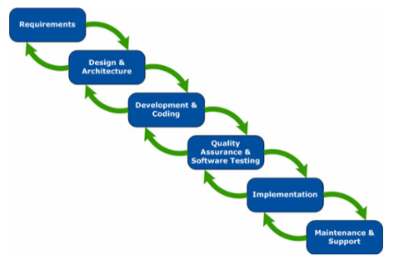

**Figure 1**

Project Framework of the Development of Learning Management System in Science for Grade 8 for Jiane Therese International School

with the ‘design and architecture’ phase until this phase fulfills the requirements of the one prior to it.

The fourth is quality assurance and software testing which is the most obvious improvements to the waterfall model when using Sashimi during the testing phase. Because of the iterative approach of Sashimi, testing occurs as part of the development process, and then again as part of the deployment process.

The fifth stage is implementation; this is the phase of the project where the developed software is installed (or deployment scripts are delivered), documentation is written or cleaned up (as documentation should be written as an ongoing part of the development process), and sometimes client training will occur.

Lastly, the sixth stage is maintenance and support, After the project is released into the wild, bad things can happen. This is why it is important that continued maintenance and support are addressed within any software development process.

The sashimi model of the system development life cycle is a suitable project development framework for the project since it helps shorten the development time. People with different skills can start working without waiting.

**Locale of the Project**

The lack of private schools in Jala-Jala and its neighboring towns and barrios became a big concern for Dr. Belina C. De Vega, a dentist by profession, and thus moved her to conceive the idea of building a school in Jala-Jala, Rizal. Along with her supportive lifetime partner, Enrico De Vega, the founder took the courage and the challenge to open a school at Linis, Sipsipin, Jala-Jala, Rizal.

The school was established and was operational in June 2000 with 35 pupils in its first year, it grew to 81 in its second year, 150 in its third year, 180 in the fourth year, and 244 in its fifth year. The enrollment profile was encouraging enough, for growth and expansion. Parents, who were satisfied with the academic achievement and the Christian values formation received by their children, paved the way to open complete elementary and high school.

Together with their supportive relatives, co-administrators, faculty, and parents. Dr. Belina C. De Vega acknowledges the untiring and benevolent support of her father, Jesus Cubilla, for her school, and has appointed him the school President. Jiane Therese International School continues to soar high and provide quality education for students that persist to reach their dream and goal in life.

**Subject of the Project**

The respondent to the project has a sample of eighteen (18) which includes seventeen (17) grade 8 students from the total population of 400 students and one (1) teacher who is teaching Science subjects from Jiane Therese International School. Since students will be the project's end users, Purposive Sampling is used to properly select a respondent for the project.

The project's proponents concluded that the teachers, who handled and taught science to students in Grade 8 at the school, would be able to assess the project's acceptance.

**Procedures of the Project**

A good capstone project is one that is scientific and systematic: with this, the project team has followed the step-by-step procedure for conducting this study.

The project team began by consulting their capstone project instructor and afterward, they conducted brainstorming ideas on possible system titles.

Subsequently, they conducted a series of interviews which helped them identify the problems of different businesses and organizations. Based on these interviews, the proponent came up with proposed system titles.

These system proposals were considered by the panel during its title defense. The panel then picked the best title among those presented by the researchers which is the E-learning in Science of Grade 8 for Jiane Therese International School in Jala-Jala, Rizal.

The project team then proceeded to the gathering of data and system requirements then they started working with Chapters 1 and 2. After that, the researchers consulted with their thesis adviser to check for errors in the manuscript.

Then, the project team started the development of Chapter 3, then several revisions of the manuscript were done. It was then checked and finalized in preparation for the colloquium or pre-oral defense.

During the colloquium, the project team presented their proposal to the panel which provided them with valuable feedback and criticism. Based on other various recommendations of the panel, the researchers revised the manuscript and finalized it and then submitted the soft bind copy of the manuscript to their capstone project instructors.

**BIBLIOGRAPHY**

A. INTERNET

Bach et. al. (July 2013), Information and communication technologies in education: a bibliometric and sociometric study of 1997-2011 https://www-scielo-br.translate.goog/j/aval/a/zsxWNc3WxRvZ4kSdkkSfBHj/abstract/?lang=pt&_x_tr_sl=pt&_x_tr_tl=en&_x_tr_hl=en&_x_tr_pto=sc

Foidl and Felderer (November 2016), Integrating software quality models into risk-based testing <https://link.springer.com/article/10.1007/s11219-016-9345-3>

Gautam et. Al. (2022), Review on Software Testing Using Machine Learning Techniques <https://iopscience.iop.org/article/10.1149/10701.3393ecst>

Gilakjani (2013), Factors Contributing to Teachers' Use of Computer Technology in the Classroom <https://eric.ed.gov/?id=EJ1053908>

Hbaci et. Al. (July 2020), Evaluating higher education educators’ computer technology competencies in Libya <https://link.springer.com/article/10.1007/s12528-020-09261-z>

Murugan et. Al. (September 2013), A Literal Review of Software Quality Assurance <https://d1wqtxts1xzle7.cloudfront.net/57941854/f7dd33cd71cbba1d56eb8a250835f4966958-with-cover-page-v2.pdf?Expires=1667497250&Signature=LnfFl5mpMnRXghwIBH1yY3NXSfW-VYHVz6R-V7bePj9vv34~w0pSK-UeP60i66LjbM~p9cgp~eXV7~cGmMkh07T5OJjVupTBKR8LnpO8WvH8rd6fRSRzWWg3MzkcYNdkqqGT8XBFtOocYXxELKCnmLQQLG1TmISePKfn55Eh4fB~10yV0i7rd~QoYoJ7JZvay-hKqSrk2E9ZH7ZOo0SlyPV3AUnh87ZniX0XFz-5W9UpUqzMzebTdRSCBPJHx9eFjYUHMdka1p8hCqnmIeefvz8sy51eGsQ-3KbgZxKGVKE8Iv1mqR09FstufNQ~EYAzNxSfrdarUGymzTqc9qwtMw__&Key-Pair-Id=APKAJLOHF5GGSLRBV4ZA>

Oliveira et. al. (August 2016), Learning Management Systems (LMS) and E-Learning Management: An Integrative Review and Research Agenda https://www.scielo.br/j/jistm/a/TT3Pk4mwkp5Cmmbf4NbfPvw/?lang=en&format=pdf

Paje et. Al. (June 2021), Teachers’ Utilization of Computer-Based Technology in Science Instruction <https://files.eric.ed.gov/fulltext/EJ1311479.pdf>

Rakhimova et. Al. (March 2016), The Development of Sociocultural Competence with the Help of Computer Technology <https://link.springer.com/article/10.1007/s10780-016-9279-5>

Roshan et. Al. (August 2012), Review of Search based Techniques in Software Testing <https://research.ijcaonline.org/volume51/number6/pxc3881387.pdf>

Schindler et. Al. (October 2017), Computer-based technology and student engagement: a critical review of the literature <https://educationaltechnologyjournal.springeropen.com/articles/10.1186/s41239-017-0063-0>

Umar, Mubarak (June 2020), Comprehensive study of software testing: Categories, levels, techniques, and types <https://www.techrxiv.org/articles/preprint/A_Study_of_Software_Testing_Categories_Levels_Techniques_and_Types/12578714>

Van de Vord and Pogue (May 2012), Teaching time investment: Does online really take more time than face-to-face? https://www.learntechlib.org/p/49702/

**APPENDICES**

**APPENDIX A**

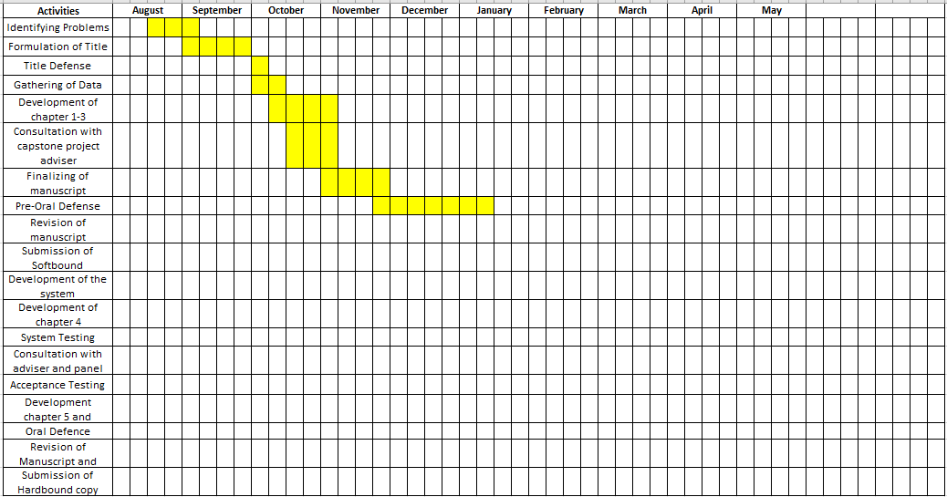**Gantt Chart of the Activities**

**APPENDIX B**

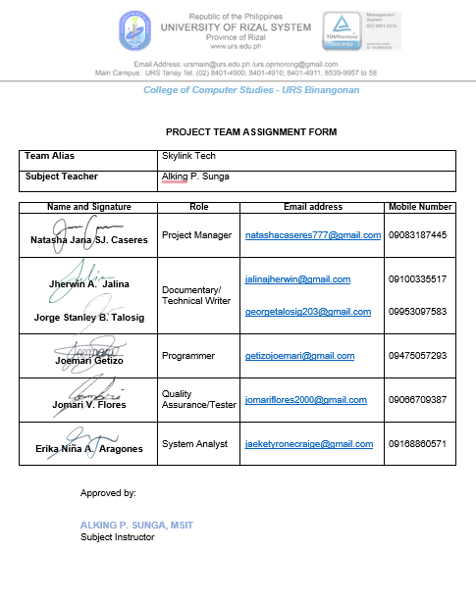**Project Team Assignment Form**



**APPENDIX C**

**Letter of Permission to Conduct the Project**

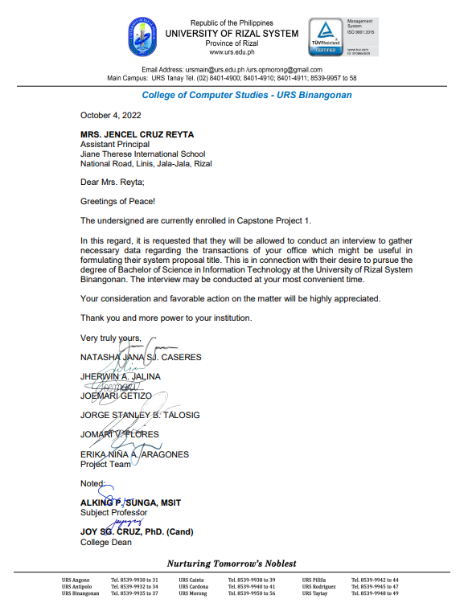

**APPENDIX D**

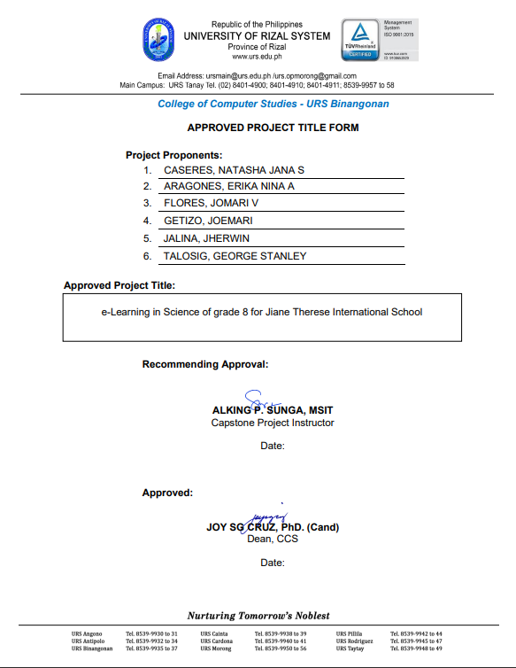**Approved Project Title Form**

**APPENDIX E**

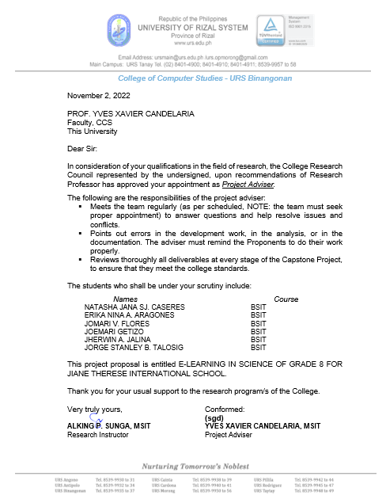**Letter of Acceptance of the Adviser and Panel**

**APPENDIX F**

**User Acceptance Evaluation Questionnaire**

Republic of the Philippines

**UNIVERSITY OF RIZAL SYSTEM**

Binangonan Campus

Questionnaire-Checklist

**DEVELOPMENT AND EVALUATION OF E-LEARNING IN SCIENCE OF GRADE 8 FOR JIANE THERESE INTERNATIONAL SCHOOL**

**Part I.** PERSONAL DATA

Name(optional): ____________________________________________

**Part II.** EVALUATION OF THE LEVEL OF ACCEPTABILITY

***Directions*:** Rate the presentation of each of the criteria by checking the appropriate box to determine the level of acceptability of the developed website.

    The scales are as follows:

5 -      Highly Acceptable

4   -    Acceptable

3   -    Moderately Acceptable

2   -    Slightly Acceptable

1   -    Not Acceptable

|  |  |  |  |  |  |  |
| --- | --- | --- | --- | --- | --- | --- |
|  | | **5** | **4** | **3** | **2** | **1** |
| **1. Functional Suitability** | | | | | | |
| 1.1 | The developed system covers all the specified tasks and objectives of the end-users |  |  |  |  |  |
| 1.2 | The developed system provides the correct results with the needed degree of precision. |  |  |  |  |  |
| 1.3 | The developed system facilitate the accomplishment of specified tasks and objectives of the end-users |  |  |  |  |  |
|  |  |  |  |  |  |  |
| **2. Performance Efficiency** | | | | | | |
| 2.1 | The develop system meets the requirements on its response and processing times and throughput rates when performing its functions |  |  |  |  |  |
| 2.2 | The developed system efficiently used the required amounts and types of resources when performing its functions. |  |  |  |  |  |
| 2.3 | The develop system maximum limits meet requirements of the end user |  |  |  |  |  |
|  |  |  |  |  |  |  |
|  |  |  |  |  |  |  |
| **3. Usability** | |  |  |  |  |  |
| 3.1 | The developed system is appropriate for the needs of the end user. |  |  |  |  |  |
| 3.2 | The developed system enables the user to learn how to use it with efficiency. |  |  |  |  |  |
| 3.3 | The developed system is easy to operate, control, and appropriate to use. |  |  |  |  |  |
| 3.4 | The developed system protects users against making errors. |  |  |  |  |  |
| 3.5 | The developed system user interface enables pleasing and satisfying interaction for the user. |  |  |  |  |  |
| 3.6 | The developed system can be used by people with the widest range of characteristics and capabilities to achieve a specified goal in a specified context of use. |  |  |  |  |  |
|  |  |  |  |  |  |  |
| **4. Reliability** | | | | | | |
| 4.1 | The developed system meets the needs for reliability under normal operation. |  |  |  |  |  |
| 4.2 | The developed system is operational and accessible when required for use. |  |  |  |  |  |
| 4.3 | The developed system operates as intended despite the presence of hardware or software faults. |  |  |  |  |  |
| 4.4 | The developed system can recover the data in the event of an interruption or a failure |  |  |  |  |  |
|  |  |  |  |  |  |  |
| **5.** **Security** | | | | | | |
| 5.1 | The developed system ensures that data are accessible only to those authorized to have access. |  |  |  |  |  |
| 5.2 | The developed system prevents unauthorized access or modification. |  |  |  |  |  |
| 5.3 | The developed System actions or events can be proven to have taken place, so that the events or actions cannot be repudiated later. |  |  |  |  |  |
| 5.4 | The developed system allows to traced the actions of an entity uniquely. |  |  |  |  |  |
| 5.5 | The developed system allows the identity of a subject or resource can be proved to be the one claimed. |  |  |  |  |  |
|  |  |  |  |  |  |  |
| **6. Maintainability** | | | | | | |
| 6.1 | The developed system composed of discrete components such that a change to one component has minimal impact on other components. |  |  |  |  |  |
| 6.2 | The developed system asset can be used in more than one form. |  |  |  |  |  |
| 6.3 | The developed system can efficiency change one or more of its parts in which it is possible to assess its impact on the system to diagnose the deficiencies of the parts to be modified. |  |  |  |  |  |
| 6.4 | The developed system can be effectively and efficiently modified without introducing defects or degrading existing system quality. |  |  |  |  |  |
| 6.5 | The developed system can establish criteria for the system to perform tests to determine whether those criteria have been met. |  |  |  |  |  |

**CURRICULUM VITAE**

