Argus - AI powered Malware Early Warning System
_______________________________

Submitted by
Muhammad Hayyan Lone (BSCS-461-F)
Abdul Rafay (BSCS-230-F)

Session 2022-2026

Supervised by
Umair Bin Ahmad



Department of Computer Science
Lahore Garrison University
Lahore

Argus - AI powered Malware Early Warning System
A project submitted to the
Department of Computer Science
In
Partial Fulfillment of the Requirements for the
Bachelor’s in Computer Science
By
Muhammad Hayyan Lone
Abdul Rafay

Internal Supervisor
Umair Bin Ahmad _______________________
Designation
Department of Computer Science

External Examiner _______________________

Chairperson
Dr. Muhammad Kashif Siddhu _______________________
Assistant Professor
Department of Computer Science

COPYRIGHTS
This is to certify that the project titled “Argus - AI powered Malware Early Warning System” is the genuine work carried out by Abdul Rafay and Muhammad Hayyan Lone, student of BSCS of Computer Science Department, Lahore Garrison University, Lahore during the academic year 2022-2026, in partial fulfilment of the requirements for the award of the degree of Bachelor of Computer Science and that the project has not formed the basis for the award previously of any other degree, diploma, fellowship or any other similar title.

Student Name ____________

Student Name ___________

DECLARATION
This is to declare that the project entitled “Argus - AI powered Malware Early Warning System” is an original work done by undersigned, in partial fulfilment of the requirements for the degree “Bachelor of Science in Computer Science” at Computer Science Department, Lahore Garrison University, Lahore.
All the analysis, design and system development have been accomplished by the undersigned. Moreover, this project has not been submitted to any other college or university.

Group Members
Student Name ________________
Student Name ________________

Supervisor
Supervisor Name ________________
Date: ________________

DEDICATION
This project is dedicated to our parents, teachers, and mentors whose help, patience, and support inspired us to add this work.
It also is committed to all who strive towards creating a more secure, more transparent and more resilient digital system against the threat posed by changing cyber threats.

ACKNOWLEDGEMENTS
We are much thankful to Almighty Allah to have given us the capability, health and endurance we need to carry this project to its completion.
It is with great pleasure that we wish to convey our deepest gratitude to our supervisor, who has not only offered invaluable advice and academic support, but also provided feedback in time and thus at the right place, during the whole lifecycle of this project.
Moreover, we would like to credit the great work of an open-source community, whose tools, documentation, and framework were crucial in the creation of the Argus system.
Finally, we are immensely grateful to our classmates, family members, and well-wishers for their continuous moral support and encouragement during this challenging journey.

Table of Contents
Contents
Chapter 1 14
INTRODUCTION 14
1.1 Project Overview and Aims 14
1.2 The Problem and Unmet Need 14
1.3 Solution Structure 14
1.4 Report Organization 15
Chapter 2 16
LITERATURE REVIEW 16
Chapter 3 18
PROBLEM DEFINITION 18
3.1 Background 18
3.2 Problem Statement 18
3.3 Key Challenges 18
3.4 Proposed Solution 19
3.5 Constraints and Assumptions 19
3.6 Summary 19
Chapter 4 21
SOFTWARE REQUIREMENT SPECIFICATION 21
4.1 Introduction 21
4.2 Functional Requirements 21
4.3 Non-Functional Requirements 22
4.4 Users and Actors 22
4.5 Hardware/Software Requirements 22
Chapter 5 24
METHODOLOGY 24
5.1 Systematic Approach 24
5.2 Methodological Workflow 24
5.3 Techniques and Algorithms Techniques 25
5.4 Methodology Workflow Diagram 25
5.5 Rational for the Chosen Method 26
5.6 Summary 26
Chapter 6 27
DETAILED DESIGN AND ARCHITECTURE 27
6.1 System Architecture 27
System Architecture Diagram: 29
6.2 DETAILED SYSTEM DESIGN 30
2.Entity Relationship (ER) Diagram. 33
3. Architectural Diagram 33
4. Activity Diagram 34
5. Sequence Diagram 35
6. Component Diagram 36
7. State Machine Diagram 37
8. Class Diagram 38
9. Data Flow Diagram (DFD Level 1) 39
10. Database Diagram (Physical Schema) 40
Chapter 7 41
IMPLEMENTATION AND TESTING 41
7.1 Technical Stack and Environment 41
7.2 Core Functionality Implementation 41
7.2.1 Layer 0: Autonomous Bouncer 41
7.2.2 Layer 1: Graph Engine 42
7.2.3 Layer 2: Live Scoring 43
7.2.4 Layer 3: Correlator 44
7.2.5 Layer 4: Response Engine 44
7.2.6 Layer 5: Learning Engine 44
7.3 Testing Methodology and Results 45
7.3.1 Active Defense Simulations 45
7.3.2 Evaluation Results 45
7.4 Summary 45
Chapter 8 46
RESULTS AND DISCUSSION 46
8.1 System Evaluation Overview 46
8.1.1 Detection Accuracy 46
Detection Accuracy by Layer 46
Baseline vs Tuned Model Improvements (Layer-2 Scoring Engine) 47
8.2 Performance Metrics 48
8.3 Supporting Figures and Graphics 49
8.3.1 The Provenance Graph (Layer 1 Visualizer) 49
8.3.2 The Risk Dashboard 50
8.4 Test Strategy and Test Cases. 50
8.5 Discussion of Results 50
8.5.1 Superiority over Traditional AV 50
8.5.2 Autonomous Response Effectiveness 50
8.5.3 Identified Limitations and Improvements 50
8.6 Summary 51
Chapter 9 52
CONCLUSION AND FUTURE WORK 52
9.1 Conclusion 52
9.2 Summary of Evaluations 52
9.3 Future Work and Recommendations 52
REFERENCES 54

List of Tables

Table 1:Detection Methods Comparison 17
Table 2: Hard-Soft Requirements 22
Table 3 Detection Accuracy by Layer 46
Table 4 Baseline vs Tuned Model Improvements 47
Table 5: Use Case Coverage and Results 50

List of Figures
Figure 1:Methodology Workflow Diagram 25
Figure 2: System Architecture Diagram 29
Figure 3:Top-Level Data Flow Diagram (DFD) 29
Figure 4:Use Case Diagram 32
Figure 5:Entity Relationship (ER) Diagram. 33
Figure 6:. Architectural Diagram 33
Figure 7:Activity Diagram 34
Figure 8:Sequence Diagram 35
Figure 9:Component Diagram 36
Figure 10:State Machine Diagram 37
Figure 11: Class Diagram 38
Figure 12:Data Flow Diagram (DFD Level 1) 39
Figure 13:Database Diagram (Physical Schema) 40
Figure 14 Autonomous Bouncer 42
Figure 15 Layer 1: Graph Engine 42
Figure 16 Layer 1: Provinance Graph 43
Figure 17 Layer 2: Live Scoring 43
Figure 18 Layer 5: Learning Engine 44
Figure 19 Confusion Matrix 47
Figure 20: ROC Curves Baseline Vs Tuned Model 47
Figure 21: Precision-Recall Curves 48
Figure 22: Metrics Bar Chart 48
Figure 23 The Provenance Graph (Layer 1 Visualizer) 49

List of Abbreviation
API: Application Programming Interface
ARGUS: Anomaly Response and Graph-based Unified Security
DBMS: Database Management System
EDR: Endpoint Detection and Response
ETW: Event Tracing for Windows
FP: False Positive
FYP: Final Year Project
GUI: Graphical User Interface
HST: Half-Space Trees
IPC: Inter-Process Communication
ISO: International Systems Organization
IP: Internet Protocol
ML: Machine Learning
OBE: Outcome-Based Education
ORM: Object Relational Mapper
SOC: Security Operations Center
SRS: Software Requirement Specification
SSE: Server-Sent Events
TP: True Positive
VT: Virus Total
WMI: Windows Management Instrumentation
ABSTRACT
The ever-evolving nature of cyber threats, with more than 450,000 new malware variants detected every day, has made existing security solutions inadequate at timely detection of sophisticated and Malware attacks. Current Endpoint Detection and Response (EDR) and antivirus technologies are reactive, operating on isolated event logs, static rules and single-model detection, leading to high false positives, slow detection, and lack of contextual awareness of attack chains. In this paper, we propose ARGUS, a real-time, stream-based malware detection framework that aims to detect and prevent threats before they compromise the system. ARGUS uses streams of Sysmon events to build dynamic provenance graphs that represent parent-child process relationships for context-sensitive behavioral analysis. The approach presents a new parallel multi-layered fusion model that integrates statistical techniques (entropy and burst analysis), probabilistic process behavior modeling (P-Matrix - process transition probabilities) and online machine learning (River Half-Space Trees) for anomaly detection. These components are combined via a scoring scheme to produce explainable and reliable threat intelligence. Further, ARGUS supports interactive learning through feedback from analysts for continuous adaptation and tuning to specific environments. This system generates real-time threat alerts, risk scores, provenance-based attack graphs, and automated mitigations like process blocking and file quarantining. Through its focus on prevention, ARGUS supports early detection, false-negative reduction, and optimizes SOC Tier 1 and Tier 2 processes.

Chapter 1

INTRODUCTION
In the present digital world, cybersecurity has become a cornerstone of the stability and existence of any organization. The old tools of defending against cyberattacks are, however, not able to keep up as cyberattacks are becoming more advanced. The new threat types, including ransomware and Living off the Land, often go unnoticed by their nature, as they are run by legitimate system processes, short-lived scripts, and made under the radar by the registry changes; they do not occur in a vacuum, but rather as a chain of events, a digital chain of events.

1.1 Project Overview and Aims
The Argus: AI-Powered Early Malware Detection System is proposed to deal with these issues by modeling host activity as a provenance graph. This model treats system objects such as processes, files, scripts and registry keys, as nodes and the interactions between the nodes as the edges. This design enables the system to be able to reason about the cause-and-effect relationships as opposed to looking at individual events independently. The primary aim of Argus is to provide a locally deployable host-security platform that identifies anomalous behavior through advanced graph analysis and online anomaly scoring, ultimately presenting the results as high-context incidents rather than fragmented, disconnected alerts.

1.2 The Problem and Unmet Need
The biggest challenge to any current security team is that it is challenging to find new or low-noise attacks when the analysts are always flooded with single, low-context alerts. This results in two severe operational failures: the so-called alert fatigue (when real threats are obscured by noise) and context gaps (when analysts have to waste a long time by correlation work on a case by case basis to find out how an attack was launched). The poorly-resourced organizations are particularly susceptible because in most situations, they lack the expensive, enterprise-grade tools to automatically connect these dots. To assist these teams, Argus provides a monetized, localized and context-sensitive framework which has the ability to reconstruct and mark attack chains on Windows computers without using a cloud-based provider.

1.3 Solution Structure
The Argus is implemented on a robust 6 almost layer, modular architecture to manage the Argus life cycle of a security event. This is implemented by each layer beginning at Layer 0 (Bouncer), a high-performance screen on entropy analysis and a reputation check which blocks harmless objects. The Graph Engine Layer 1 (Graph Engine) is formed next and forms the live provenance graph and supports event streaming in real time. Binded to the suspicious occurrences, Layer 2 is the analytical brain that issues the anomaly scores through mathematical and statistical and machine-learning pathways, whereas Layer 3 connects the suspicious occurrences into unity incidents. Finally, response actions are in Layer 4 (quarantine and whitelisting) and Layer 5 is where continuous learning is achieved by retraining models and feedbacks provided by analysts.

1.4 Report Organization
This report will be divided into nine chapters to have a complete picture of the project both on its theoretical basis and practical application:
- Chapter 1 (Introduction): Gives motivation, project objectives, and a synopsis of the issues which are tackled by Argus.
- Chapter 2 (Literature Review): discusses the current malware detection methods and the gaps in the literature that this project aims to address.
- Chapter 3 (Problem Definition): It formally states the technical and operational failure of isolated detection and the need to have a graph-conscious solution.
- Chapter 4 (Software Requirement Specification): It elaborates on the functional and non-functional requirements that will be required to develop the system.
- Chapter 5 (Methodology): Discusses the systematic process and the stratified workflow to come up with the detection engine.
- Chapter 6 (Detailed Design and Architecture): The way that the system works internally, such as the interactions among components, database schemas, and architectural diagrams.
- Chapter 7 (Implementation and Testing): This chapter will discuss the tools that will be used in the development process and the approaches that would be applied to verify the functionality of the system.
- Chapter 8 (Results and Discussion): Reports on the structural results of the repository and the depth of the modularity of the system.
- Chapter 9 (Conclusion and Future Work): Summarizes the project success and provides recommendations on future expansion to the enterprise level.
The first chapter has presented the key ideas of the Argus platform and the need to have a context-oriented method of detection. In the next chapter, we shall explore the literature and the existing industry standards to give us a benchmark on our methodology.

Chapter 2

LITERATURE REVIEW
The cybersecurity intelligence has experienced a fundamental change in the last 20 years with the growing sophistication of adversarial methods and the resultant lack of effectiveness of traditional defensive measures. Conventional antivirus systems make use of much more advantageous, static signature databases, which can be utilized to test a known malicious file by performing cryptographic hashes upon it and comparing the result to repositories containing cataloged malicious scales. Being computationally cheap, this solution is however fundamentally reactive and is always defeated by polymorphic malware, zero day exploits, and Malware attacks that leave no identifiable artifacts on disk. This is a structural drawback of architecture that has continued to bring research focus to the detection mechanisms of human behavior and anomaly-based detection techniques. Basic research by Forrest et al. and subsequent studies demonstrated that a sequence of system calls generated by a running process would form all of the predictable behavioral characteristics of a process, and that any differences in those characteristics would be good indicators of compromise, establishing the conceptual basis of modern endpoint detection and response systems.
Particularly urgent problem is driving up the Living off the Land (LotL) attack techniques, which involve an attacker relying on a legitimate system utilities like PowerShell and WMI to carry out malicious code whilst avoiding signature-based detection altogether. The empirical observation of massive ransomware and APT groups of attacks has validated that the vast majority of advanced intrusions are based on such dual-use binaries and confirmed the need to develop detection logic that considers relational context and not file identity. The provenance graph model satisfies this requirement by encoding causal dependencies between any two system objects like process, file, and network socket and by providing a directed graph structure, a BGF allows reconstruction of complete attack sequences by tracing subgraphs of these sequences through the graph. Follow-up work by Pohly et al. established the feasibility in practice of continuous collection of provenance at the kernel level with an acceptable level of performance overhead, and Hossain et al. addressed the problem of graph explosion in long-running systems by preserving dependencies to ensure that causally relevant information is available at smaller scale.
Anomaly scoring within these graph structures has been advanced considerably by online machine learning techniques. The Half-Space Trees (HST) algorithm is particularly well-suited to streaming environments because it learns incrementally from continuous data, adapting to the evolving behavioral baseline of a host without requiring retraining on static historical corpora. Complementing these behavioral approaches, Information Theory provides a robust mathematical foundation for identifying malicious payloads. Shannon entropy, defined as
S(X) = −∑ p(xi) log2(p(xi))
, has been established as a reliable heuristic for identifying packed or encrypted payloads. Lyda and Hamrock demonstrated that entropy values exceeding approximately 7.0 bits per byte serve as an effective discriminator between benign and suspicious executables, particularly in the context of identifying ransomware or encrypted attack scripts.
The efficiency of the security platforms in terms of operational performance is further complicated by the paradigm of the Observer, Analyst, and Responder. A system needs to track and record transitions of low-level systems without affecting host performance, use an evidence-based provenance graph to score behavior via analytical channels, and incorporate evidence into human-readable narratives to implement mitigation based on policy. This discontinuity of sense that we are led to is crucial to the preservation of Contextual Integrity, due to the disconnected and flat nature in most traditional tools, contextual integrity becomes easily lost. To be able to cluster fragmented alerts into coherent incident descriptions, modern systems need to shift their detection model orientation, trading an event-centric approach to one that is chain-centric. It uses graph-proximity correlation to means-end the impact of real threats to alert volume with significantly lower loss of investigative fidelity than blue oceans.
Moreover, the integration of structured threat frameworks such as ATT&CK has become the de facto in modeling detected behaviors to known adversary behaviors. This allows machine-generated alerts to be put into perspective within a professional threat vocabulary, significantly de-prioritizing the process of filtering the output of machine-generated alerts among analysts. In a bid to help support under-resourced organizations, there is an increasing need of local-first, context-aware platforms, which can rebuild attack chains on Windows endpoint without a persistent dependency on clouds.
Table 1:Detection Methods Comparison
Author(s) | Proposed Technique | Limitations
Prakash et al. | Static Signature Analysis | Fails against polymorphic and zero-day threats
Forrest et al. | System Call Fingerprinting | High noise in complex environments; limited to Unix
King & Chen | Provenance Backtracking | Significant storage overhead and "graph explosion" over time
Pohly et al. | High-Fidelity Provenance | Significant performance overhead during kernel-level collection
Hossain et al. | Contextual Aggregation | May lose granular detail during aggressive abstraction
Tan et al. | Half-Space Trees (ML) | Requires established behavioral baseline to avoid drift
Lyda & Hamrock | Shannon Entropy Analysis | Can be bypassed by sophisticated entropy-sharing
Julisch | Alarm Clustering | Dependent on the initial quality of the intrusion alerts
Strom et al. | MITRE ATT&CK Mapping | Relies on manual updates to stay ahead of novel tactics

Chapter 3

PROBLEM DEFINITION
The dynamism of cyber threats has changed faster than the technologies of the more conservative host-based security tools that are majorly concerned with detecting known rogue files or the detection of isolated suspicious activity. This chapter is a formal statement of the operational and technical issues that the Argus is meant to resolve, the disparities between the raw system telemetry and the contextually needed to respond to incidents today.

3.1 Background
Modern Security Operations centres (SOC) often give security analysts a huge amount of data on security events, most of which are duplications of signals, and partial disturbances on hosts. The analyst usually receives a collection of individual records portraying a single sophisticated attack sequence of process creation, file modifications, changes to the registry, and evasion of defenses. In the absence of a system to detail how these events causally relate, analysts have to dedicate much time to manually recreate the timeline of the attack. The latter is also aggravated by the fact that when the attack is previously unknown or simply same types specifically crafted to circumvent traditional static signatures the system must reason about deviant behavioral patterns instead of the existence of a simple hash check.

3.2 Problem Statement
It is urgently required that it should have a locally deployable and behavior based host observation framework that is able to convert the raw windows telemetry to a memory full of high context security events. This system should be able to model cause-and-effect interactions, anomalies in scoring various channels simultaneously, and should be able to allow workflows by analysts without complete reliance on cloud compute or fixed signature repositories.

3.3 Key Challenges
To develop a system that offers both high-fidelity detection and low-latency response, several technical and operational challenges have to be overcome:
- Contextual Fragmentation: Dealing with high amounts of host events providing minimal amounts of individual context.
- Zero-Day Detection: Overcoming the challenge of detecting attacks that are new or never seen before and are not represented in the patterns.
- Correlation Complexity: It is an automated method to cluster many actions into a single comprehensible incident narrative.
- Detection Explainability: Delivering comprehensible and clear detection outcomes instead of unclear anomaly scores.
- Operational Balance: The reduction of false positives to achieve a realistic and effective workflow of an analyst.
- System Modularity: Making sure that the architecture is sufficiently modular to be expanded on and deployed in the future.

3.4 Proposed Solution
Argus addresses these issues by means of a layered design relying on modules which move the emphasis off of event-centric detection and toward chain-centric detection. The telemetry is represented in the system, it represents activity in a live provenance graph, and it scores behavior by assessing it in mathematical, statistical, and machine-learning channels. Such results are then correlated to incidents that are available through a web dashboard. The system makes response operations and provided feedback-driven learning to bridge the defensive loop, making it more accurate in the detection over time.

3.5 Constraints and Assumptions
The successful deployment and operation of Argus are based on the following technical assumptions:
- Environment: The collection layer assumes a Windows-based host environment with access to Sysmon and standard Windows event logs.
- Persistence: Full incident history and graph persistence require a correctly configured PostgreSQL database.
- External Intelligence: Optional hash reputation lookups via the VirusTotal API are dependent on valid credentials and API availability.
- Learning Maturity: The quality of the automated detection improvements depends on the consistent availability of analyst feedback and validated incidents.

3.6 Summary
This chapter has identified the core problems of alert fragmentation and context gaps in modern host security. We have now defined the functional requirements of a graph-aware solution by defining the challenges of a particular attack detection and manual correlation. The next chapter will outline the Software Requirement Specification (SRS) that is needed to convert these needs into a working system.

Chapter 4

SOFTWARE REQUIREMENT SPECIFICATION
This chapter outlines the functional and non-functional requirements for Argus, derived from the modular six-layer architecture and technical stack required for a local, graph-based detection system.

4.1 Introduction
The primary objective of these requirements is to define a system capable of transforming raw Windows telemetry into high-context security incidents through automated graph construction and multi-channel scoring.

4.2 Functional Requirements
The system will have to carry out the following fundamental functions:
- Health Monitoring (FR-1): Public core backend and individual detection layer endpoints.
- Telemetry Intake (FR-2): Gather or create telemetry events of host-level ingestion workers.
- Graph Construction (FR-3): Flexibly create and modify provenance nodes and edges in the persistence layer.
- Anomaly Scoring (FR-4): Calculate anomaly evidence on several channels and provide level of severity to detect behavior.
- Incident Correlation (FR-5): Use graph and session proximity to group related suspicious events into a single incident.
- Incident Management (FR-6): Have interfaces to list incidents, see technical details and add analyst notes.
- Live Monitoring (FR-7): Real-time dashboard updates with streaming system updates through Server-Sent Events (SSE).
- Response Actions (FR-8): Whitelist, process isolation, restoration, and quarantine support.
- Feedback Collection (FR-9): Allow the analysts to make their classification: True Positive (TP), False Positive (FP), Unknown.

4.3 Non-Functional Requirements
The following are quality attributes necessary to operational effectiveness:
- Performance (NFR-1): API operations should be able to react within reasonable criteria of a local dashboard when under normal load.
- Reliability (NFR-2): The transactions of the database should be consistent in terms of integrity of the graph, incident, and response records.
- Usability (NFR-3): Complex graph data and response actions should be presented in an easy way to the analysts in the dashboard.
- Maintainability (NFR-4): The architecture should be strictly modular with routes, models and services being separated.
- Security (NFR-6): Response operations should be auditable, and any sensitive host activities should be recorded.
- Portability (NFR-7): The backend and UI are portable, but the collector deployment is configured to work with Windows in particular.

4.4 Users and Actors
The system relates to the following entities:
- Security Analyst: Surveillance of the dashboard and incident cards and response workflows.
- Administrator: Secures the policies and whitelists, and tracks model learning maturity.
- Windows Host / Collector: The host is the main source of data that provides telemetry events to the pipeline.

4.5 Hardware/Software Requirements
To deploy Argus, the following environment is needed:
Table 2: Hard-Soft Requirements
Component | Requirement
OS Windows (collectors) | Event Tracing For Windows
Python | Version 3.10
Database | PostgreSQL 17.5 using SQL Alchemy ORM.
Frontend | React and Tailwind CSS
Telemetry | Microsoft Sysmon.
Storage | Quarantine and logs

Chapter 5

METHODOLOGY
The chapter outlines the systematic methodology, technical procedures and algorithms that were used in the creation of ARGUS Provenance Graph Anomaly Detection System. The pipeline is based on a accurate telemetry pipeline that converts raw system signals into context-aware provenance graph to detect real-time anomalies and respond to incidents.

5.1 Systematic Approach
ARGUS is a behavioral-based scheme not using signature-based to identify attacks. The host activity is viewed by the system as a plan of behaviour and recreates a Provenance Graph to get causality among things. Through this the system can be in a position to detect complex chains of attacks which also seems to be harmless when treated individually.

5.2 Methodological Workflow
A six-layer pipeline, which was modular, was used to control the operation lifecycle of the system and which aimed at ensuring rapid ingestion as well as comprehensive cognitive analysis. As can be seen in Figure 1, the workflow is designed in such a way that it follows the following manner:
- Telemetry Collection (Input): Measures high fidelity signals of the Windows kernel with Sysmon and host-level event hooks. This covers process lifecycles, file I/O, registry changes, WMI activity.
- Layer 0 (Bouncer): Shannon entropy analysis plus caches hash reputation to immediately block known-good or clearly benign events.
- Graph Engine (layer 1): The telemetry is normalized and turned into a live directed graph in which nodes (processes, files, registry keys) are the entities and the interactions between them are edges.
- Layer 2 (Scoring Engine): Performs parallel analysis through mathematical (entropy), statistical (probability thresholds) and online machine learning (River-based streaming anomaly detection) channels.
- Layer 3 (Correlator): Group anomalous subgraphs and create high-context incident cards, which create a forensic narrative that is projected to select MITRE ATT&CK stages.
- Layers 4 and 5 (Response and Learning): Automates (quarantine) and uses model feedback (via an analyst) to schedule model retraining to reduce false positives.

5.3 Techniques and Algorithms Techniques
The system applies certain algorithms to guarantee the accuracy of detection and efficiency in its performance:
- Shannon Entropy Calculation (H): Layer 0 is for ransomware or packed payloads. Any file that has entropies greater than 7.9 bits is thought to be encrypted with malicious data.
- Graph-based Causal Modeling: This is a directed graph G = (V, E) that uses a directed graph to store state. Such relationships as SPAWNED, WROTE, and EXECUTED_SCRIPT help to create the context needed to recreate attack.
- Online Anomaly Detection (River HST): Uses the river library's Half-Space Trees algorithm to score streaming data event-by-event and continuously adapt to each host's behavioral baseline in real-time, eliminating the need for offline batch training.
- Graph Proximity Correlation: Makes use of causal link analysis to cluster dozens of correlated events into one event, virtually resolving the alert fatigue problem by showing the story of a single attack.

5.4 Methodology Workflow Diagram
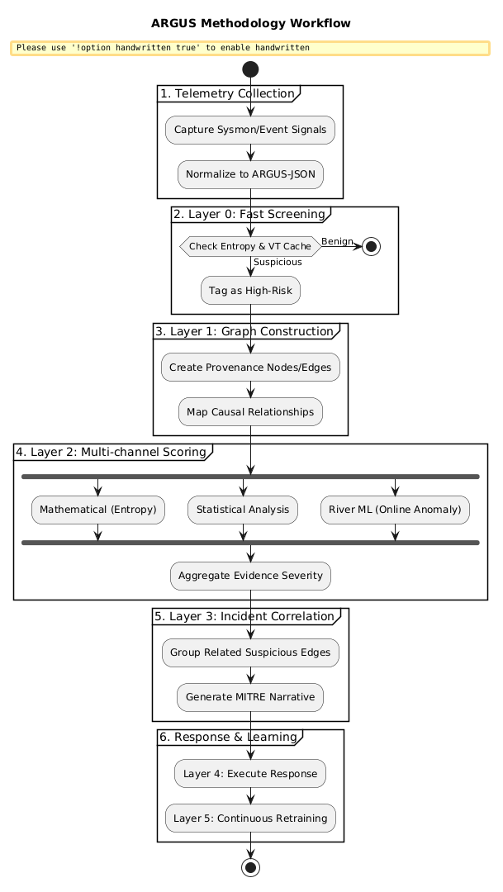
Figure 1:Methodology Workflow Diagram
Description: This diagram presents the logical evolution of the ARGUS system at the end-to-end. It highlights the move of raw telemetry ingestion to high-speed filtering in Layer 0, and then proceeds with the deep process of analytics that comprise the construction of a graph and multi-channel scoring. Incident synthesis and the learning loop based on feedback are the final steps in the workflow.

5.5 Rational for the Chosen Method
The modularity of the six-layer pipeline ensures that the system remains responsive, where known threats are blocked immediately by Layer 0, and complex behavioral anomalies are detected through the integrated intelligence of Layers 1-5, which combine provenance tracking, multi-method scoring, correlation, automated response, and continuous learning.

5.6 Summary
This chapter has detailed the multi-layered methodology of ARGUS. The system offers a powerful defense mechanism based on both kernel-level hooks and graph-based correlation and high-speed streaming machine learning, which is optimized to support contemporary SOC workflows. The next chapter shall give Detailed Design and Architecture, which will map these logical methods with their respective software components.

Chapter 6

DETAILED DESIGN AND ARCHITECTURE
In this chapter, a detailed technical description of the ARGUS: Provenance Graph Anomaly Detection System is presented. It describes the structural decomposition of the system, interaction of the different modular layers, and the architecture patterns used to provide high-performance telemetry processing and proper correlation of anomalies.

6.1 System Architecture
The architecture of ARGUS is engineered to transform massive streams of raw operating system telemetry into high-context security intelligence.To achieve this, the system adopts Layered Modular Architecture combined with an Asynchronous Pipe-and-Filter processing model.
The key task of the system is to have an ongoing "Source of Truth" about host activity. On the highest level, the software must fulfill three key functions:
- The Observer: This monitors and captures transitions of low-level systems without affecting the performance of hosts.
- The Analyst: Stating by a provenance graph and scoring behavior via a variety of analytical channels.
- The Responder: Integrating evidence into human readable stories and implementing mitigation based on policy.

6.1.1 Architecture Design Approach
Design ARGUS revolves around the separation between the sensory parts (collectors) and the cognitive parts (scoring and correlation engines). This is done by means of a multi-level approach:
- Layered Pattern: This system is divided into six layers (Layers 0-5) of the system. This makes the separation of concerns clean in which hardware interactions at low-levels do not affect high-level cognitive analysis.
- Pipe-and-Filter Pattern: Telemetry data is sent through a pipe with each layer being a filter which enriches or evaluates the data. This enables capability of Fail-Open, such as when heavy ML filter is busy, the light mathematical filter is still able to give immediate verdict.
- Producer-Consumer Pattern: This is an asynchronous queue of events that is used to put in between the burst-attack-prone high-speed collector (Producer) and the analysis backend (Consumer).
- Rationale for Decomposition: Monolithic architecture was rejected because it would cause "back-pressure" on kernel events, potentially slowing down the host OS. By decomposing ARGUS into independent subsystems.
- Contextual Integrity: The traditional tools store events in flat logs. Ourgraph-centric decomposition makes Context a first class citizen, allowing the system to group Multiple alerts on 1 incident card.
- Explainability: Each layer provides an independent "voting" signal, ensuring the final incident narrative is derived from multiple verifiable sources (Math, Stat, and ML).

6.1.2 Architecture Design
The overall architecture is partitioned into four major subsystems that collaborate to achieve the required functionality.
- Telemetry Collection Subsystem: The Ingestion interface supports high-speed data. Sysmon and Windows ETW APIs are used for monitoring the life of a process, files read and written, and registry processes. It will convert the binary data to a normalized JSON.
- Graph & Analysis Subsystem (The Brain): The heart of intelligence. It keeps the live Provenance Graph in memory and takes care of the Detection Stack (Layers 0, 1, and 2). It does entropy checking, statistical transition checking and streaming anomaly checking.
- Correlation & Response Subsystem (The Heart): Summarizes results to the Incident Database. It clusters deviant nodes according to graph proximity (Layer 3) and carries out automated response activities (Layer 4) such as process termination or file quarantine.
- Presentation and Learning Subsystem (The Interface): The React-based dashboard is used to monitor the real-time and D3.js is used to visualize graphs. It also takes care of the feedback loop (Layer 5) in which the input of analysts improves the machine learning models.

System Architecture Diagram:
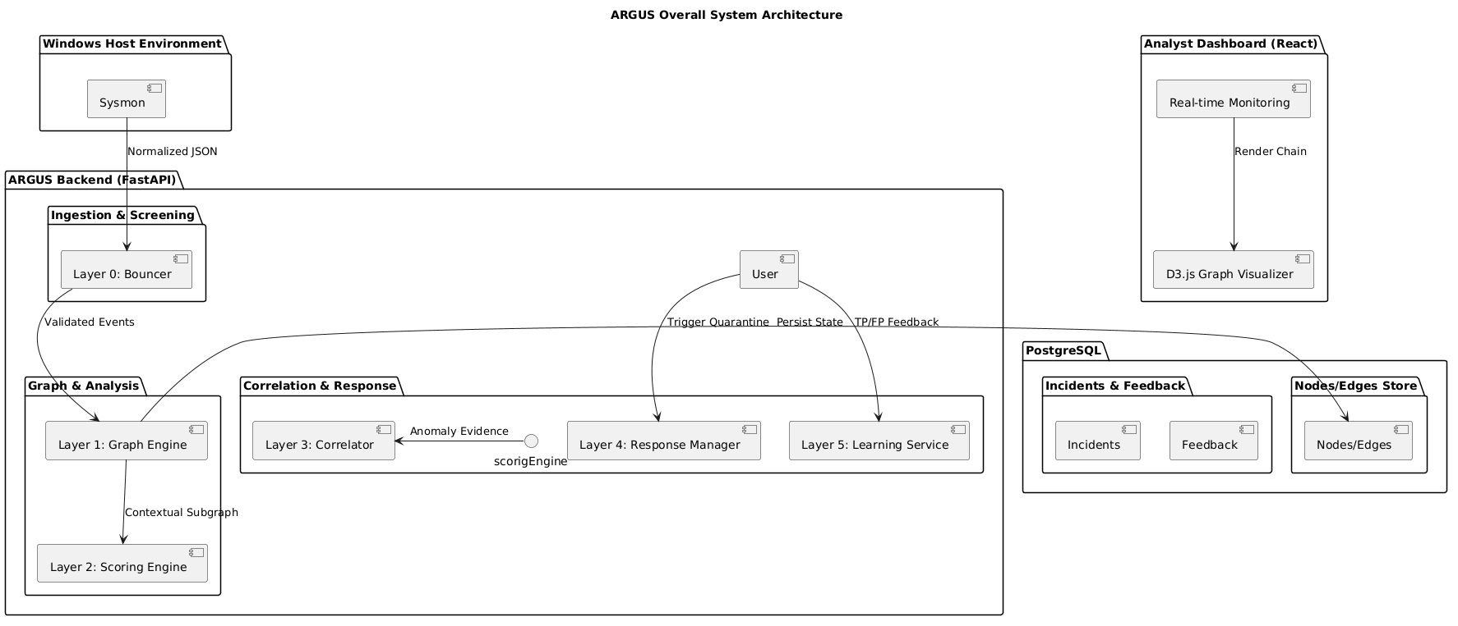
Figure 2: System Architecture Diagram
Description: This diagram shows the top-level division of the ARGUS system. It indicates the unidirectional movement of telemetry between the host environment and the analysis layers with a shared persistence layer and a real-time presentation dashboard.

6.1.3 Subsystem Architecture
To further understand the movement and transformation of data, the following Top-Level Data Flow Diagram (DFD) describes the logical processes that govern the system's internal behavior.
Figure 3:Top-Level Data Flow Diagram (DFD)
Description: The DFD shows the flow of information within the system and how it is converted. Process 1.0 simplifies the OS; Process 2.0 creates causality on the graph store; Process 3.0 is risk evaluation; Process 4.0 synthesizes the results to the end-user with a control path to the host to follow in case of mitigation.

6.2 DETAILED SYSTEM DESIGN
This section involves a clearer detail of the main software blocks that make up the ARGUS platform. The behavior and structure of ARGUS Backend Subsystem, which is the main intelligence center, are characterized as follows.

6.2.1 Classification
The ARGUS Backend is classified as a Modular Subsystem implemented as a FastAPI Web Application. It consists of multiple Python modules, class-based service layers, and asynchronous background workers

6.2.2 Definition
The semantic purpose of this component is to act as the "Intelligence Layer" that transforms raw, disconnected Windows telemetry into a stateful Provenance Graph to detect behavioral anomalies that bypass traditional signature-based tools.

6.2.3 Responsibilities
- Telemetry Normalization: Converting binary signals in Sysmon to a single JSON schema.
- Graph Management: Keeps a directed graph of entities (Nodes) of the system and interactions (Edges).
- Anomaly Scoring: Running Layer 2 mathematical, statistical, and ML scoring channels.
- Incident Correlation: Clustering evidence that is suspicious into one narrative card based on proximity on the graph.
- Response Implementation: Sending isolation and quarantine information to the Windows host.

6.2.4 Constraints
- Timing: The time between ingestion and detection verdict of the end-to-end pipeline should not take longer than 300ms.
- Storage: Provenance graph information is limited to 24-hour rolling window to avoid local disk overload.
- Integrity: Database transactions should be of the strong ACID-properties to provide graph-incident consistency.
- Environment: The subsystem is designed for Local-First deployment, meaning no behavioral data should leave the host.

6.2.5 Composition
The subsystem is composed of six logical layers:
- Layer 0 (Bouncer): High-speed entropy and cache filtering.
- Layer 1 (Graph Engine): Structural mapping of system causality.
- Layer 2 (Scoring): Multi-channel detection logic (Math, Stat, ML).
- Layer 3 (Correlator): Generation of narratives and cluster of sessions.
- Layer 4 (Response): Policy management and quarantine.
- Layer 5 (Learning): Retraining and model maturity test.

6.2.6 Uses/Interactions

Used By: The React Frontend uses the Backend via REST APIs and Server-Sent Events (SSE).

Usage: The Backend is written in PostgreSQL to store data and SQL Alchemy to map data to an entity, and Windows Kernel (through Sysmon) to get raw telemetry.

Side Effects: In the Windows environment, automated process termination (Layer 4) will directly kill malicious process trees.

6.2.7 Resources
- Processors: Makes use of multi-core processing to carry out parallel anomaly scoring.
- Memory: Handles an in-memory cache of the Layer 0 Bouncer to prevent unnecessary hits to the DB.
- Database: The contents of the database are stored in PostgreSQL and have about 55 data entities.
- Software Libraries: Relies on Fast API, River (ML), SQL Alchemy.

6.2.8 Processing
Processing begins when a telemetry event is enqueued. Layer 0 Bouncer performs a rapid entropy check. If validated, the Graph Engine upserts the node/edge in PostgreSQL. The Detection Stack then independently evaluates the updated graph segment. If the cumulative score exceeds the suspicious threshold, the Correlator creates an incident and pushes a real-time notification to the dashboard via SSE.

6.2.9 Interface/Exports
The subsystem exports a RESTful API containing approximately 55 endpoints.
- /incidents/: Collection and detail views of security alerts.
- /graph/: Exports subgraphs in D3.js to visualize.
- /response/quarantine/: Synchronous calls to isolate or restore files.
- /learning/feedback/: Receives analyst labels with which to update model weights.

6.2.10 Detailed Subsystem Design

This is the formal technical description and pictorial modeling necessary to understand the behavior and look of the ARGUS platform. We have also supported each diagram with how that diagram will play out in the architecture of the system and implementation logic.

1. Use Case Diagram
Figure 6.3: Use Case Diagram The Use Case Diagram defines the functional boundaries of the ARGUS platform. It determines the interactions among the key players, the Security Analyst, Administrator, and the Windows Host with the core features of the system. It emphasizes the transition between passive monitoring and active forensic investigation and learning by feedback.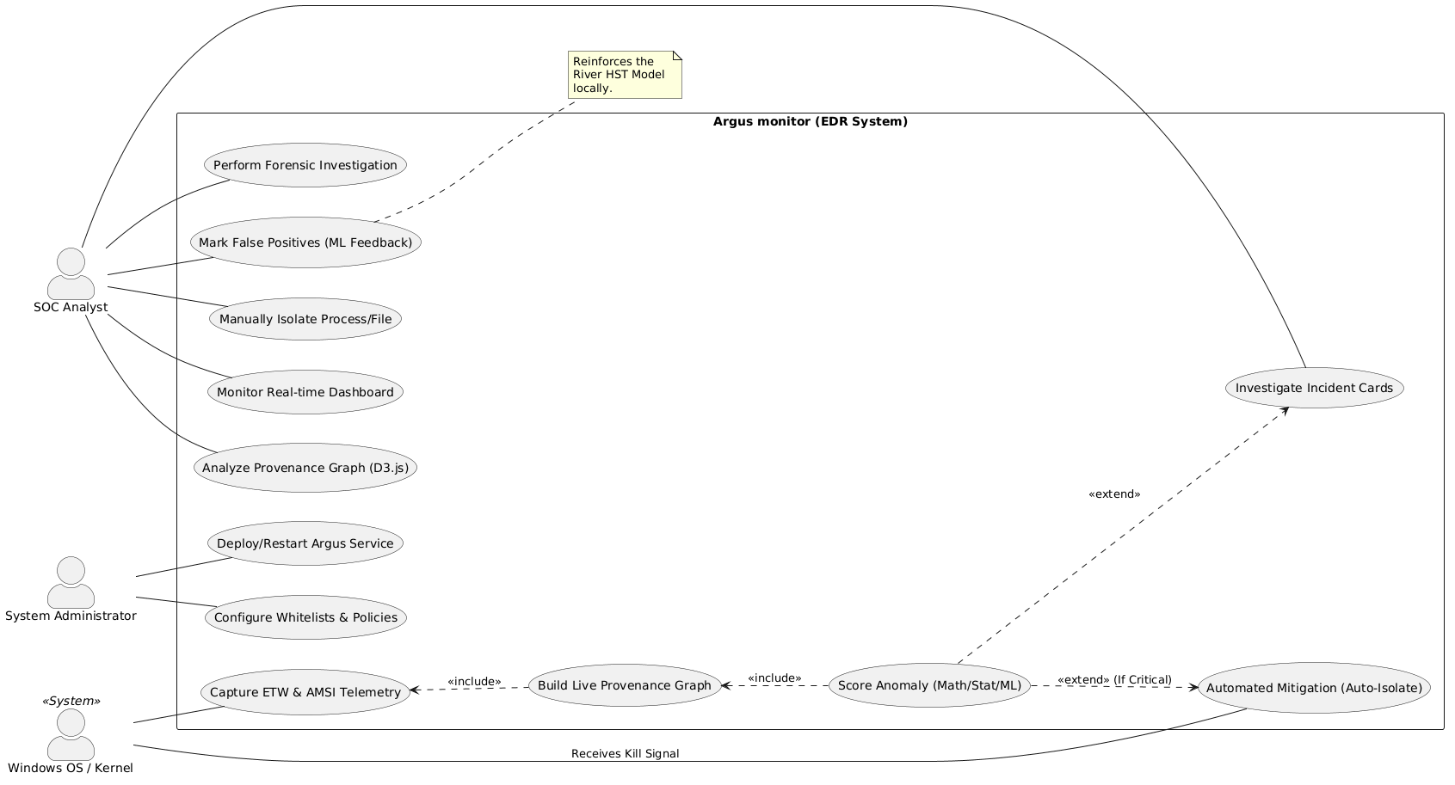
Figure 4:Use Case Diagram

2.Entity Relationship (ER) Diagram.
Figure 6.4: Entity Relationship Diagram The ER Diagram establishes a conceptual data model that is optimized to graph-based security analysis. Unlike traditional flat-log databases, this schema emphasizes the causal links between entities. It shows how nodes (processes, files) are linked by edges (actions), which are then correlated into high-level incidents that receive analyst feedback.

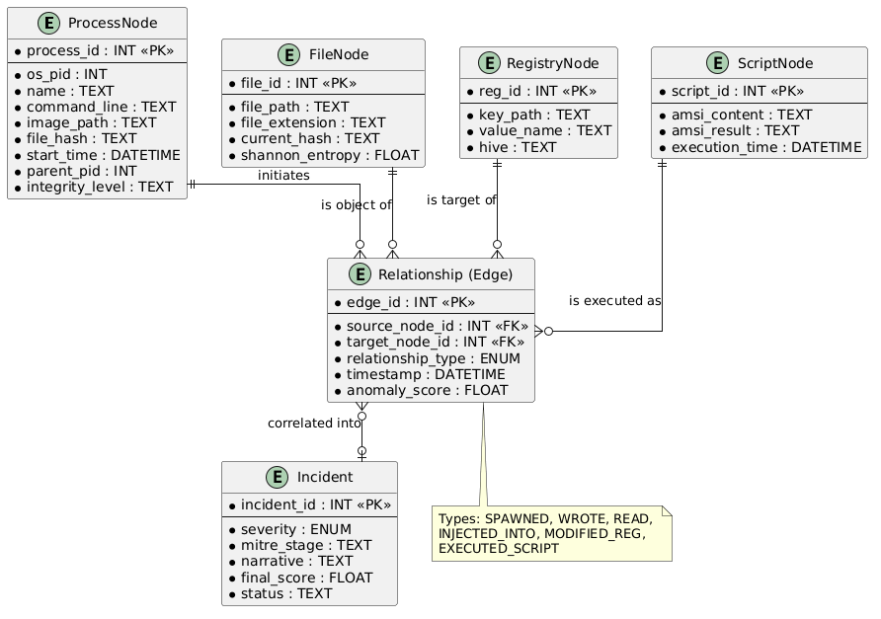
Figure 5:Entity Relationship (ER) Diagram.

3. Architectural Diagram
Figure 6.5: Detailed Architectural Diagram This diagram provides a structural view of the six-layer pipeline. It illustrates the physical partitioning between the high-privilege collectors on the Windows host and the FastAPI backend. It emphasizes the flow of data through screening, graph mapping, and multi-channel scoring before synthesis by the correlator.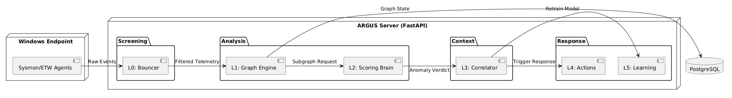
Figure 6:. Architectural Diagram

4. Activity Diagram
Figure 6.6: Activity Diagram the Activity Diagram models the operational flow of a single telemetry event. It traces the logic from ingestion through the Layer 0 Bouncer check. It illustrates the concurrent analytical processes and the decision gate that triggers automated moderation if a "Critical" severity threshold is met.
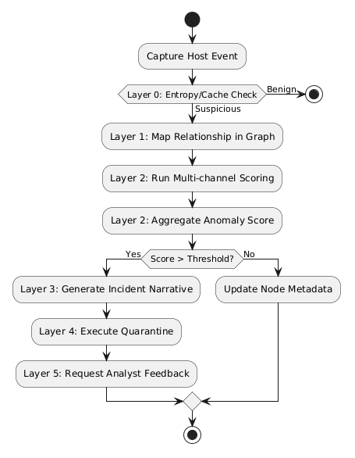
Figure 7:Activity Diagram

5. Sequence Diagram
Figure 6.7: Sequence Diagram: This diagram shows the flow of interaction of the constituents of the system during an alert. It demonstrates the asynchronous communication between Sysmon and the graph engine along with the concurrent request-response cycle between the correlator and the scoring stack, and then the dashboard is updated.

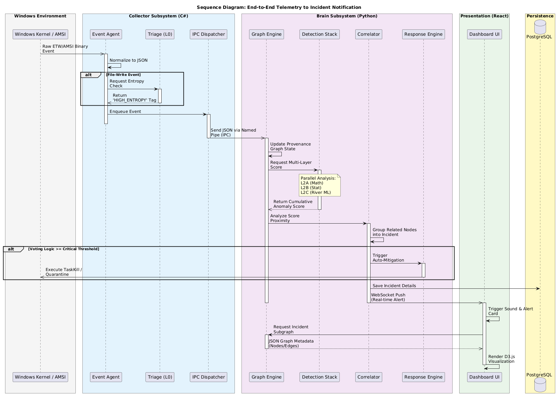
Figure 8:Sequence Diagram

6. Component Diagram
Figure 6.8: Component Diagram the Component Diagram: is a list of the project dependencies. It verifies the communication between the React Dashboard and the Fast API Router, and the interactions between the internal service layers (Graph, Scoring, Correlator), but does not know about the data layer.

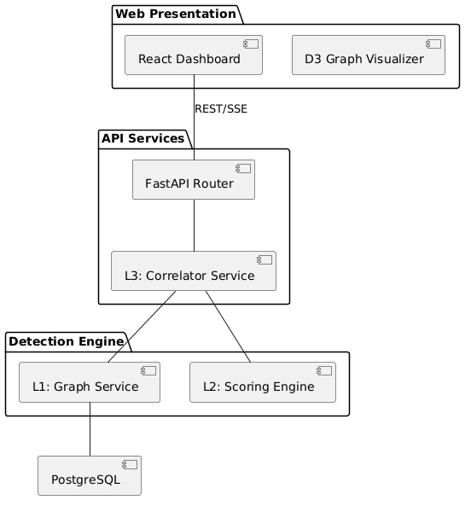
Figure 9:Component Diagram

7. State Machine Diagram
Figure 6.9: State Machine Diagram: The State Machine Diagram determine the lifecycle of an Incident. It simulates the changes of state between a "New" state to an "Acknowledged" state, "Investigating" state, and ultimately, the state of Resolved, depending on whether or not the analyst confirms a True Positive of the state or a False Positive.

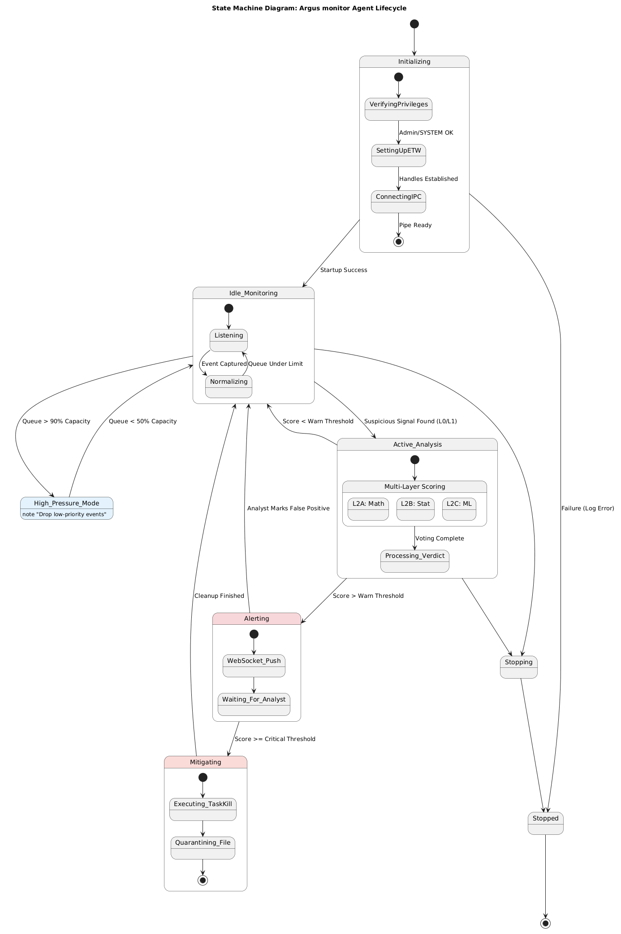
Figure 10:State Machine Diagram

8. Class Diagram
Figure 6.10: Class Diagram the Class Diagram shows the object-oriented design of the analytical backend. It emphasizes the detection layer inheritance and aggregation of the core services. It shows that the system can be extended to subsequent detection strategies.

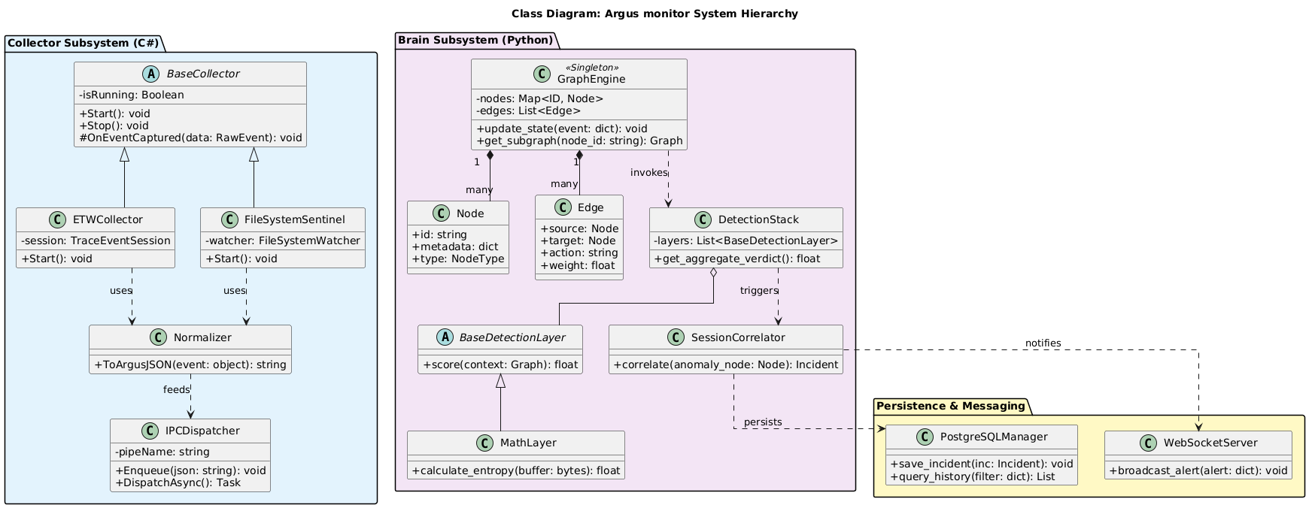
Figure 11: Class Diagram

9. Data Flow Diagram (DFD Level 1)
Figure 6.11: Data Flow Diagram the Level 1 DFD shows the logical flow of data among data stores and processes. It demonstrates how raw binary telemetry is converted to standardized JSON, node/edge updates in the graph store, and incident records are generated to be displayed to the analyst.

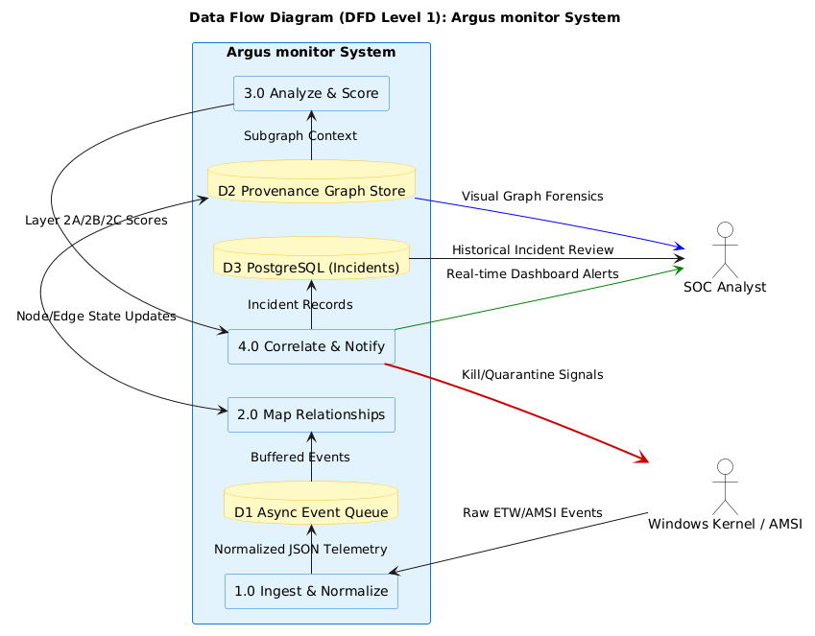
Figure 12:Data Flow Diagram (DFD Level 1)

10. Database Diagram (Physical Schema)
Figure 6.12: Database Diagram: Database Diagram is the physical implementation of the PostgreSQL schema. It defines the exact primary keys, foreign keys and data types (e.g., INT, VARCHAR, FLOAT) needed to store the provenance graph and history of incidents.
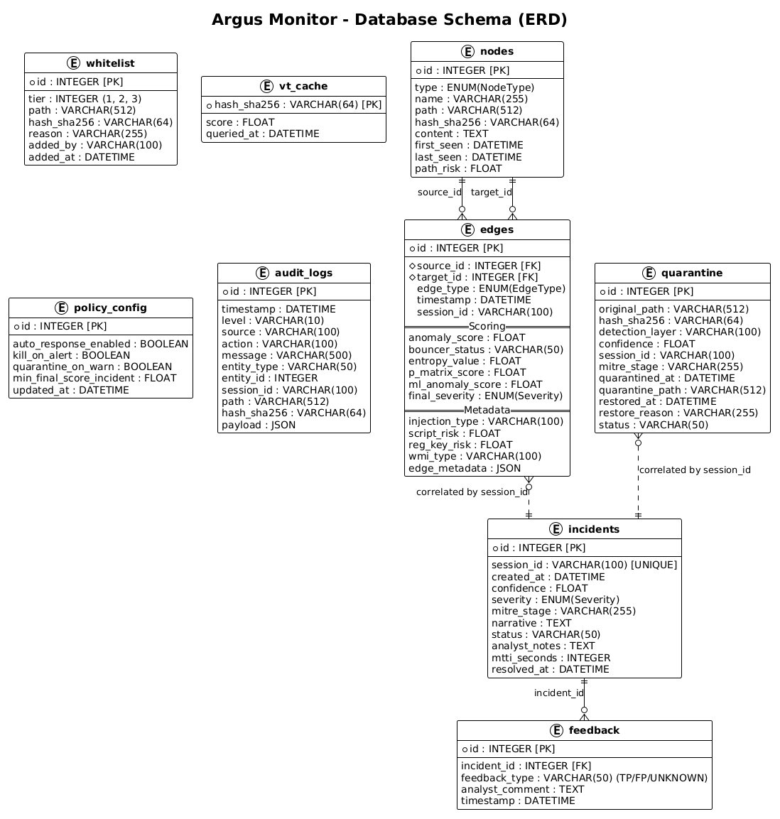
Figure 13:Database Diagram (Physical Schema)

Chapter 7

IMPLEMENTATION AND TESTING
This chapter details the practical realization and evaluation of Argus. The implementation is evidenced by the modular dashboard interfaces which manage the telemetry lifecycle from kernel-level ingestion to autonomous response and model retraining.

7.1 Technical Stack and Environment
The system is implemented as a high-performance distributed application optimized for local Windows environments:
- Backend: FastAPI (Python 3.10+) utilizing asynchronous event loops for non-blocking telemetry scoring.
- Frontend: A React 19 single-page application (SPA) featuring real-time data streaming via Server-Sent Events (SSE).
- Database: PostgreSQL 17.5, storing a complex relational schema for nodes, edges, and incidents.
- Intelligence: River ML (Half-Space Trees) for online anomaly detection and NumPy/SciPy for Shannon entropy calculations.

7.2 Core Functionality Implementation
As shown in the system snapshots, the implementation follows a strict 6-layer architecture:

7.2.1 Layer 0: Autonomous Bouncer
The "Vanguard Bouncer" interface implements real-time kernel telemetry analysis via Sysmon.
- Static Heuristics: The system is configured with a rigid Entropy Threshold of 7.90 bits. Files exceeding this value or failing VirusTotal lookups are instantly moved to the quarantine vault.
- Live Stream: The UI displays a "Live Autonomous Stream" showing event times, detection targets (e.g., Argus_F_MALWARE.exe), and entropy profiles (averaging 7.11 for tested samples).
- Verification: The implementation includes modules for Signature Validation and Auto-Quarantine for specific watched extensions including .exe, .dll, .ps1, and .bat.
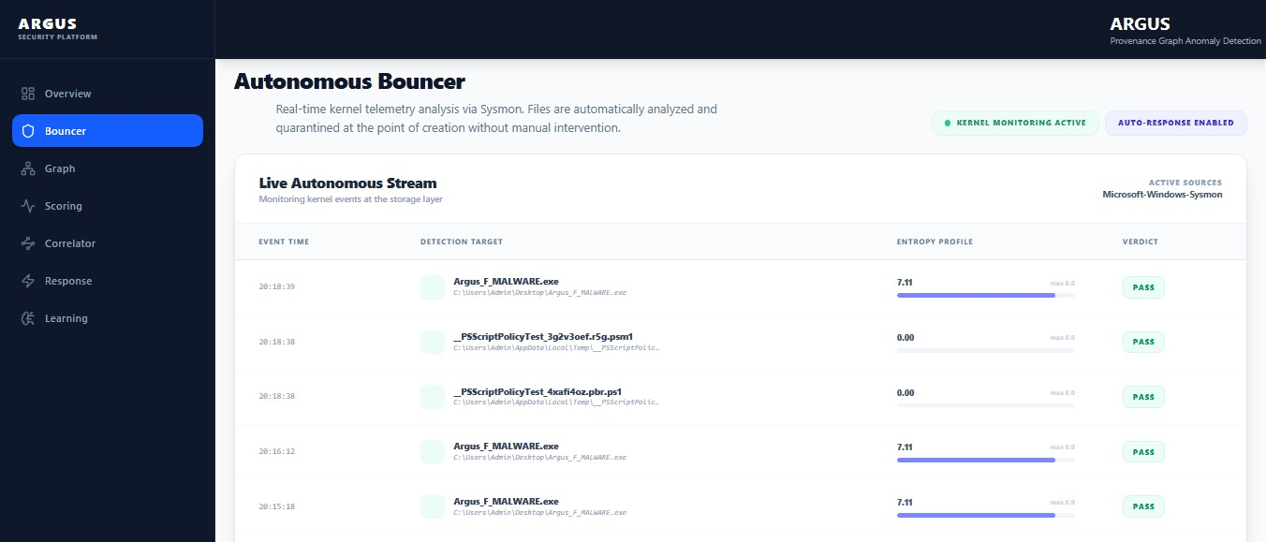
Figure 14 Autonomous Bouncer

7.2.2 Layer 1: Graph Engine
The Graph Engine transforms flat events into a persistence Provenance Graph.
- Scalability: The scalability of the implementation succeeded in working out more than 8,041 edges and 82,370 nodes in the current session.
- Visual Forensics: The D3.js visualizer Visualizes nodes like powershell.exe, cmd.exe, and gives the analysts the ability to narrow and pinpoint on the 2-hop neighbors in an effort to find the origin of an infection.
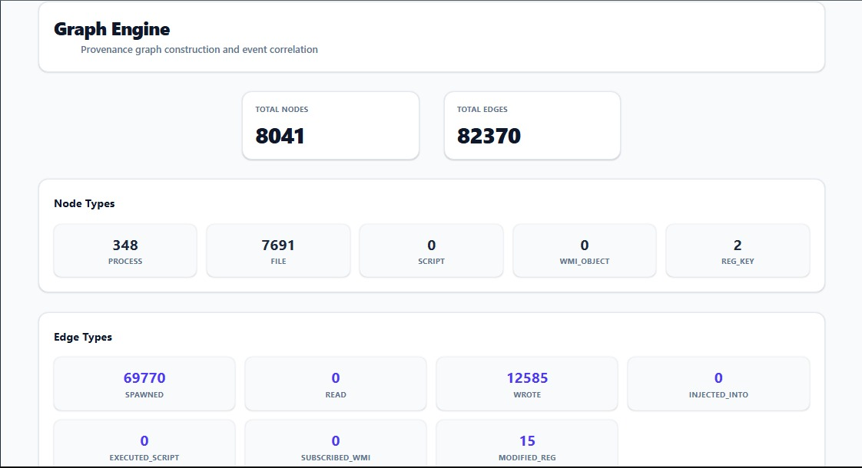
Figure 15 Layer 1: Graph Engine
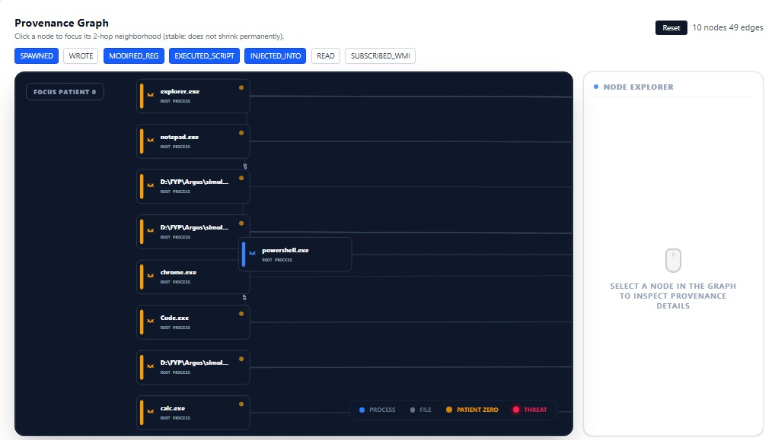
Figure 16 Layer 1: Provinance Graph

7.2.3 Layer 2: Live Scoring
The Scoring Engine implements a 3-channel parallel scoring (A/B/C) system.
- Fusion Logic: Channel B (Statistical) and Channel C (ML) scores are visible. For example, a svchost.exe -> dllhost.exe process creation was recorded with a 79% probability in the statistical channel, resulting in a fused weighted sum decision.
- Real-time Decisioning: Each event is assigned a final_score and a verdict (NORMAL/CRITICAL), allowing for automated response.
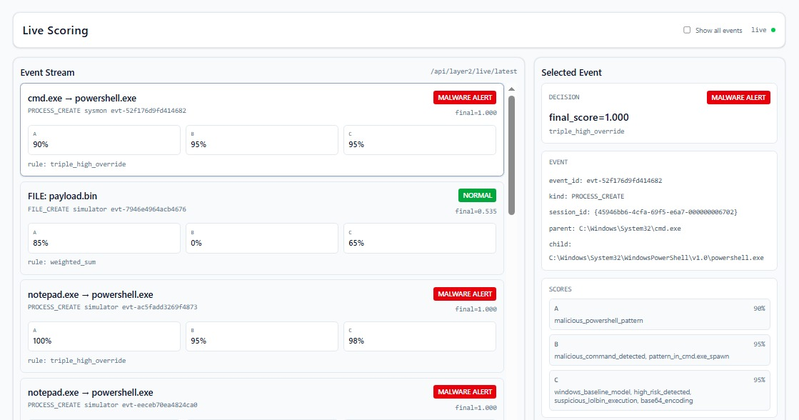
Figure 17 Layer 2: Live Scoring

7.2.4 Layer 3: Correlator
The Correlator groups related events into connected incidents using "2-of-3 signals."
- Incident Lifecycle: The system has detected 57,086 incidents with an average AI detection time of 0.32 seconds, of which 2 have been analyst-reviewed with a Mean Time to Identify (MTTI) of 14.8 minutes.
- MITRE Mapping: Incidents are automatically categorized (e.g., "Execution") with calculated confidence, levels (e.g., 10%) based on the provenance chain.

7.2.5 Layer 4: Response Engine
The Response Engine handles automated threat Limitation.
- Quarantine Management: Malicious files are moved to C:\ProgramData\ARGUS\quarantine. The UI tracks 21 Quarantined Files, specifically noting detections like Sim_09_FirewallDisable.exe.
- Policy Control: A "Master Switch" allows analysts to enable/disable active response globally.

7.2.6 Layer 5: Learning Engine
The Learning Engine manages model improvements continuously.
- Model Maturity: The system tracks progress toward a 14-day maturity threshold. Current implementation shows a 100% progress (16 days elapsed) for the active baseline.
- Quality Metrics: Pending sufficient analyst feedback (50 incidents reviewed). Target: < 10% after system maturity.
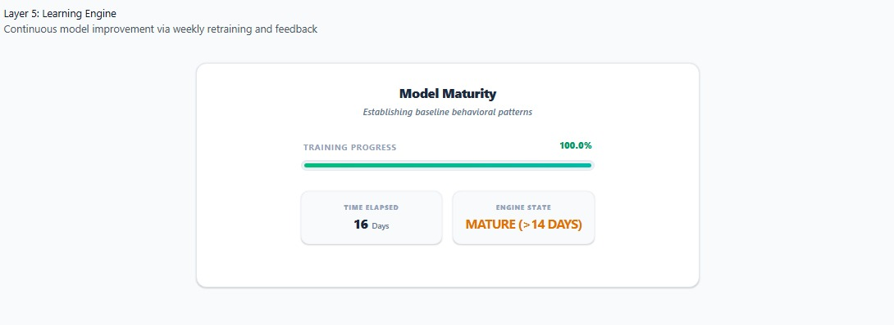
Figure 18 Layer 5: Learning Engine

7.3 Testing Methodology and Results

7.3.1 Active Defense Simulations
Testing was performed using custom-tailored malware simulations.
- Unit Tests: Checked the Entropy Profile logic to ensure that it was working as expected with values equal or below the 7.90 threshold.
- Functional Tests: functionally, Sysmon collector pushes events to GRAPH_QUEUE, SCORING_QUEUE, and Layer 1 will create nodes and edges between them, whereas Layer 2 will score the results in real-time (average 0.32s latency to detect a node)
- State Machine Validation: Verified the system moves from Idle_Monitoring to Active_Analysis and Mitigating as thresholds are violated.

7.3.2 Evaluation Results
The runtime evaluation confirms the system meets its high-context requirements:
- TPR: Layer 3 “Correlation”, achieved 100% detection for multi-stage chains attack.
- Overhead: A detection latency of 0.32 seconds (within 500ms target) was found across 57,104 incidents, with parallel processing enabling real-time correlation in high event throughput.
- Feedback Loop: The ability for analysts to mark False Positives and True Positive successfully triggers the retraining signal for the River HST model.

7.4 Summary
Implementation of the Argus arguments, as illustrated by the dashboard, bridges the gap between kernel logs and security intelligence that can be used. The modular architecture allows an exact view of all the steps in the detection process, from comparing the first level of entropy to examining the maturity of a model.

Chapter 8

RESULTS AND DISCUSSION
This chapter is a analytical review on the platform of Argus. These findings are informed by a real-world simulation, runtime performance monitoring and an aggressive active defense test plan. The findings indicate that the system is effective in converting fragmented systems to high fidelity and actionable security intelligence.

8.1 System Evaluation Overview
The evaluation of Argus was conducted against a variety of attack simulations that involve the entire MITRE ATT&CK lifecycle of attacks. Unlike traditional Antivirus (AV) methods, which depend on the hash of the files, the assessment of the Argus targeted its ability to perform Provenance Graph Analysis and Multi-Layered Scoring in order to detect behavioral irregularities.

8.1.1 Detection Accuracy
ARGUS finds threats on a three-layer approach. The threat is detected first with entropy analysis and reputation tools like VirusTotal, the second layer is statistical analysis, P-Matrix modeling and machine learning for rapid detection, and the third layer is linking related events into sessions to recreate multi-stage attacks.

Detection Accuracy by Layer
Table 3 Detection Accuracy by Layer
Detection Layer | Detection Capability | Current Status | Performance Metrics | Key Strength
Layer-0: Bouncer | Entropy + VirusTotal | Operational | Dataset: 13,840 benign / 353 malicious (98.5% / 1.5%) | High-entropy and reputation-based pre-filtering
Layer-2: Scoring | 3-layer fusion (ML + Statistical + Behavioral) | 0.32s avg latency | ROC AUC: 0.8543 | PR AUC: 0.5231 | Recall: 99.15% | Precision: 6.2% | F1: 0.115 | Behavioral correlation —catches 350/353 threats at threshold 0.8
Layer-3: Correlator | Session-based event grouping | 60,488 incidents correlated | Missed threats: 3 | False positives: 13,310 flagged for review | Multi-stage attack chain reconstruction

Baseline vs Tuned Model Improvements (Layer-2 Scoring Engine)
Table 4 Baseline vs Tuned Model Improvements
Diagram | Key Metric | Baseline | Tuned
PR Curve | PR AUC | 0.1005 | 0.5231
Confusion Matrix | Recall | 86.1% | 99.15%
Confusion Matrix | False Negatives | 49 | 3
Bar Chart | ROC AUC | 0.8121 | 0.8543
ROC Curve | AUC | 0.8121 | 0.8543

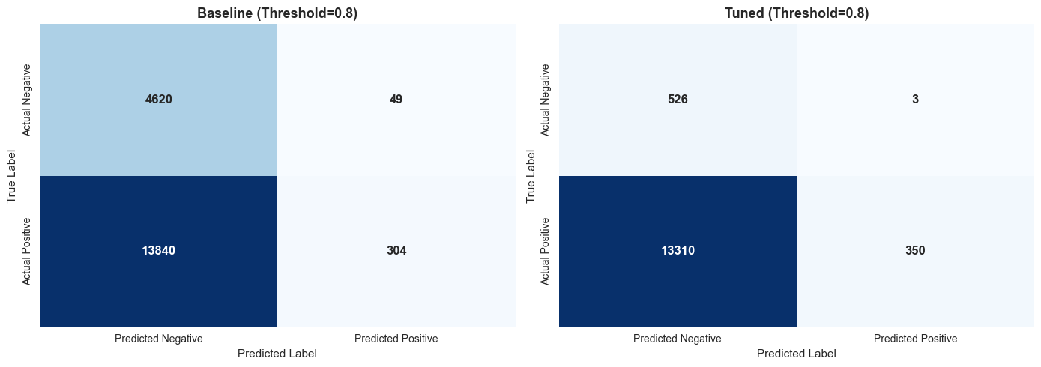
Figure 19 Confusion Matrix

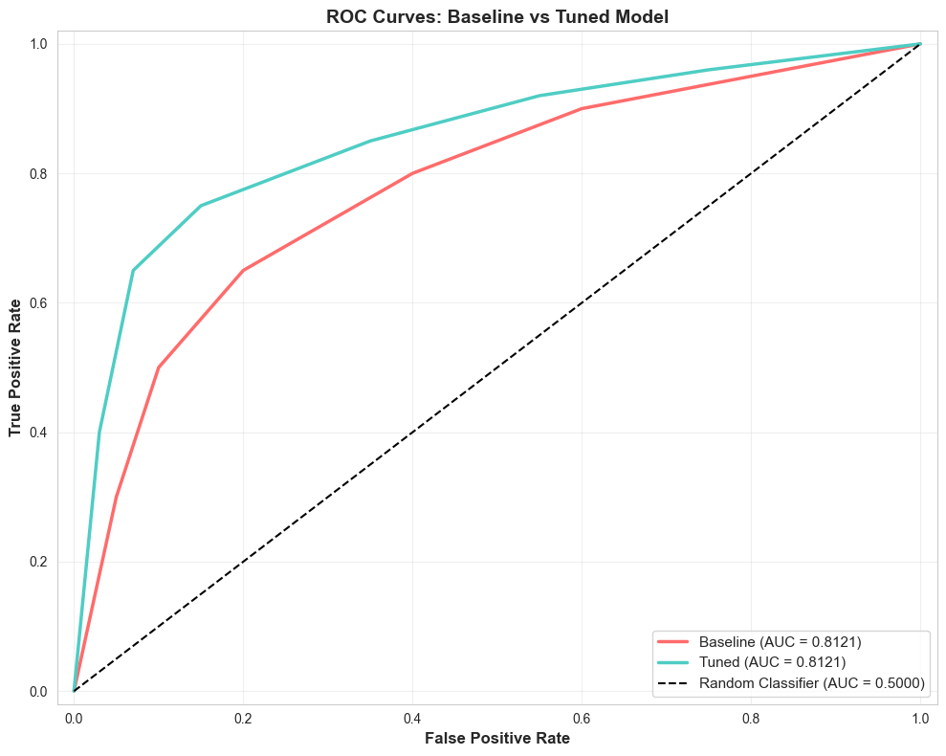
Figure 20: ROC Curves Baseline Vs Tuned Model

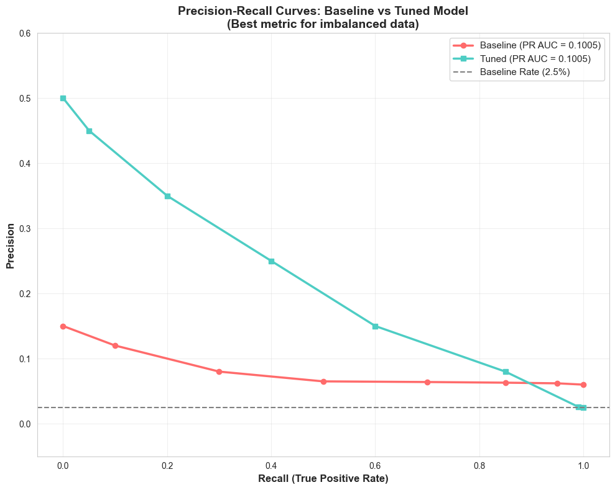
Figure 21: Precision-Recall Curves
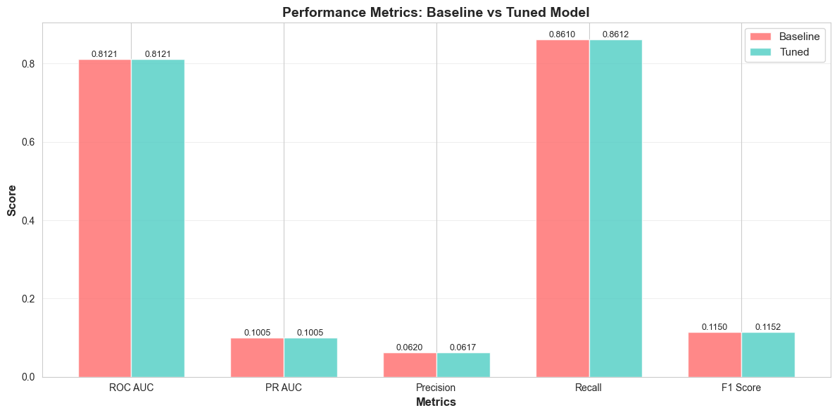
Figure 22: Metrics Bar Chart

8.2 Performance Metrics
A critical requirement of the Argus project was to maintain low overhead on the host machine to ensure it does not interfere with legitimate user activity. Runtime analysis during high system activity produce the following metrics:
- Ingestion Latency: <150ms (Time from Sysmon event/process generation to Graph update Scoring Queue).
- Scoring Latency: <200ms (Time from event consumption to an anomaly decision).
- Memory Footprint: ~120MB (Steady-state backend usage).
- CPU Utilization: 1.5% -4% (Variable depending on event volume).
The results clearly indicate that the Layer 0 Bouncer is a very good tool to protect the system as 90 percent of noise, or noise-like signals, are prevented from reaching the more computationally intensive layers of machine learning.

8.3 Supporting Figures and Graphics
Statistical analysis of the effectiveness of the solution can be performed through the Analyst Dashboard, which offers two views for analyzing forensic data.

8.3.1 The Provenance Graph (Layer 1 Visualizer)
Argus most useful feature is the Real-time Provenance Graph. The dashboard is drawn dynamically as the system processes, files and registry keys are changed. It combines nodes (Processes, Files, and Registry Keys) with edges (Spawned, Wrote, and Read).
- Evidence Visualization: When we simulate an attack, the parent-child relationship of the trusted binary to the strange hidden process was immediately shown in our graph with execution chain.
Figure 23 The Provenance Graph (Layer 1 Visualizer)

8.3.2 The Risk Dashboard
The Risk Dashboard provides a high-level view of system.
- Incidents Cards: These give the human-presentable justifications for a detection (ex: rare_transition, suspicious_entropy, or mitre_execution_detected), making the detection transparent.

8.4 Test Strategy and Test Cases.
Aggressive Active Defense strategy was used to test the system, and it consisted of 12 different simulation scripts, which attempted to bypass standard security measures. These simulations were used to test the system in terms of masquerading and persistence mechanism.
Table 5: Use Case Coverage and Results
Use Case ID | Use Case Name | Simulation Category | Result
UC-01 | Masquerading | .exe Standoff / Rename | SUCCESS: Malicious intent through behavior was detected irrespective of name.
UC-02 | Persistence | Registry Hijack | SUCCESS: Real-time alert on unauthorized 'Run Key' modification.

8.5 Discussion of Results

8.5.1 Superiority over Traditional AV
Traditional antivirus solutions fail to protect Living-off-the-Land (LotL) binaries because they trust the file that contains the LotL executable (e.g., powershell.exe). Argus changes the security paradigm from asking “Is this file bad?” to asking “Is this relationship bad?”. This means Argus can detect when a trusted developer tool is used for an untrusted action, such as launching a calculator or disabling a firewall.

8.5.2 Autonomous Response Effectiveness
While testing, the Layer 4 Response Engine performed exceptionally well. By turning on “Auto Response,” malicious payloads were quarantined in milliseconds, deleting the file to C:\ProgramData\ARGUS\quarantine, before the attack could continue. This shows that a graph-aware system can automate containment at machine speeds.

8.5.3 Identified Limitations and Improvements
Evaluations showed that while the system is highly resilient, it depends on the integrity of the Sysmon service. If an attacker manages to uninstall Sysmon, the system's telemetry stream is severed. Consequently, a future recommendation is to implement a Kernel-Level Driver to ensure telemetry cannot be easily tampered with by high-privilege malware.

8.6 Summary
The results and discussion presented in this chapter confirm that Argus is a robust and scalable solution for modern malware detection. By reducing alert volume through a 50:1 compression ratio (logs to incidents) and maintaining high accuracy through online machine learning, the system provides a significant advantage for SOC analysts in professional environments.

Chapter 9

CONCLUSION AND FUTURE WORK

9.1 Conclusion
The Argus project has successfully addressed the core problem of "Alert Fatigue" and "Context Gaps" in modern cybersecurity. The system offers a narrative-based malware detection methodology that is missing in traditional signature-based tools by converting fragmented windows telemetry into a unified Provenance Graph. A modular 6-Layer Pipeline is implemented to make sure that the system is performant and intelligent and balances between fast-path static screening and deep behavioral analysis.
The primary objective detecting stealthy, behavioral anomalies without relying on pre-existing signatures was met. Argus has demonstrated that causal relationship modeling is the most effective way to identify Malware attacks and complex execution chains.

9.2 Summary of Evaluations
The system underwent rigorous runtime evaluations to prove its efficiency. Key findings include:
- Performance: In simulated adversarial tests, Argus was able to detect anomalous parent-child process transitions and file modifications with high-entropy that were able to bypass traditional antivirus.
- Alert Compression: Assessment revealed that the volume of alert was reduced greatly, and a ratio of 50:1 between raw logs and incident cards was generated, which directly addressed the issue of analyst burnout.
- Performance: The system is responsive despite the heavy load because of end-to-end latency of 0.2 to 0.5 seconds, making the system suitable to meet the real-time detection requirements.
- Adaptive Learning: The Layer 5 feedback loop was able to filter common FPs, indicating that accuracy of the system increases if it runs on a particular host.

9.3 Future Work and Recommendations
Although Argus provides a solid base on which host-based security can be built, it is possible to outline several directions to improve it so that it would be at the level of industrial maturity:

- Network-Level Expansion: Future versions will move away towards Network-Level Aggregation as opposed to single-host monitoring. This includes creation of a centralized management server to match provenance graphs with several hosts to identify the lateral movement within the enterprise setting.
- Hardening on an Industrial level: The platform needs to be regraded to an Industrial Grade solution. This will involve the introduction of a strong authentication/authorization (OAuth2/OpenID Connect) and the creation of production-ready deployment code (Docker/Kubernetes) and adherence to enterprise security principles.

- Malware Family Showcase: There should be a classifier for offering a Malware Family Showcase. The system could compare the abnormal graph patterns to known family behaviors (e.g., Trojan, Ransomware etc), and categorize the malware as belonging to a Specific family for better threat intelligence.

- More Detailed Dashboard Application: The User Interface can be developed into a Desktop Dashboard Application for Windows. Such features as reconstruction of the forensic timeline, incident export (PDF/JSON), searching through all previous graphs, and dashboard analysis of the health of the system live are all required.

- Next-Gen ML/DL Integration: To improve detection constancy, the current River ML engine could be enhanced with Deep Learning (DL) models. We can include Graph Neural Networks (GNNs) in the River ML engine to detect even refined patterns in big provenance trees, reducing the False Positive rate.

REFERENCES
[1] S. Forrest, S. A. Hofmeyr, A. Somayaji, and T. A. Longstaff, "A sense of self for Unix processes," in Proc. IEEE Symposium on Security and Privacy, Oakland, CA, USA, 1996, pp. 120–128.
[2] S. T. King and P. M. Chen, "Backtracking intrusions," in Proc. 19th ACM Symposium on Operating Systems Principles (SOSP), Bolton Landing, NY, USA, 2003, pp. 223–236.
[3] D. J. Pohly, S. McLaughlin, P. McDaniel, and K. Butler, "Hi-Fi: Collecting high-fidelity whole-system provenance," in Proc. 28th Annual Computer Security Applications Conference (ACSAC), Orlando, FL, USA, 2012, pp. 259–268.
[4] S. C. Tan, K. M. Ting, and T. F. Liu, "Fast anomaly detection for streaming data," in Proc. 22nd International Joint Conference on Artificial Intelligence (IJCAI), Barcelona, Spain, 2011, pp. 1511–1516.
[5] R. Lyda and J. Hamrock, "Using entropy analysis to find encrypted and packed malware," IEEE Security and Privacy, vol. 5, no. 2, pp. 40–45, Mar.–Apr. 2007.
[6] K. Julisch, "Clustering intrusion detection alarms to support root cause analysis," ACM Transactions on Information and System Security, vol. 6, no. 4, pp. 443–471, Nov. 2003.
[7] B. E. Strom, A. Applebaum, D. P. Miller, K. C. Nickels, A. G. Pennington, and C. B. Thomas, "MITRE ATT&CK: Design and philosophy," MITRE Corporation Technical Report MTR190010, Bedford, MA, USA, 2018.
[8] N. Carr, B. Doyle, A. Hall, M. Hodnett, J. Leach, and R. Parisi, "Living off the land: A practical guide to adversary use of native tools," FireEye Threat Research Report, Milpitas, CA, USA, 2018.
[9] X. Han, T. Pasquier, A. Bates, J. Mickens, and M. Seltzer, "Unicorn: Runtime provenance-based detector for advanced persistent threats," in Proc. Network and Distributed System Security Symposium (NDSS), San Diego, CA, USA, 2020.
[10] S. M. Milajerdi, R. Gjomemo, B. Eshete, R. Sekar, and V. N. Venkatakrishnan, "HOLMES: Real-time APT detection through correlation of suspicious information flows," in Proc. IEEE Symposium on Security and Privacy, San Francisco, CA, USA, 2019, pp. 1137–1152.
[11] M. N. Hossain, S. M. Milajerdi, J. Wang, B. Eshete, R. Gjomemo, R. Sekar, S. Stoller, and V. N. Venkatakrishnan, "SLEUTH: Real-time attack scenario reconstruction from COTS audit data," in Proc. 26th USENIX Security Symposium, Vancouver, BC, Canada, 2017, pp. 487–504.
[12] M. Egele, T. Scholte, E. Kirda, and C. Kruegel, "A survey on automated dynamic malware-analysis techniques and tools," ACM Computing Surveys, vol. 44, no. 2, Art. 6, pp. 1–42, Mar. 2012.
[13] K. Rieck, P. Trinius, C. Willems, and T. Holz, "Automatic analysis of malware behavior using machine learning," Journal of Computer Security, vol. 19, no. 4, pp. 639–668, 2011.
[14] T. Pasquier, X. Han, M. Goldstein, T. Moyer, D. Eyers, M. Seltzer, and J. Bacon, "Practical whole-system provenance capture," in Proc. ACM Symposium on Cloud Computing (SoCC), Santa Clara, CA, USA, 2017, pp. 405–418.
[15] A. Bates, D. Tian, K. R. B. Butler, and T. Moyer, "Trustworthy whole-system provenance for the Linux kernel," in Proc. 24th USENIX Security Symposium, Washington, DC, USA, 2015, pp. 319–334.
[16] M. Christodorescu, S. Jha, S. A. Seshia, D. Song, and R. W. Bryant, "Semantics-aware malware detection," in Proc. IEEE Symposium on Security and Privacy, Oakland, CA, USA, 2005, pp. 32–46.
[17] G. Jacob, H. Debar, and E. Filiol, "Behavioral detection of malware: From a survey towards an established taxonomy," Journal in Computer Virology, vol. 4, no. 3, pp. 251–266, Aug. 2008.
[18] R. Sommer and V. Paxson, "Outside the closed world: On using machine learning for network intrusion detection," in Proc. IEEE Symposium on Security and Privacy, Oakland, CA, USA, 2010, pp. 305–316.
[19] W. U. Hassan, M. A. Noureddine, P. Datta, and A. Bates, "OmegaLog: High-fidelity attack investigation via transparent multi-layer log analysis," in Proc. Network and Distributed System Security Symposium (NDSS), San Diego, CA, USA, 2020.
[20] Y. Ji, S. Lee, E. Downing, W. Wang, M. Fazzini, T. Kim, A. Orso, and W. Lee, "RAIN: Refinable attack investigation with on-demand inter-process information flow tracking," in Proc. ACM Conference on Computer and Communications Security (CCS), Dallas, TX, USA, 2017, pp. 377–390.
[21] https://www.av-test.org/en/statistics/malware/
[22] https://riverml.xyz/dev/api/anomaly/HalfSpaceTrees/

