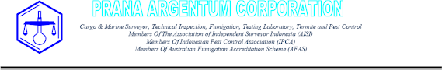

Serial No. Date issued (dd/mm/yyyy)

TREATMENT CERTIFICATE - Methyl Bromide Fumigation
Certificate number | Treatment provider ID number
 | ID0018MB

Consignment details
 | Related Document Number :
 | Containers :
 | CONSIGNEE :
Consignment link (container
numbers if applicable)
 | NOTIFY PARTY :
Seal numbers(s) and Carrier/vessel (if applicable) | Seal numbers : Carrier/vessel :
Client name and address
Commodity description and quantity
Commodity country of origin Destination country |  | Port of loading Port of unloading
Target of fumigation |  | Enclosure type

Treatment schedule (prescribed/specified treatment schedule)
Dose rate | g/m3 | Exposure period | (hours) | Temperature | ℃

Fumigation details (treatment applied)
Applied dose | g/m3 | Exposure period | (hours) | Temperature | ℃

Place of fumigation (Full address)
Date and time fumigation commenced (dd/mm/yyyy – HH:MM)
Date and time fumigation completed (dd/mm/yyyy – HH:MM)
Final TLV reading (ppm)

Declaration
I, the fumigator-in-charge declare:
- The fumigation certified was conducted in accordance with the treatment schedule, import conditions, and all the requirements in the Methyl Bromide Fumigation Methodology, and
- The information I have provided is true and correct.

Signature
Full name Accreditation number |  | Date (dd/mm/yyyy)

Additional Declarations

Printed digitally through: FUMI TRUST by BARANTIN. The authenticity of this document can be verified through the QRcode above or via the following l

