**System Design Document (SDD)**

1. **A diagram of a software company

   Description automatically generated with medium confidenceClass Diagram**

* In this class Diagram, the main class HayatYogurt and Sales&Marketing, Finance&Accounting, HumanResources, Manufacturing&Production classes are subclass.
* We used composition in the relationships between departments and the company because the departments cannot exist without the company.
* The HumanResources class encompasses employees. However, in a company where there might not be a human resources department, employees can still exist. That's why we used aggregation.
* The Sales&Marketing, Finance&Accounting, and Manufacturing&Production classes include their respective managers and department employees. Since department-based employees cannot exist without the departments themselves, we used composition.
* Furthermore, since department-based employees are also considered employees, we utilized inheritance between employees and department-based employees.

1. **User Interface**

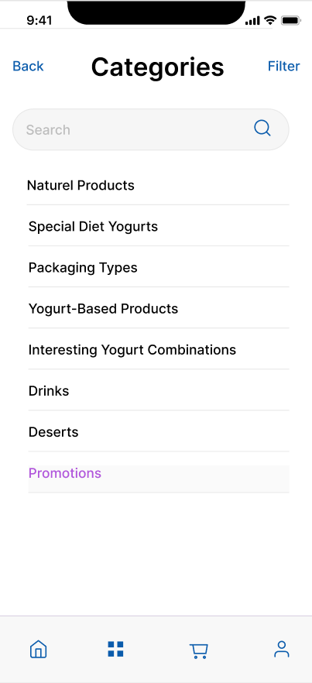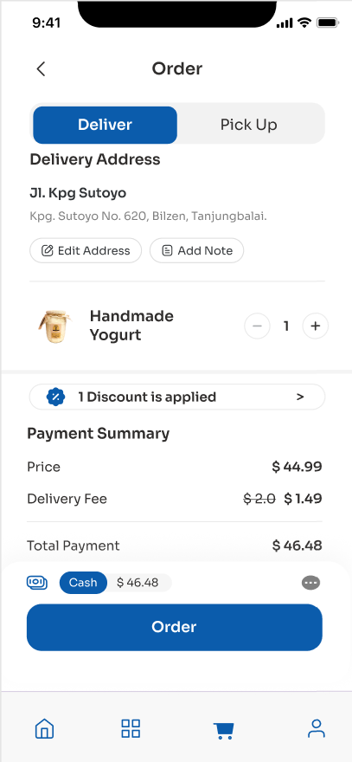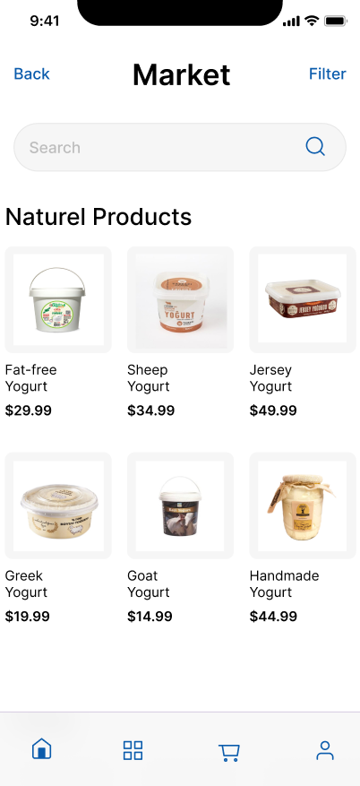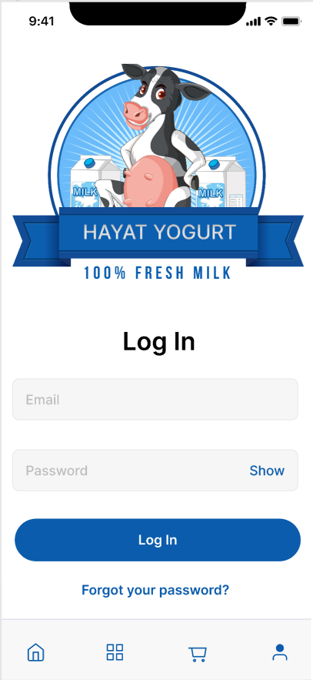

Hayat Yogurt Company has a user interface design consisting of four main pages in order to offer its users a more effective and easier-to-use interface, prioritizing user experience. These pages are "Login", which includes login procedures, "Category", which allows you to explore product categories, "Products", which allows you to examine product details, and "Cart" pages, which make it easier to manage your shopping transactions.

To ensure that users have a comfortable experience while navigating the page, it is easier for them to understand which page they are on thanks to the icons at the bottom of the pages. These icons help users quickly reach the page they want, while making overall navigation more intuitive.

The "login" page allows users to securely log in to their account. In this way, they can have personalized experiences, track their order history and benefit from other user features. A user-friendly login screen allows users to easily manage their accounts.

The "Category" page introduces Hayat Yogurt's wide product range to users. Providing quick access to different categories, this page allows users to discover the products they want. Visual elements and simple filtering options enrich the shopping experience.

The "Products" page allows users to take a closer look at the products they have selected and see detailed information. Details such as product features, pricing information and customer reviews help users make informed purchases.

The "Cart" page provides a hub where users can view their selected items, edit their quantities, and manage checkout. A user-friendly checkout process increases customer satisfaction and completes the shopping experience.

1. **Security Culture**

Employees are informed about the methods used to ensure security and necessary training is provided.

* Software updates:

Software updates are made regularly to ensure the security of the application. Additionally, updates are made based on user feedback and bug reports. These updates are important for more effective use of the system.

* User Security:

2-step verification application is used to ensure user security. A code is sent to the e-mail and phone information the user provides when registering. Thus, when the user logs in from a different device, it is verified that it is the user. Apart from this, a mandatory password renewal notification is sent to the user at regular intervals (preferably every 6 months). Thanks to these applications, the security of the user account is ensured.

* System Security:

Establishing backup systems and redundant infrastructure is very important to ensure the availability and integrity of data and systems in case of interruption or failure. That's why database backups are taken at regular intervals. Additionally, power backup systems such as generators or UPS (uninterruptible power supply) are used to take precautions against power outages.

A business continuity plan is available, including steps such as data backup, system restore, and personnel communication. The business continuity plan is prepared as a guide against predetermined disaster scenarios. A detailed recovery plan has been created to quickly restore systems in case of disaster. This plan includes rapid replacement of hardware and software. Plans are updated depending on changing business needs and technological changes.

With the internal user access policy, data and systems are prevented from falling into the hands of malicious people.

* E-mail Security:

Staff are trained on social engineering attacks and email scams. Employees' awareness of recognizing and reporting suspicious e-mails is increased. By implementing email authentication protocols such as Sender Policy Framework (SPF), and DomainKeys Identified Mail (DKIM), email authentication is strengthened.

* Network Security:

Firewalls are integrated to protect against unauthorized access and malicious activities. Firewalls are integrated into various levels of the network infrastructure, monitoring, and filtering network traffic. This is important to control data packets coming into and out of the network and to prevent unwanted access.

HTTPS ensures the secure transmission of data sent and received by users by encrypting the data. This prevents unauthorized access to this data by third parties. Additionally, with HTTPS, data integrity is maintained. It prevents changes to send and receive data, thus ensuring the accuracy of the data.

WPA2 encrypts Wi-Fi traffic, allowing users and devices to transmit their data securely when connected to the network. WPA2 is regularly updated for vulnerabilities and vulnerabilities that are discovered over time.

* Physical Security:

Biometric access control maintains identities using physical or behavioral characteristics to be performed. These systems provide more secure and personal identification than more traditional access control methods. We use the fingerprint recognition method in this system. Individuals are authenticated using their fingerprints. Every individual's fingerprint is unique, so it is a reliable biometric feature.

**GROUP-1**

Hazal PALTACI

Enes KAR

Helin YİĞİT

Deniz Arda KÜÇÜK

Necmi Mert KINAY