Marketing Campaign Materials

**Generated: June 15, 2025 at 13:05**  
Session ID: default_session

# Email Copy

Okay, here's an email marketing copy draft designed to be friendly, persuasive, and drive sign-ups for an AlbertaEnergy electric plan and HVAC repair service.

**Subject:** Is Your Home Feeling the Heat (or Cold)? We Can Help (and Save You Money!)**

**Preheader Text: Reliable HVAC Repair + 5% Off! Don't let HVAC issues break the bank. Read on!**

**Body:**

Hi [Homeowner Name],

Is your furnace acting up? Is your air conditioner on the fritz? Don't let HVAC problems leave you sweating (or shivering!) this season. We understand how frustrating and costly unexpected HVAC repairs can be. That's why we're dedicated to providing fast, reliable, and affordable HVAC repair and maintenance services to homeowners like you.

**Peace of Mind, Priced Right: Expert HVAC Service You Can Trust**

We pride ourselves on delivering professional and friendly service you can count on. Our team of certified technicians is skilled in diagnosing and repairing all makes and models of HVAC systems. We offer transparent pricing, explain the issue clearly, and ensure you're comfortable with the solution before we start any work.

**Here's the Best Part: Save Money on Your HVAC Repair!**

We've partnered with AlbertaEnergy to bring you an exclusive offer! When you sign up for an AlbertaEnergy electric plan, you'll receive a **5% discount** on your HVAC repair service. That's right – top-notch HVAC service at an even lower cost!

**Why Choose Us for Your HVAC Needs?**

* **Fast Response Times:** We're there when you need us, minimizing discomfort and potential damage.  
* **Certified Technicians:** Experience and expertise you can rely on.  
* **Transparent Pricing:** No hidden fees or surprises.  
* **Friendly and Professional Service:** We treat your home with respect.  
* **PLUS: 5% Discount with AlbertaEnergy Electric Plan!**

**Ready to Keep Your Home Comfortable and Save Money?**

Don't wait until a small HVAC issue becomes a major (and expensive!) problem.

**Click Here to Sign Up for an AlbertaEnergy Electric Plan and Get 5% Off Your HVAC Repair!**

[Button: Sign Up & Save!]

We look forward to helping you keep your home comfortable all year round.

Warmly,

The [Your Company Name] Team

[Your Company Website Link]  
[Your Company Phone Number]

**Footer:**

[Your Company Address]  
[Unsubscribe Link]  
[Privacy Policy Link]

**Explanation of Choices:**

* **Subject Line & Preheader:** Focus on the problem (HVAC issues) and the solution (savings). They are concise and enticing.  
* **Personalization:** Using "[Homeowner Name]" creates a more personal feel.  
* **Problem/Solution Focus:** The copy immediately addresses the homeowner's potential pain points (HVAC problems and costs).  
* **Benefit-Driven Language:** Highlights the benefits of the service (peace of mind, reliable service, transparent pricing, savings).  
* **Friendly Tone:** Uses words like "warmly," "we understand," and emphasizes the friendly service.  
* **Natural Integration of Key Message:** The AlbertaEnergy discount is woven naturally into the copy as a major benefit.  
* **Clear Call to Action:** The CTA is prominent, specific, and reinforces the benefit (Sign Up & Save!).  
* **Bulleted List:** Breaks down the benefits into easy-to-digest points.  
* **Format:** Designed to be easily readable on mobile devices.  
* **Medium Length:** Provides enough information without being overwhelming.  
* **Footer:** Includes standard email footer elements for compliance and professionalism.

## Related Images



*Image: HVAC_Technician_Email_Image.png*

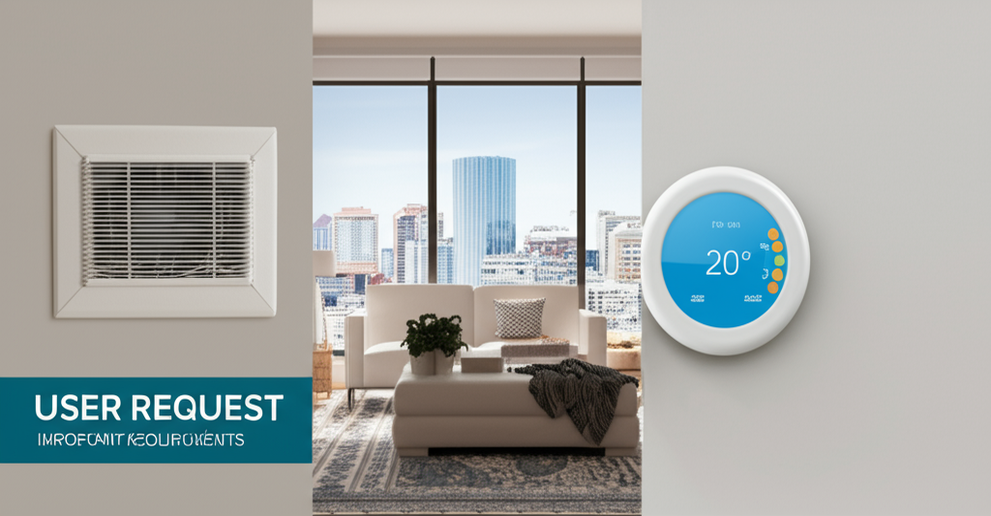

*Image: churn_reduction_email_image.png*

# Email Copy

**Subject:** We're Listening, Calgary: Let's Talk About Your Home Comfort

Hi [Customer Name],

We appreciate you choosing us as your trusted electricity provider and for also entrusting us with your home's HVAC system. At [Your Company Name], we're committed to keeping your home powered and comfortable, year-round. We understand that your satisfaction is earned, and we’re constantly striving to be the best choice for your Calgary home.

**Is Your Home Comfort Where It Should Be? Your Opinion Matters.**

We know you have choices when it comes to your home's electricity and HVAC needs. Factors like competitive offers, the reliability of your service, and even the clarity of your monthly bill all contribute to your overall experience. We're actively working to address these areas, ensuring you receive the best possible value and uninterrupted service from [Your Company Name].

**We're Focused on What Matters Most: You and Your Home**

We understand that keeping your home comfortable in Calgary's unpredictable weather is a top priority. That's why we're investing in:

* **Enhanced Reliability:** We're continuously upgrading our infrastructure to minimize outages and ensure consistent power and efficient HVAC performance, especially during peak seasons.  
* **Transparent Billing:** We're making your bills easier to understand with clear explanations of charges and consumption.  
* **Competitive Pricing:** We're constantly evaluating our rates to offer you the best possible value for your electricity and HVAC services.  
* **Unmatched Customer Service:** Our Calgary-based team is ready to assist you with any questions or concerns you may have, promptly and efficiently.

**But We Need Your Help!**

We believe the best improvements come from understanding your experiences. We truly value your feedback, as it helps us fine-tune our services and provide you with the exceptional support you deserve. Have you noticed any areas where we could improve? Are there specific features or services you'd like to see? We're all ears!

**Unlock Exclusive Loyalty Programs Designed Just for You**

As a valued customer with both electricity and HVAC services, you may be eligible for exclusive loyalty programs designed to save you money and enhance your home comfort experience. These programs may include:

* **Priority Service:** Get moved to the front of the line for repairs and maintenance.  
* **Discounted Maintenance Packages:** Keep your HVAC system running smoothly with regularly scheduled maintenance at a reduced cost.  
* **Exclusive Savings:** Access special offers on energy-efficient upgrades and new HVAC equipment.  
* **And More!**

**Your Satisfaction is Our Guarantee**

At [Your Company Name], your satisfaction is our top priority. We’re dedicated to providing you with reliable electricity and efficient HVAC services, backed by a team that truly cares about your needs.

**Ready to Chat? Let's Connect!**

We encourage you to reach out to us today to:

* **Discuss your current service:** Let us answer any questions you may have and address any concerns.  
* **Explore exclusive loyalty programs:** Discover how you can save money and enjoy even greater benefits.  
* **Share your valuable feedback:** Help us improve our services and provide you with the best possible experience.

You can reach us by calling [Phone Number] or by replying directly to this email.

Thank you for being a valued customer. We appreciate your business and look forward to continuing to serve you.

Sincerely,

The Team at [Your Company Name]

[Website Link]  
[Social Media Links (Optional)]

## Related Images



*Image: HVAC_Technician_Email_Image.png*



*Image: churn_reduction_email_image.png*

# Usage Instructions

**•** This document contains your complete marketing campaign materials.

**•** Copy and paste the content into your preferred email marketing platform.

**•** Use the embedded images in your campaigns by right-clicking and saving them.

**•** Customize the content as needed for your specific brand voice and requirements.

**•** For email campaigns, test the formatting in your email platform before sending.