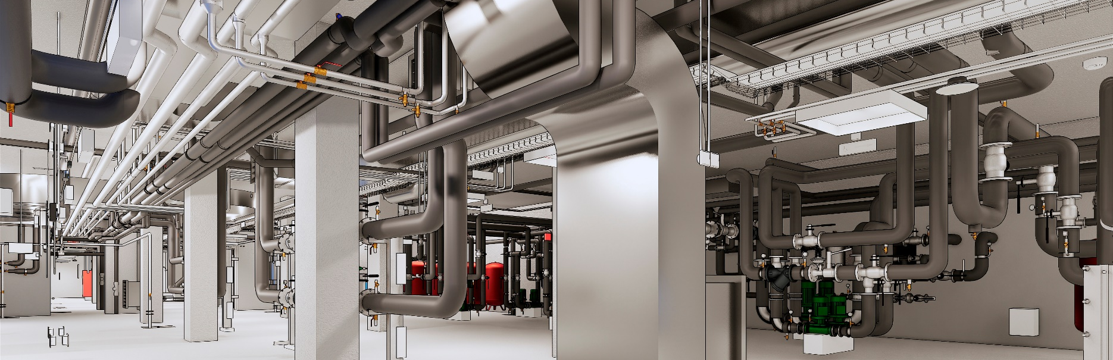

AX3000® MEP Professional
Professional Software for HVAC and MEP
“AX3000” is the results of a profitable collaboration, having taken place over many years, between technicians of the plant-engineering sector, technical schools and universities specialized on process engineering and energy management. The key benefit of the program is a simple user interface, which can be learned in a short time with great success. “AX3000” is flexible and can be adopted easily.
Its continuous development creates the basis for a guaranteed investment in time.

Modules
Ventilation and Air-Conditioning
Heating (Plumbing Heating and cooling)
Sanitation (Plumbing Cold/Hot/Waste Water)
Electrical Engineering

Basic Philosophy
Use a simple 3D-line and connect it to intelligent blocks -
Based on physical formulas, depending on the transported
medium the systems are calculated and a 3D-model is generated.
This system is called Easyline.
You can also plan directly in 3d and get the calculation.
Both systems can be mixed.

Simple User Interface
The modular construction of AX3000 offers you extensive special solutions for HVAC and MEP systems.
You have to become familiar with the software only once because the functionality is continuous.

Optimal data organization
AX3000 uses the functionality from the basic CAD system and is fully compatible to DWG-based drawings and Brics-BIM

Libraries
Libraries in both imperial and metric units are includes and can be changed easily.
The database contains:
components (blocks)
- materials (galvanized steel, copper etc.) tables for parametric standard fittings
- information concerning the specific medium, fitting loss coefficients and material properties
Libraries can be edited and extended by the user

Specific functions
- simple calculation of variants (pe.: pipes or rectangular fittings)
- sizing of all main and branch duct-system at a
constant friction or maximum duct velocity
- fixation of diameters, special fittings and routing.
- calculation results added as attributes
- analyzation of the system (velocity etc.)
detailed 2D labeling output linked to 3D Model

BIM
- The BIM model can be used optionally to create room books
- visualizations and 3D representation of information
and room properties
for heating and cooling load calculations and simulation

AX3000© Ventilation
Lines, blocks and material tables form the basis of AX3000 and automatically three-dimensional systems are created. Variants can simply be created on basis of different parameters.
“Equal Friction Loss” is used as calculation method, regarding a maximum velocity.
The calculation is based on Darcy-Weisbach equation, the roughness of the material and tables for loss coefficients.
Easyline-Systems are divided into supply air and exhaust air by starting points.
Duct Design Fundamentals are the flowrate of the outlets, components, fittings and materials.
The dimensioning will be accomplished optionally by entering the cross section, volume flow or R-value.
By means of frame conditions the system is dimensioned, calculated and drawn in 3D. All data, relevant for the system calculation is saved immediately and is recallable and changeable at any time.

Central- construction
3D-Modeling of complex systems or specific details complete the planning.

Materials and Tables
- Materials for rectangular or round ducts are stored in the database
Materials can be added and extended.

Ventilation planning
- Intelligent drawing elements (3D line concept)
- Easy connection of ventilation outlets
- Project planning with calculation of variants
- Manipulation- and copy- services
Automatic access to the component database

Ventilation construction
- System construction via center line or outer contour
- Automatic intermediate length calculation
Automatic position-, lengths- & dimension- labeling

Bills of Material
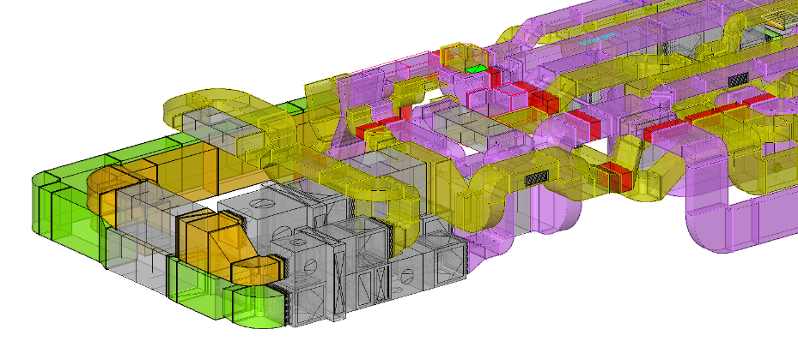
User-configurable bills of material can be created in Excel or Pdf. Various reports provide accurate information such as manufacturing and fitting lists.

Drawings & Labeling
- Users can easily create 2D drawings out of the 3D model.
A convenient and flexible labeling function is available.
Imperial and metric units can be changed simultaneously.

Evaluations
- Calculation of duct sizes based on the design methodology
- Optimize fittings
- Pressure loss calculation
- Balancing
- calculation results added as attributes
- graphical analyses of the system (velocity, diameter, temperature, etc.)
- detailed labeling
2D Output linked to 3D Model

Application Areas
Building Services for Non-residential and residential buildings
Food and Beverage, Hospitals, Industrial and Administration buildings, etc.

Technical Specifications
- BricsCAD®-compatible
- AutoCAD®-compatible

AX3000©Heating
The heating system is created by drawing simultaneously centerlines for flow and return. The start point defines the system parameters for material and system temperature. Fan coils, radiators or floor heating systems are the load points.
The calculation is based on Darcy-Weisbach equation, the roughness of the material and tables for loss coefficients.
The result of the Easyline method is a fully 3D planed piping system, including pipes fittings, components, valve settings and pressure loss calculations

Capabilities
- Automatic placement of radiators based on BIM- room books
- Definition of free defined load points
- Definition of connection types and valves
- Automatic load point connection in different layout variants.
- Comfortable manipulation services
- Automatic pipe dimensioning acc. to friction and velocity
- Change of the medium properties like density and viscosity
- Automatic assignment of required fittings
Comfortable labelling functions

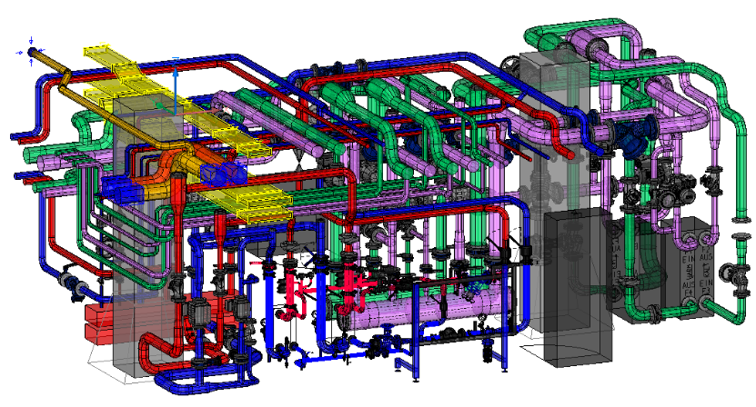
Distributor- / Central- construction
- 3D-pipe construction
- Calculation of the distributor diameter
- combination of components
- Placement of armature-groups to a predefined height
Manufacturer database

Evaluations
- Valve setting lists
- Pressure loss calculation
Calculation of the water quantities in the piping and the radiators

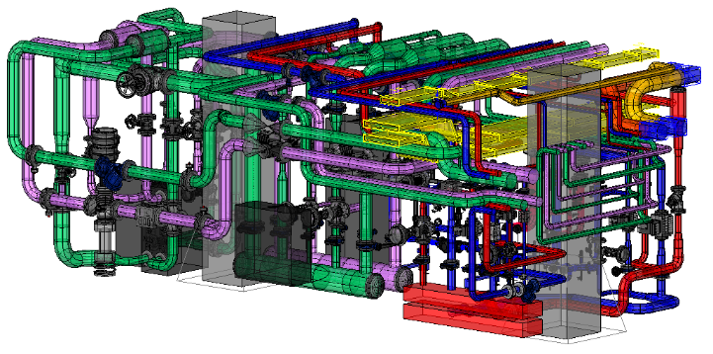
Bills of Material
User-configurable bills of material can be created in Excel or Pdf. Various reports provide accurate information such as manufacturing and fitting lists.

Drawings & Labeling
Users can easily create 2D drawings of the 3D model.
Convenient and flexible labelling and annotation functions are available to finish the layout.
Imperial and metric units can be changed simultaneously.

Application Areas
Building Services for Non-residential and residential buildings
Food and Beverage, Hospitals, Industrial and Administration buildings, etc.

Technical Specifications
- BricsCAD®-compatible
- AutoCAD®-compatible

AX3000©Sanitation
The Easyline sanitation systems include potable water with optional circulation and waste water.
Every load point has connectors to its necessary fluid. Typical load points are sinks, toilets, showers, washing machines etc. or concealed frames. The Easyline method is creating the pipe works by using hydraulic calculations based on Darcy-Weisbach’s and Prandtl-Colebrook's equation.
The result is a fully 3D planed piping system, including pipes fittings, components, valve settings and pressure loss calculations

Capabilities
- Predefined blocks and connection types for sanitary objects
- Comfortable placement of sanitary objects or free defined load points
- Automatic load point connection with different connection variants.
- Comfortable manipulation services
- Automatic pipe dimensioning acc. to constant friction or velocity
- Change of the medium properties like density and viscosity
- Automatic assignment of required fittings
- Circulation system calculation
Comfortable labeling-functions

Waste water / Sewage
- Predefined connection types and functions
- Special fittings
Automatic generation of pipe slope

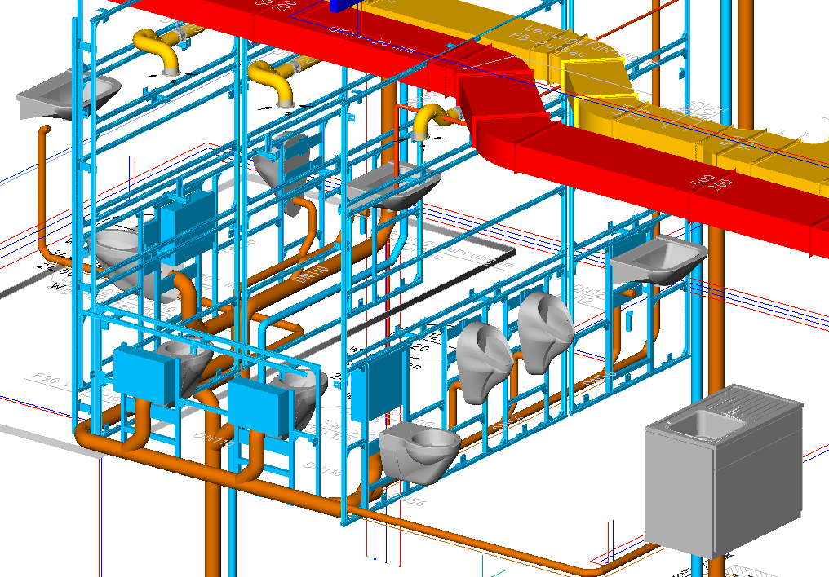
Distributor- / Central- construction
- 3D-pipe construction
- Calculation of the distributor diameter
- combination of components
- Placement of armature-groups to a predefined height
Manufacturer database

Bills of Material
User-configurable bills of material can be created in Excel or Pdf. Various reports provide accurate information such as manufacturing and fitting lists.

Drawings & Labeling
Users can easily create 2D drawings of the 3D model.
A convenient and flexible labeling function is available.
Imperial and metric units can be changed simultaneously.

Evaluations
- Pressure loss calculation
- Heating loss of the PWC/PWH/PWH-C system
Circulation-Valve setting lists

Application Areas
Building Services for Non-residential and residential buildings
Food and Beverage, Hospitals, Industrial and Administration buildings, etc.

Technical Specifications
- BricsCAD®-compatible
- AutoCAD®-compatible

AX3000©Electrical
Placement of electrical elements (switch, socket, etc.) and their connection via conduits.
A smart design of cable trays and cable leathers, based on manufacturer databases including posts an hangers.

Placement of lamps, switches, sockets
- Predefined blocks and connection types
- Intelligent symbols with 2D/3D view
- Easy placement of components
- Automatic access to database
- Comfortable labeling-functions
Conduit connection

Cable routing
- Special parametric fittings for cable trays
- Database with manufacturer fittings
- Hangers and posts mounting systems
3D modeling

Bills of Material
User-configurable bills of material can be created in Excel or Pdf. Various reports provide accurate information such as manufacturing and fitting lists.

Drawings & Labeling
A convenient and flexible labeling function is available.
Imperial and metric units can be changed simultaneously.

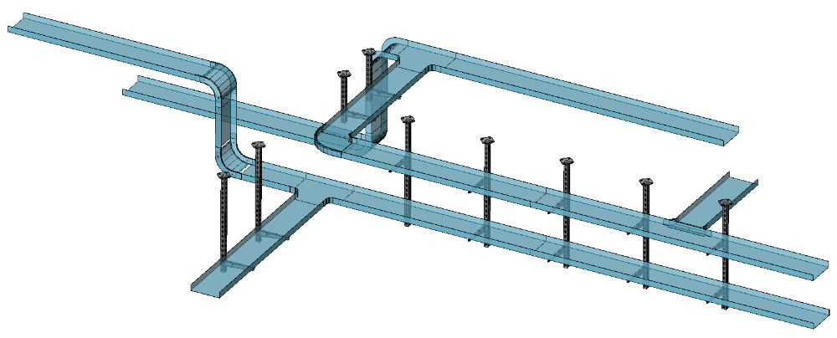
Application Areas
Building Services for Non-residential and residential buildings
Food and Beverage, Hospitals, Industrial and Administration buildings, etc.

Technical Specifications
- BricsCAD®-compatible
- AutoCAD®-compatible

