Folate system correlations in DNA microarray data

Tomas Radivoyevitch
Department of Epidemiology and Biostatistics
Case Western Reserve University, Cleveland, Ohio 44106 USA
Tel: 216-368-1965; Email: radivot@hal.cwru.edu

Abstract

Background
Gene expression data is abundantly available from the Gene Expression Omnibus (GEO) and various websites. Pathway specific analyses of gene-gene correlations across these datasets remain relatively unexplored, though they could be informative.

Methods
Folate gene expression data was explored here in two ways: (1) using gene-gene scatter plots and gene expression time course plots of the data itself; and (2) indirectly, using de novo purine (DNPS) and thymidylate (DNTS) synthesis flux predictions of a folate model perturbed by relative gene expression modulations of its V_{max} parameters.

Results
Positive correlations within and between DNPS and DNTS were observed in the folate gene expression data examined. For steady state measurements across childhood leukemia patients, positive correlations between DNPS and DNTS are consistent with higher proliferative fractions requiring higher levels of both fluxes. For cells exposed to ionizing radiation, transient increases in both pathways are consistent with DNA damage driven dNTP demand, and steadily decreasing backdrops are consistent with radiation induced cell cycle arrest. By and large, folate model based flux predictions paralleled these mRNA findings. Differences relative to the direct analyses were a gain of correlation information for TEL-AML1 leukemia data, and a loss of one interesting inference, namely, that RNA repair driven DNPS precedes DNA repair driven DNTS after a 10 gray dose of ionizing radiation.

Conclusions
Pathway focused correlation analyses of DNA microarray data can be informative, with or without a mathematical model. Conceptual models are critical. Mathematical model based analyses can supplement, but should not replace, direct data analyses.

Background
The folate system (Figure 1A) is central to de novo purine synthesis (DNPS) and de novo thymidylate synthesis (DNTS) and is a key target of several anti-cancer agents. For example, methotrexate (MTX), in its polyglutamated forms, inhibits dihydrofolate reductase (DHFR), thymidylate synthetase (TS), glycinamide ribonucleotide formyltransferase (GART), and other folate system enzymes (see the MTX containing reaction equations [1] in Methods); the novel multi-targeted anti-folate ALIMTA has similar targets [2], though with a very different spectrum of inhibition constants K_{i} such that GART inhibition is dominant [3]; the anti-folate raltitrexed (Tomudex) mostly inhibits TS [4]; and 5-fluorouracil also inhibits TS (as FdUMP), though it also kills cells via incorporation into DNA and RNA [5].

Folate has two key double bonds (Figure 1B, arrows). Saturating the upper double bond yields dihydrofolate (DHF) and saturating the lower double bond yields tetrahydrofolate (THF). Folates are used to convert serine side chains into reactive single carbons: 5-methyl-THF (CH₃THF) is used to convert homocysteine into methionine; 5,10 methylene-THF (CH₂THF) is used by TS of DNTS to convert dUMP (deoxyuridylate) into dTMP (thymidylate) for the sole purpose of having it enter DNA; and 10-formyl-THF (CHOTHF) is used to set up the purine ring closure reactions of DNPS for many purposes, including RNA, DNA, ATP, GTP and others. These three single-carbon consuming folate functions interact via competition for CH₂THF. Using publicly available DNA microarray data, the primary objective of this study is to explore folate cycle interactions at the higher level of mRNA. A secondary objective is to assess the added value to these analyses of a published mathematical model of the folate system [1]. Specifically, inferences obtained directly from the DNA microarray data are compared here to those obtained indirectly using folate model predictions of DNPS and DNTS based on the same DNA microarray data.

Methods
Mathematical model of Morrison and Allegra
The folate cycle model of Morrison and Allegra [1] has the following mathematical form:
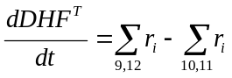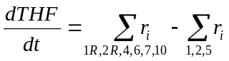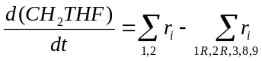
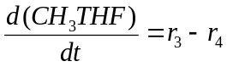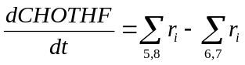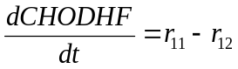
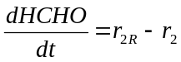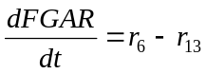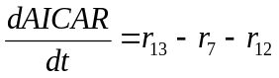
These equations restate the system configuration information of Figure 1A, i.e. they state that the rate at which a metabolite concentration increases equals the sum of the synthesis reaction fluxes (arrows into a node) minus the sum of the degradation reaction fluxes (arrows leaving a node). The r_{i} in these equations are:
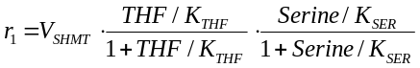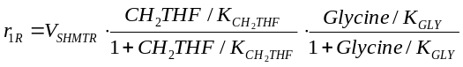
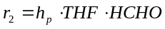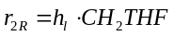
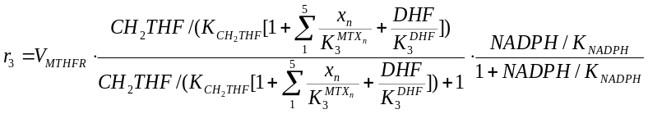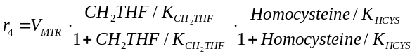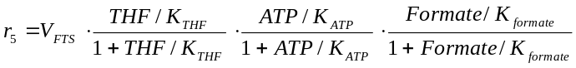
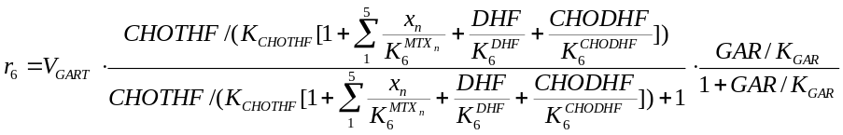
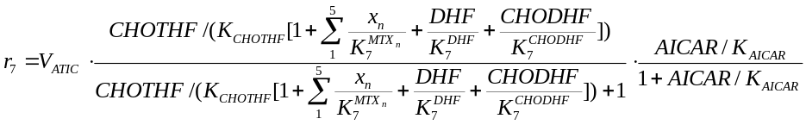
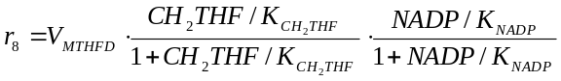
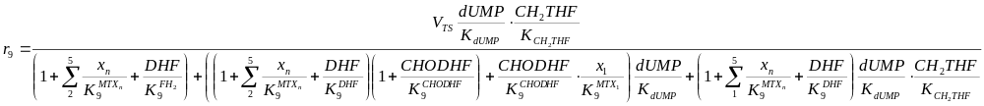
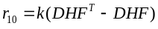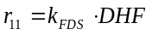
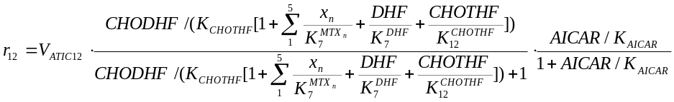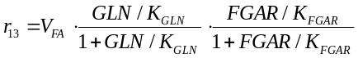
where DHF^{T}-DHF (total DHF minus free DHF) is the concentration of DHF bound to DHFR, x_{i} is the concentration of i-glutamated MTX, and all folates are assumed to be penta-glutamated. Not shown are 10 additional differential equations for up to penta-glutamation of MTX either free or bound to DHFR. These 10 equations are irrelevant when MTX=0 as in the microarray data analyses below; they were used here only to validate the current implementation of the model against its previously published responses, see Figure 2 [1].

Model limitations
Since the model has only one compartment, the cytosol, it cannot handle changes in the mitochondrial enzymes MTHFD2 and SHMT2, nor can it handle changes in the extra-cellular folate hydrolase gene FOLH1 (the gene that codes for prostate-specific membrane antigen, PSMA), so these genes were ignored in the analyses. Further, the folate genes GGH (polyglutamate hydrolase), FPGS (polyglutamate synthase), and RFC (reduced folate carrier), were not considered in the microarray analyses because these reactions are included in the model only for MTX and not folate, and because MTX=0 for the microarray data.

Model modifications
Flux boundary conditions for dUMP and GAR synthesis in the original model [1] were replaced by downstream concentration boundary conditions set to their initial values. This was done because steady state flux differences across patients would otherwise be nullified; e.g. if the flux into GAR were fixed, the steady state flux through GART would also be fixed, and artificially then, there would be no variation in predictions of this flux across patients.

Model-data linkage
For steady state flux predictions of leukemia patient diagnostic samples, MAS5 microarray measurements of Ross et al [6] and Yeoh et al [7] were normalized by dividing by the mean of the leukemia subtype medians. Step functions from 1 (for t < 0) to the resulting metrics (for t ≥ 0) were then used as modulators of the baseline folate model V_{max} values, i.e. microarray data normalization values were equated to the steady state of the model. Individualized patient steady states were then computed as simulation endpoints 40 hours after the V_{max} perturbations; all time courses were inspected visually to assure settled steady states at 40 hours. For radiation response time course microarray data [8], initial measurements corresponded to the steady state of the model, so this data was normalized by its control values at t=0. Linear interpolations of the normalized data were then used as time-varying V_{max} modulators. For both the steady state leukemia data and the time course radiation response data, proportionality between mRNA levels and protein levels was assumed. This assumption was motivated by simplicity, convenience, and a lack of better alternatives. In the future, as proteomic-transcriptomic combined dynamic response data (e.g. [9]) accrues, this assumption will likely be replaced by a set of gene specific lead-lag filter [10] assumptions. In the meantime, direct proportionality can serve as a first order approximation or as a temporary crutch.
Computational details
The computational environment R [11] was used with R packages of Bioconductor [12] to implement this study. Specifically, the package Biobase was used to manipulate microarray data as expression set (class eset) objects and SBMLR [13, 14] was used to simulate a systems biology markup language (SBML) [15-17] representation of the folate metabolism model [1]. R scripts reproducing figures 2-8 are included with SBMLR as an illustrative example of package use. For convenience, array data used in this study have been repackaged as eset objects in R data packages available from the author’s website [14]. Throughout, genes with multiple probe sets were represented by the set with the highest average value.

Results

Folate system correlations across childhood leukemias
The childhood acute lymphoblastic leukemia (ALL) microarray data of Ross et al [6] and Yeoh et al [7] is shown in Figures 3 and 4. Several points can be made regarding this steady state diagnostic bone marrow data. Firstly, since TYMS and DHFR (similarly MTHFD1, GART and ATIC) operate in series, it makes sense that the system would attempt to match these throughput capabilities as closely as possible to avoid the costs of maintaining unneeded excess “equipment.” Thus, positive correlations within the DNPS and DNTS branches are expected. Secondly, growing cells require commensurate increases in both DNTS and DNPS, so positive correlations between these cycles are also expected. Finally, DNPS genes are higher in T cell leukemic cells than in B-cell leukemic cells, consistent with measured DNPS fluxes being three fold higher in T cells than in B cells [18].
To assess the added value of the folate model, since MTHFD1 and TYMS are the gatekeepers of DNPS and DNTS, respectively, correlation plots for these genes were compared to corresponding flux predictions in Figure 5. The plots show that, for the most part, model predicted fluxes are more correlated than measured MTHFD1 vs. TYMS mRNA. To estimate the amount of correlation attributable to steady state model flux constraints alone, 1000 uncorrelated normally distributed (mean = 1; standard deviation = 0.30) random numbers were applied to the model as V_{max} modulators. The amount of correlation (r=0.18, Figure 6) is more than expected for BCR-ABL and T cell leukemias (Figure 5), and less than expected for TEL-AML1 leukemias, so for this leukemia subtype, one can deduce that there must be additional information contributed by other folate genes inputted into the model.

Folate system analysis of radiation time course data
Folate system correlations in radiation response time course data [8] were also investigated. The data (Fig. 7) shows that TS, DHFR, GARFT and MTHFD each have a dose-dependent transient increase after irradiation, consistent with radiation induced DNA damage causing a transient rise and fall in P53 activity [19] with a subsequent induction of ribonucleotide reductase subunit P53R2 [20] causing a transient increase in de novo deoxynucleotide synthesis for DNA repair; a 17-fold increase in R2 protein 24 h after irradiation [21] is radioprotective [22], further supporting this conjecture. The data also shows a steady decline in many of the gene expression time courses, possibly due to radiation induced cell cycle arrest. At 10 gray, inspection of TS, DHFR, GARFT and MTHFD further suggests that RNA repair driven DNPS (peak at 2 hours) precedes DNA repair driven DNTS (peak at 6 hours).

In Figure 7, gene expression time courses are more likely to be signals if they differ between 3 and 10 gray only in terms of minor time shifts and dose ordered amplitude changes, so MTHFR and SHMT1 were dismissed as noise. The remaining six gene expression time courses were normalized by their values at t=0 and applied to the folate model as linearly interpolated time-varying modulators of corresponding V_{max} parameters. The resulting model-based predicted time courses are shown in Figure 8. These plots affirm the “dose-dependent spike resting on a decreasing backdrop” response of DNPS and DNTS that was qualitatively inferred from Figure 7. In contrast to the data itself, however, at 10 gray, model-based RNA repair driven DNPS (peak at 12 hours) and DNA repair driven DNTS (peak at 10 hours) have the opposite ordering, and both are delayed. Since NTP production tends to be in high gear full time, compared to dNTP production, it likely has a greater ability to respond rapidly to oxidative damage. Further, a dNTP peak at 6 hours (compared to 10 hours) is more consistent with a P53 spike at 5 hours [19]. Thus, until measurements of DNPS and DNTS in 10 gray irradiated cells suggest otherwise, the direct data inference that RNA repair precedes DNA repair seems to be the more credible of the two.

Discussion
Pathway focused analyses are essential for gene-gene correlation studies because the number of possible correlations would otherwise be too large to investigate. For example, if a chip carries 10,000 genes, the number of 2D plots requiring correlation tests is then 10,000 choose 2, or ~50 million. Thus, relative to differential gene expression, multiple-testing problems are much worse when statistically significant gene-gene correlations are sought. Pathway focused analyses offer a feasible approach to multivariate gene-gene correlations studies.

Although TS and DHFR are predominantly controlled at the protein level, Figures 3 and 4 [Figure 7] indicate[s] that some steady state [transient] control effort is also exerted at the mRNA level. Thus, protein level control may dominate a particular regulatory system, but mRNA signals may still be informative of what the overall system is trying to accomplish. That DNPS and DNTS are correlated in a consistent manner across disparate steady state and transient datasets lends credence to the view that DNA microarray data is a valid source of biochemical system coordination and control information.

Conclusions
The main conclusion of this paper is that interesting inferences can be gleaned from genome-wide microarray data (with or without mathematical models) if gene-gene correlations are analyzed in a pathway specific manner. The added value of analyzing microarray data using Morrison and Allegra’s folate model, relative to simply eye-balling the gene expression data, was minimal at best. For example, in figure 5, gate-keeper focused gene expression scatter plots are roughly as revealing as model-predicted DNPS vs. DNTS scatter plots. Similarly, for the radiation time course data in Figures 7 and 8, the spike increase in DNPS and DNTS and the baseline downward trend at larger times are apparent with either approach. Thus, the value of pathway focused microarray data analyses derives largely from: a) the availability of conceptual models; and b) multivariate analyses of manageable dimension correlated data subspaces. Nevertheless, to go beyond qualitative statements and to plot predictions (Figures 5 and 8), a quantitative model is needed. Further, as models expand in scope and complexity, gedanken experiments underlying eye-ball data analyses will become increasingly difficult to carry out, and mathematical models will then become indispensable. So we must continue to develop model-based approaches. However, in view of the RNA repair versus DNA repair timing discrepancy, they should supplement, but should not replace, direct data analyses.

Competing interests
TR has no competing interests

List of abbreviations
DHF = dihydrofolate; THF = tetrahydrofolate; DNPS = de novo purine synthesis; DNTS = de novo thymidylate synthesis; DHFR = dihydrofolate reductase; TS = thymidylate synthetase (protein); TYMS = thymidylate synthetase (gene); GART = glycinamide ribonucleotide formyltransferase; MTHFR = methylene-THF reductase; MTR = methyl-THF transferase; FTS =formyl-THF synthetase; FDS = formyl-DHF synthetase; SHMT = serine hydroxymethyl transferase; GAR = glycinamide ribonucleotide; FGAR = formyl-GAR; AICAR = aminoimidazole-4-carboxamide ribonucleotide; FAICAR = formyl-AICAR; dUMP = deoxyuridylate; dTMP = thymidylate; MTX = methotrexate; SBML = Systems Biology Markup Language.

Authors' contributions

TR is the sole contributor.

Acknowledgements
This work was supported by the Comprehensive Cancer Center of Case Western Reserve University and University Hospitals of Cleveland (P30 CA43703), the American Cancer Society (IRG-91-022-09), the National Cancer Institute’s Integrative Cancer Biology Program (P20 CA112963-01) and NIH grant 1K25 CA104791-01A1.

References

Figures

Figure 1. The folate cycle model of Morrison and Allegra [1] (A) and the molecular structure of folate (B).

Figure 2. Morrison and Allegra’s model [1] responding to 1 µM MTX applied continuously after t=0. Concentrations are in µM (top 6 plots) and fluxes are in µM/hour (bottom 3 plots).

Figure 3. MAS5 U133a folate gene expression data of Ross et al [7]. Symbols are TEL-AML1 (B), BCR-ABL (b) and T-cell (T). In mirrored positions relative to the main diagonal, corresponding Pearson correlation coefficients r are given with their P values.

Figure 4. MAS5 U95av2 folate gene expression data of Yeoh et al [8]. Only the Yeoh et al [8] patients who are also in the Ross et al dataset [7] are considered. MAS5 summary measures were computed from cel files using Bioconductor’s AFFY package. Symbols are as in Figure 3.

Figure 5. Comparisons of measured MTHFD1 vs. TYMS versus predicted DNPS vs. DNTS.

Figure 6. DNPS vs. DNTS predicted with random numbers replacing Figures 3 & 4.

Figure 7. Lymphocyte radiation response data of Jen and Cheung [8]. SHMT1 and MTHFR were not applied to the folate model, see text. Time is in hours.

Figure 8. The folate model’s response to the radiation time course data. Fluxes are in µM/hr.

