**Test @ mar 8**

1. When user accepted the offer letter and notification email should go, what gateway we need to use.
2. OR/XOR (I don’t know whether it is OR/ XOR but I choose this)
3. Complex
4. AND
5. Event Based
6. When you click on delete button you are getting an confirmation box with 2 buttons and what are label it should be.
7. Yes,No
8. True,False
9. Cancel,Delete
10. A person who remove all the impediments in the team and set up team meetings and collaboration and 2 more options.
    1. Scrum Master
    2. Product Owner
    3. Solution Architect
11. I want to click this button, so that I can see the Page, Which Part is missing here.
    1. User Personas
    2. Purpose
    3. Activity
    4. Acceptance Criteria
12. As a user, I want to click home page button, so that I can redirect to homepage from anywhere in the application, What are best 2 acceptance Criteria for this story.
    1. When user click home page button, I should direct to homepage
    2. HomePage Button should be visible to all the pages
13. I want to see this letter,so that I can see full information/auditlog information, Which part is missing in this User Story.
    1. Action
    2. Purpose
    3. User
    4. Acceptance criteria
14. Flow Chart with BPMN nodes and asked to find XOR Gateway.
15. Match the following for Which Gateways for which flow Like below.
    1. Incoming paths and multiple outgoing path with condition(OR)
    2. Incoming path with one outgoing path(XOR)
    3. Incoming with some restriction and outgoing(Complex)
    4. Once all incoming paths are reached then all the outgoing will happen as join ( AND)
16. HR onboarding wants to reduce the manual tasks of getting documents from the employee on the first day and set up the paycheck and all other activities, What is the best way to automate this via Appian.
    1. HR send email to employee 3 days before and send the task to respective team once employee completes the details.
    2. HR send email to employee on the first day and transpose the data to subsystem
17. Match the following for Appian objects like Expression Rule, Process Modeler, Site, Appian Designer
    1. Monitor,Deploy (Appian Designer)
    2. Evaluate and some business rule (Expression Rule)
    3. User experience for different User (Site)
    4. Flow Chart and gateway Logic ( PM )
    5. Run the Workflows and something (PM)

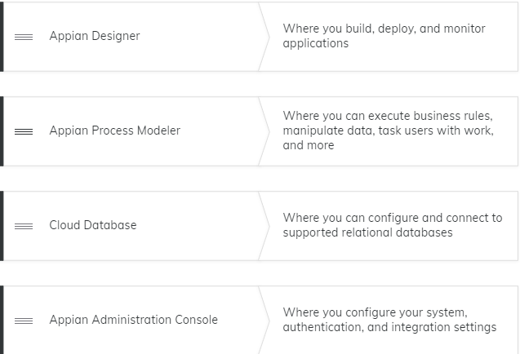

1. Best 2 Appian storage Capabilities in this below
   1. Upload Document to Appian
   2. Download document to Local
   3. Upload all local instance to Appian
   4. Upload Document into Appian and store in third Party Integration
2. Stakeholders brough new items after the sprint review, but each stakeholders have different prioritize option, how Appian Analyst handle this situation
   1. Analyst directly interact with stakeholders and set expectation and prioritize the story
   2. Analyst ask PO to check with Stakeholders to finalize the priority.
3. Stakeholders brough new items after the sprint review, How analyst ask the Product Owner to do.
   1. Prioritize the backlog with the new items
   2. Prioritize the new items from the bottom of the backlog
   3. Add the new items in the top of the backlog
4. Estimate Process and Prioritize the Backlog which meeting is this
   1. Sprint Planning
   2. Sprint Review
   3. Backlog Refinement session
   4. Sprint Retro
5. User Experience options for viewing records in Appian, Select all Apply
   1. Site
   2. Embedded Interface
   3. SAIL
   4. Tempo (Portals also correct)
6. Appian capabilities related Question
7. What Analyst will do on Release Plan--- they prepare stakeholders
8. Match the following with options of Connected system, Integration
9. Definition of Ready – 2 questions
10. When user story meet requirements and acceptance criteria is completed what status of Story
    1. Done
    2. Open
    3. New
11. Cloud Db - 1 Question
12. Which requirement methods are used to gather information?
13. Appian Analyst Role – Gathering and communicating business requirements in the form of user stories and identifying KPIs