Lesson 03

Overview
In this worksheet, we explore the principle of Separation of Concerns (SoC) - a foundational concept in software design. SoC encourages structuring a program into distinct sections, each responsible for a specific concern, such as business logic, user interface, database access, or security.
A common implementation of SoC is the Model-View-Controller (MVC) architecture.
Before you attempt the questions in this worksheet, you should go through the respective topics in your notes:
Worksheet | Notes
Section A | Separation of Concerns, Model-View-Controller(MVC)
Section B | Code Review
Section C | CA1 Deliverable
Section D | Submissions

Do seek your lecturer’s advice when in doubt

Section A – Separation of Concerns, Model-View-Controller (MVC)
Exercise 1
- Make a copy of the existing StudentApp project and rename it to StudentAppMVC
- In StudentAppMVC,
  - Create a file named db.js
  - Create a file named .env
  - Create a folder named controllers
  - In controllers, create a file named StudentController.js
  - Create a folder named models
  - In models, create a file named Student.js
- Screenshot your StudentAppMVC project structure and paste it here.
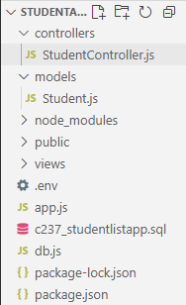

Exercise 2
- Copy the code below and paste it into .env file.
DB_HOST=localhost
DB_USER=root
DB_PASSWORD=YOUR_PASSWORD
DB_NAME=c237_studentlistapp

Remember to replace the database password with your own.
Should .env file be uploaded to the cloud?
No. they contain sensitive information such as database credentials, API keys, and passwords. Uploading them publicly can expose your application to security risks, including unauthorized access to your database or services.

Exercise 3
- Paste the code here to db.js

const mysql = require('mysql2');
require('dotenv').config(); // Load variables from .env
//Database connection details
const db = mysql.createConnection({
host: process.env.DB_HOST,
user: process.env.DB_USER,
password: process.env.DB_PASSWORD,
database: process.env.DB_NAME
});
//Connecting to database
db.connect((err) => {
if (err) {
console.error('Error connecting to MySQL:', err);
return;
}
console.log('Connected to MySQL database');
});
module.exports = db;

Exercise 4
- For each file,
  - Paste the prompt you used to generate the code for
  - Summarise the response you recieved.
  - Was the response correct and aligned with your expectations?

  - Student.js
Prompt: Generate a function-based student model for Node.js using the MVC pattern. The model should export an object with methods for common database operations (get all students, get student by ID, add, update, delete). Each method should accept parameters and a callback, and use a MySQL connection from require(‘../db’).

Use SQL queries that match a students table with fields like studentId, name, dob, contact, and image.

Response: I'll create a short todo list (marking the model implementation as in-progress), then open the existing models/Student.js so I can update it to the requested function-based model. Expected outcome: todo list recorded and file contents returned. I'll run two quick tool calls now.

Created 3 todos

Read Student.js

Now I'll mark the first todo (implement Student model) as completed in the todo tracker. Expected outcome: todo list updated.

Completed (1/3) Implement Student model

Update — Student model ready ✅
I inspected Student.js and it already contains a function-based model that matches your requirements: it exports an object with methods for common DB operations, each accepts parameters and a callback, and it uses the MySQL connection from require('../db').

What I checked
File: Student.js
Methods present:
getAll(callback) — returns all students
getById(studentId, callback) — returns one student by ID
add(student, callback) — inserts a new student (expects { name, dob, contact, image })
update(studentId, student, callback) — updates student by ID
delete(studentId, callback) — deletes student by ID
SQL queries reference the students table and use fields: studentId, name, dob, contact, image.
Uses const db = require('../db') and db.query(...) with error-first callbacks.
Next steps (recommended)
Validate the model at runtime by requiring it from a small script or running your app and hitting routes that use it.
Optionally rename methods to getAllStudents, getStudentById, addStudent, updateStudent, deleteStudent if you prefer those specific names. Current names are concise and idiomatic.
Add a short README or comments with example calls. I can add that for you if you want.

  - StudentController.js
Prompt: Generate a function-based student controller for Node.js using the MVC pattern. The controller should export an object with methods for common operations: list all students, get student by ID, add, update, and delete a student. Each method should accept the standard Express req and res objects, call the corresponding method from the student model (imported from ../models/Student), and handle the response or error appropriately.

Response: I'll create a short todo list for the controller work, then open controllers/StudentController.js to see current contents before editing. Expected outcome: todo list recorded and file contents returned.

Added 2 todos

Read StudentController.js

Updating the todo list to mark the controller implementation complete.

Completed (4/5) Implement Student controller

Done — Student controller exists and matches your request ✅
What I checked

File: StudentController.js
Exports an object with Express-style handlers that accept (req, res):
list — lists all students, renders index
getById — gets a student by ID, renders student
add — creates a student (supports req.file for uploads)
update — updates a student (keeps existing image if no new upload)
delete — deletes a student by ID
plus editForm to render the edit page
Each handler calls the appropriate method from ../models/Student and handles success and error flows (console logging server errors and returning 500/404 or redirecting/rendering views).

  - app.js
Prompt: Update app.js to use the MVC pattern with the function-based student controller and model.

Import the student controller from ./controllers/StudentController.
Replace all direct SQL queries and database logic in the route handlers with calls to the corresponding controller methods.
Use the controller methods for listing all students, getting a student by ID, adding, updating, and deleting students.
Ensure the routes use the correct HTTP methods and paths, and that file uploads (with multer) are handled for add and update operations.
The controller methods should handle rendering views or redirecting as appropriate.
Remove any unused direct database connection code from app.js.

Response: I'll read the current app.js to find direct DB logic and where to replace it with controller calls; outcome: I'll return the file contents and then prepare an edit.

Read app.js

I'll update app.js to remove direct DB code, import the StudentController, and replace route bodies with calls to the controller methods while keeping multer for uploads. Expected outcome: app.js updated to use MVC controller and no direct MySQL code.

app.js+17-135
Added 1 todo

Update complete — app.js now uses the function-based MVC controller and no longer contains direct MySQL connection or query logic.

Summary of changes

Removed direct MySQL import, connection setup, and query logic from app.js.
Imported the controller with:
const StudentController = require('./controllers/StudentController');
Replaced route handlers to delegate to controller methods:
GET '/' -> StudentController.list
GET '/student/:id' -> StudentController.getById
GET '/editStudent/:id' -> StudentController.editForm
POST '/addStudent' -> upload.single('image'), StudentController.add
POST '/editStudent/:id' -> upload.single('image'), StudentController.update
GET '/deleteStudent/:id' -> StudentController.delete
Kept multer setup and upload middleware for add/update routes.
Kept GET '/addStudent' that renders the add form (unchanged).
What I ran (edits)

Updated c:\\...\\StudentAppMVC\\app.js to call the controller instead of running SQL.

Exercise 5
Test that you are able to run StudentAppMVC and perform the functions*

Functions | Working (Yes/No – If no, describe the issue)
View all students | Yes
View student by ID | Yes
Add new student | Yes
Update student details | Yes
Delete student | Yes

*You may get different results depending on what was generated for you using genAi assistance earlier.

Exercise 6
- Test that you are able to perform all the functions in the web browser.
- Screenshot the working functions into your worksheet
  - View all students
  - View student by ID
  - Add new student
  - Update student details
  - Delete student
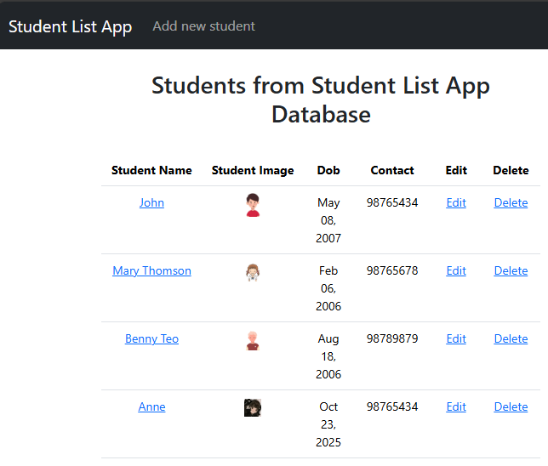
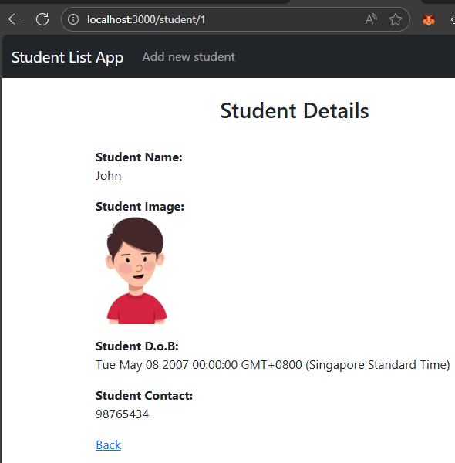

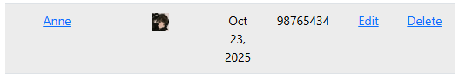


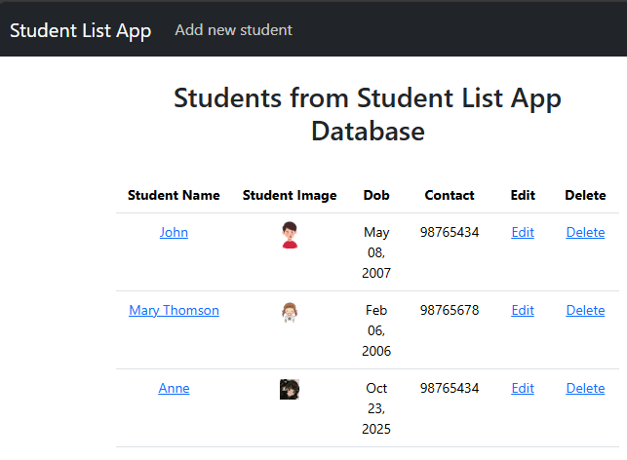

Section B – Code Review
Exercise 7
- What happened to all the code in the original app.js from StudentApp?
Previously, app.js file handled everything—from retrieving and storing data to processing user input and updating views.
Now, app.js is streamlined to define routes only. These routes trigger the appropriate controller functions, which in turn interact with the relevant models to handle data operations.

Exercise 8
- Using Copilot in VSCode, compare app.js from StudentApp and app.js from StudentAppMVC.
- What prompt did you use?
“Compare app.js from StudentApp and app.js from StudentAppMVC. Highlight the differences in structure, responsibilities, and how database operations are handled.”

- Did you include any context? If so, what was it?
Yes. I included the context that StudentApp was a monolithic Node.js application with direct SQL queries in app.js, and StudentAppMVC was refactored to follow the MVC pattern using separate controller and model files.

- What response did you receive?
StudentApp’s app.js contains direct MySQL connection setup and SQL queries inside route handlers.
StudentAppMVC’s app.js imports the controller (StudentController) and delegates all route logic to it.
The database logic is now encapsulated in the model (Student.js), and the controller handles request/response logic.
This improves maintainability, readability, and aligns with the MVC architecture.
Multer is still used for file uploads, but now integrated within controller methods.

Section C – CA1 Individual Deliverable
Exercise 9
In the Resources folder, SupermarketApp project files and c372_supermarketdb.sql is provided to you.
- Setup and test that SupermarketApp works as expected.
- Create a copy of SupermarketApp and name it SupermarketAppMVC
- Follow the steps you did for StudentAppMVC
- Prepare the project structure for SupermarketAppMVC

Document your work in the file:
C372 Individual CA1 AI Interaction Journal – STUDENTID – STUDENTNAME.docx

Sample logins
Admin | User
peter@peter.com  123456 | bobochan@gmail.com  123456

Exercise 10
- Create a public GitHub repository
- Check in StudentAppMVC and SupermarketAppMVC to your own GitHub Repository.
- Fill in the form with your GitHub repository URL
https://forms.office.com/r/PEKn31juZx

Section D – Submissions
Deliverables for today
POLITEMALL
- Worksheet (Individual)
- StudentAppMVC project code (Individual, zipped)
- SupermarketMVC project code(Individual, zipped)
- C372 Individual CA1 AI Interaction Journal – STUDENTID – STUDENTNAME.docx
Upload your deliverables even if it is incomplete before the next session.
You can resubmit by 2359 if there are updates.

SA3.0 (CA 1 Interim submission)
- SupermarketMVC project code(Individual, zipped)
- C372 Individual CA1 AI Interaction Journal – STUDENTID – STUDENTNAME.docx

