Mentat System Design

SQLite Orchestration

STATUS  Proposed |  | OWNER  Mentat project |  | LAST UPDATED  August 18, 2026

Authors | Project owner + OpenAI Codex
Reviewers | Project owner and per-slice adversarial reviewers
Related docs | Pivot plan; Architecture; Data layout
Scope | SQLite Tasks, Runs, AgentEvents, migration, dispatch, and database convergence.

1. Abstract
Mentat will make its existing owner-private mentat.sqlite3 database authoritative for Tasks, Runs, and normalized AgentEvents. A one-time, verified migration retires tasks.json as live state while preserving current APIs. Agent identity and runtime bindings remain in agent-registry.sqlite3 until a later convergence slice moves them into one unified database.
The design supports one local operator, concurrent agent activity, restart recovery, bounded history, and the future React console. It preserves loopback-only access, Hermes capability boundaries, WAL-safe backup/restore, and compatibility with the current static frontend. It does not add a second runtime, dynamic routing, or automatic import of unverifiable historical Console events.

2. Goals and Non-Goals
Goals | Non-goals
One authoritative SQLite Task store with exact migration and no dual writes. | No second runtime, dynamic routing, supervisor, or A2A delegation in this work.
Transactional Run/Event lifecycle suitable for concurrent agents and the React console. | No fabricated import of old Console timelines whose identity or sequence cannot be proven.
WAL-safe backup/restore, bounded retention, export diagnostics, and fail-closed recovery. | No credential consolidation or direct writes to Hermes-owned files.
Preserve current APIs/UI during cutover; finish with repeatable Lighthouse 100 scores. | No immediate Agent Registry merge; full database unification is an explicit later slice.

3. Background and Problem Statement
Mentat currently rewrites tasks.json for every task mutation while agent identity, attachment metadata, webhook receipts, and private run history already span SQLite and JSON stores. That model is understandable for a personal dashboard, but it cannot atomically reserve a task, create a run, and append ordered events. It also requires full-file scans and application-level coordination as multi-agent concurrency grows.
The Python Local Bridge remains the security and API boundary. A new orchestration repository owns task, run, and event transactions in mentat.sqlite3; AgentRegistry continues to resolve validated runtime bindings; AgentRuntimeRegistry dispatches through HermesRuntime. The governing invariant is: durable intent is committed before external execution, and no browser or runtime projection becomes a competing source of truth.

4. Proposed Architecture

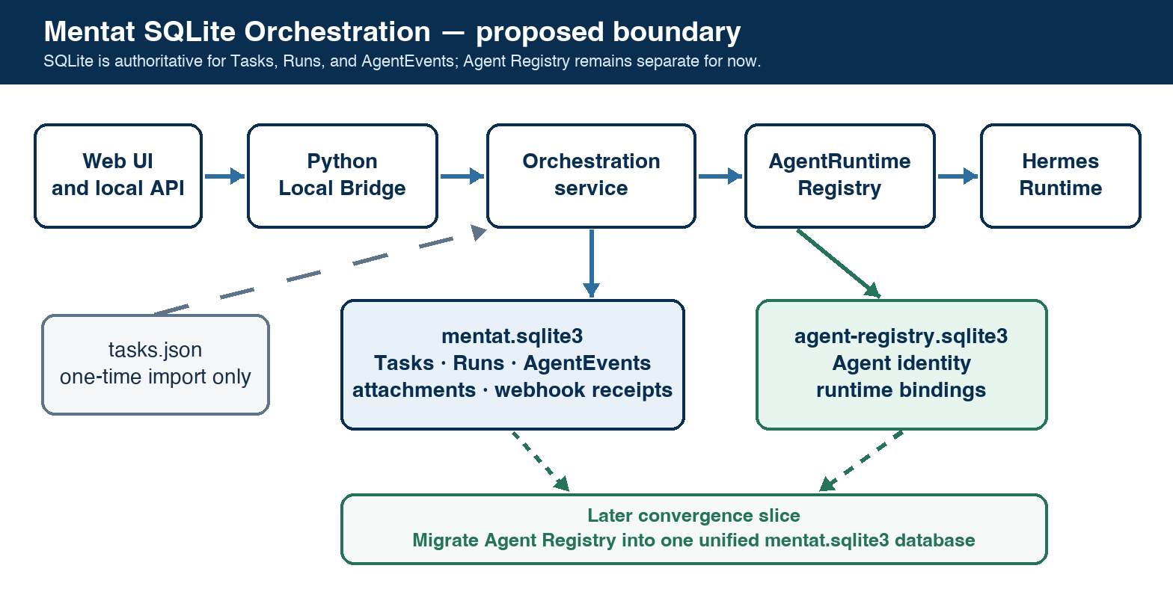
Figure 1. Mentat SQLite orchestration boundary and later database convergence.

Core components

Component | Responsibility | Primary storage | Failure behavior
Task repository | Validate, query, revise, and migrate canonical planning tasks. | mentat.sqlite3 | Rollback transaction; old source remains untouched until verified cutover.
Orchestration service | Reserve exact task revisions; create Runs; coordinate status and retention. | mentat.sqlite3 | Fail closed before dispatch or record explicit partial failure after acceptance.
Runtime boundary | Resolve capability-scoped adapters and submit normalized task snapshots. | AgentRuntimeRegistry + HermesRuntime | No arbitrary fallback or blind retry; surface bounded runtime error.
Event journal | Append ordered normalized events and expose cursor-based history/SSE projections. | mentat.sqlite3 | Conflicting duplicate or continuity loss is durable and visible, never silently repaired.
Agent Registry | Own Agent identity and private runtime binding until convergence. | agent-registry.sqlite3 | Unavailable or changed binding blocks dispatch; no stale cached authority.

5. Request Lifecycle
- A local client submits a task mutation, migration request, dispatch request, or run query through the versioned Mentat API.
- The Local Bridge enforces loopback origin, request shape, size limits, task validation, dependency rules, and bounded identifiers.
- The service loads the current task revision and, for dispatch, the assigned Agent and runtime binding from AgentRegistry.
- The orchestration service validates capabilities and obtains an immediate SQLite write reservation for the exact task revision.
- Mentat commits the immutable task input snapshot, starting Run, and first AgentEvent before invoking HermesRuntime.
- The adapter performs one bounded submission. Runtime acknowledgements and normalized events are appended idempotently; ambiguous acceptance is recorded as partial failure and reconciled without blind resubmission.
- Terminal status, usage, artifacts, retention metadata, and API projections are committed transactionally. SSE wakes clients; durable state remains authoritative.

6. API and Data Contracts

Primary data contract

Field | Type | Required | Description
Task | Relational record | Yes | Canonical planning fields, revision, lifecycle timestamps, and validated bounded metadata.
assigned_agent_id | Opaque ID | No | References the Agent Registry logically; assignment alone never grants unsupported capabilities.
Run | Relational record | On dispatch | Immutable task/agent/runtime snapshot plus current status, outcome, usage, and retention state.
AgentEvent | Append-only record | For each Run | Mentat-owned ID, Run ID, monotonic sequence, normalized type, timestamp, summary, bounded content/metrics.
task_revision | Integer | Yes | Increments on mutation and binds dispatch to the exact reviewed task state.
runtime_binding | Snapshot IDs | On dispatch | Agent ID, runtime type, config ID, and declared/effective capabilities; never credential values.
retention_boundary | Sequence/flags | No | Marks compacted history so clients can distinguish a partial timeline from complete replay.

Contract guarantees

- Task revision, dispatch reservation, Run creation, and the first event must commit before external execution begins.
- Mentat owns opaque Task and Run IDs; each Run owns a monotonic event sequence. Identical duplicate events are idempotent and conflicting duplicates fail closed.
- Every Run captures task revision, normalized task input, Agent ID, runtime type/config ID, capability set, schema version, and timestamps needed for audit and replay analysis.
- mentat.sqlite3 is authoritative for Tasks, Runs, and AgentEvents. Agent Registry is authoritative only for Agents/runtime bindings; Hermes references remain adapter-private.
The versioned schema and migration contract are maintained in mentat_db.py and ARCHITECTURE.md; each schema change receives focused migration, restore, and forward-version refusal tests.

7. Consistency, Idempotency, and Replay

SQLite transactions provide one local serialization point for task revisions, dispatch reservations, Run state, and event ordering. External Hermes submission cannot share that transaction, so Mentat records durable intent first, uses one submission attempt, and reports accepted-but-unverified outcomes honestly. Retention never removes active or waiting Runs and never presents a truncated timeline as complete.
Scenario | Expected behavior | Reasoning
Repeated mutation or event | Same idempotency key and content returns the existing result; conflicting content is rejected. | Prevents duplicate Runs and protects append-only event meaning.
Required SQLite or Agent Registry read fails | No runtime call occurs; return a bounded retryable/unavailable error. | Durable authority and validated binding are prerequisites for execution.
Hermes accepts but verification fails | Mark Run partial/unknown, reconcile authoritatively, and never resubmit automatically. | Avoids duplicate external work while preserving honest operator state.
Task or runtime config changes during execution | The Run keeps its immutable captured revision; later runs use the new revision. | Mid-run behavior remains auditable and deterministic.

8. Security and Privacy Considerations

- All APIs remain loopback-only and same-origin. Task and run mutations use fixed handlers; no database query or runtime command is browser-supplied.
- Persist normalized fields and bounded display content only. Exclude raw Hermes payloads, chain-of-thought, credentials, local paths, webhook bodies, and unrestricted tool arguments/results.
- Provider and webhook secrets remain outside orchestration tables. Runtime bindings continue to store references—not credential values—in owner-private storage.
- Migration, import, restore, retention, and diagnostic tools default to preview or read-only behavior, validate file identity, and fail closed on schema or state drift.
- Keep all active/waiting Runs; retain the newest 250 terminal Runs and up to 1,000 normalized events or 4 MiB of event content per Run. Mark truncation explicitly and cascade only terminal history.

9. Operational Readiness
Signal | SLO or alert | Owner | Launch gate
Migration completeness | Every source task imported once; canonical reconstruction and counts match exactly. | Mentat | Required
Mutation/dispatch latency | Local task CRUD remains responsive; dispatch reservation adds no visible UI stall. | Mentat | Required
Database/adapter failures | No unrecorded external submission; all partial outcomes are queryable and diagnosable. | Mentat | Required
Source-of-truth drift | Zero runtime reads/writes of live tasks.json after cutover; contract scan enforced in CI. | Mentat | Required
Recovery and quality | Backup/restore round-trip, restart reconciliation, full CI, browser smoke, and Lighthouse 100/100/100/100 pass. | Mentat | Required
Rollout constraint: preview exact import and backup first; cut over atomically; retain a verified rollback artifact; publish each slice only after tests and two independent adversarial reviews.

10. Alternatives Considered

Alternative | Why it was considered | Why it was not selected
Keep tasks.json canonical | Minimal code and highly inspectable state. | Cannot atomically coordinate Tasks, Runs, events, reservations, and concurrent clients.
Add separate orchestration.sqlite3 | Clear subsystem boundary and smaller initial changes. | Creates a third database and postpones rather than simplifies eventual convergence.
Unify every database immediately | Strongest cross-entity foreign keys and one backup unit. | Expands the first cutover to Agent Registry and attachment migrations before orchestration is proven.
Dual-write JSON and SQLite | Appears to offer gradual rollback. | Creates two authorities and complex divergence/reconciliation failure modes.

11. Open Questions
- Resolved: SQLite replaces tasks.json as the sole live Task source; tasks.json becomes packaged seed/import material only.
- Resolved: extend the existing mentat.sqlite3 database rather than create a third orchestration database.
- Planned decision: execute unified-database convergence after the two-runtime proof and before shared-tool/dynamic-routing work, unless operational evidence justifies moving it earlier.
- Deferred product choice: whether operators need configurable retention or archival export beyond the fixed, bounded initial policy.

12. Decision and Next Steps
Proceed through four independently reviewed slices: establish schema/repository contracts; migrate and cut over tasks.json without dual writes; add durable Runs, AgentEvents, dispatch, and retention; then complete compatibility cleanup, operational evidence, and frontend quality gates. The later unified-database slice migrates Agent Registry into mentat.sqlite3 after orchestration and the two-runtime model are proven.
Milestone | Deliverable | Exit criteria
1C-A | SQLite Task schema, repository, exact import preview, export, and migration safety contract. | Schema/integrity tests, reconstruction proof, backup evidence, and no production cutover yet.
1C-B | Atomic tasks.json import and API/storage cutover with compatibility responses and rollback. | All task workflows use SQLite; no dual writes or live JSON reads; full suite and reviews pass.
1C-C | Durable Runs, AgentEvents, generic dispatch, reconciliation, retention, and run APIs. | Restart/partial-failure/event-order tests and real Hermes compatibility evidence pass.
1C-D | Legacy cleanup, operational docs, frontend/browser regression, and reproducible Lighthouse gate. | CI and browser smoke pass; Lighthouse is 100 in performance, accessibility, best practices, and SEO.

